Topics

Networking Fundamentals

Types of Networks

Network Security Tools

Network Attacks

Incident Response

Network Evidence & Investigation
Networking Fundamentals

Network Concepts

TCP/IP (Transmission Control Protocol / Internet Protocol)

The common language for the Internet

Client/Server Network

Each computer has one of the roles: client or server

Modern computers mix the roles

Peer-to-peer Network

Every member has same role, as both client and server

Commonly used with bittorrent to share files illegally
Network Types

LAN (Local Area Network)

Within a single building or a few nearby buildings

WAN (Wide Area Network)

Larger area

Internet

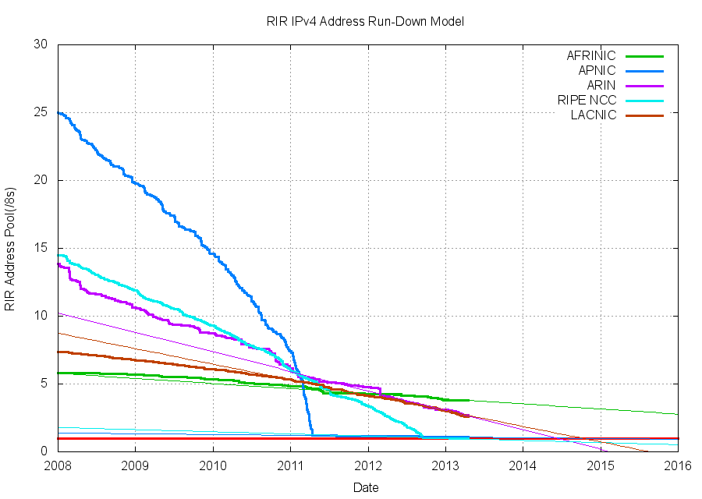
Largest WAN, the whole world

MAN (Metropolitan Area Network)

PAN (Personal Area Network)

Bluetooth: max. range 10 meters

CAN (Campus Area Network)

IP Addresses

IPv4: 32 bits, in four octets

Each octet written as a decimal number 0-255

Ex: 192.168.1.101

Only four billion total addresses

They are running out

IPv6: 128 bit in eight 16-bit fields

Each field a 4-character hexadecimal valoe

Range 0000 – FFFF

Ex: 2001:0db8:0000:0000:1111:2222:3333:4444

Many addresses: 300 billion billion billon billion

Network Security Tools

Firewalls, IDS, and Sniffers

Filters inbound and, optionally, outbound traffic

Simple firewalls filter based on packet headers

IP address, port nnumber

Layer 7 firewall

Looks inside packet to discriminate more

Can detect Facebook, TeamViewer, BitTorrent

Intrusion Detection System

Blocks malicious traffic based on a set of definitions

Ex: Snort

Sniffer

Captures packets for analysis

Ex: Wireshark
Network Attacks

Network Attacks

DDoS (Distributed Denial of Service)

Many bots attack a server

IP Spoofing

False Source IP in packets

Can make attacks appear to come from trusted sources

Man-in-the-Middle

Intercept traffic

Attacker can examine or alter data

Can impersonate user

Defense is SSL

Social Engineering

Tricking people into security violations

Most Common Hacking Methods

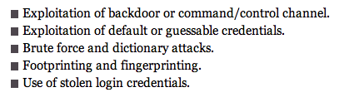
Backdoor

From a malware infection allowing remote control

Footprinting

Gathering public information about a target

Fingerprinting

Scanning a target for open ports and other information

Based on a 2011 Verizon study

Insider Threat

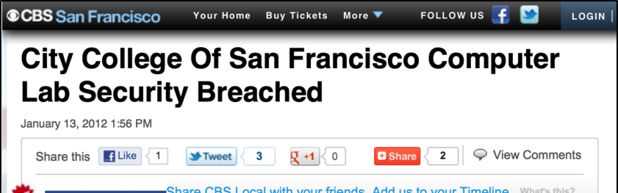
The biggest threat

Does more harm than external attacks

Difficult to detect or prevent



Link Ch 9a

Incident Response

NIST Process


Preparation

Planning for security incidents

Proactive defenses, such as

Hardening systems

Patching

Perimeter defense

User awareness training

Policies, procedures, and guidelines

Detection and Analysis

IDS produce false positives

Network traffic is erratic

NIST Process

Containment

Eradication

Recovery

Postincident Review

Root-cause analysis

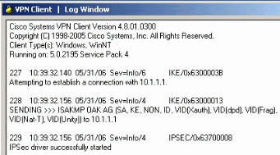
Plan how to prevent future incidence

Revise policies and procedures

Network Evidence & Investigation

Where is the Evidence?

All devices along the route may contain log files

Servers

Routers

Firewalls

Evidence may be volatile

Log Files

Authentication log

Account and IP address of users

Application log

Timestamps shown when application was used and by whom

Operating system log

Track reboots, file access, clients served, and much more

Device logs

On routers and firewalls

Network Investigative Tools

Wireshark

Sniffer

NetIntercept

Hardware applicance to record network traffic

NetWitness Investigator

Can gather and analyze network traffic

Snort

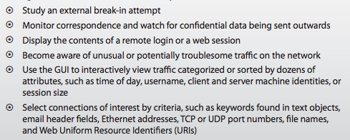
IDS

NetIntercept

Links Ch 9b, 9c

Network Investigation Challenges

IP addresses can be spoofed

Bounced through proxies

Or through compromised systems

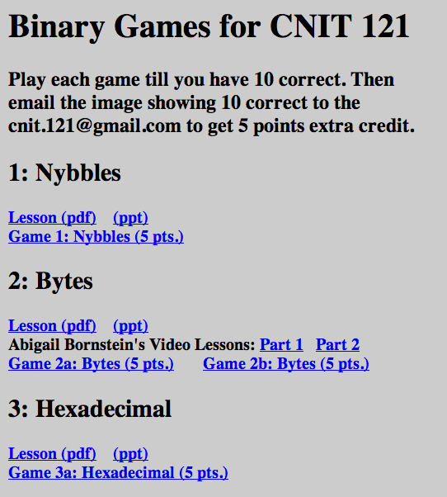
Or through the Tor anonymity network

Logs are often incomplete or absent

Logs are erased after some time

Attackers can erase logs

Jurisdiction

Attacks can cross state or national boundaries

Binary

In Extra Credit Projects

Expect binary on the Ch 9 quiz

NOTE: Quiz Ch 9 next week (April 25)

Last modified 4-17-13

