Topics

Cellular Networks

Cell Phone Operating Systems

Evidence on Cell Phones
Cellular Networks

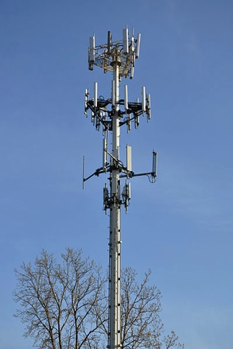
Cell Phone Basics

Important evidence

Emails & SMS messages

Internet history

GPS (Global Positioning System)

Photos

Videos

Challenge: Diversity

Many makes, models, and operating systems

No standard hardware interface

More of them now have mini USB or micro USV

Cell Phone Tower

Also called “Base Transceiver Station” or “Cell Site”

Image from Wikipedia (Link 10a)

Cell Network Components

Base Station

Antennas and related equipment

Base Station Controller (BSC)

Regulates the signals between base stations

Critical as phones move from place to place

Mobile Switching Center (MSC)

Processes calls within the network

Holds a lot of evidence

Coordinates calls between different wireless networks and land lines

Handles SMS messages

Call detail records and logs are here

Visitor Location Register (VLR)

Database linked to a MSC

All mobile devices currently being controlled by that MSC are recorded in the VLR

Interworking functions are gateways to outside data networks such as the Internet

Home Location Register (HLR)

Information about individual subscribers

ID, billing, and services

Stores encryption keys

Supports Authentication Center (AuC) which controls access to the network

Short Message Service Center (SMSC)

Responsible for SMS messages

Messages may be recovered

No rule dictating how long providers must keep those messages

Handoff

Each cell phone is regularly communicating with nearest cell tower

Even if it’s not in use

It sends identification data to the tower

Cell phone number and service provider

Handoff is the transfer from tower to tower as you move

Handled differently in GSM & CDMA networks

GSM (Global System for Mobile Communication)

Hard handoff: Phone can only attach to one tower at a time

CDMA (Code Division Multiple Access)

Soft handoff

Phone can connect to multiple towers at once

Records showing when a phone was connected to a tower can determine the approximate location of that phone

Mobile Switching Center (MSC)

Once your call hits the tower it’s transferred to the MSC

If you are calling a phone outside the network, call is passed to the PSTN (Public Switched Telephone Network)

Messaging Services

SMS (Short Message Service)

Text messages

Maximum of 160 characters

MMS (Multimedia Messaging Service)

Improved functionality

No 160 character limit
Types of Cellular Networks

CDMA (Code Division Multiple Access)

GSM (Global System for Mobile Communications)

iDEN (Integrated Digitally Enhanced Network)

CDMA (Code Division Multiple Access)

Originally military technology

Uses spread spectrum

Used by Sprint, Verizon, Alltel, and NEXTEL

Does not use SIM (Subscriber Identity Module) cards

Handsets identified by Electronic Serial Number (ESN)

ESNs have 32 bits and ran out in 2010, and the new system, MEID, has replaced it

MEID has 56 bits (Link Ch 10b)

GSM (Global System for Mobile Communications)

Used internationally

Uses Time Division Multiple Access (TDMA)

Uses SIM (Subscriber Identity Module) cards

Carriers include AT&T, Verizon, T-Mobile and Cellular One

Handsets identified by International Mobile Equipment Identity (IMEI) numbers (15 or 16 digits)

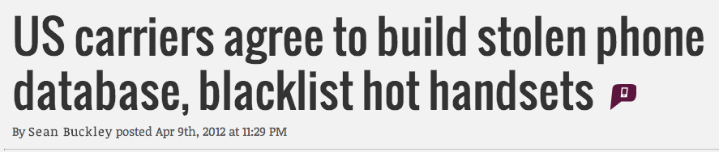
IMEI Blacklist

IMEI uniquely identifies phone, and is not changed by replacing the SIM card

IMEI can be used to blacklist stolen phones

Links Ch 10c & 10d

iDEN (Integrated Digitally Enhanced Network)

Two-way radio-like functionality

Supports normal phone users and “push-to-talk” dispatch users

Sprint will stop supporting iDEN in June, 2013

Link Ch 10e

Prepaid Cell Phones

Can be purchased with cash

No trail to the identity of the user

Cell phone will hold any subscriber information

Network provider will have call details

Location and calls sent and received
Cell Phone Operating Systems

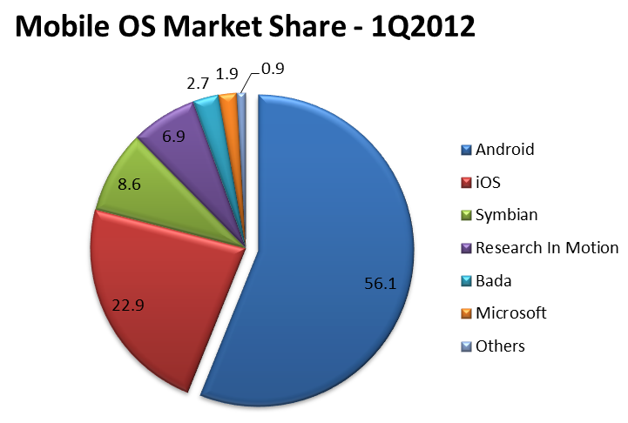
Symbian

Apple iOS

Windows CE and Windows Mobile

Google’s Android

Blackberry OS

Link Ch 10f

Symbian

Started as EPOC in the 1980s

First used on phones in 2000 by Sony

Passed through many different companies

Nokia recently made it open-source

In 2011, Nokia switched to Windows Phone

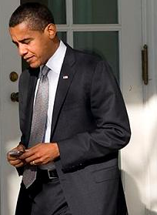
Accenture continues to support Symbian

Blackberry

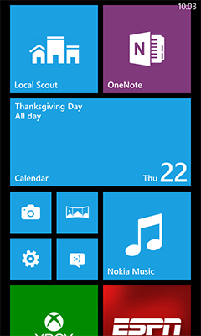
Introduced in 1999 by Research In Motion (RIM) from Canada

Common at workplaces

Synchronize with Novell’s GroupWise and Microsoft’s Exchange

Different OS versions for each carrier

Link Ch 10h

Android

The most popular OS by far

Open Source

Used on Motorola, Sony Ericsson, and HTC phones

Also on tablets

Apple’s iOS

Used on iPhone, iPad, and iPod Touch

Based on OS X

Second most popular phone OS

Windows Mobile (now Windows Phone)

Windows OS versions for smartphones and pocket PCs

Windows Phone 8 was released in Oct. 2012

Link Ch 10i

Evidence on Cell Phones

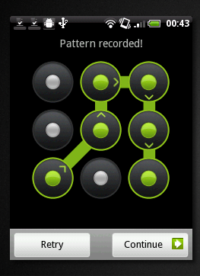
Potential Evidence Items

Call history

Text messages (active & deleted)

Email

Photos & video

Browser history

Contacts

GPS location information

Chat sessions

Calendar

Voice memos

Documents

PIN (Personal Identification Number)

Can be used to secure the handset

Three failed attempts will lock the SIM

A Personal Unlock Key (PUK) is needed to unlock the SIM

PUK comes from the provider of the SIM card

Image from link Ch 10j

Predictive Text

Intended to make it easier to type on 10-digit keypads

Fills in text when the user types part of a word

System learns frequently used words


Database may contain words, slang, abbreviations, E-mail addresses or URLs

Also creates hilariously mangled messages

Link Ch 10k

Call Detail Records (CDR)

Used by the provider to troubleshoot and improve performance

May show:

Date/time call started and ended

Who called who

Whether call was incoming or outgoing

Originating and terminating towers

But you can’t tell who was holding the phone

Subscriber information is different from CDR

Name, address, acct. numbers, email address,
credit card #

Retention Policies

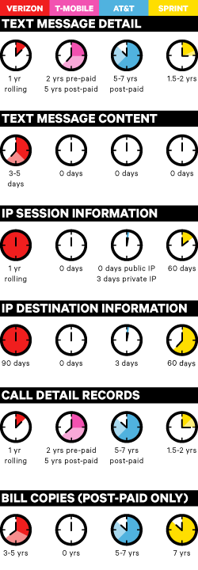
Link Ch 10l

Carrier IQ

Software included in phones to send tracking data back to the carrier

Privacy controversy (Link Ch 10m)

Locating Cell Phones

Triangulation

Measure signal delay to three nearest towers

Can give approximate location of phone

Directional antenna

Enables location determination with only two towers from delay measurements

Image from link Ch 10o

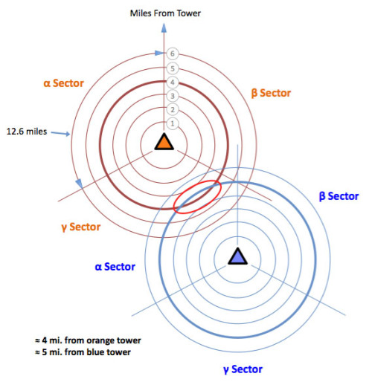

GPS

Locates cell phone with satellites

Wi-Fi Positioning System

Uses data on known Wi-Fi access points

Included on the iPad

Link Ch 10n

Last modified 4-24-13

