Topics

Collecting and Handling Cell Phones as Evidence

Cell Phone Forensic Tools

GPS (Global Positioning System)
Collecting and Handling Cell Phones as Evidence

Isolate the Phone

Use a Faraday bag or a paint can to block radio signals to the phone

This prevents

Remote wiping

inbound emails, texts, and calls, which could overwrite evidence

If phone is on, leave it on

Turning off the ohone will preserve the battery charge, but it might require a PIN when it’s turned back on

A dead battery might trigger the security function, locking up the phone

If Phone is Off

Leave it off

Remove the battery and SIM card

Photograph the phone, front and back

Record identifying numbers under the battery

IMEI/ESN/MEID

Isolate the phone from the network, just like a powered-on phone

Imaging the Phone

Best procedure

Identify make & model of phone

Create a forensic image

Examine the image

Manual Examination

If there’s no alternative, you can examine the live phone by hand

Take good notes

Explain why this was necessary

Hostage situation or to prevent a violent act

Navigate through the phone, taking photographs

Voicemail

You will need the password-reset code from the carrier

Or, carrier may provide you with the data itself

Other Items

Look for

Additional handsets

SIM cards

Power and data cables

A phone in isolation drains its battery rapidly, seeking a signal

SIM (Subscriber Identity Module)

Numbers on SIM card

IMSI (International Mobile Subscriber Identity)

Identifies the subscriber’s account information

ICC-ID (Integrated Circuit Card Identifier)

Serial number of the SIM card itself

Evidence on SIM Card

Subscriber identification (IMSI)

Service provider

Card identity (ICC-ID)

Language preferences

Phone location when powered off

User stored phone numbers

Numbers dialed by the user

SMS text messages (potentially)

Deleted SMS text messages (potentially)

Only a small number of SMS messages are usually stored on the SIM card (link Ch 12e)

SIM Components

CPU

RAM

Flash memory

Crypto-chip

Cell Phone Acquisition
Physical and Logical

Physical

Bit-for-bit copy

Includes latent data

Logical

Only files and folders, no deleted data

Can be performed with nonforensic tools like backup utilities

No write blocker is used
Cell Phone Forensic Tools

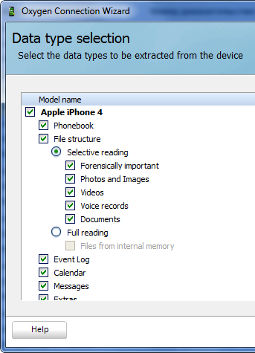
Limitations of Tools

A tool can’t support all phones

Two tools may not recover the same information from the same phone

Multiple tools will be required

BitPim

Free, open-source software

Allows you to view and manipulate data from CDMA phones from Samsung and other manufacturers

Link Ch 10p

Oxygen Forensic Suite

Supports more than 6500 devices

$2500

Claims to extract more data than other tools

Link Ch 10q

Paraben

Hardware and software products for mobile device forensics

Link Ch 10r

AccessData MPE+

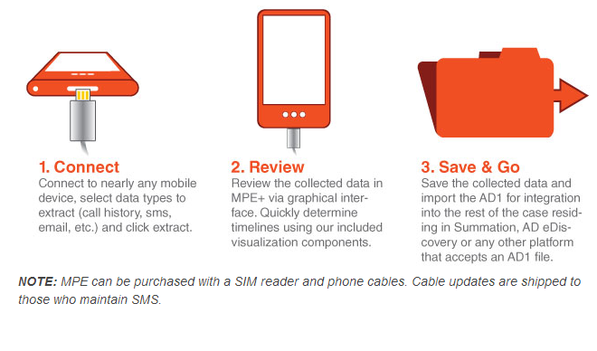
Supports 6800 devices

May be a free version

Link Ch 10s

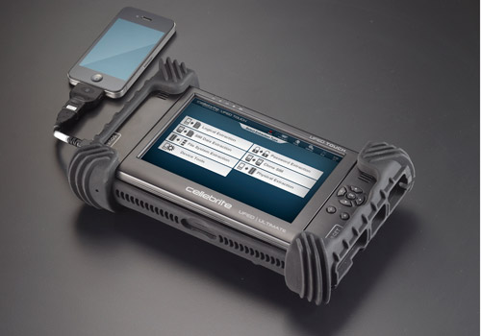

Cellebrite UFED

Hardware device that extracts data from mobile devices

They also make devices top copy data from one phone to another in phone stores

Link Ch 10u

EnCase Forensic v7

Includes smartphone acquisition

Automatically detects device type—just plug it in

Link Ch 10t

GPS (Global Positioning System)

Evidence on GPSs

Physical location log

Some have

Mobile phone logs

SMS messages

Images

Remembered places and routes

Waypoints

Tracks

Routes

Link Ch 10u

Four Categories of GPS

Simple

Can store trackpoints & logs

Smart

Automotive or USB storage devices

2 GB or more storage

Can play MP3s, store photos, & favorite places

Four Categories of GPS

Hybrid

Feature-rich. Ike a smartphone

Bluetooth connection to phone

May have SMS messages, call logs, address book

Connected

GSM radio; real-time Internet

Google searches, traffic information

Subscription-based service

Information available from provider

Data on GPS Devices

System data

Trackpoints are automatically generated and can’t be altered by the user

The track log records where the unit has been

User data

Waypoints are locations the user saved

The user may not have gone there

Points Of Interest are supplied by GPS manufacturer

GPS Handling

Like cell phones

May have volatile data

Are constantly interacting with satellites

Last modified 5-1-13

