Topics

Standards and Controls

Cloud Forensics

Solid State Drives

Speed of Change
Standards and Controls

Standard

A prepared sample that has known properties that is ued s a control during forensic analysis

Control

A test performed in parallel with experimental samples

A sample that provides a known result

Some forensic authorities want to use these concepts in computer forensics, others don’t
Cloud Forensics

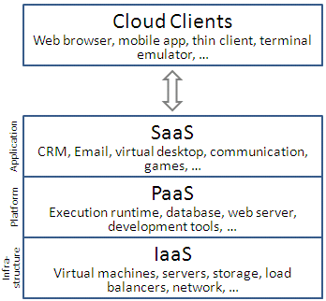
Cloud Computing

Infrastructure as a Service (IaaS)

Software as a Service (SaaS)

Platform as a Service (PaaS)

Image from Wikipedia, link 11a

Infrastructure as a Service (IaaS)

Most basic cloud service

Like renting a physical server at a colocation facility

Provides virtual machines and network service to the customer

Customer installs OS & apps

Responsible for maintaining and upgrading the them

Examples: Amazon EC2, Azure Services Platform, Google Compute Engine, Rackspace Open Cloud

Platform as a Service (PaaS)

Provides a computing platform that includes

Operating system

Programming language execution environment

Database

Web server

Application developers design apps without managing the lower hardware & software layers

Examples: AWS Elastic Beanstalk, Windows Azure Cloud Services, Google App Engine

Software as a Service (SaaS)

Provides an application for clients to use

Clients don’t control hardware, OS, or application

They just use the features the application provides

Examples: Google Apps, Microsoft Office 365

Private and Public Clouds

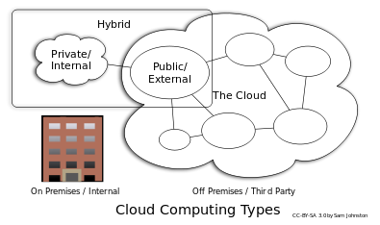
Private cloud

Company purchases and maintains servers

Restricted to company users

Eliminates many of the advantages of cloud computing

More secure (?)

Public Cloud

The most common type, provided by Amazon or Microsoft, etc.

Image from Wikipedia, link 11a

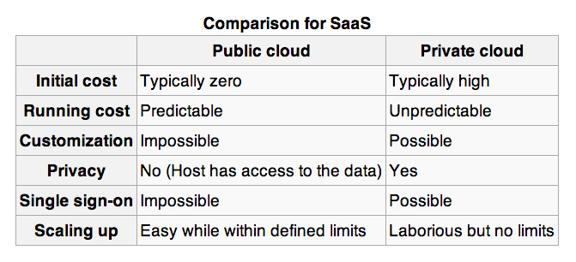
Benefits of the Cloud

Startup cost is much lower

Flexibility

Scalability

Redundancy

Outsources server maintenance tasks so business can focus on their core competency

Legal Concerns

Usually no way to recover deleted data

Deleted data is on shared storage, and mapping is removed immediately when a file is deleted

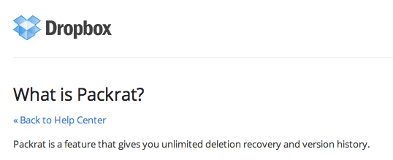
Few forensic tools are available for cloud environments

Cloud Persistence: Dropbox

Dropbox saves all deleted files

For 30 days by default for home users

Forever with the Packrat extension (default for business users)

Very handy for investigators!

Link Ch 11b

Jurisdiction

Cloud providers may be anywhere in the world

Regulations could help, if they required Cloud Service Providers to retain and provide data to investigators

Service Level Agreements may cover digital evidence collection and preservation

Wise precaution when litigation is expected
Solid State Drives

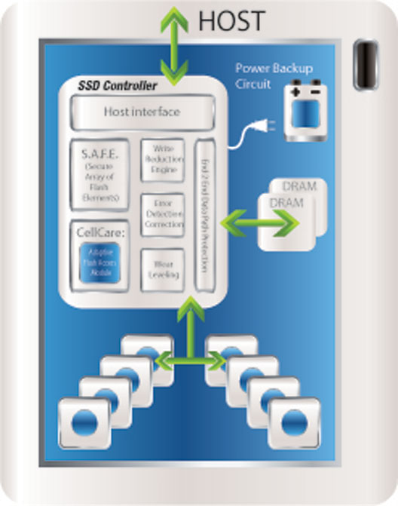
Internal Structure of an SSD

Link Ch 11d

SSD Structure

Link Ch 11c

SSDs and TRIM

SSDs get slower as they fill up

SSD speed is only fast when it can do many writes in parallel

The smallest structure you can write is a page (4 KB)

But you cannot write to a page unless it is empty

The smallest structure you can erase is a block (512 KB)

Also, you can only erase a block 10,000 times before it fails (at least as of 2009)

SSDs are not all the same—they make different attempts to increase lifespan with “wear leveling”

Link Ch 11e

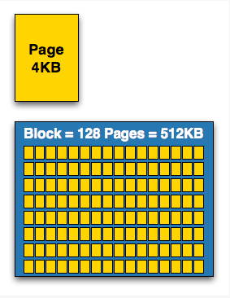
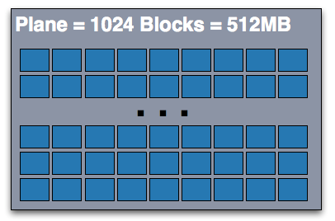

File Translation Layer

Computer thinks it knows where data is going on the drive

SSD uses a File Translation Layer to map apparent locations to real locations

The real location is adjusted by the SSD controller for wear leveling

Garbage Collection

SSD controller erases deleted files

When this happens varies across drive brands

Data on the drive may even be changing during forensic acquisition

This process may depend on the OS and drive format

TRIM command enables the OS to tell the SSD controller that a file has been deleted

Supported by Windows 7 and OS X but only active when conditions are right

Speed of Change

Case backlogs

Constant updates of software require new methods, retraining and research

Professional networking

HTCIA

Twitter

Conventions

Last modified 5-15-13

