Based on this Document

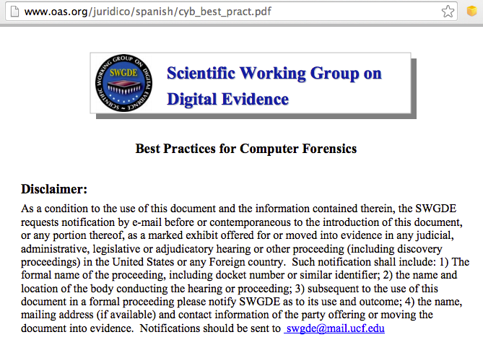

1.0 Seizing Evidence

Must have legal authority

Additional authority for additional evidence outside scope of the search

If evidence cannot be removed, image it at the scene

Remove all suspects, witnesses, and bystanders from the scene

Solicit information from potential suspects, witnesses, LAN administrators, etc.

Passwords, operating systems, screen name, email address

Search scene systematically and thoroughly

Searcher should be able to recognize the different types of evidence

1.1 Evidence Handling

If the computer is off, leave it off

If the computer is on, consider the potential of encryption

If appropriate, image the machine before powering down

Assess the power need for devices with volatile memory

E.g. cell phones, tablets, etc.

Document the condition of the evidence

Photograph whole scene from several angles

Close-up photographs of cables, serial numbers, etc.

Document connection of external components

Document any pre-existing damage to the evidence

1.1.1 Stand-alone Computer (Non-Networked)

Disconnect all power sources

Remove battery from laptops

Place evidence tape over power plug connector on the back of the computer

1.1.2 Networked Computer

Workstations

Remove the power connector from the back of the computer

Place evidence tape over the power plug connector on the back of the computer

1.2 Servers

Determine the extent of data to be seized

Capture volatile data if necessary

If shutdown is necessary, use the appropriate commands

Warning: Pulling the plug could severely damage the system; disrupt legitimate business; and/or create officer and department liability.

Evidence Handling

Package evidence to protect it from change

Maintain chain-of-custody

Packaging:

Plastic/paper bags or sleeves

Computer case sealed with evidence tape over access points and power connectors

Devices with volatile memory should be packaged appropriately to allow for power to be maintained to the device

Evidence Handling

Care with transportation, to avoid

Physical damage

Vibration

Magnetic fields

Static electricity

Large variations in temperature or humidity
2.0 Equipment Preparation

"Equipment" is non-evidentiary hardware and software used for imaging or analysis

Equipment must be monitored and documented to maintain proper performance

Test equipment regularly

3.0 Forensic Imaging

Document the current condition of the evidence

Prevent exposure to toxic or dangerous substances on the evidence

Use write blockers

Use forensically sound and verifiable acquisition methods

Hashes: MD5, SHA-1, etc.
3.0 Forensic Imaging

Capture "bit-stream" forensic image

Use properly prepared media when making forensic copies

Ensure no commingling of data from different cases

Forensic image should be archived to media

4.0 Forensic Analysis/Examination

Review documents from requestor to determine necessary processes

Need legal authority, such as:

Consent by owner

Search warrant

Other legal authority

4.0 Forensic Analysis/Examination

Preliminary considerations

Urgency and priority of request

Additional types of examination which may need to be carried out (e.g. fingerprints)

Other evidence items that may need to be requested, such as removable USB drives

Examine copies, not original evidence

Recommended Civil Case Search Procedure

Look at USBSTOR first to see what other devices to request

Examine documents, photos, Internet history, email, desktop

Recommended Search Procedure

Start with keywords from description of case

Name of suspect, company involved, etc.

Search for evidence by keyword

Find more keywords in that evidence

Search using new keywords

When you aren't finding any new keywords, the search is done

Logical and systematic examination

4.1 Non-Traditional Technologies

Cell phones, PDA's, iPods, DVR's, gaming systems, etc.

Gather forensic images if possible

Non-traditional methods may be required

Validate procedures first if possible

Document all steps in methodology

5.0 Documentation

Evidence handling documentation

Copy of legal authority

Chain of custody

Initial count of evidence items

Information re: packaging and condition of evidence upon receipt by the examiner

Description of evidence

Communications regarding the case
5.0 Documentation

Examination documentation

Case-specific

Contain sufficient details to allow another competent forensic examiner to identify what has been done and assess the findings independently

Preserve documents
6.0 Reports

Reports should address the requestor's needs

Provide all information in a clear and concise manner

Last modified 2-11-14

