Ch 1: What is Computer Forensics?

Computer Forensics

Determining the past actions that have taken place on a computer system

Using artifacts—files, settings, or system changes that occur when the user or the OS performs a specific action

Ex: Creation date of a user's home directory shows the first time that user logged in

Testing is essential—don't trust anyone else

What You Can Do with Computer Forensics

Recover deleted files

Find out what external devices have been attached

Determine what programs have been run

See what web pages users have viewed, their email, chat logs

SMS messages from phones

Find malware and determine what it has done

Computer Forensics Jobs

Expert witness for crime investigation

Must choose prosecution or defense, difficult to change later

Incident Response (IR)

Or DFIR (Digital Forensics, Incident Response)

Including malware analysis

Data recovery

eDiscovery

Collecting evidence as required by a court order during a lawsuit
How People Get Involved in Computer Forensics

Law enforcement

Military

College programs

IT and/or Infosec

Law Enforcement

"Innocent Images" (Child pornography) is a huge part of the FBI's work

5,600 cases as of April 2012 (link Ch 1a)

Almost every crime investigation requires digital forensics

Laptops, tablets, phones, GPS units, etc.

Top 3 FBI National Security Priorities

1. Protect the United States from Terrorist Attack

2. Protect the United States against Foreign Intelligence Operations and Espionage

3. Protect the United States against Cyber-Based Attacks and High-Technology Crimes

Link Ch 1b

Military

First responders gather evidence in the field

Analysts work on it later in labs

Most military forensic examiners do not gain experience in testifying

University Programs

Relatively new

Often don't provide testimony experience

This class won't

We focus on the technical issues in forensics

IT or Infosec Professionals

Computer security professionals are drawn into forensics by incident response

How did attacker get into a system?

What damage was done?

Other issues

Stalking

Inappropriate Web use

Tracking emails
The Most Important Trait

Never rely on facts that can't be tested or verified

TEST IT YOURSELF

Stick to the evidence—just the facts

Don't trust your forensic tools

Verify important findings with two tools

A raw hex editor like HxD is a good second tool

Incident Response vs. Computer Forensics

Incident Response examines a live running system

Computer Forensics classically focused on post-mortem analysis of a static disk image

A forensic image is a complete bitwise copy of an entire hard disk

Or SSD, flash drive, RAM, etc.

RAM Analysis

Until recently, forensics focused on the hard disk and RAM was considered unimportant

This has reversed in the last few years

The projects reflect this

First we do RAM analysis

Hard disk images come later

Target was hacked with RAM Scrapers

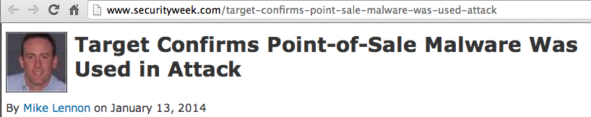
Credit card #s are unencrypted in RAM

Link Ch 1c

How Computer Forensic Tools Work

Parse entire forensic image

Rebuilds active and deleted files

Presents them in an easy-to-use interface

Forensic Suites

All-in-one tools that do almost everything you need

Two famous, expensive commercial tools

EnCase

Used by many police departments

FTK (Forensic ToolKit)

Used by the FBI

Others

ProDiscover (free, runs on Windows)

Sleuthkit and Autopsy (Open-source, runs on Linux)

Specialized Tools

Do only one task

File carving

PhotoRec, Recuva, Disk Drill, Scalpel, Bulk Extractor

Steganography tools

Network traffic analysis

NetWitness

Malware analysis

Mandiant Redline

Professional Licensing

Some states require a private investigator license for forensic examinations

But CA doesn't

Link Ch 1d
Ch 2: Learning Computer Forensics

Training

Get good training with hands-on projects

Don't attempt to serve clients without proper training first

After this class, you can answer this question with YES:

"Have you received formal computer forensics training?"

Vendor Training

Many classes available

viaForensics for Android and iPhone

Teel Technologies – how to remove NAND (flsh) memory for physical inspection

BK Forensics – free training on mobile devices

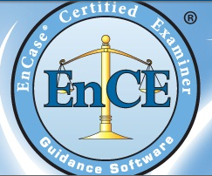
X-Ways Forensics –recommended

Links Ch 2a-2d

Vendor Certifications

EnCase Certified Examiner

FTK ACE (AccessData Certified Examiner)

Paraben Certified Mobile Examiner

SMART Certified Examiners

Links Ch 2e-h

Vendor-Neutral Certifications

The International Society of Forensic Computer Examiners

Certified Computer Examiner

High-Tech Crime Network

SANS

International Association of Computer Investigative Specialists

Links Ch 2i-l

Costs

ENCE

Requires 64 hours of computer forensics training or 12 months' experience

Test costs $200; Guidance Software's ENCE training costs $2,500

FTK ACE exam is free online

Requires a licensed copy of FTK ($2,000)

CCE exam costs $395

You can use any tool you like

Stay Current

Constant research in new tools, techniques, issues, opportunities

Join Twitter!

Go to conventions

I like hacker cons

BSidesSF is coming in Feb.

BayThreat every December

RSA (meh)

Forensics Conventions (Expensive)

HTCIA

CEIC

Techno Forensics

Black Hat

SANS

Blogs

Hacking Exposed Computer Forensics Blog

SANS DFIR

Windows Incident Response

Forensics from the sausage factory

Forensic Focus Blog

Links Ch 2n-q

Podcasts

Forensic 4cast

CyberSpeak

Inside the Core (Mac forensics)

Links Ch 2r-t

Associations

High Tech Crime Investigators Association International

Must not work for defense

Association of Certified Fraud Examiners

Links Ch 2u-v

Last modified 1-13-14

