Ch 10: Establishing the Investigation Type and Criteria

Topics

Types of Investigation

When Criteria Overlap

When no Criteria Match

Types of Investigation
Human Resources Cases

Employees:

Viewing porn at work

Wasting time on Facebook or playing games instead of working

Sexually harassing co-workers

Threatening coworkers

Having an affair with a co-worker

Simple Techniques

HR cases may not even require forensic tools

Logs from firewalls, proxies, and email systems may provide enough evidence to prove suspects' activities

One case was solved by just running Wireshark sniffing DNS requests

Creating proper forensic images is good practice, to allow further investigation later if it is warranted

Goals of an HR Case

Usually never goes to court

Suspect may not have broken any law, but just company policy

Typical result is termination of employment

You need enough proof to defend your work in case the employee sues the company for improper termination
Improper Termination

Firing

For false pretenses

In an unfair manner

In a way that is inconsistent with how other employees have been treated

Discrimination

Lawsuit typically seeks lost wages and damages

Rarely, also demands to be re-hired

Recordkeeping

Good records can defend the company against such lawsuits

Often the case will be dropped when the plaintiff sees that the evidence is undeniable

Retain your records

Work product

Documents produced during investigation

May be excluded from discovery during litigation

Disposal of Evidence

You need to develop a policy

Retain forensic image and data collected until

Case has been settled and client no longer needs data (can be up to a year later)

Case has run out of appeals and parties can no longer litigate (can be 3-5 years)

Plan to keep and maintain plenty of evidence storage space

Keep images organized so you can find them quickly years later

Administrator Abuse

Reading users' email

Finding salary of other workers

Using Remote Access Tools such as VNC to view others' computer screens

Using keyloggers

Accessing users' personal files

Stalking employees using PII

Running personal or side-job sites on company resources

Bypassing policy granting unfiltered Web access for prohibited activities

Goals of an Administrator Abuse Case

May end in civil or criminal charges

Termination of employment

Difficult to conceal an investigation from an administrator

May be reading emails of legal and HR department

Use telephone calls instead of email or other computer-based communications

Photograph administrator's desk before investigating; return all objects to original location
Stealing Information

Usually originated by Legal, not HR

Usually involve a current employee who is leaving the company

Employee takes data to their new employer, to give them an unfair advantage

Stealing Information

Sales person taking business contacts for use in another business

Employees taking bids on current, future, or former projects

Taking trade secrets to a competitor

Forwarding company emails to a personal account

Uploading data to file-sharing sites for later access

Wholesale backup of company systems to personal hard drives

External hacking into company systems

Goal of a Stealing Information Case

Civil litigation against the former employee

And possibly their new employer
Internal Leaks

Employee is not usually leaving the company

Employee needs to maintain access to secrets to leak them

First job is to identify the leaker

Data Loss Prevention (DLP)

Network appliances that monitor all traffic leaving the company, watching for credit card #s, SSNs, etc.

May also refer to Endpoint Protection

Full-disk encryption to prevent loss through stolen laptops

Log and limit access to external storage

Goal of Internal Leaks Cases

Identify the leaker and terminate them

May also charge them with civil or criminal charges

Keyloggers and Malware

Keylogger used by an employee

Keylogger used by a spouse

Malware that enters a system through employee's Internet use

Malware targeted at the company

Goals of Keylogger and Malware Cases

Determine

Who was infected

How it got on the system

What are the capabilities of the malware

If malware got onto the system, private information may already have been compromised

Malware Analysis

Static analysis

Examining malicious files to identify and/or reverse-engineer them

Dynamic analysis

Run malware in a safe virtual environment

Observe its behavior

CNIT 126: Malware Analysis

Not offered in Fall 2014, but probably in Spring 2015
When Criteria Overlap

One type of case may change into another

Administrator abuse turns to a HR case when the suspect is caught trying to sell information to another company

Document your findings

Keep the two cases separated in your records

Two sets of bookmarks in forensic tools

Easier to explain your actions later

Write your report with two sections, to prevent confusion

Get approval if scope of your investigation changes
When No Criteria Match

What to Investigate

Where should the evidence be?

Did this occur over a network?

Did this occur on a local system?

Drawing diagrams or charts can help

Discuss case with colleagues

Network Evidence

Consider all devices between the machines in question and the Internet—do they have logs?

Proxy logs

Firewall logs

IDS logs or IPS logs

Router logs (rarely useful)

Local firewall logs

Domain authentication logs

Internal email servers

VPN servers

DHCP logs

Local System

Antivirus logs

Desktop search indexes

List all files on a system

Event logs

Flash cookies

Windows Registry

Temporary Internet Files

Web browser history

Much, much more

SIFT Super Timeline

Gathers logs, history files, and more into a chart organized by time

Links Ch 10a, 10b
Ch 11: Human Resources Cases

Topics

Results of a human resource case

How to work a pornography case

How to work a productivity waste case

Results of a Human Resource Case

Termination

Main question: "Is there enough evidence to support termination of the employee for violating company policy?"

Policies vary, but generally

Viewing porn at work leads to termination

Playing games at work leads to reprimand or counseling

Employees making threats against others via email or instant messaging

Causes risk to the employer
How to Work a Pornography Case

Very Common

Viewing pornography is the most common unsavory activity an employee will do if they think no one is monitoring them

Easiest type of evidence to detect

Usually existence of pornography on a work system is enough evidence to warrant termination

Most employees will not sue after termination because of embarrassment
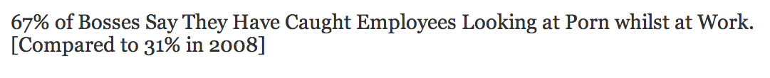

Employees working "anti-social hours" are more likely to view porn

Especially when unsupervised

Link Ch 11a (from 2013)

Pornography Case Study

Usually a simple review of Internet history and viewing of the images on his hard drive will reveal obvious evidence

If suspect is aware that they are being monitored

They may use privacy features to avoid leaving evidence

The Sluggish Network

Employees complained that the Internet was slow

Corporate IT director assigned staff to troubleshoot the problem

Bandwidth consumption reports on the firewall

Showed that the IT Director was visiting obvious porn sites 5-7 hours a day, despite the company content filter appliance

HR -> Legal -> Forensics

IT staff who found the logs took them to HR

HR contacted in-house conusel (legal)

In-house counsel determined that terminating the IT Director was likely to result in litigation

Contacted outside counsel

Outside counsel contacted a digital forensics company

Assignment

Conduct an investigation

Do all imaging covertly, during evening when employees are gone

EnCase Enterprise or FTK Enterprise with an agent to image over the network is very good for this, but expensive

IT Director was known to be aggressive and paranoid about people going near his work area

Black Bag Job

Careful nighttime operation

Leaves no evidence

Photograph the desk

Return everything just as you found it

Analysis

Imaged system

Internet history file showed 3-5 hours per day surfing porn

Conclusive evidence presented to HR Director

But HR Director wanted more proof

Review of content filter log showed that the IT Director had specifically excluded his IP address from content filtering

Analyzing Internet History with FTK

See projects 12 and 13
How to Work a Productivity Waste Case

Facebook

To determine time spent on Facebook and similar sites

Internet history file with URLs, timestamps, etc.

Internet Explorer 4-9 stored Internet History in index.dat files

No longer used in Internet Explorer 10 (default on Windows 8)

Facebook Chat

Facebook Chat files can be found by searching for "msgID"

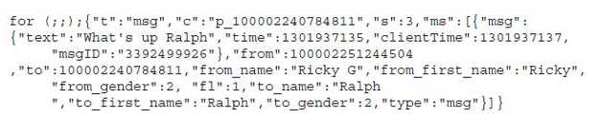
Examine files of interest to find proper keywords for your case

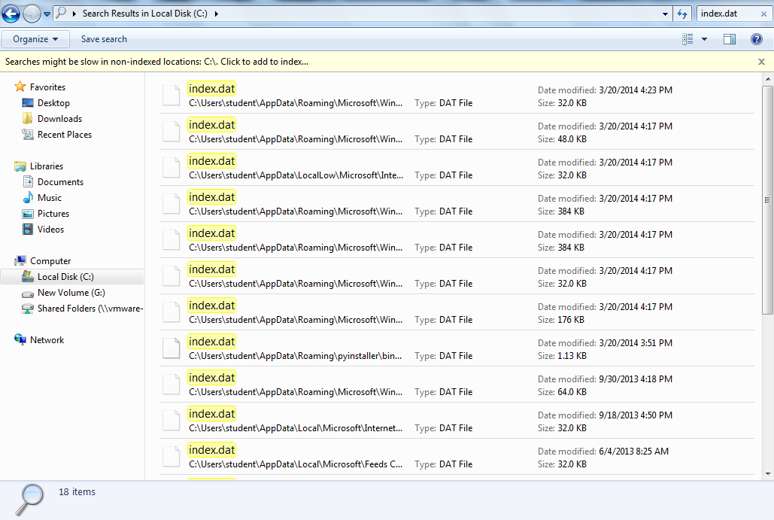
Index.dat Files on Windows 7 with IE 9

Show Protected Operating System Files

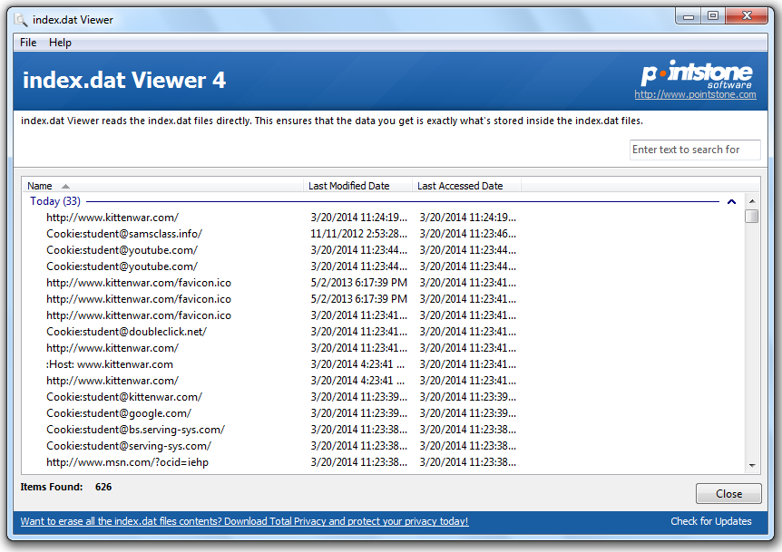

index.dat Viewer

Link Ch 11b

Last modified 3-20-14

