Topics

Challenges

Investigating an administrator running his own business out of his employer's network

Investigating an ex-administrator spying on his prior employer
Challenges

High Stakes


Administrator abuse is as bad as it gets

Challenges in analyzing data

Admin has access and ability to erase evidence

Can also watch email accounts to follow investigators

Warn everyone in the investigation not to use any corporate-controlled systems to communicate

VoIP phones, email, instant messaging, etc.

Massive damage inflicted on organization

Terry Childs

Rogue San Francisco network administrator

Link Ch 12a

Image from http://cbssanfran.files.wordpress.com/2011/05/terry_childs.jpg?w=370

David Hotchkiss & Anthony Castillo

CCSF CTO and contractor who created a worldwide scandal with fake virus warnings

Links Ch 12b, 12c

Anthony Castillo image from https://www.linkedin.com/in/drjazz

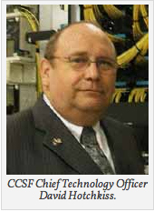


The Abuse of Omniscience

Administrators are paid to know everything

They have unlimited access

Network credentials

username and password, or token, etc. required to gain access to servers, routers, security appliances, etc.

Security appliances

Firewalls, content filters, data loss prevention systems, etc.

Greatest Weakness

Arrogance

One suspect never deleted logs because he though no one was smart enough to find them

Another failed to wipe data, thinking investigators wouldn't find it

Administrators often leave evidence intact because they think they own "their systems"

Administrator's Role

Administrator manages

Servers (physical and virtual)

Workstations

Routers and switches

Firewalls

Databases

Email servers

Authentication mechanisms

SIEM (Security Information and Event Manager)

SIEM systems maintain all the events and logs from systems in the network

A goldmine of evidence about network activities

BUT grab it fast because it's overwritten quickly

Canary Trap (also called a Barium meal)

Giving false information to a suspected traitor

When the information leaks, you know its source

This can happen when the administrator takes action demonstrating knowledge of private executive emails
Investigating an administrator running his own business out of his employer's network

Spam Email

A woman got a spam email, with a link to a pornographic site

She examined the Email headers and found the originating IP and domain

Complained to the company

Company owner saw that the links led to pornography hosted on his company's network

IT Director

Owner asked IT director to investigate

No evidence that the servers had been compromised

No unusual content on any web server

No Further Action required

Owner was not satisfied; knew from news that hacking tracks are typically hidden

Private Investigator

Hired by owner to conduct a thorough threat assessment

PI hired a computer forensic contractor

Great care is needed to hide an investigation from an administrator this brazen

List of Possible Evidence

Make a list and update it as the investigation proceeds

Web server itself

Web server as an interface to other systems, like

Databases and business applications

Web server is often the first point of breach

Attacker pivots to other systems from the compromised Web server

Web Server

Microsoft Internet Information Services (IIS)

Receives HTTP requests like GET and PUT

Allows directory browsing with WebDAV

Web content may be on other systems, such as a Distributed File System (DFS)

A Web server in Miami may be serving content stored in Los Angeles

To recover deleted data, you need to locate the actual physical servers that held it

You may need to image many systems

Other Services

Web server can interface with

Databases like Microsoft SQL Server

Using ASP.NET, Java, PHP, etc.

Email (Exchange)

Content management systems

Wordpress, Joomla!, etc.

Make custom Web pages based on database queries

Personalized for each user

Investigating the Web Server

The Web server did not contain any pornographic material

But all five servers on the network were default installations of Windows Server 2000

IIS on by default, so all five were actually Web servers

Pornography was on the file server

In an obscure folder inside the Program Files folder

Not officially regarded as a Web server

Forensic Technique

Image the file server

Look at the images in a forensic tool like FTK, EnCase, or ProDiscover

See the pornographic pictures
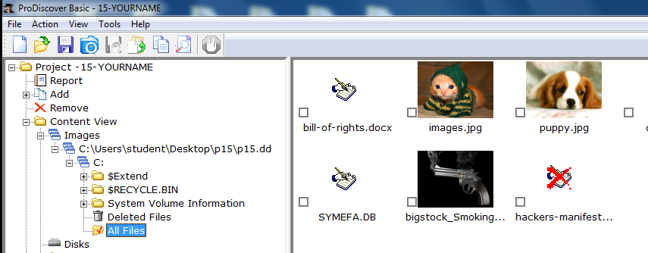

Web Root

Web servers serve content from a web root directory and its subdirectories

IIS uses C:\Inetpub\wwwroot by default

The web root can be changed

Virtual Servers

IIS can run multiple "virtual servers" with different web root directories and domain names

sales.example.com

support.example.com

example.com

another.com

They can each have a different IP address, or share the same IP address

HTTP GET

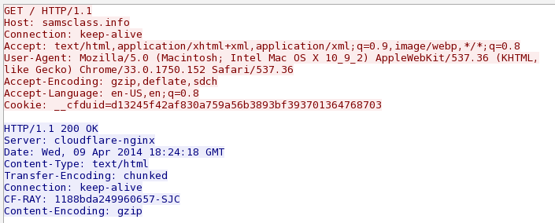
Host: tells the server which site you want to see
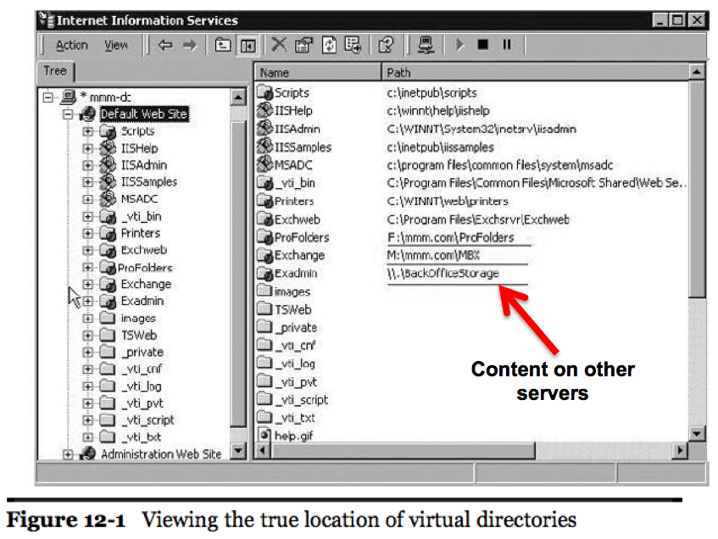

Databases

Source code for the pornography site contained calls to "Northwind Traders" database

A sample database included in Microsoft SQL Server 2000

Forensic tools cannot mount relational databases

Export data (.mdf) and log (.ldf) files from the forensic image

Recreate the Database

Mount the database on a separate SQL Server

Results: pornographic site user and credit card information was being maintained in the Northwind Traders database

Real data mixed with Microsoft sample data

Hidden in plain sight

Following Data Packets

Traced traffic to firewall

Firewall had four external IP addresses provided by ISP

One was assigned in DNS to the porn site instead of company email

Porn site's email server was on a different IP range at a remote commercial hosting company

These changes indicate that internal IT staff was complicit in the offense

More Images

With this evidence, the investigators got authorization to image all company computers

To find out who was involved

Network administrator's computer contained

Several hits to the pornographic website's domain

Also hits to the remote email server management interface

Remnant copies of the porn site's inbox

Emails from online payment system and customers

Confession

Confronted with this evidence, the network administrator admitted he owned the site
Investigating an ex-administrator spying on his prior employer

Private Investigator Calls

PI was hired to look for listening devices in a company's offices

Company suspected competitors were listening to their conversations

Because a new competing company had emerged and taken many customers away

PI could not find any listening devices

Wanted computers scanned to see if they had been compromised

As If They're Reading Our Minds...

Five former long-term employees had recently resigned

Started a new competing company

Always one step ahead of the client company

Had knowledge of confidential business information

Initial Scope

Scope: Client determines what they are looking for and what they want you to determine

Image several computers from high-ranking former employees

Determine whether they had accessed critical client information to take with them to the competitor

Find communications with the new company while they were still employed

Current Employees

Also received computers from the highest ranking current staff

Determine whether they sere compromised in some fashion

Such as with keyloggers or other malware

No evidence of compromise was found

Recommendation: network vulnerability assessment

Civil to Criminal

This case began as a civil investigation

At the end of the civil case, a criminal investigation was commenced by the FBI

Remember, your case can turn criminal

Keep good case records and chain-of-custody records to assist law enforcement in their use of your forensic images

Network Vulnerability Assessment

First indication of compromise

Outlook Web Access (OWA) logs

Network service accounts had been reading emails from

Company president, CFO, legal counsel, marketing director, and more

50 high-ranking staff members' emails

Network Service Accounts

Corporate voicemail server account

Blackberry Exchange Server account

Database server account

Needed to explain to executives that it's not normal for a voicemail server to log into webmail sites

All the service accounts had network administration rights and were administrators over the mail server

So they could read anyone's email

Web Server Logs

Exported from the forensic image

Imported into a relational database

Revealed that someone had been using those service accounts to access emails of executives nine months earlier

Source IP addresses were both external and internal

Local addresses indicate that insiders were involved, or attacker used a VPN or other remote access

VPN Server

Captured a forensic image

Analyzed logs

The same external IP addresses documented in the webmail server logs had connected to the VPN server

Sequence of Events

External client logs onto VPN server

Assigned local IP address

Starts a Webmail session to read executive's emails

In other cases, intruders connected directly from outside IP addresses to the webmail server's external interface

After messages were read, they were remarked as unread

IP Addresses

Some of the external IP addresses were tracked to the new company

Other addresses led to the home ISP addresses of the ex-employees

Scope of Damage

Document which emails had been accessed

And what sensitive data had been compromised

OWA logs are the best place to find that information

Record title of every email

And every attachment that is opened

Open URLs in a Web browser running an OWA session

You can see email and attachments exactly as they were read by the user

Email Review

Thousands of emails to review

Re-created Exchange Server

Restored incremental backups to it

Passed URLS of emails and attachments through a Web browser with an automated process

Provided copies of every email and attachment that had been read to client

Attackers Exploited Insider Knowledge

Knowledge that those obscure service accounts all had domain administrative privileges

Knew how to log onto the VPN

Used PCAnywhere to take over client systems and cover their tracks

Knew where the front door and back door were

Ex-Administrator Instructions

He had set up all administrative permissions

Ex-Administrator was recorded leaving instructions to his replacement

Never change passwords to the service accounts

Because no one knows what it would break
Stepping Up Your Game

You v. Administrator

Your skills are pitted against the administrator's skills

Administrator has greater technical knowledge of the network you are trying to analyze

Be patient

Investigate in a methodical and logical manner

Administrator made mistakes and left some evidence behind

Mistakes

Clever

Hid porn site on a back-end server

Stored client transactions in a sample database

Mistake

Didn't clean his own computer, and left behind all the Internet history files

Mistakes

Clever

Used service accounts to access emails

Hid tracks using VPN and PCAnywhere

Mistake

Didn't delete IIS logs on the webmail server

Forensic Tools

There is no such thing as a "court-approved forensic tool"

What matters is

Creating sound forensic images of the evidence you are preserving

Can replicate the process you used to show another examiner

So that examiner can reach the same conclusion

Outside Forensic Tools

Forensic tools and methods were used to obtain and preserve legally defensible data

Most of the real work was done outside forensic tools

Use the best method to analyze the data

You are not limited to features in your forensic tool

Last modified 4-9-14

