Topics

How to look for patterns and identify artifacts

How to determine where the data went

How to detect which data has been taken on external devices

Stealing Information

Theft of corporate information by a (soon-to-be) ex-employee
How to look for patterns and identify artifacts

What Are We Looking For?

Evidence of an employee stealing

Correspondence

Customer contacts

Drawings

Contracts

Spreadsheets

Emails

Source code

Other company-owned information

Patterns

Increase in user access to files

Large umber of files accessed in a single day

Perhaps another set the day after

Files copied to removable storage

USB, FireWire, eSATA, etc.

Or uploaded to file hosting or webmail sites

If email is used, it won't be the corporate email

It will be Yahoo! mail, Gmail, Hotmail, etc.

Email Artifacts

Most suspects believe that webmail leaves no trace on their computer

Commercial forensic tools have webmail analysis and carving features

Search the drive image for the headers used by popular webmail systems

Across active HTML files and deleted files

AJAX (Asynchronous JavaScript and XML) and JSON (JavaScript Object Notation)

Can update just part of a page at a time

Used in almost all Web 2.0 applications

Less email can be recovered, because artifacts are rewritten more quickly

Artifacts and What They Tell You

Webmail

If suspect was sending attachments from the suspect's computer through a personal email account

LNK Files

Suspect was accessing files copied onto another drive

Shellbags

What other directories exist on other drives identified from the LNK files

Artifacts and What They Tell You

USBSTOR Registry Key

Make, model and serial number of an external storage device, and when it was last plugged in

Setupapi Logs

The first time a storage device was plugged in

Log Fragments

Activity showing what the suspect was taking
Popular Webmail Finders

These products can help you find the most popular kinds of webmail for review

They search a forensic image and find all known webmail fragments

Internet Evidence Finder

from Magnet Forensics (link Ch 13a)

Evidence Center

From Belkasoft (link Ch 13b)

Inbox View

Often, one of the recovered HTML files will be the user's Inbox

Typically a static web page

Written to disk in its entirety

Shows sender, date, subject, and whether an attachment was included

Limitations

You can only recover what the suspect received from the web server

You cannot recover text typed into a form and sent up to the Web server

NetAnalysis

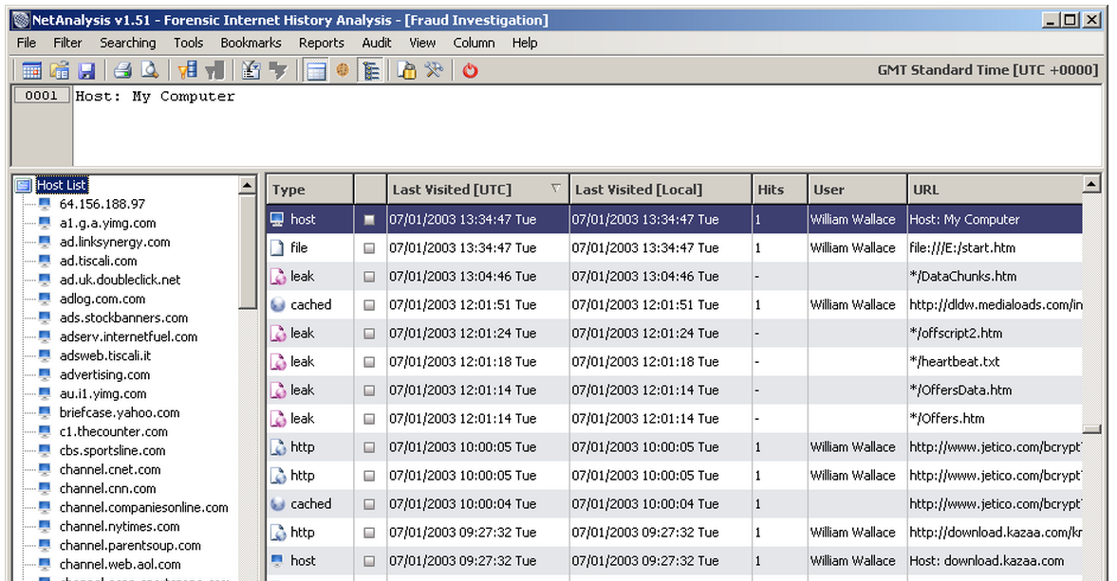
Link Ch 13c

BCC:

User may use corporate account but include BCC: copy to home account

Search of Internet history will usually find their home accounts

LNK Files (Recent Items)
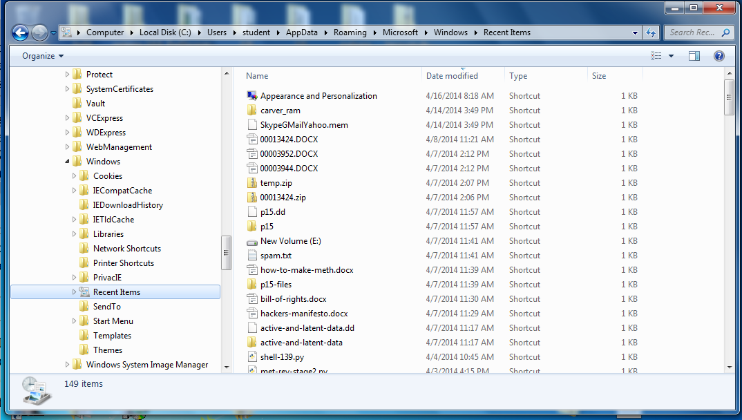

LNK Files

Created whenever files or folders are opened in Windows, with this information

Full path to the file, which can be on local drive, network share, removable media, etc.

Type of drive the file is being accessed from

File size

Volume name and serial number of the drive from which the file is being accessed

Additional Information in LNK Files

MAC address of system where file is stored, if it's being accessed over the network

Date information

When the associated file was created, modified, and accessed

When the LNK itself was created, modified, and accessed

Recovered LNK Files

LNK files are found in both the active file system and the free space on the drive

Commercial forensic tools like FTK can recover LNK files from free space (Link Ch 13d)

Windows File Analyzer

Link Ch 13i
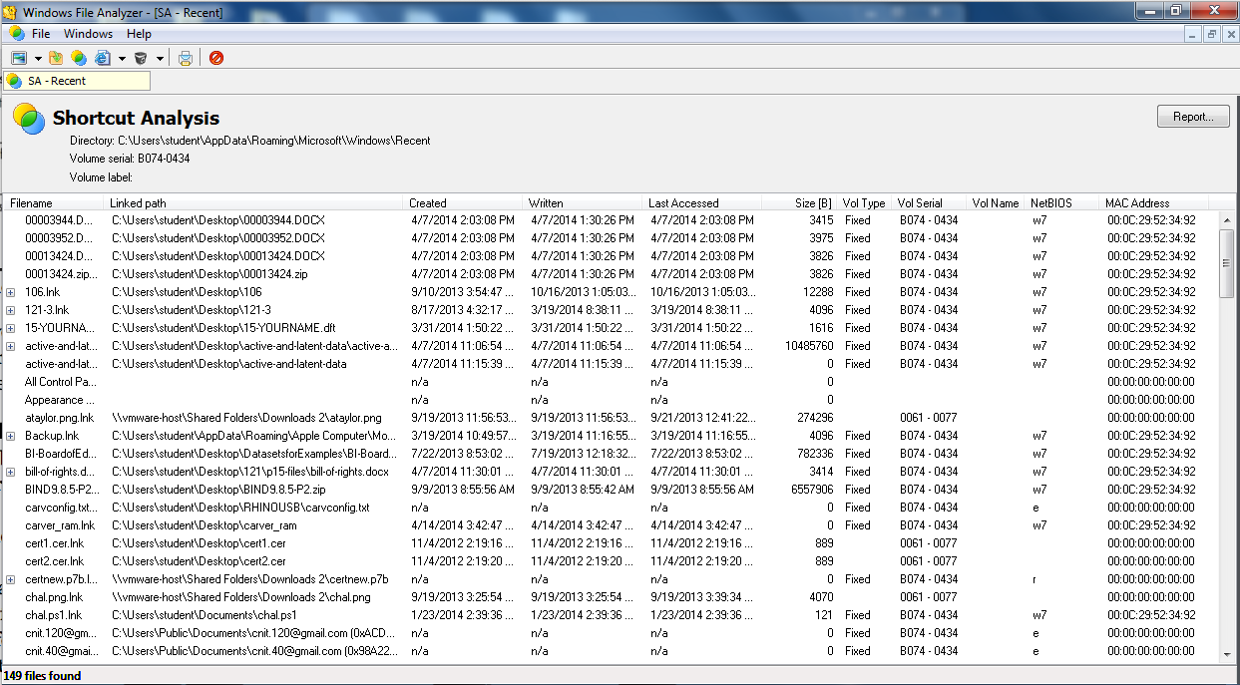

Demonstration of Times

Create a folder and a file

Wait a while

Open it again

Examine LNK file timestamps

Shows time LNK was created, accessed, modified

Analyze with Windows File Analyzer

Shows time original file was created, accessed, modified

Folder and file created at 10:59

No LNK file created at that time

Folder and file opened at 11:12

LNK file created with timestamp 11:12
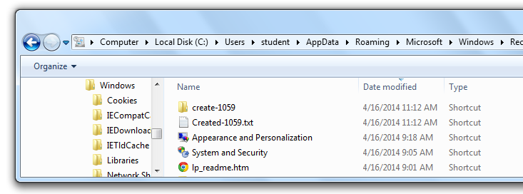

Windows File Analyzer shows the time the file was actually created: 10:59
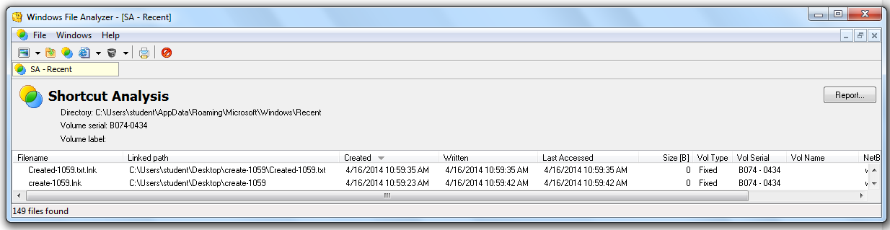

Shellbags

Registry entries that store user preferences for folder display in Windows Explorer

Only folders that have been opened by the user appear in the shellbags

Shellbags are part of the user's profile, in these files:

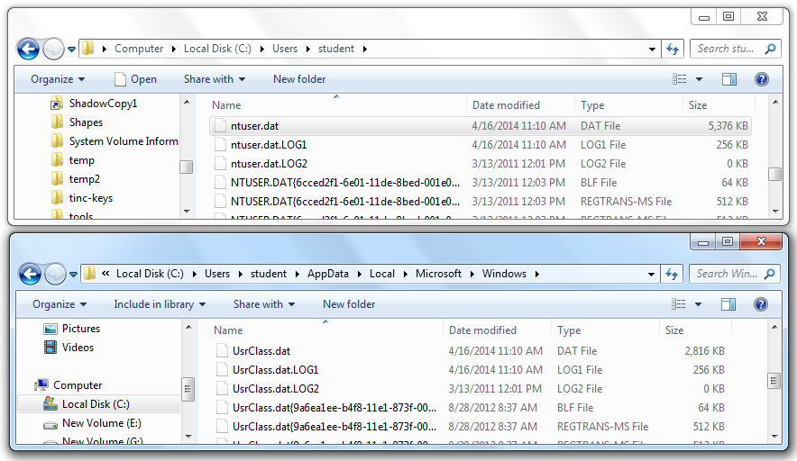
NTUSER.DAT and USRCLASS.DAT

Shellbags v. LNK Files

LNK files show files that were opened, and possibly directories

Shellbags show every directory a user accessed whether the user opened a file or not

sbag (not free)
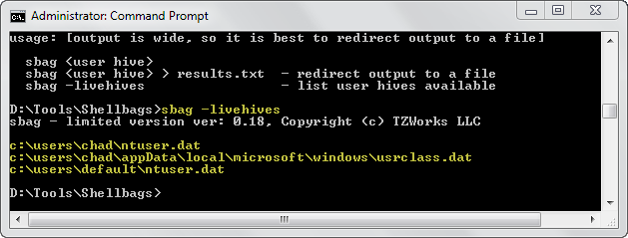

Images from SANS (link Ch 13k)

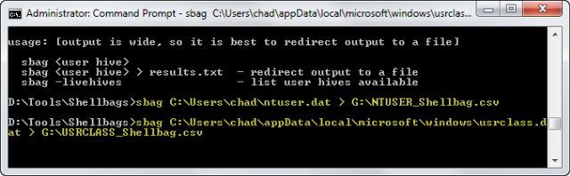

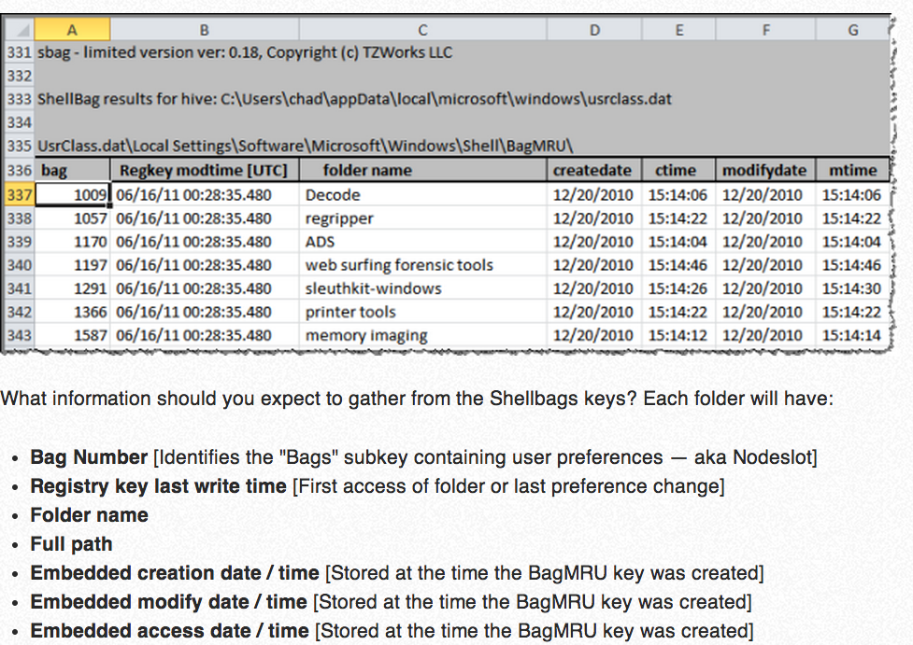

Case History

Web Developer

Web development company was losing major client in 90 days

To a different company, for a major upgrade

Would lay off staff

A developer wanted to jump ship to the new company

To impress them, he downloaded the whole site by FTP to start working on it early

Customer Data

He also downloaded 100,000 customer records that were kept in archival files on the Web server

Automatically generated each midnight

Hosting provider noticed the large amount of traffic

Notified the owner, giving filenames and IP address of downloader

Court Order

Company hired a law firm to get a court order

Got customer information from ISP, based on IP address

Developer denied downloading the files

Agreed to a forensic examination of his laptop

Search Terms

Archival files had a standardized naming convention

Useful as search terms

Thousands of the names found in a partially overwritten log file for WS_FTP (the FTP client the developer used)

Authorized Seizure

This evidence was sufficient to get a judge to authorize seizure of all media at the developer's residence for analysis

Concerns that the developer had copied the data

Developer admitted to the download

USB drive revealed that the files had been copied to it, but it was then reformatted

Recovered more than 70,000 customer files

No evidence of any other copies

Last modified 4-16-14

