Topics

Why internal leaks happen

How to investigate internal leaks

File system metadata
Why Internal Leaks Happen

Insider Threat

Insiders have easy access to critical data

Protections are focused on outside intruders

Types of Internal Leaks

Corporate espionage

Intellectual property theft

Stolen business processes

Stolen pricing schedules, vendor agreements, and customer relationship management (CRM) data

Finance and accounting information to guide stock investments in public companies

Types of Internal Leaks

Disgruntled employees may steal information as revenge

Poor information security practices can lead to theft

Should use strong group policy settings, digital rights management, Active Directory (AD) auditing, and Internet usage tracking

Negligence or incompetence leading to theft

Laptops can be stolen from cars, etc.

Insider Threat Countermeasures

Insiders dare to steal because

They see poor security practices and limited internal reviews and audits

Security review and auditing of business practices

Using a competent outside consultancy

Let people know you have tools, training, and processes in place to track what they have done
Investigating Internal Leaks

Preserve Evidence

Forensic artifacts are time-sensitive

Because normal computer use will overwrite data

Use proper forensic methods to acquire and preserve evidence promptly

Hard drive, external devices, file server

Cell phone, email, tape backups, etc.

Best if suspect does not know you are gathering evidence

So they can’t hide or destroy evidence

Avoid Risky Shortcuts

Don't examine a suspect's PC to look for smoking guns before taking a forensic image

Such actions could destroy the data you are looking for

Copying files changes their timestamps

And overwrites latent data

Court Order

If a judge has issued a protective order to preserve a computer

Your snooping around, even merely booting up the machine, violates that order

Make a forensic image and work with the copy

File System Metadata

Metadata

Data about the data

Creation, modification, and access times

Some applications also record

Author's name

Name of computer that created the file

Which printer the file was sent to

Who the file was emailed to

Original filename

Looking for Files Copied to External Media

Review registry files

User activity in UserAssist and RecentDocs in NTUSER.DAT

USBStor in SYSTEM shows use of external storage devices

File activity in LNK files

Obtain and examine any involved external storage devices

Registry Files

Review each user's NTUSER.DAT

Compare creation date of NTUSER.DAT

With creation dates of \Windows, \Users, and \Program Files

Determines the age of the system and user profiles

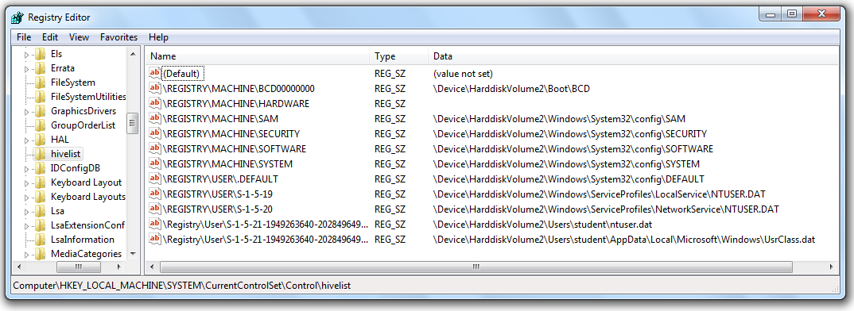
Registry Hive Files
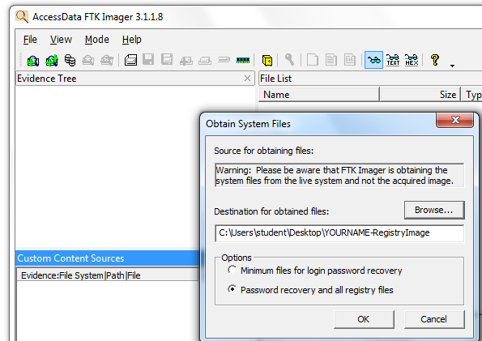

Live Imaging of the Registry

Acquired Registry Files
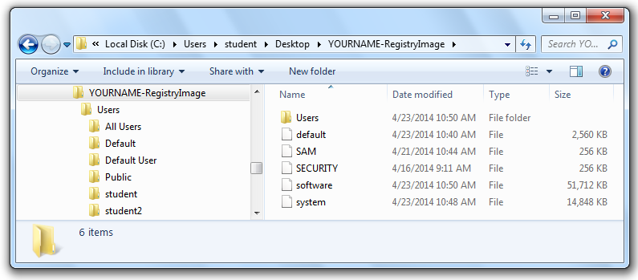

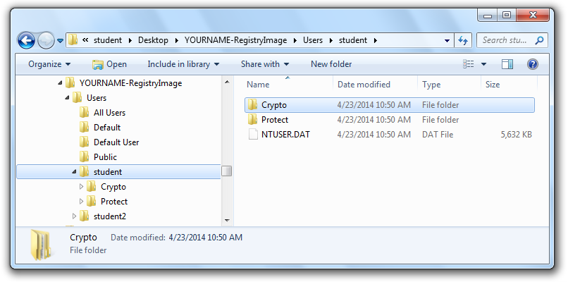

NTUSER.DAT Files

Important Registry Files

For Windows Vista and Win 7

C:\Users\username\NTUSER.DAT

For Windows XP

C:\Documents and Settings\username\NTUSER.DAT

C:\Windows\System32\Config\SYSTEM

C:\Windows\System32\Config\SOFTWARE
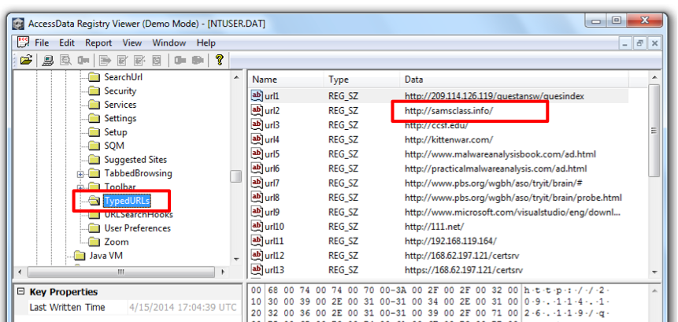

TypedURLs

UserAssist
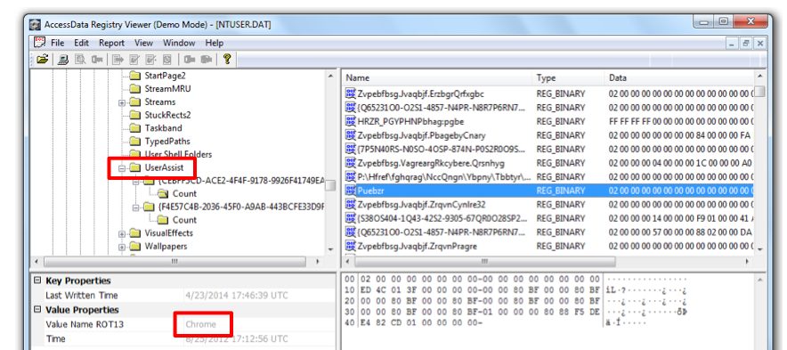

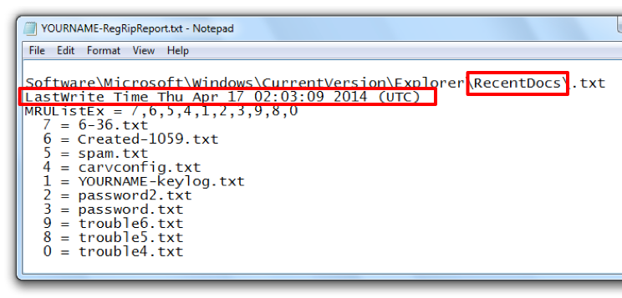

RecentDocs

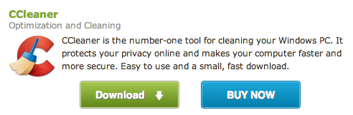

CCleaner

Free tool

Often used to empty these registry keys

Link Ch 14a

Important Registry Locations

NTUSER.DAT\Software\Microsoft\Internet Explorer\TypedURLs

NTUSER.DAT\Software\Microsoft\Windows\CurrentVersion\Explorer\UserAssist

NTUSER.DAT\Software\Microsoft\Windows\CurrentVersion\Explorer\RecentDocs

Also referenced starting with HKCU

How they appear in RegEdit

SYSTEM\CurrentControlSet\Enum\USBSTOR

Also referenced starting with HKLM

How it appears in RegEdit

Error in Textbook

The UserAssist key is in HKCU, not HKLM as stated at location 4291.

Restore Points

Windows makes automatic backups called Shadow Copies

Shadow Explorer will let you examine them

Very useful; contain copies of files and the Registry before they were deleted

Link Ch 14b
Metadata for Special File Types

Special File Types

These filetypes all may contain metadata, such as last time they were printed

CAD drawings

Microsoft Office files

PDF files

EXIF Images (many JPEGs)

Microsoft Office Metadata

Some examples of metadata that may be stored in your documents

Your name

Your initials

Your company or organization name

The name of your computer

The name of the network server or hard disk where you saved the document

Other file properties and summary information

Non-visible portions of embedded OLE objects

The names of previous document authors

Document revisions

Document versions

Template information

Hidden text or cells

Personalized views

Comments (from link Ch 14c)

Last modified 4-23-14

