Topics

Defining keyloggers and malware

Detecting keylogger and malware

Determining how the infection occurred

Identifying what data was captured

Finding information about the attacker
Defining Keyloggers and Malware

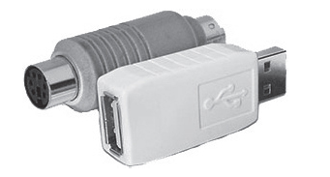
Keyloggers

Keyloggers capture keystrokes for an attacker

Hardware keyloggers as shown contain flash memory

Software Keyloggers

Programs that capture keystrokes, and often other user activity, such as screenshots and mouse actions

API-based hooks into the OS to capture keystrokes

Kernel-based intercepts keystrokes via a modified keyboard driver

Form grabbing intercepts Web-form data before it is sent to the Internet

Malware

Malicious software

Includes viruses, Trojans, rootkits, spyware

Also "Potentially Unwanted Programs"
Detecting Keyloggers and Malware

Malware Artifacts

Artifacts may be created in

System startup

Running processes

Services

Installed or modified drivers

System files

More

Registry Files

NTUSER.DAT

SOFTWARE

SYSTEM

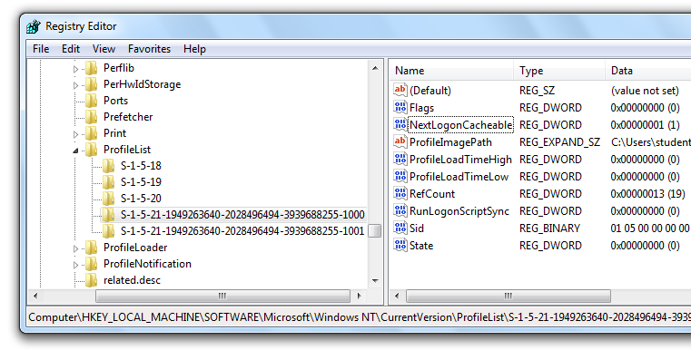
Use Registry Viewer or regripper

Registry: User Profiles

HKLM\SOFTWARE\Microsoft\Windows NT\CurrentVersion\ProfileList

Last Written Time

Not visible in Regedit, but shown in Registry Viewer in lower left pane

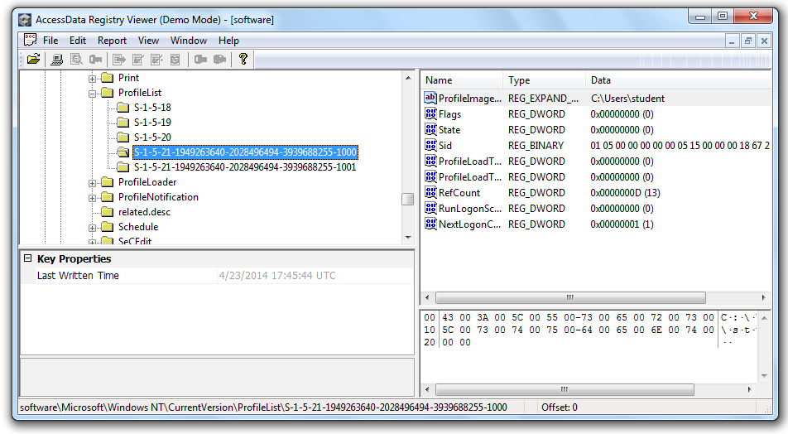
Shows last time this user logged off

Run Keys

Malware often puts itself here to survive a system reboot

HKLM\Software\Microsoft\Windows\CurrentVersion\Run

HKCU\Software\Microsoft\Windows\CurrentVersion\Run

Many more, as listed in link Ch 15a

Examples of Infected Machines

Top: Suspicious RUN key entry

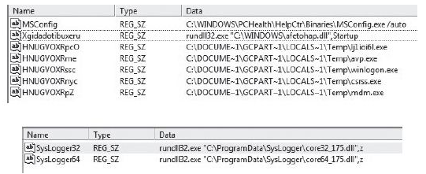
Bottom: Keylogger entry

Registry: System Services

HKLM\System\CurrentControlSet\Services

Long, complex list; infections may appear here
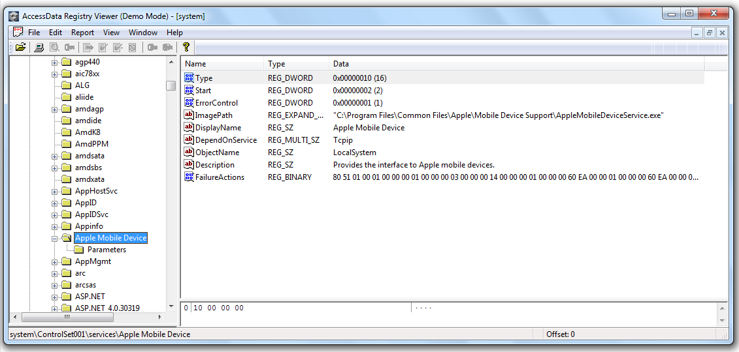

Prefetch Files

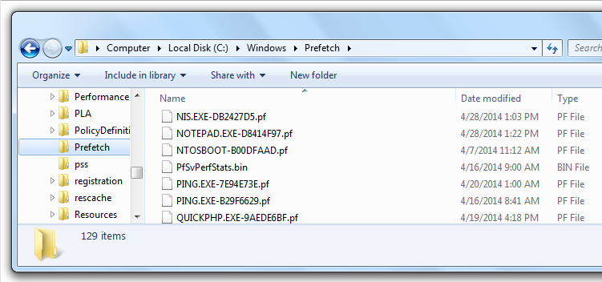
.PF extension, in C:\Windows\Prefetch

Inside Prefetch Files

List of files the application depends on

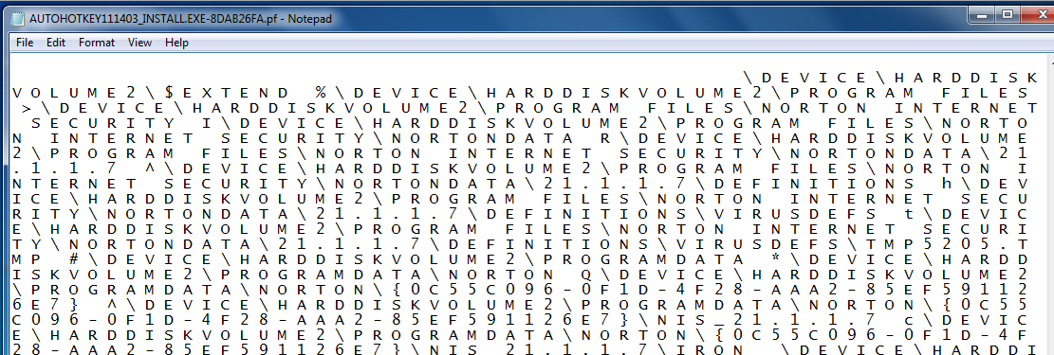
Unicode-encoded

Keyword Searches

Often locate commercial keyloggers

Search for "keylogger" and for names of popular product

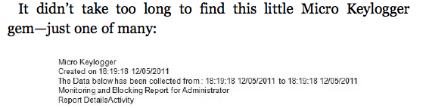
Tip: install the keylogger in a VM, use RegShot to see what registry keys it makes

Handling Suspicious Files

Use online scanners like

virustotal

Jotti

Threatexpert (links Ch 15b, c, d)
Determining How the Infection Occurred

Timing

Look at creation dates of malware files to determine time of infection

What was the user doing at the time of the infection?

At work, checking email, surfing the Web?

Was the user away, perhaps home asleep during this time?

Other Files

Sorting files created or modified near that time will help determine what activity was taking place

Check event logs

Export them from C:\Windows\System32\Config

View them using Event Viewer from the same OS they were created in

Fix corrupted event logs with Fixevt.exe (link Ch 15e)

Example: Fake Antivirus

Run key showed a filename "lj1ioi6l.exe"

Searching for that keyword in EnCase or FTK fund a deleted file

That file contained more strange filenames to search for

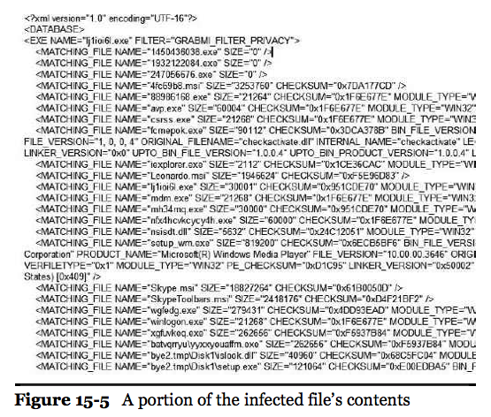

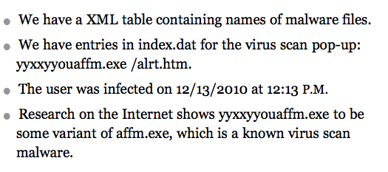

LNK File

Infection came in on a USB stick
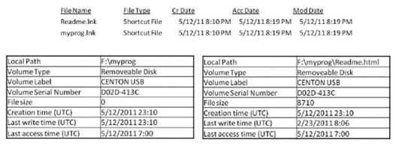

USBSTOR Key

Can identify the exact USB stick that caused the infection
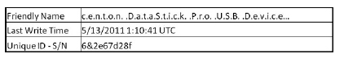

How to Get Serial # of USB Stick

Use a hardware USB write-blocker that will display the serial number on its screen

Use forensic imaging software to pull the serial number

Use a registry hack to block USB writes, then compare USBSTOR entries to see if you have a match
Identifying What Data was Captured

Micro Keylogger's Website
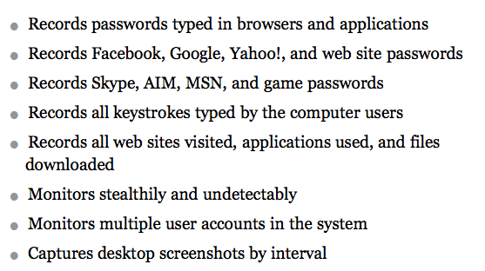

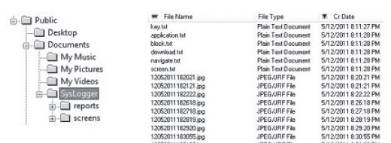
Found Captured Data

Antiforensic Measures

If you encounter these

Packed binaries

Encryption

Data wiping

Obfuscation

You may have better results with live analysis—infect a virtual machine and watch the effects
Finding Information About the Attacker

Help.HTML File

Left behind by malware

Examples and directions to connect webmail accounts and upload to FTP server

Use keyword search for webmail accounts

Gmail, Yahoo, Verizon, hotmail, etc.

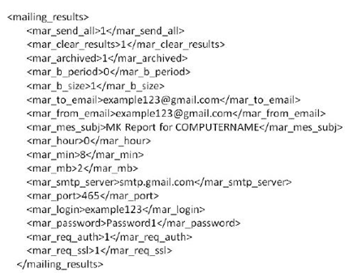
Gmail Account and Password

Found on deleted XML file in slack space

Don't Log In!

Just finding the password is NOT legal authorization to log in to the account

Report your findings and let legal counsel decide what the next steps should be

Last modified 4-28-14

