Ch 16: Documenting Your Findings with Reports

Forensic Tools

The "report" feature in your forensic tool is NOT sufficient

It's too dry and technical, and too long

Attach it as an appendix to your report

Only the opposing expert will look at it
Documenting Your Findings

Areas to Cover

Who asked you to undertake the investigation

What you were asked to do

What you reviewed

What you found

What your findings mean

Who Asked You to Undertake the Investigation

You need this record for yourself, as well for your client

You may need to answer questions about this report years later

Someone may try to bury the investigation later

Questions may come up about whether you were properly authorized

What You Were Asked to Do

Suspect may claim that they were unfairly targeted, with:

Human resources review

Improper termination lawsuit

The most common type of lawsuit an internal forensic examiner may get involved with

Union employees may have contractual restrictions on discipline/termination

What You Reviewed

Specify exactly what evidence you reviewed

Example: a laptop

Who used the laptop

Network name

Laptop make, model, serial #

OS

"Evidence in your possession" may refer to a forensic image, not the original device

What You Found

Describe what you found in plain English

Avoid technical jargon

Your client needs to be able to understand it

Your client is not an expert; it's your job to convert technical babble to clear, comprehensible conclusions

Example Findings

The Internet history records were deleted the day before we forensically imaged the computer

The Internet history records were recovered from the deleted space on the disk

The Internet history records revealed regular access to adult web sites during work hours

The login records show that Jim Smith was the only user logged into this computer during those times

Example Narrative

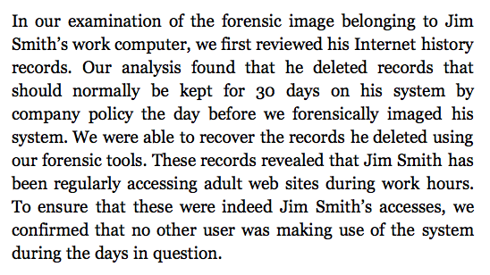
What Your Findings Mean

Conclusions

An expert witness is not a journalist

It is not your role to present evidence and let readers draw their own conclusion

You are an expert, and are being hired to state an expert opinion on what the findings mean

State your own personal opinion

Just make sure you can justify it with evidence

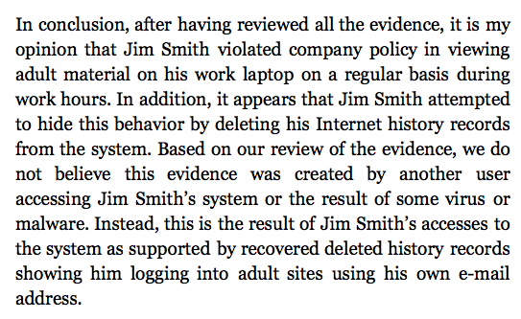

Example Conclusion

Types of Reports

You must know who your audience is

If report is only for the person who requested it to make a decision, an informal report may be suitable

If report details the impact of an incident, such as malware or an intrusion, an incident report may be required

If report is meant for internal review by human resources and legal, a formal internal report is likely required

Declaration and affidavit are the most formal types of reports, to be used in court

Informal Report

Can be just an email containing your conclusions

However, make sure it captures the topics detailed earlier:

Who requested the work

What was requested of you

Your conclusions

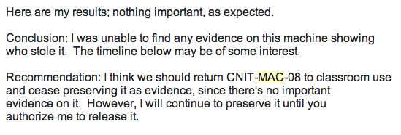
Even an informal report can be used in litigation

Example Informal Report

Incident Reports

Cover impacts and exposure of data that may have occurred because of an incident

Typically focused on malware and intrusions

Ensure you have all the details discussed at the beginning of this chapter

Report may be passed on to regulators or legal entities in compliance with breach notification laws

Internal Reports

More traditional

Three major areas

Executive Summary

Findings

Technical Details

"Technical details" will contain screenshots of artifacts, excerpts from recovered data, and evidence to support your conclusions

Declaration

A legal document

A sworn statement

Will likely be submitted into materials used in a formal legal matter

Will likely be critiqued by opposing computer forensic experts

Be careful—you may face legal penalties for making false statements

Resist pressure to slant your conclusions

Declaration is Public

Unless it is sealed, your declaration is a public document

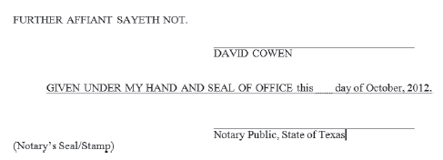
Anyone in the future can examine it and question you about it

You will have to live with what you've written for the rest of your career

Affidavit

Similar to a declaration

Signed in the presence of a notary public

Title should be "Affidavit of Your Name"

Signature block shown to the right


Fred Zain

Hired by W Va. police in 1977 based on falsified credentials

Flunked or barely passed chemistry

Gained a reputation for being able to solve extremely difficult cases

Looked on as a "god" by W Va. district attorneys

Image from herald-dispatch.com

Warning Signs

In 1985, an FBI agent told state police Zain had failed basic forensic courses

Two workers claimed to have seen Zain record results from blank plates

These complaints were ignored

Zain gained a reputation for being "pro-prosecution"

DNA Evidence

In 1997, Zain's examination of semen and his testimony led to the conviction of Glen Woodall

Sentenced to 335 years in prison

In 1998, DNA testing proved Woodall was innocent

Woodall's defense team found serious errors in Zain's work

1993 Report from Supreme Court of W Va.

Zain had

Misstated evidence

Falsified lab results

Reported scientifically implausible results

Resulted in as many as 134 wrongful convictions in Virginia

A Texas investigation found at least 180 more such cases in Texas

Zain's Trial

Charged with fraud

Trial put on hold after he was diagnosed with liver cancer

He died in 2002 while awaiting his second trial for obtaining money under false pretenses

Links Ch 16a, b, c
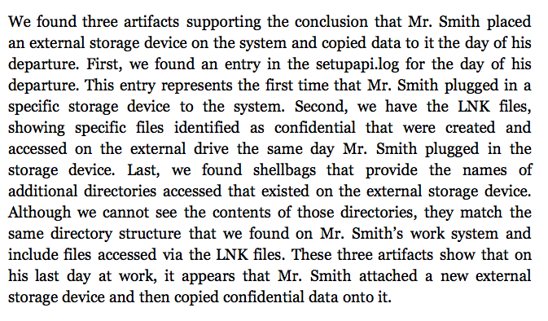
Explaining Your Work

Define Technical Terms

Such as forensic image, unallocated space, carved file, slack space, file fragment

Definition may be in a footnote, or after a sentence using the term

Provide Examples in Layperson Terms

Example: slack space is like leftover old programs on a VHS tape

Explain Artifacts

Ch 17: Litigation and Reports for Court and Exhibits

Legal Terms

Litigation – the judicial process

Plaintiff – the person or company that initiated the lawsuit (in civil cases)

Defendant – the person or company being sued (in civil cases)

In criminal cases, the plaintiff is always the government

Outside counsel – the law firm a company hires to represent it in court

Discovery – plaintiffs and defendants ask each other for documents

eDiscovery – Electronic discovery

Responsive document – relevant to the request

Admissibility – Determination whether a piece of evidence or statement should be entered into court record

Evidence is inadmissible if it is:

Privileged communication

Attorney-client work product

Irrelevant to the proceeding

Hearsay

Unable to be authenticated

Attorney-client privilege – Email sent between an attorney and a client is exempt from discovery unless a judge rules otherwise

Work product – drafts and materials used in support of a lawyer's work on a lawsuit

Remember, this is all up to a judge

Items you regard as privileged or responsive may be ruled otherwise by a judge
What Type of Witness Are You?

Witness

Someone called upon to testify in a court of law or a deposition

Must have first-hand knowledge of event

You personally witnessed the event you are testifying about

If you heard the information from someone else, it's hearsay

First-Hand Knowledge

As a forensic examiner, you personally reviewed an image or tested an artifact to prove its meaning

An expert witness is allowed to rely on other people's statements, which otherwise would be considered hearsay evidence

That is the only exception to the first-party knowledge rule

Fact Witness

The most common role for a first-time computer forensic examiner

Your job is to attest to facts about how you obtained evidence

Plus anything you personally experienced that cannot be re-created from the forensic image

Your Role

Bear witness to facts you personally know

Your first-hand knowledge makes your forensic images admissible

Limits of Testimony

Qualifications: your education, certifications, and experience

Events that occurred around the facts you are testifying about

Discovery and Admissibility

Your correspondence with attorneys are not discoverable because of attorney-client privilege

You can speak candidly in your emails with attorneys

Notes of reports you made involving the investigation will be discoverable, if you make reference to them in your testimony

You may be asked to provide chain-of-custody documents you created

Expert Consultant

Advises outside attorneys on technical details

You will not be called on to testify or to give a deposition

Your Role

An advisor. You will have access to all materials generated in the lawsuit, even protected ones

You can advise the legal team on technical issues

Limits of Testimony

You should not be called on to testify

Discoverability and Admissibility

Expert consultants enjoy full privilege regarding emails and documents created while advising the legal team

They are work products and thus inadmissible unless ruled otherwise

Expert Witness

Review evidence, testimony, and facts of the case

Form an opinion

Deliver that opinion in a formal written report and through testimony

Both in a deposition and at trial

Deposition

Testimony recorded by a court recorder

Lawyers from plaintiff and defense are present and take turns asking questions

You cannot ask questions at a deposition

During a break, you can advise your legal team of questions you think they should ask you

Expert Witness

Your Role

Designated by your legal team

They will formally designate you as an expert on a specific topic, such as "computer forensics"

The opposing legal team will also know who you are

You will form an opinion based on the evidence in the case, testimony, and facts in the case

And defend that opinion when challenged

Daubert Standard

A US Federal standard for expert witnesses

To qualify as an expert, you must show knowledge of the subject based on experience, education, or training

Voir Dire – questioning an expert witness in court to qualify him or her

Used in most states

California has been a special case, but apparently it now uses this standard, since 2013 (Links Ch 17a, 17b)

Expert Witness

Limits of Testimony

You can be questioned about your experience, education, training, past opinions, past testimony, current opinions, and anything else a judge deems relevant

Also regarding discussions with attorneys and your client

Discoverability and Admissibility

As of Dec. 2010, experts' emails and report drafts are no longer automatically discoverable in federal court

But they may be discoverable in state courts

Ask your legal team about the rules before sending emails or report drafts

Don't rush into being an expert witness

All your prior testimony as an expert witness is admissible every time you testify (unless it is sealed)

If you act as an expert witness before you are ready, you may contradict yourself and have a jury instructed to ignore your testimony

That will follow you for the test of your career

Acting as an expert witness is a common goal, but don't do it until you are ready

Special Master

Appointed by a judge to answer a question for the court

When the parties in a lawsuit can't agree on a fundamental fact of the case

Or can't answer a judge's question to his or her satisfaction

Your Role

Agent of the court

Judge gives special master the authority to

Request evidence

Request people to attend depositions

Conduct on-site inspections to find the truth

Report

Role ends with a report to the judge

Details findings and answers the court's question

Limits of Testimony

Special masters are not deposed

They deliver their reports directly to the judge

Discovery and Admissibility

The master's report is available for both parties to review

The master's work product is typically only or the judge's review

Neutral

A third party who plaintiff and defendant agree to engage and review evidence

Not selected bu the judge

No authority to demand production of any data

Your Role

Engaged when there's a contested piece of evidence

One party wants to review it

Does not trust the other party to disclose it fully

Rather than giving a "hostile expert" full access to the evidence,

Evidence given to a neutral expert

Neutral expert reviews the data and reports findings

Limits of Testimony

Neutrals typically do not give testimony

Unless their work is questioned

Discoverability and Admissibility

Neutrals are not retained exclusively by either party

No emails or documents created by the neutral should be considered privileged, unless otherwise agreed to

Writing Reports for Court

Declarations in Support of Motions

Begins with name of lawsuit and what party you are working for

Otherwise same as described in chapter 16

Example on next page from link Ch 17c

Expert Reports

Strict requirements; must state:

Who retained you

Your educational background

Any training you have received

Any certifications you hold

What experience you have

What other cases you've testified in as an expert witness

What you are paid for your work as an expert witness

What you have reviewed in forming your opinion

Creating Exhibits

Exhibits are supporting documents included with your report

An alternative to trying to embed spreadsheets, images, or other artifacts within the report

Exhibits can be printed out or stored on a CD, DVD, or other storage device and provided with the report

May be included in report in PDF or TIFF format, or saved as a separate file in its native format

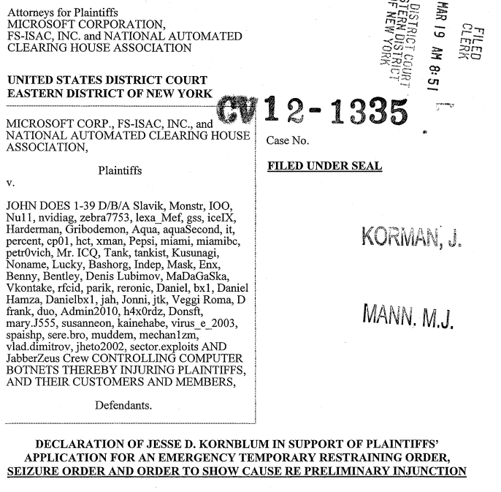

Working with Forensic Artifacts

If exhibit is self-explanatory, it can be presented alone

Otherwise, include a description within the exhibit itself

Don't leave room for misunderstanding of the exhibit

That can be used against you

Last modified 5-7-14

