Topics

Where to put your lab

Tools of the trade

Forensic software

Storing evidence
Where to Put your Lab

Criminal v. Civil Investigations

Only law enforcement officers can perform criminal investigations

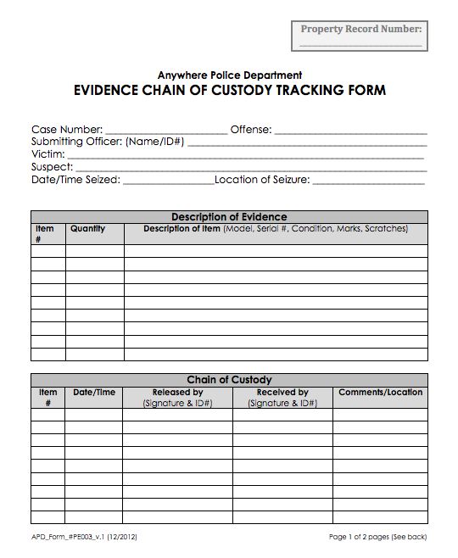
And those they contact

You can do forensic investigations for your employer

Employee misconduct

Or for customers you represent in civil court

Where to Put Your Lab

Access controls

Physical and network

Electric power

Air Conditioning

Privacy

Access Controls

You need to maintain chain of custody

A document stating who had possession of the evidence and where it was stored

It must be securely stored at all times from collection to court, or it will lose its value as evidence

Sample form at link Ch 3a

Information to Record About a Forensic Image

Information about the system the evidence was acquired from

PC, laptop, DVD, thumb drive, phone, etc.

Make, model. serial number

Where the forensic image is stored

Make, model, serial # of drive

The forensic image itself

With a hash value to verify integrity

Hash Algorithms

MD5 is the most common

Old and not 100% reliable

128 bits long

SHA-1 is newer and better

160 bits long

In practice, both are fine for forensic image verification, because you are only trying to detect copy errors, not malicious forgery

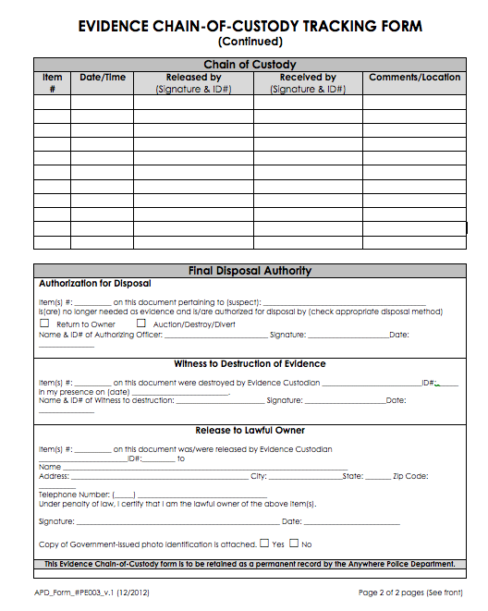
Physical Access Controls

Human guard, lock, proximity card sensor, etc.

Do not let cleaning crew or facilities people have access to forensic lab

Logging every entry and exit is desirable

You need to testify in court that you made sure no one tampered with the evidence

Network Access Controls

You must make sure no one can tamper with your images over the network

One good procedure

Work in isolation (also called Air Gap)

No Internet connection on any of your forensic devices

Move files in and out on portable USB devices

Requirements for a Networked Forensic Workstation

You need administrator privileges on your workstation

You need to deny other IT personnel access to your workstation

Your workstation needs to be on a separate domain, and you need to control domain policies that get pushed to it


You need to install and maintain your own firewall and antivirus software

Electrical Power

As lab grows. more power is required

UPS (Uninterruptible Power Supply) protects your systems from brief power outages

Air Conditioning

The more devices, the more heat they generate

Lab must be kept cool all times machines are on

Privacy

You will be viewing materials that are sensitive and often offensive

You need a real door, and you need to work with it closed

Image from link Ch 3b

Tools of the Trade

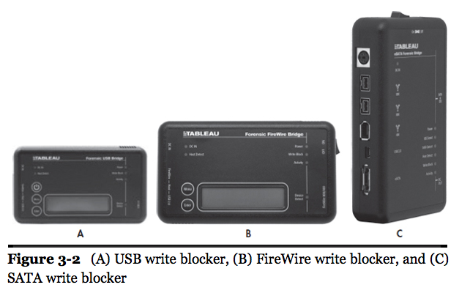
Hardware Write Blocker

Hardware device that permits reading from a drive without writing to it

Expensive ($1000 or so)

Not always available for all hardware, such as cell phones

Original Evidence

The actual real device that was seized at the crime scene

Laptop computer

Hard drive

Phone

CD, DVD, thumb drive, etc.

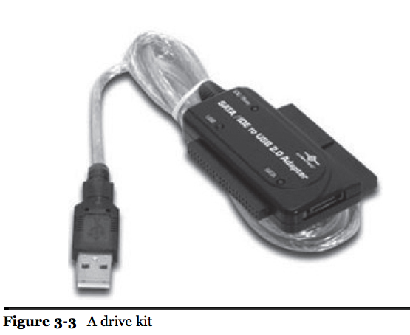
A copy is much less useful in court, because it is not original evidence

Destroying Evidence

If you mix up source and destination, you can erase the original drive instead of copying it

Pros use expensive write-blockers to avoid this

You can buy very expensive disk duplicators with write-blockers built in, and that are very fast

Software Write Blocker

We'll use software write-blocking

A common feature of Linux-based Forensic LiveCDs such as DEFT

Windows registry can block writes to USB drives

Project 5

Drive kit allows you to connect SATA drives through USB 3

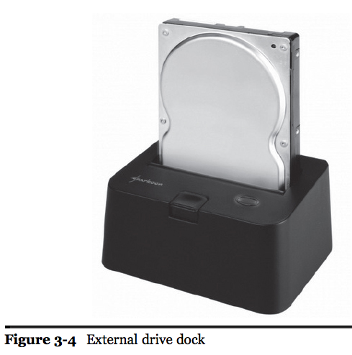
Test Your Equipment

Try to write to a scratch drive to test write-blocker

Make sure devices work before going to client site

External drive dock

More permanent alternative to a drive kit

Windows FE, a special version of Windows, can be used to make a forensically sound boot disk

Link Ch 3c

External Storage

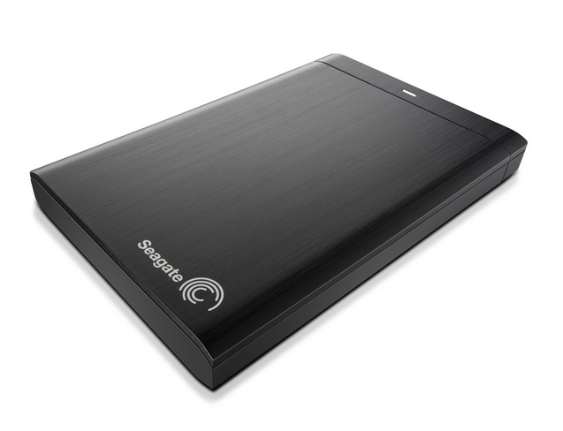
Fast connection is very handy

USB 3, eSATA, Thunderbolt

Good heat dissipation

Drive can overheat and crash

Image from amazon.com

Tools

Jeweler's Screwdrivers, including Torx and star heads

Antistatic bags

Adaptors
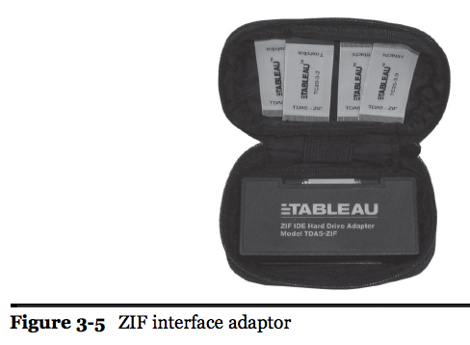
Forensic Software

Forensic Workstation

Any good PC works

Lots of processing power, RAM, and storage

Larger cases require larger servers

Processing a case on a laptop can take overnight

Forensic Software

SIFT (SANS Investigative Forensics Toolkit)

Open source and free, Linux-based

EnCase Forensic

Expensive, proprietary, on Windows

FTK

Expensive, proprietary, on Windows

USE MULTIPLE TOOLS, NEVER TRUST JUST ONE

SIFT and DEFT

SIFT is from SANS, under constant vigorous development, and used in their classes

Download at link Ch 3d

DEFT is an Italian forensic live CD I used in this course previously

Can image the MacBook Air

Download at link Ch 3e

Other Tools

ProDiscover – has a free version, runs on Windows

SMART Forensics

X-Ways

There are many others, but they all should end up finding the same evidence if used competently

Storing Evidence

Securing Your Evidence

Locking file cabinet, safe, evidence room

All that matters is "who has access?"

If file cabinet has a generic master key, you need to add a secondary lock to it

File cabinets are notoriously easy to pick

Safe is better, but can fill up fast

Evidence Room

Walls must go to the ceiling

No way to climb over

Watch our for drop-down ceiling

Controlled access to room

Preferably a digital lock

No unsupervised access by cleaning crew, etc.

Fire suppression must be "dry pipe" to avoid damaging evidence

Organizing Your Evidence

Make sure you can find it

Create standards for labeling evidence and drives

Track evidence with a spreadsheet

Or a shared Google document, etc.

Record make, model #, serial # of drives

Exact locationm shelf #, etc.

Disposing of Old Evidence

Ask client before destroying anything

Keep email or other document saying you can destroy it

You can wipe and re-use the drives (!)

Last modified 1-19-14

