Topics

Investigative process

Testing your hypothesis

Assessing the forensic data landscape

How to determine what you have authority to access
Investigative process

Basics

Target of investigation is a suspect

Know what you are being asked to find ou

You need authorization to perform an investigation

Honey pot is a system designed to attract attackers, so their activities can be monitored

Where Would the Data Exist?

Ex: viewing indecent images at work

Outbound proxy or web-filtering log

Computer used for viewing the images

Firewalls logging outbound access

What applications might have been used to create the data?

Often a Web browser; Chrome, IE, Safari, etc.

Should you request to go beyond the scope of an investigation?

Data Carving

Reconstructing files from unallocated blocks of data

Also called latent data

Uses file headers and footers, also called file signatures

Active data

Files and folders that are in the directory

No carving needed to reconstruct them

Should You Request to Go Beyond the Scope of an Investigation?

Child Pornorgaphy: STOP THE INVESTIGATION

You are legally required to notify the National Center for Missing and Exploited Children

missingkids.com

Also notify your cient

Ask the Person Requesting the Examination

"If I find an indication of something other than the original action as requested, would you like me to go forward in examining that issue?"

Don't assume you are allowed to investigate without approval

Index.dat and TypedURLs

Index.dat file contains Internet Explorer history

Link Ch 4a

TypedURLs is a registry key

Contains the last 25 addresses typed into Internet Explorer

Link Ch 4b

Textbook confuses these two at location 1537

Testing Your Hypothesis:
Scientific Method

Characterization of artifacts

Ex: Index.dat file (IE History) shows forbidden URLs

Hypothesis

These represent actual Web browsing, not random pop-ups, because they were found in TypedURLs

Predictions

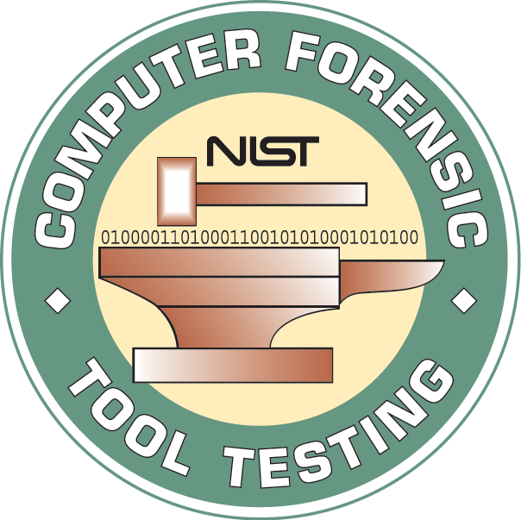
If I use a test machine and type a URL into the IE address bar, it goes into TypedURLs, but if I just click on a link, it doesn't

Experiments

Testing

Use a clean virtual machine

Get the same version of software the suspect used

Document your testing

Computer Forensic Tool Testing Project

Link Ch 4c
Forensic Data Landscape

Active data

Unallocated space

Slack space

Mobile devices

External storage

Active data

Any nondeleted files or data

All files and folders

Logs, registry, email archives

File system objects such as $MFT

Master File Table, used to store the directory on NTFS volumes

Unallocated space

Parts of the disk that are not currently allocated to active data

Chunks of old data scattered randomly on the disk

Can be reconstructed into files with carving

But only if the file signature is intact

Can be searched for keywords

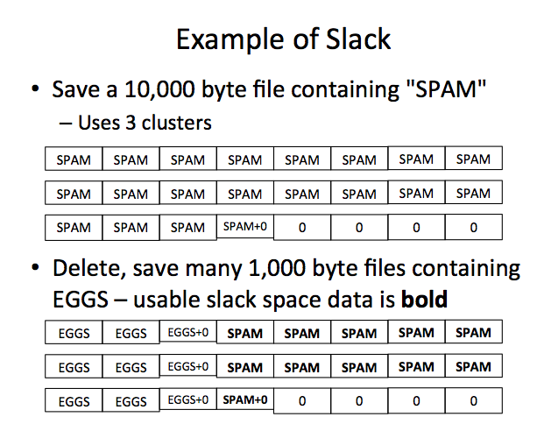
Even if the file cannot be reconstructed

Slack space

Portions of a cluster that are not used by the current active file

Left over at the end of many files

Almost always incomplete

Keywords are more effective than file carving for this data

NTFS Volume

4 KB clusters

512 Byte Sectors

8 sectors per cluster

The drive controller will only allow a read or write operation to a whole sector

The Master File Table will only assign complete clusters to a filename

Mobile devices

FTK & EnCase can acquire contents

Standard Cell Phones

Text messages & images & call records

SIM card reader can gather a forensic image of the SIM card

PDAs and Media Players

iPods, MP3 players, PDAs

Falsh storage with recoverable deleted data

Mobile devices

Smart Phones

iPhone, Android, Windows Phone, Symbian?

Have flash storage and recoverable deleted data

Text messages & images & call records

Also emails, documents, Internet activity

Mobile Device Specialized Tools

Paraben Device Seizure

Oxygen Forensic Suite

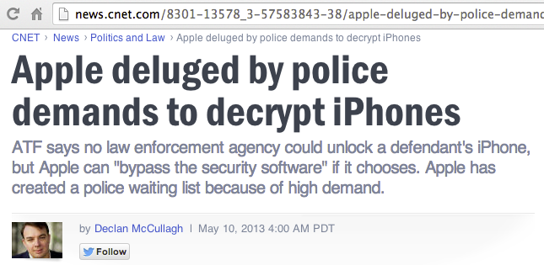
Elcomsoft's iOS Toolkit

Password Protection

Blackberries will wipe themselves if too many wrong passwords are entered

Some devices have password bypass vulnerabilities

You may be able to get the password from the suspect or a corporate administrator

Link Ch 4d

Can also get iTunes data from a computer synced to the phone (link Ch 4e)

Tablets

iPad, Android tablets, Microsoft Surface

Similar information as a smart phone

But no call records or SMS

External Storage

USB thumb drives

USB hard disks

CDs and DVDs

All appear to be hard drives to OS, so hard disk imaging products work

How to Determine What You Have Authority to Access

Authority

Law enforcement authority is defined in search warrant

Private investigators get authority from company that hires them

Who Hosts the Data?

If company owns the server, no problem

Cloud resources may not grant the company the right to search the data, or may not grant administrator access to the machines

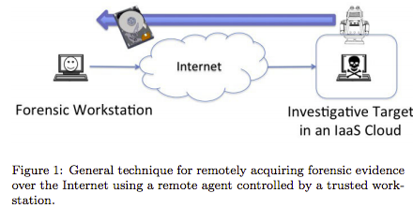
Imaging Cloud Servers

FTK and EnCase can do it, but there are many complications

Links Ch 4f, 4g

Who Owns the Device

Company-owned is simple: company can authorize a search

BYOD (Bring Your Own Device)

Personal device used for company business

Unclear what rights the company has to search the data on it

Need legal advice

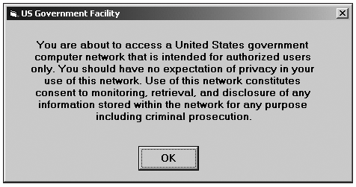
BUT: if the suspect consents to a search, it's OK

Expectation of Privacy

Need legal advice: if company has not warned employees that there is no expectation of privacy, evidence may be inadmissible in court

Commonly part of a logon banner

Logon Banner

From "Guide to Computer Forensics
and Investigations , Fourth Edition", by Nelson, Phillips, Steuart

Privileged Communications

Attorney-client communications are not admissible in court

"This email communication may contain CONFIDENTIAL INFORMATION WHICH ALSO MAY BE LEGALLY PRIVILEGED and is intended only for the use of the intended recipients identified above..."

Personal Communications

Not protected in US unless there is a reasonable expectation of privacy

In Europe, data privacy laws require written consent from the suspect to make a forensic image of any system on which he or she may have stored private data
Last modified 1-28-14

