Topics

Forensic imaging methods

How to determine your comfort level with various methods

Standard forms and a lab manual

Forensic imaging methods
Forensic Imaging Methods

With hardware write-blocker

With software write-blocker

On dedicated devices

Of live systems

Using custom boot CD/DVDs

These all make the same images, except for live acquisition

How to determine your comfort level with various methods

Questions

Are you comfortable on Linux command line?

If not, avoid Linux CD/DVD methods

Can you afford a write-blocker?

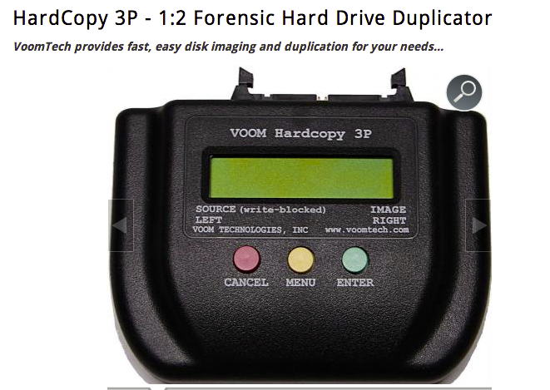
If not, you need to use software write-blocking

A forensic CD/DVD works too

Write-blockers are not perfect—test them

Do you have a large budget but a low tolerance for risk?

Self-contained forensic imaging systems are available

Cost $1500 - $4000

Very easy to use, low chance of mistakes

Link Ch 5a

Are you comfortable testing and explaining Windows registry changes?

USB registry write-blocking works in Windows XP, 7, or 8 (but not Server 2008!)

Are you comfortable with the Windows command line?

You can use Windows FE, a bootable forensic CD/DVD (Link Ch 3c)

Command-line environment

Hardware Write Blocking Pros and Cons

Pros

Reliable protection, documented and tested by vendor

Any forensic imaging program, OS, or analysis tool can be used without the risk of modifying the evidence

Some device-specific imaging programs allow faster imaging (e.g. Tableaux)

Cons

The number of devices you can image at one time is limited by the number of write blockers you have

The type of devices you can forensically image are limited by the type of write blockers you have

Hardware write blockers are moderately expensive

Software Write Blocking Pros and Cons

Pros

You can image many systems at once, by making more CD/DVDs

You can image any type of media as long as there are drivers for it in the CD/DVD

Free

Cons

Can be slower than hardware write blockers

Without good prior testing and procedures, software write blockers can fail

Dedicated Unit Pros and Cons

Pros

Created specifically for forensic imaging

Fastest method

Cons

Expensive

Number of devices you can image is limited by the number of units you have

Many types of media are not supported

Issues may require a firmware update to fix

Creating standard forms and a lab manual

Essentials

After creating an image, fill out a form that states:

Where it came from

How you forensically imaged it

Validates that hashes match

Indicates when the evidence is no longer in your custody

Chain of Custody Form

From Scientific Working Group on Digital Evidence

Link Ch 5b
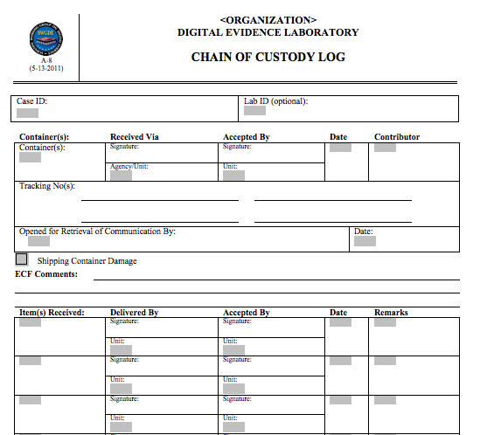

Request Forms

Who is requesting the information

Who is being investigated

The devices you are being authorized to access

What you are being asked to investigate

The date of the request

This document will protect you from unhappy executives if a case gets political

Report Forms

You need to fill out a report tempate

Explain in human terms what you found

Attach the output of a forensic tool as an appendix
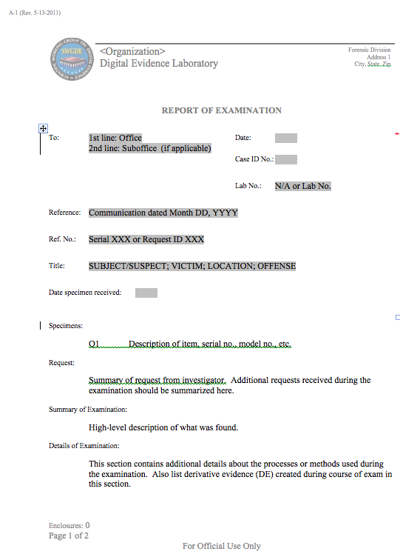

Standard Operating Procedures Manual
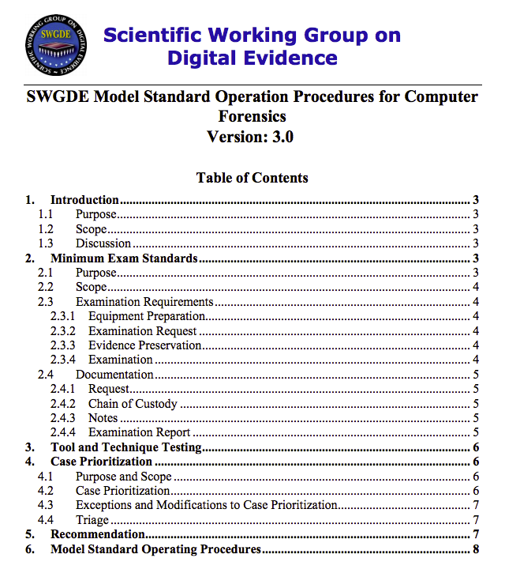

Link Ch 5c

Last modified 1-28-14

