Topics

How and when to test your tools

Where to get test evidence

How and where to access forensic challenges

How and where to access tool testing images

When Do You Need to Test?

To collect data for public research or presentations

If you find a new technique, the original case data is probably confidential

You need public test data

To test a forensic method

To test a tool

For private tests, you can use your own old cases
Evidence File Formats

Raw Images

Also called "dd images"

Uncompressed: same size as the original evidence drive

Simple bitwise copy of the drive, no container

May be broken into a series of files with fixed siize

Works in all forensic tools

E01 (Expert Witness format)

Used by EnCase

Compressed

Wrapped in a file with other data, such as hashes

Not supported by all tools

Not supported by all tools

AFF (Advanced Forensic Format)

Open source forensic image format

S01

Raw image compressed with gzip

Geometry and hashes in a separate file

AD1

AccessData's format
Creating Your Own Test Images

Using a Virtual Machine

Install the OS

install same applications and service packs/patches as the system you are re-creating

Create same data you are testing for

Exit the VM and either create a forensic image, or feed the virtual drive into your forensic tool directly

Directly connecting it may risk altering the data

Tools to Work with Virtual Hard Disks

VMXRay (link Ch 6a)

VMware’s Virtual Disk Development Kit

Link Ch 6b

Encase, FTK, and FTK Imager all support reading virtual hard disks, including VMware

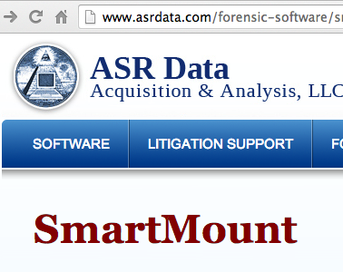

SmartMount from ASR Data

Mount forensic images in VMware and run them (link Ch 6c)

Changes are store in an "overlay" file, so they never affect the forensic image itself

Live View

Free, Java-based tool

Converts dd images to VMware virtual machines

All changes to VM are written to a separate file, to make it easy to return to the original state

Link Ch 6d
Forensic Challenges

LearnForensics YouTube Channel

Link Ch 6f

Honeynet Challenges

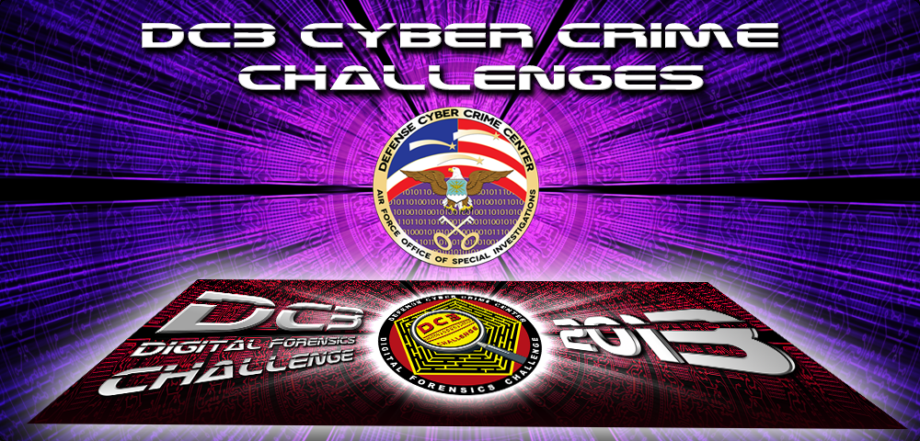
Link Ch 6g

DC3 Challenge

From US DoD

A year long

Includes unanswered questions that require you to develop new tools

Ch 6h

DFRWS Challenge (Digital Forensics Research Workshop)

Smartphone evidence re: an arms dealer

Link Ch 6i

image from Wikipedia

SANS Forensic Challenges

Link Ch 6j

High School Forensic Challenge

Link Ch 6k

Network Forensics Puzzle Contest
Tool Testing Images

Tool Testing Images

Digital Forensic Tool Testing Images (Sourceforge)

Link Ch 6k

NIST Computer Forensics Reference Data Sets Images

Including "The Hacking Case"

Link Ch 6l

Last modified 2-10-14

