Topics

Advantages and risks of live forensics

When live forensics is the best option

Tools for live forensics

Advantages and risks of postmortem forensics

Postmortem memory analysis

Live and Postmortem Forensics

Live Forensics

Evidence system is running and logged in

Attach an external storage device, or connect to a network share

Run a program on the system to capture data, including RAM and the hard disk

Postmortem Forensics

Evidence system is powered off

Remove hard drive, image with write-blocker

Does not capture RAM
Advantages and Risks of Live Forensics

Advantages of Live Forensics

Live forensics can capture RAM

Essential for

Capturing malware that is only in RAM

Recovering authentication and encryption passwords from RAM

Risks of Live Forensics

If the system is connected to a network, it may be remotely wiped

Examiner's tools and acts may overwrite data in the page file and cause data loss

In practice, IR (Incident Response) teams are usually not interested in deleted data

More concerned about rootkits and malware

RAM is far more important

Imaging the Hard Drive

You can image the hard drive live

That preserves its state and allows you to return to the saved state

Do this before you begin your analysis, because analysis changes files and datestamps
When Live Forensics is the Best Option

When Live Forensics is the Best Option

Live Imaging

Incident Response

Malware Analysis

Encrypted Systems

Nonsupported File Systems

Enterprise Forensic Tools

Live Imaging

Copying a hard drive while the system is running

Required when you cannot take down a system for imaging, such as a shared server

RAID or SAN storage is easier to image live

Because the drivers may not be available for forensic software, such as live DVDs

Arrays are difficult to re-create offline

Minimizing Impact

When performing live imaging of a hard drive

Run your tools from external storage

Store evidence on external storage

This minimizes the impact to the evidence system

Incident Response

An investigation in reaction to a security incident

Breach by a hacker

Malware outbreak

Network outage

DFIR (Digital Forensics / Incident Response)

Consider response to a hacker intrusion

The only way to track down the attacker is with live forensics to track

Memory

Network activity

Postmortem forensics may have a role later after the incident is over

Malware Analysis

Must inspect system memory to see what malware is doing

Captured memory image can be parsed with tools like Memoryze

The malware is not running

It cannot hide its actions

Encrypted Systems

Hard disk may be encrypted (e.g. BitLocker)

Live OS has access to the hard drive while it's running, so it can be imaged in a decrypted state

Without needing the encryption keys

Encryption keys may be in memory

Can be retrieved from a RAM image with memory analysis

Nonsupported File Systems

Legacy systems may not be supported by any forensic tools

A traditional hard disk image will be of little use

You can still search for keywords and carve for known file types

But you won't see the file system structure; folders, owners, timestamps, etc.

Back up the live system into an intermediary storage file

tape, zip, tar, etc.

This may be the only way to preserve the data in a reviewable form

Special cases may require unusual procedures

Document what you did

Note: Updated tools support more old systems

Enterprise Forensic Tools

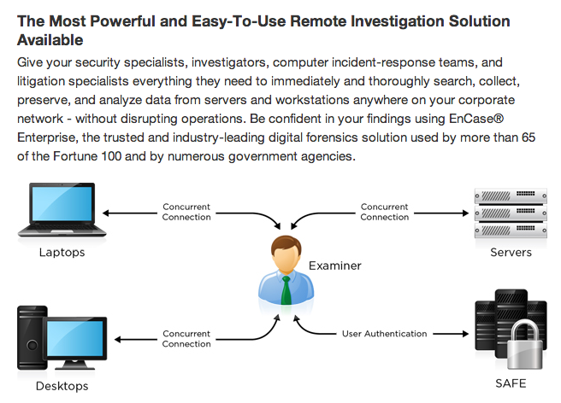
Link Ch 7a

Deploy agents to remote systems to collect data while systems are used

That's live forensics

If agent was loaded before the incident, one could argue that it has less effect on evidence

Tools for Live Forensics

Memory Dumping

Must be logged in as administrator or root

Use 64-bit tools for 64-bit systems

All tools should have similar results

Although not perfectly identical, because the tool changes the RAM somewhat

Memory Dumping from Windows

Memoryze from Mandiant

Can collect data as well as examine it (link Ch 7b)

Mdd from Mantech

Captures RAM (updated in 2013) (link Ch 7c)

DumpIt from Moonsols

Combines win32dd and win64dd into one tool (link Ch 7d)

FTK Imager from AccessData

Can image RAM and hard disks too (link Ch 7e)

Memory Dumping from Linux

dd

Could image RAM in older kernels

No longer possible since 2.6 kernel (2003)

Fmem

Creates a device named /dev/fmem

Use dd to image it like any other device
(link Ch 7f)

Second Look

Commercial Linux Intrusion Detection and Incident Response tool (link Ch 7g)

Memory Analysis Tools

All tools should find the same information

They differ in cost and convenience

Memory Analysis Tools

Volatility

Free, very popular (link Ch 7h)

Included in Kali Linux

FTK

Can visualize processes to memory locations from a RAM image

Memoryze from Mandiant

Primarily for malware analysis

Free (link Ch 7b)

Live Disk Imaging Tools

Caution

The live system may be untrustworthy

Rootkit infections can hide data from an imaging tool

Run tools from your own CD, thumbdrive, etc.

Note

You must be logged in with Administrator rights to access the physical disks in Windows

Live Disk Imaging Tools

FTK Imager Lite

Best choice for Windows

No installation needed

Runs directly from external storage (CD or thumbdrive)

Free from AccessData (link Ch 7e)

dd

Best choice for Linux

dcfldd is a variant that adds hashes
Advantages and Risks of Postmortem Forensics

Advantages of Postmortem Forensics

Low risk

System is powered off

No risk that an external threat can change or destroy the evidence

No need for a password or other credentials to access the system

Unless the hard drive is encrypted

Risks of Postmortem Forensics

Errors in imaging process

Failure to use a write-blocker

Other accidents

Such errors will be much more heavily scrutinized

Than live images, which everyone understands have been changed during collection

Postmortem Memory Analysis

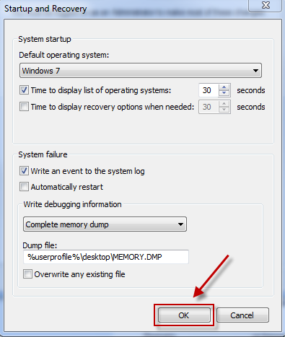
RAM Data in a Disk Image

Core dumps

Hibernation files

Core Dumps

When Windows crashes with a Blue Screen of Death

It saves some memory on the disk

But it's not usually a complete image
(link Ch 7i)

Core Dump Files

Windows dump files end with .DMP

Linux code dumps are named Core or code

Hibernation Files

Hiberfil.sys

Contains a copy of RAM when a system was placed in Hibernation mode

Some Hiberfil.sys files are compressed (link Ch 7k)

Some versions of Windows use "Hybrid Sleep" (link Ch 7l)

Last modified 2-17-14

