Topics

Creating forensic images of:

Hard drives

External storage drives

Network shares
Imaging a Hard Drive

Forensically Sound

A forensically sound method does not alter the existing evidence

Uses some sort of write-blocker

Sometimes there is no forensically sound way to capture evidence

Then you need to document the procedure you used and why

Exclude the changes you made from the evidence

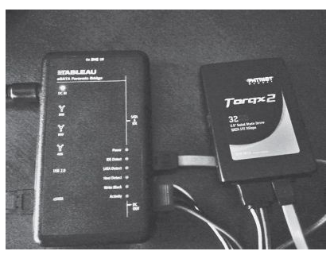
Internal Hard Drives

Three methods

Remove drive and use a hardware write-blocker

Remove drive and use a USB connection, with Windows registry software write-blocking

Use a forensic boot DVD including software write-blocking

Hardware Write Blocker

Power off evidence machine

Remove drive

Connect write-blocker to evidence drive and forensics computer

Power on write blocker

Use FTK Imager or something similar to capture image

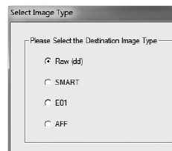
Image Types

All are forensically sound

Raw (dd) are supported by every tool, but uncompressed

S01 or SMART are just compressed raw images

E01 can be compressed and password-protected

AFF can be compressed and encrypted

Hashes

MD5 is 128 bits long

Oldest, weakest hash type

Has known collisions

SHA-1 is 160 bits long

No known collisions

SHA-2 and SHA-3

Longer and more secure

Rarely used

All these hashes are OK for forensic work

Verify Images

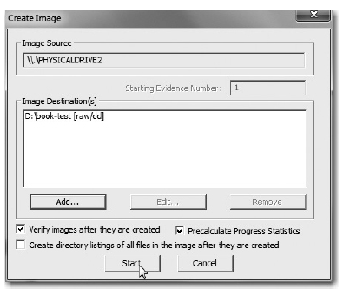
Calculates MD5 and SHA-1 hashes of both the original evidence drive and the image

Verifies that they match

If Hashes Don't Match

You may have bad sectors on the evidence drive

Image it again

If hash still doesn't match, that probably means the evidence drive is failing

Stop using it, document the issue in your chain of custody form, and continue with your investigation

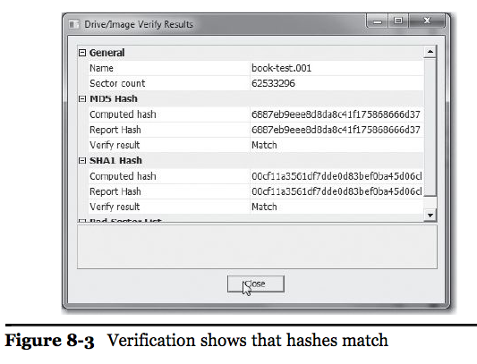
If necessary, you can send the drive to a data recovery company like Drive Savers for repair

Chain of Custody

Update Chain of Custody form to indicate

Forensic image made and verified

Put a text file in the same folder as your image

Including drive make, model, serial number, verification hashes, options selected

USB Software Write-Blocker

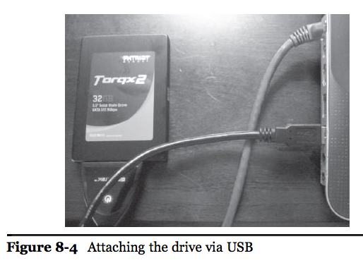
Power off evidence system

Block all USB writes on your forensic computer with a Registry change

Remove drive, connect to USB port with a drive kit

Note: you will need to store the image on a PATA or SATA-connected drive, since USB writes are all blocked

Warning

Software write-blocking is less reliable

OS updates may change it

This hack is not well-known or publically supported by Microsoft

Test the write-blocking regularly

Try to write to a USB drive (one without evidence on it, of course)

Forensic Boot DVD

Includes software write-blocking

For all connection types; USB, PATA, SATA

Can be done on original evidence computer without removing the drive

But it must be restarted and booted from DVD
Imaging an External Drive

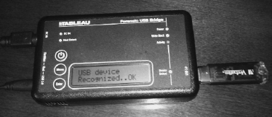
Imaging a USB Drive

Forensic boot disks work well

Raptor, Win FE, DEFT, etc.

Mounts all drives as read-only by default

FTK Imager

With software USB write-blocking, or

Hardware USB write-blocker

Hardware USB Write Blocker
Imaging a Network Share

Logical Acquisition

Includes contents of a file or directory

Stores the data and provides a hash value to verify data

FTK uses AD1 format, EnCase uses L01

Does not include

Track and sector information

Deleted data

File system metadata

Imaging Mobile Devices

Phones, iPads, Androids, Blackberries, etc.

Methods change rapidly

Expensive proprietary software and hardware devices support mobile devices

Free solutions are more rare; good topic for research!
Imaging a Mac (not in textbook)

Mac Issues

Less software available

Special tools & skills needed to disassemble hardware

MacBook Pro with Hard Drive

HD can be removed & imaged like any other drive

MacBook Air with SSD

SSD drivers missing from most forensic distributions

Mac Acquisition Tools

Mac Memory Reader

Acquires RAM

Not yet updated for Mavericks

Link Ch 8a

Black Bag's MacQuisition

Sure-fire commercial solution

Costs $1000

Link Ch 8e

Other Acquisition Tools

Raptor, Paladin, Helix, and LinEn all fail

FTK Imager for Mac GUI is available

As a beta

Live acquisition only

DEFT reportedly works

But requires a USB DVD drive

Won't boot from thumbdrive, as far as I can tell

Doesn't support Retina displays (link Ch 8g)

EnCase Portable works from CD

But not USB thumbdrive (link Ch 8d)

Thunderbolt

Place evidence Mac in "Target Disk Mode"

Image to another Mac through the Thunderbolt cable

Runs at 10 GB/s

Can also use FireWire

No write-blocking

Link Ch 8g

Mac Analysis

Volatility works for RAM analysis

But only for analysis, not acquisition

Link Ch 8h

EnCase, FTK, and ProDiscover can all analyze Mac disk images

They also support remote acquisition over the network

With expensive versions

Last modified 3-4-14

