Topics

What is nontraditional forensics?

When and why to use nontraditional forensics

Understanding volatile system artifacts

Memory acquisition and analysis

Encrypted file systems and live system imaging

Dealing with mobile devices

Working with solid-state drives

Virtual machine forensics
What is Nontraditional Forensics?

Impact on the Evidence

Traditional, forensically sound, methods have no effect on the evidence during acquisition and analysis

Capture with a write-blocker

Examine only the captured data

Verify copy with a hash value, such as MD5 or SHA-1

Nontraditional Methods

Changes the evidence

Examiner attempts to minimize the changes

May be needed because

Technical issues

Organizational decision

Whim of a client

Communicate with Client

Get authorization from stakeholders before using nontraditional methods

Normal goals include

Minimize downtime of computer you're investigating

Preserve evidence perfectly with no changes

If you cannot do both of those, explain that to the stakeholders and decide how to proceed

Stakeholders

Corporate environment

Management

Legal

Working as a contractor

Customer

Never assume you are authorized

Get an explicit statement of authorization

Recordkeeping

Approach every investigation as if it were going to court

Preserve evidence properly

If you must deviate from traditional forensic procedures

Make sure you know the reasons for doing so

Back up your actions and decisions with documentation
When and Why to Use Nontraditional Forensics

Traditional Forensics

Power is off

Acquire hard disk image with write-blocker

Analyze the copy

Still most common type of forensics

However, it misses volatile artifacts

Running processes

Network connections

Routing table entries
Understanding Volatile System Artifacts

Volatile Artifacts

System artifacts that exist only when the system is up and running

Routing tables

Open and listening network ports

Established network connections

Cached login credentials

Passwords

Found in RAM or page file (swap space)

Must be collected before power-off

Incident Response and Malware Analysis

Rely heavily on state of a running compromised system

Must capture RAM image

Malware can add routes to the routing table which are not stored on the hard disk in the registry

They exist only in RAM

Types of Malware

Viruses

Embed themselves in files and spread

Worms

Spread through network connections

Trojan horses

Appear to be beneficial but actually do harm

Such as fake antivirus

Spyware

Gather information and send it to a server

Example: keyloggers

Scareware

Scares user with messages asking for money

Example: 'Virus Detected"

Crimeware

Specifically designed for identity theft and fraud

Features of Malware

Persistence

Restarting computer does not stop the malware

Adds itself to a RUN registry key or some other Autostart Extensibility Point

Prevent Removal

Disable antivirus

Block antivirus updates, often by adding routes to blackhole their servers

Encrypted File systems and Live System Imaging

Encrypted File Systems

Full Disk Encryption

Microsoft's BitLocker

Apple FileVault

Open source TrueCrypt

Pretty Good Privacy (PGP)

Check Point's Pointsec FDE

Main purpose: protect data when a laptop is lost or stolen

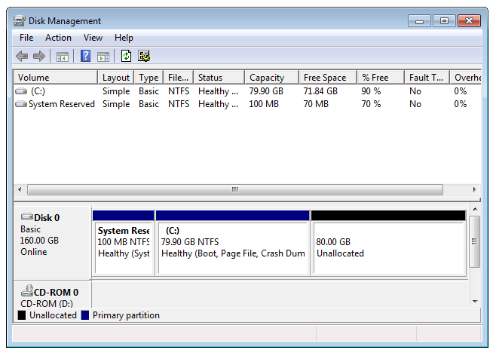
Sometimes also used on desktop computers

When physical access is not controlled

Unencrypted Boot Partition

Small partition (100 MB or so)

Contains a boot loader

Asks user for credentials

If they are correct, it decrypts the OS partition and starts the system

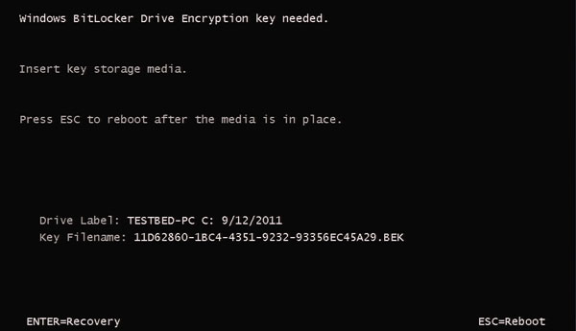
Image from https://kb.acronis.com/sites/default/files/content/2010/11/16249/vhd002.png

BitLocker with Startup Key

image from http://www.maximumpc.com/files/u139222/howtobitlocker-step03.jpg

BitLocker with Recovery Password

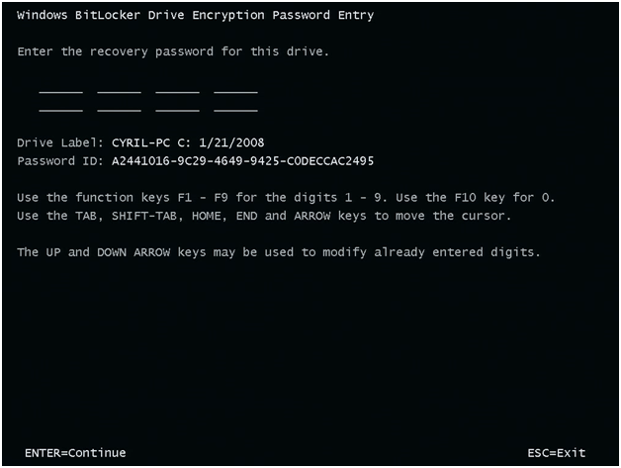
Image from http://blogs.technet.com/cfs-file.ashx/__key/telligent-evolution-components-attachments/13-5628-00-00-03-05-41-37/Test_2D00_SecureStartup3.png

File and Folder-Level Encryption

May be used instead of, or in addition to, full disk encryption

Microsoft's Encrypting File System

Apple's FileVault

Pretty Good Privacy (PGP)

TrueCrypt

Winzip encryption

Microsoft office password protection

Many, many more

Self-Encrypting Drives

Hard drive firmware includes encryption

Custom firmware simulates an unencrypted boot partition

But the entire user-accessible portion of the disk is encrypted

User must enter a key to boot up

Forensic erase takes less than a second

Simply overwrite the key

Links Ch 9a, 9b

Self-Wiping Hard Drives

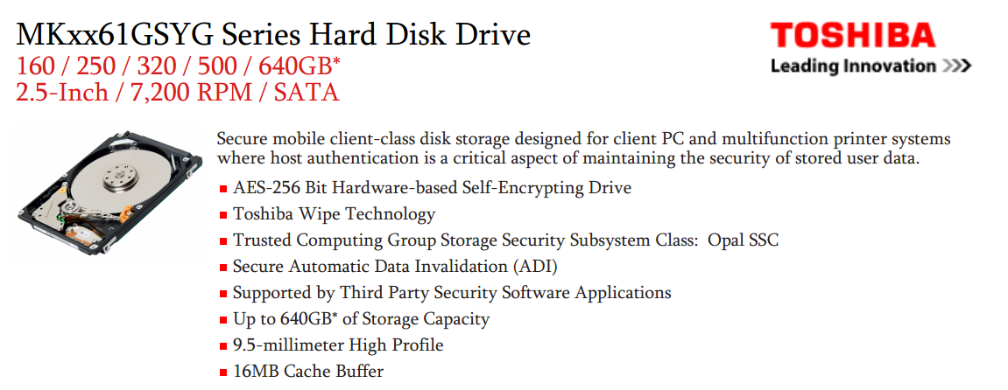
Wipes out the key when drive is moved to a different computer

Makes traditional acquisition impossible

Links Ch 9c, 9d

Challenges to Accessing Encrypted Data

Traditional approach

Image the encrypted drive

Use a forensic product to decrypt the drive (assuming you have the key)

But few tools are available that can decrypt drives

And they are not kept up-to-date with encryption process changes

Live acquisition

BitLocker makes the physical disk appear encrypted even when the system is on and logged in

All you can get is active data (link Ch 9f)

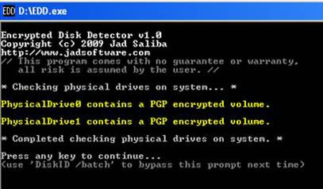
Encrypted Disk Detector

Link Ch 9e

Using Virtual Machines

In some cases, you can unencrypt volumes this way

Acquire the encrypted disk with dd

Use LiveVIew to mount the dd file as a VHD (read-only)

Boot VMware machine with a Pointsec recovery boot disk

Decrypt the disk with Pointsec (assuming you have the key)

Reboot with a forensic CD

Image the decrypted volume

Link Ch 9g

Simpler Way

Just decrypt the original drive with the recovery disk (assuming you have the key)

Then image it

Technically this alters the evidence, but in practice it's been accepted in court

Could keep an image of the original encrypted drive just as a precaution

If You Don't Have the Key

Your only option is to do a live acquisition

Get what you can

There are no known secret keys or backdoors into full disk encryption products

Dealing with Mobile Devices

Types of Mobile Devices

iPhone, iPad, iPod

Android phones

Windows mobile

Tablets

PDAs

Google Glasses

Many, many more

Evidence on Mobile Devices

Phone calls

Text messages

Email

GPS locations

Web browsing history

Much, much more

Traditional Techniques

Disassemble the device and extract the storage devices

Image them with a write-blocker

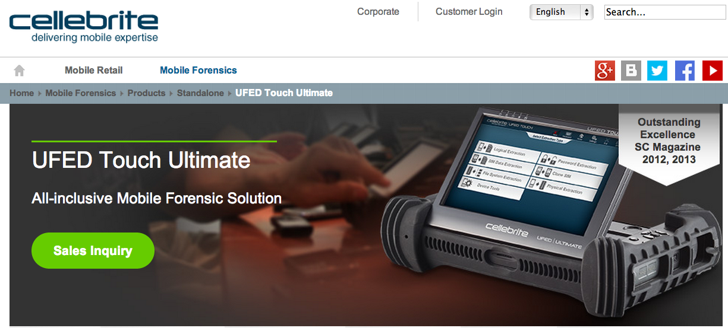
Not practical for most examiners, although DriveSavers can do that

Mount Device as a Removable Drive

Connect device via USB

Use USB write-blocker

Hardware or software

Image drive as usual

Commercial Devices

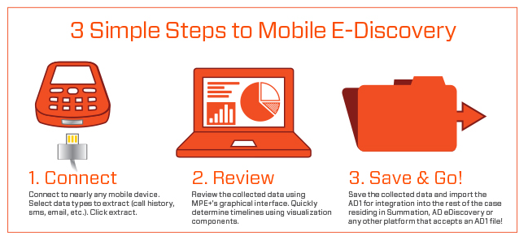
Link Ch 9i

AccessData Mobile Phone Examiner

Link Ch 9l

Limitations of Physical Acquisition

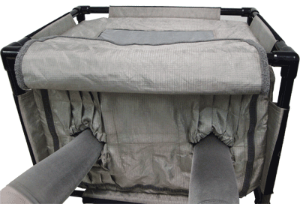
To take a full physical image of a mobile device, it often must be "rooted" or "jailbroken"

It must also be powered on

It may receive calls or text messages

Calls or messages may be deleted

May be remote wiped

Recommended: work in a Faraday cage, tent, or bag

Paraben - Tabletop StrongHold Tent

Link Ch 9m

Forensic Soundness

None of these procedures are forensically sound

They all involve changing the evidence to some extent, because they are live acquisitions

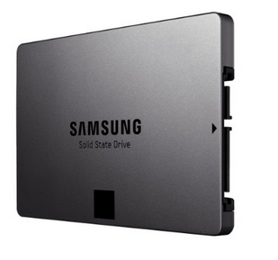
Phones are constantly changing state while power is on

Timestamps, messages, phone calls, etc.
Working with Solid-State Drives

SSD Drives

Faster than hard drives

Consume less power

More expensive

Image from Amazon

SSD Popularity

From http://www.isuppli.com/Abstract/P28276_20130322152341.pdf
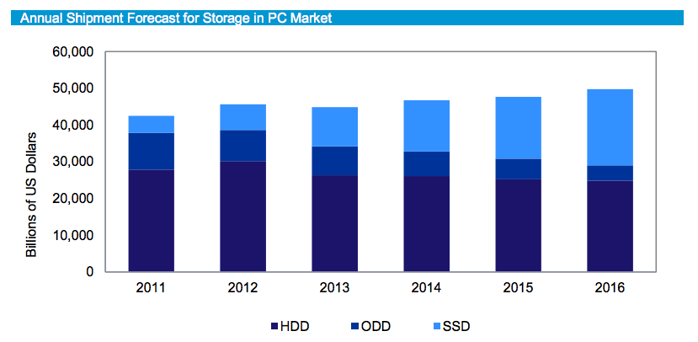

How SSDs Work

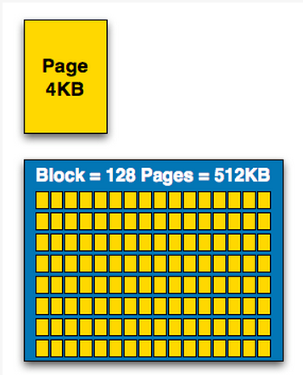
Data can be read and written one page at a time, but can only be erased a block at a time

Each erasure degrades the flash—it fails around 10,000 erasures

From http://www.anandtech.com/show/2738/5

Garbage Collection

SSD controller erases pages all by itself, when it knows they are empty

The TRIM command is sent to the SSD when a file is deleted

But only if you use a the correct OS, Partition type, and BIOS settings

Yuri Gubanov calls this “Self-Corrosion” – I call it Data Evaporation

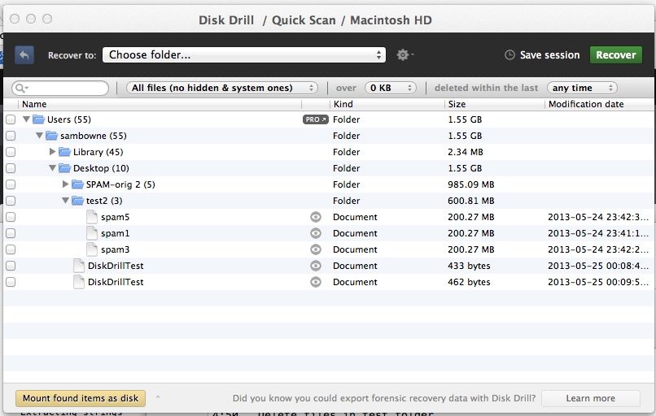
Demo on Mac: Disk Drill

Deleted files from desktop evaporate in 30-60 min

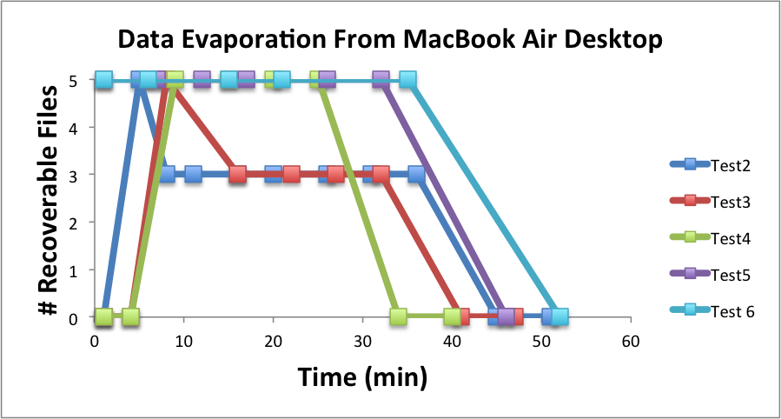

Demo on PC

Save data on an SSD

Watch it evaporate!

How to test TRIM

fsutil behavior query DisableDeleteNotify

Zero = TRIM enabled

When Does TRIM Work?

BIOS: Drive must be SATA in AHCI mode, not in IDE emulation mode

SSD must be new (Intel: 34 nm only)

Windows 7 or later

NTFS volumes, not FAT

Mac OS X 10.6.8 or later

Must be Apple-branded SSD

When Does TRIM Work?

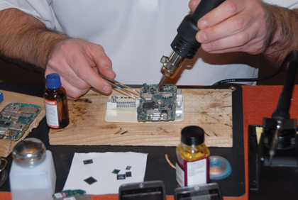
External Drives must use SATA or SCSI, not USB

PCI-Express & RAID does not support TRIM

From http://forensic.belkasoft.com/en/why-ssd-destroy-court-evidence

Meaning for Forensics

Deleted data sometimes evaporates, so there is no forensically sound way to acquire it

The hash keeps changing

All you can do is document your procedure and take what you can get

Like a live acquisition

Active data is OK, but the deleted data may be largely lost

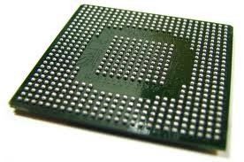
Chip-Off Forensics

Disassemble the SSD memory and image the material directly

Bypassing the SSD controller

This is a true static acquisition

Hash value doesn't change

Expensive, difficult, and may destroy the SSD

Drive Savers can do this

Chip-Off Forensics

Links Ch 9o, 9p

Link Ch 9q
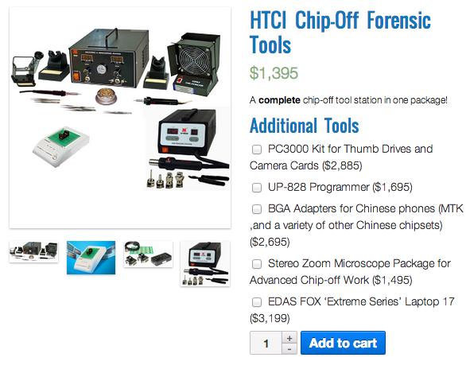

Missing Artifacts

When Windows 7 is installed on an SSD, it disables some features

ReadyBoost

SuperFetch

Automatic defragmentation

So the Prefetch folder will be empty

Link Ch 9s, 9t

The book says UserAssist will be missing too

I'd like to test this

Virtual Machine Forensics

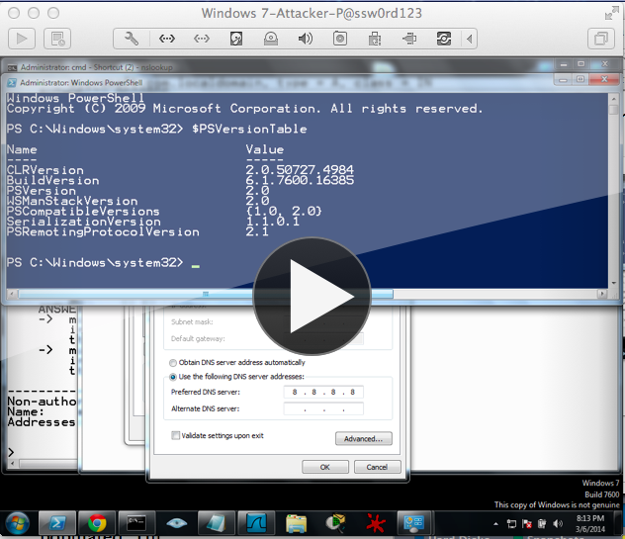
Suspend

Suspend a VM

Stops it, preserves HD and RAM

Like Hibernate

Copy the whole folder containing the VM

Live Acquisition of a VM

To get HD, copy the virtual hard disk files

VHD. VMDK. VDI, etc.

Capture RAM with FTK Imager or any other live acquisition tool

Last modified 3-13-14

