What You Need for This Project
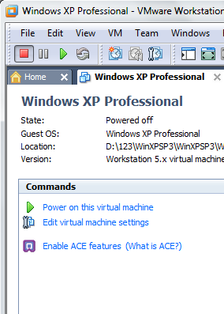
- A virtual machine. It can use any OS, and the host machine can be using any OS. You can also use any virtual machine software you like.
- The instructions below assume you are using a host of Windows 7, VMware Workstation, and a guest of Windows XP, as set up in the S214 lab.

Starting VMware
- Double-click the VMware Workstation icon on the desktop. In the VMware Workstation window, from the menu bar, click View, Go to Home Tab.
- On the Home tab, click the Open Existing VM or Team icon. Navigate to the VMs: drive, open your folder, open the Win XP SP3 folder, and double-click the Windows XP Professional.vmx file. You should see a Windows XP Professional VM in the Powered Off state, as shown to the right on this page.
- The virtual machine’s “State” must be “Powered Off”, as shown to the right on this page. If it is “Suspended”, resume it and shut it down.

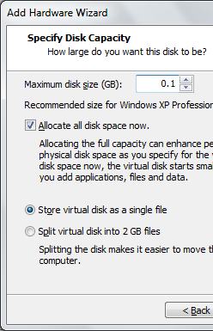
Adding a Small Hard Disk to your Virtual Machine
- In the “Windows XP Professional – VMware Workstation” window, on the left side, click the "Edit virtual machine settings" link.
- In the “Virtual Machine Settings” box, click the Add… button.
- In the “Add Hardware Wizard” box, accept the default selection of "Hard Disk" and click the Next button.
- In the “Select a Disk” box, accept the default selection of "Create a New Virtual Disk" and click the Next button.
- In the “Select a Disk Type” box, accept the default selection of "IDE (Recommended)" and click the Next button.
- In the “Specify Disk Capacity” box, set the "Maximum disk size (GB)" to 0.1 and check the "Allocate all disk space now" as shown to the right on this page. Click Next.
- In the “Specify a Disk File” box, accept the default selection and click Finish.
- In the “Virtual Machine Settings” box, click OK.

Starting Your Virtual Machine
- In the Windows XP Professional – VMware Workstation window, on the left side, click the "Power on this virtual machine" link.

Downloading and Installing HxD
- In your virtual machine, start Firefox and go to mh-nexus.de/en/hxd
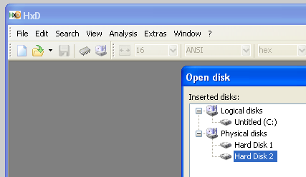
- Scroll down and click the "Download page" link. Download and install the English version of HxD. Accept the default options.

Examining a New Disk
- In your virtual machine, if HxD is not open, click Start, "All Programs", "HxD Hex Editor", HxD.
- In HxD, click Extras, "Open disk…".
- In the "Open disk" box, in the "Physical disks" section, click "Hard Disk 2", as shown to the right on this page. Click OK.
- HxD shows the contents of the disk, as shown below on this page. Find these things:
- Each horizontal row shows 16 bytes, labeled with the Offset (h) value in hexadecimal at the top. On the left, the byte value is shown in hexadecimal. On the right, it's shown in ASCII.
- Because this is a new hard disk, every byte is zero. There is no information at all on this disk.
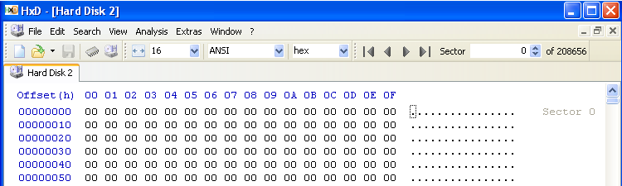
- In the upper right, notice that you are viewing "Sector 0 of 208656". Each sector contains 512 bytes, so that is a total of 208,656 x 512 bytes = 106,831,872 bytes. This is approximately 100 million bytes, or 0.1 GB.

Initializing the Disk
- In your virtual machine, click Start. Point to "My Computer" and right-click. Click Manage.
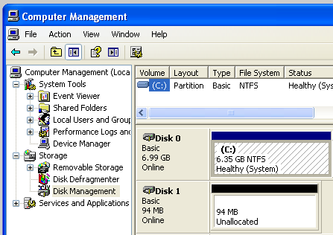
- In the left pane of "Computer Management", click "Disk Management".
- The "Initialize and Convert Disk Wizard" pops up. Click Next, Next, Next, and Finish. This writes a Master Boot Record to the disk.
- The disk should now appear in Disk Management as "Disk 1", containing approximately 100 MB of Unallocated space, as shown to the right on this page.

Viewing the Master Boot Record (MBR)
- In HxD, click View, Refresh. Nonzero values should now be visible on the disk, as shown below on this page.
- Scroll down to the end of the first sector, locations 1FE and 1FF, and note that the last two bytes are 55 and AA. Bytes 200 and above still contain zeroes.
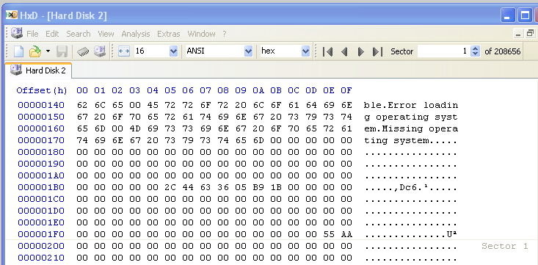

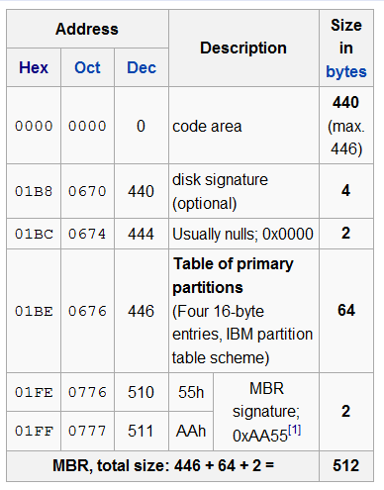
- The chart to the right shows the main features of the MBR Find these features in your HxD window:
- Start of Partition Table: Locations 01BC and 01BD contain zeroes
- Partition Table: Locations 01BE through 01FD contain 64 bytes of zero. These are four 16-byte records, which specify the four possible partitions on a Basic Disk. Since there are no partitions on the disk, they are all zero now.
- End of Boot Sector: Locations 01FE and 01FF contain 55 and AA. This is the MBR Signature--it marks the end of the MBR, and also the end of the Partition Table.

Partitioning the Disk
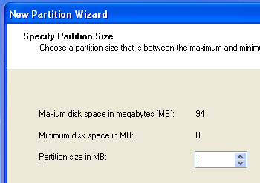
- In your virtual machine, in "Disk Management", right-click the "94 MB Unallocated" area of Disk 1 and click "New Partition".
- In the "Welcome to the New Partition Wizard" box, click Next.
- In the "Select Partition Type" box, accept the default selection of "Primary partition" and click Next.
- In the "Specify Partition Size" box, enter a Partition Size of 8 as shown to the right on this page, and click Next.
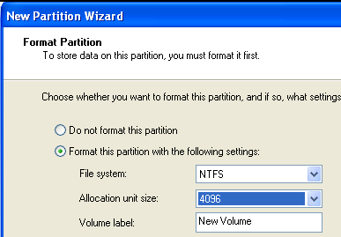
- In the "Assign Drive Letter or Path" box, accept the default selection of E and click Next.
- In the "Format Partition" box, set the "Allocation unit size" to 4096, as shown to the right on this page, and click Next.
- In the "Completing the New Partition Wizard" box, click Finish.

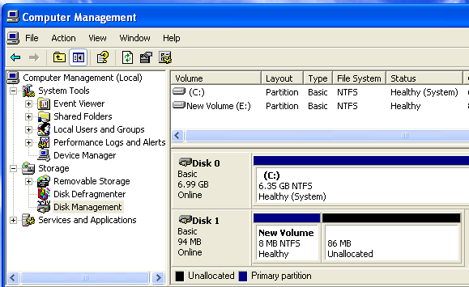
- Disk Manager should now show New Volume (E:) new volume with a size of 8 MB, as shown to the right on this page.

Viewing the Partition Table
- In HxD, click View, Refresh. Notice that the first record of the partition table now contains data, as highlighted in the image below on this page.
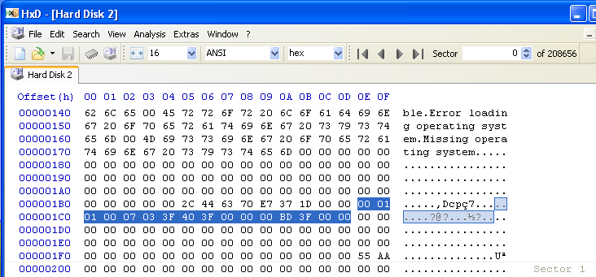

Filling the E: Partition with Spam
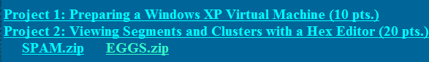
- In your virtual machine, in Firefox, and go to samsclass.info
- Click the "CNIT 121" link. Click the "Projects" link.
- Under "Project 2", click the SPAM.zip link. In the "Opening SPAM.zip" box, click "Save to Disk". Save the file on your desktop.
- Click the EGGS.zip file and save it on your desktop as well.
- On your desktop, right-click the SPAM.zip file and click "Extract All".
- In the "Welcome to the Compressed (zipped) Folders Extraction Wizard" box, click Next.

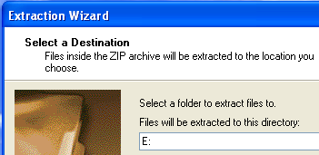
- In the "Select a Destination" box, enter a directory of E:, as shown to the right on this page. Click Next.
- An error message pops up, saying "There is not enough space on the disk to extract the file". Click OK. In the "Extraction Wizard" box, click Cancel.
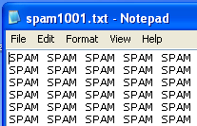
- Click Start, "My Computer". Double-click "New Volume (E:)". Double-click the SPAM folder to open it.
- You see a lot of files named spam1001.txt, spam1002.txt, etc. Double-click spam1001.txt. As you can see, the file contains the word SPAM repeated many times, as shown to the right on this page. Each "spam" file contains 10,000 characters.

Viewing the Stored SPAM Data
- In HxD, click View, Refresh. Scroll down with the mouse until you find the start of the SPAM. The exact location may vary. When I did it, the spam started at sector 695, as shown below on this page.
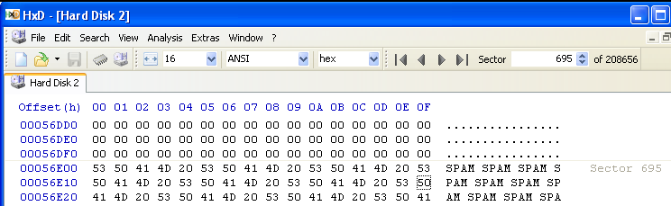

- Tap the PageDown key on the keyboard until you reach the end of the SPAM text in this file. When I did it, the text ended in sector 714, as shown in the image below on this page.
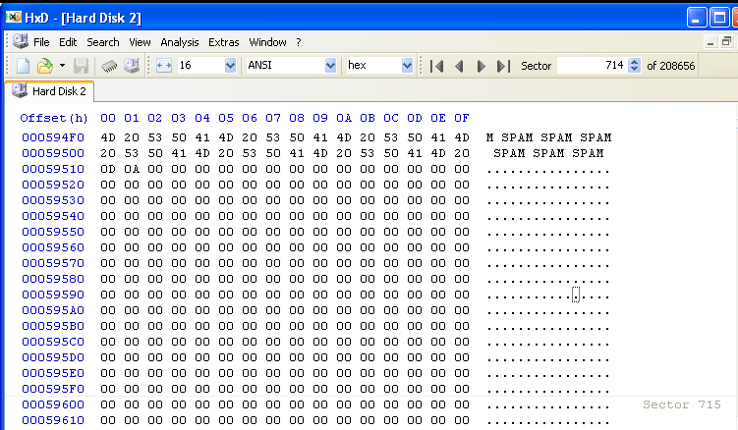
- The partition is formatted with 4096-byte clusters, each containing eight 512-byte sectors. The spam files contain 10,000 characters each, so they occupy three clusters, as shown below. Look at these clusters and verify that they contain the expected data. Your Sector numbers might be different, but you should see this pattern of data in 24 sequential sectors.

CLUSTER 1 |  |  | CLUSTER 2 |  |  | CLUSTER 3
Sector | Contents |  | Sector | Contents |  | Sector | Contents
695 | SPAM |  | 703 | SPAM |  | 711 | SPAM
696 | SPAM |  | 704 | SPAM |  | 712 | SPAM
697 | SPAM |  | 705 | SPAM |  | 713 | SPAM
698 | SPAM |  | 706 | SPAM |  | 714 | SPAM + 0
699 | SPAM |  | 707 | SPAM |  | 715 | 0
700 | SPAM |  | 708 | SPAM |  | 716 | 0
701 | SPAM |  | 709 | SPAM |  | 717 | 0
702 | SPAM |  | 710 | SPAM |  | 718 | 0

Deleting the Files on the E: Drive
- In your virtual machine, click Start, "My Computer". Double-click "New Volume (E:)". Right-click the SPAM folder and click Delete. In the "Confirm Folder Delete" box, click Yes.
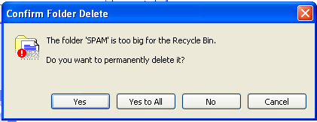
- Another "Confirm Folder Delete" box pops up, saying that these files will be "permanently deleted". Click Yes.

Viewing the SPAM Data
- In HxD, click View, Refresh.
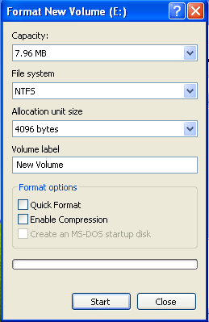
- Scroll through the 24 sectors you examined previously, and verify that all the SPAM text is still there. Deleting the files did not erase any text data. All it changes is records in the Master File Table.

Formatting the E: Drive
- In your virtual machine, click Start, "My Computer". Right-click "New Volume (E:)" and click Format….
- In the "Format New Volume (E:)" box, make sure that the "Quick Format" box is cleared, and that the "Enable Compression" box is cleared, as shown to the right on this page. Click Start.
- A "Format New Volume (E:)" box pops up saying "WARNING: Formatting will erase ALL data on this disk". Click OK. When the message "Format Complete" appears, click OK.

Viewing the SPAM Data
- In HxD, click View, Refresh.
- Scroll through the 24 sectors you examined previously, and verify that all the SPAM text is still there. Formatting the disk did not erase any text data either.

Adding "EGGS" Files to the E: Partition
- On your desktop, right-click the EGGS.zip file and click "Extract All".
- In the "Welcome to the Compressed (zipped) Folders Extraction Wizard" box, click Next.
- In the "Select a Destination" box, enter a directory of E:, as shown to the right on this page. Click Next.
- When the extraction completes, click Finish.
- Click Start, "My Computer". Double-click "New Volume (E:)". Double-click the EGGS folder to open it.
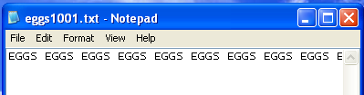
- You see a lot of files named eggs1001.txt, eggs1002.txt, etc. Double-click eggs1001.txt. As you can see, the file contains the word EGGS repeated many times, as shown to the right on this page. There are a total of 1000 characters in each "eggs" file, much smaller than the "spam" files.

Viewing the EGGS Data
- In HxD, click View, Refresh.
- Scroll through the 24 sectors you examined previously, and find some EGGS data. If necessary, use the mouse to scroll, or the "Search" menu item, to find some EGGS text. Find the place where the EGGS data ends, as shown below on this page.

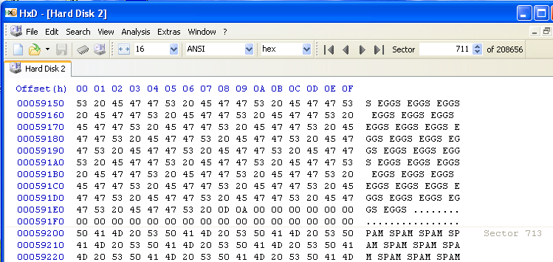

Reflection
- This single image shows three essential concepts:
  - Active data: the EGGS text is part of a file referenced in the Master File Table
  - RAM Slack: The 24 Zeroes at the end of the EGGS data contain zeroes when written by modern operating systems. However, in Windows versions prior to Win 95 Version B, this area contained data from RAM, which could potentially contain passwords or other confidential information.
  - File Slack: the SPAM text at the end of the "eggs" file is old data, left within active clusters

Saving a Screen Image
- Make sure your screen shows the three essential items: the EGGS text, the Zeroes, and the SPAM text.
- Click the taskbar at the bottom of your host Windows 7 desktop, to make the host machine listen to the keyboard, instead of the virtual machine.
- Press the PrintScrn key in the upper-right portion of the keyboard. That will copy the whole desktop to the clipboard.
- On the host machine, not the virtual machine, click Start. Type mspaint into the Search box and press the Enter key.
- Click in the untitled - Paint window, and press Ctrl+V on the keyboard. The desktop appears in the Paint window (only a corner of it will be visible). If you don’t see an image, minimize Paint and press the PrintScrn key again.
- In the untitled - Paint window, click File, Save. Save the document iwith the filename Your Name Proj 2a. Select a Save as type of JPEG.

Observing the Sectors
- Scroll through the sectors, and make sure they show the pattern shown in the chart shown to the right on this page. Your Sector numbers may be different, but there should be three sequential sectors with these contents. Make sure you understand the Terms for each type of data.
Sector | Contents | Term
711 | EGGS | Active data
712 | EGGS + 0 | Active data +  RAM Slack
713 | SPAM | File Slack

Zeroing the Disk
- Now we will use a tool that can really erase the disk: DISKPART.
- In the Windows XP virtual machine, close all windows, except the HxD window.
- Click Start, Run. In the Run box, type CMD and press the Enter key.
- In the Command Prompt window, type this command and then press the Enter key:
DISKPART
- In the Command Prompt window, type this command and then press the Enter key:
LIST DISK
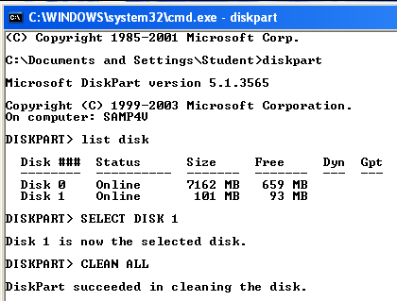
- You should see two disks, as shown below on this page. Disk 0 is the system disk containing Windows XP. Disk 1 is the 100 MB disk we want to erase.
- In the Command Prompt window, type this command and then press the Enter key:
SELECT DISK 1
- Verify that the message says "Disk 1 is now the selected disk." BE CAREFUL when using this tool--if you erase the wrong disk, it's GAME OVER.

Viewing the Zeroed Disk
- In HxD, click View, Refresh. All the SPAM and EGGS text is now gone. Scroll to the top and observe that the whole disk is empty--even the MBR is gone.

Turning in your Project
- Email the JPEG imagesto me as an attachmentsto an e-mail message. Send it to: cnit.121@gmail.com with a subject line of Proj 2From Your Name, replacing Your Name with your own first and last name. Send a Cc to yourself.

Sources:
Wikipedia, en.wikipedia.org/wiki/Master_boot_record

Last Modified: 7-6-10

