What You Need for This Project
- A virtual machine (VM). While you could install FTK on a real machine, you might have a problem when you hit the limitation of 5000 evidence items for the trial version. I therefore recommend using a VM so you can easily start over with a clean machine if necessary.
- The instructions below assume you are using a host of Windows 7, VMware Workstation, and a guest of Windows XP, as set up in the S214 lab.

Starting Your VM (Virtual Machine)
- Double-click the VMware Workstation icon on the desktop. In the VMware Workstation window, from the menu bar, click View, Go to Home Tab.
- On the Home tab, click the Open Existing VM or Team icon. Navigate to the VMs: drive, open your folder, open the Win XP SP3 folder, and double-click the Windows XP Professional.vmx file. You should see a Windows XP Professional VM in the Powered Off state, as shown to the right on this page.
- Power on or resume the virtual machine.

Downloading Forensic Toolkit (FTK)
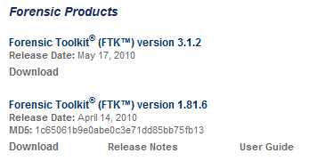
- In your host machine, open Firefox and go to accessdata.com
- On the upper right of the page, click SUPPORT. Click "AD Downloads". In the "Forensic Toolkit (FTK) version 1.81.6" section, click "Download", as shown to the right on this page.
- Save the file on your desktop.

Installing FTK in your VM
- Move your VM window so you can see both the host machine's desktop and the VM's desktop. Then drag the FTK installer from your host machine's desktop, and drop it on the VM's desktop. It should copy quickly--it's only 60 MB.
- In your VM, double-click the installer and install the software with the default options.

Starting FTK in your VM
- After installation, FTK will launch.
- When you get an Error box saying "No security device was found…", click No.
- When you get an Error box saying "The KFF Hash library file was not found…", click OK.
- When a box pops up explaining the limitations of the demonstration version, click OK.

Starting a New Case
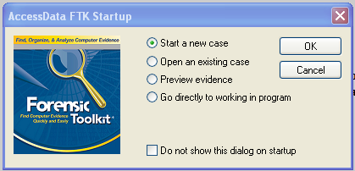
- In the "AccessData FTK Startup" box, accept the default selection of "Start a new case", as shown to the right on this page, and click OK.
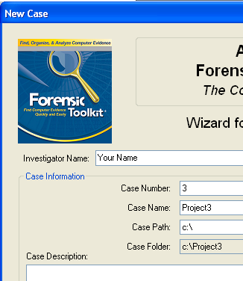
- In the screen titled "Wizard for Creating a New Case", fill in the fields as shown to the right on this page. Click Next.
- In the screen titled "Forensic Examiner Information", leave the fields blank and click Next.
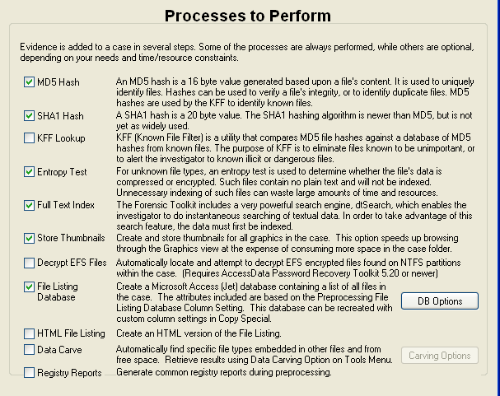

- In the screen titled "Case Log Options", accept the default selections, which will log everything. Click Next.
- In the screen titled "Processes to Perform", deselect "KFF Lookup" and "Decrypt EFS Files", because those features won't work anyway, as shown to the left on this page. Click Next.
- In the screen titled "Refine Case-Default", accept the default of "Include All Items". Click Next.
- In the screen titled "Refine Index -Default", accept the default options. Click Next.

Making a Clean Disk
- You should have a small virtual hard drive attached to your VM, which you created in Project 2. If you don't have one, create one now, or plug in a USB flash drive. It doesn't matter what data is on it for now.
- If your drive has any data on it, clean it completely as you did in project 2, with the DISKPART, SELECT DISK, and CLEAN ALL commands.

Adding Evidence to the Case
- In the "Add Evidence" box, click the "Add Evidence…". button.
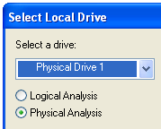
- In the "Add Evidence to Case" box, select "Local Drive, and click Continue.
- In the "Select Local Drive" box, click "Physical Analysis" and select the drive "Physical Drive 1", as shown to the right on this page. Click OK.
- In the "Evidence Information" box, click OK.
- In the "Add Evidence" box, click Next.
- In the "New Case Setup is Now Complete" box, click Finish.
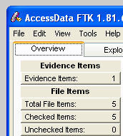
- A "Processing Files…" box appears. Wait till the processing completes--it won't take long if you have a small drive.
- You should now see a screen like that shown to the right on this page, showing "Evidence Items: 1" in the upper left portion of the window.

Saving a Screen Image
- Make sure your screen shows the "Evidence Items: 1" message.
- Click the taskbar at the bottom of your host Windows 7 desktop, to make the host machine active. Press the PrintScrn key in the upper-right portion of the keyboard.
- On the host machine, launch Paint and paste in the image. Save the image with the filename Your Name Proj 3. Select a Save as type of JPEG.

The FTK Window
- Look in the upper left of the FTK window. In the "File Items" section, FTK says 'Total File Items" is 5. How can that be, on a totally empty disk?
- To find out, click the "Total File Items:" button. The lower pane now shows five items, named "DriveFreeSpace1","DriveFreeSpace2","DriveFreeSpace3", etc.
- In the bottom pane of the FTK window, click "DriveFreeSpace1". The upper right corner now shows a hexadecimal view of the bytes in that file, as shown below on this page. This is just like the HxD utility you used in Project 2. As you can see, the file is empty--it's not really a file at all, because it has no header or footer or file name or any data at all. FTK just breaks empty space up into chunks it calls 'Files" for handling.
- To see that the disk is really empty, look at the "File Status" and 'File Category" columns in the upper left portion of the FTK window. You can see that FTK was unable to find any usable data in any known format on this disk--it's clean.
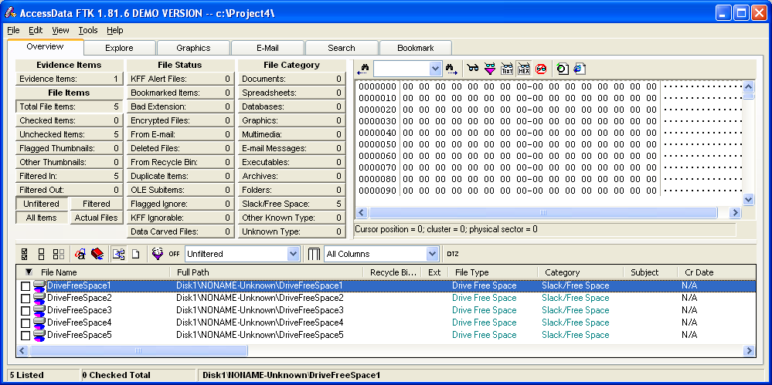

Turning in your Project
- Email the JPEG image to me as an email attachment. Send it to: cnit.121@gmail.com with a subject line of Proj 3 From Your Name, replacing Your Name with your own first and last name. Send a Cc to yourself.
Last Modified: 1-25-12

