What You Need for This Project
- A Windows machine, real or virtual. The instructions below assume you are using Windows 7.

Downloading FTK Imager Lite
- Open a Web browser and go to accessdata.com
- On the upper right of the page, point to SUPPORT. Click "Product Downloads".
- In the "Current Releases" section, expand the "FTK Imager" section, as shown below. On the "FTK Imager Lite version 3.1.1" line, click Download.
- Enter your email address when you are prompted to.
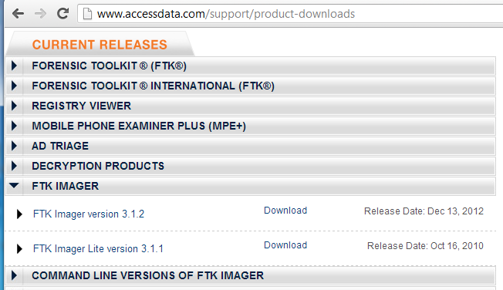
- Save the file in your Downloads folder.

Downloading FTK Registry Viewer
- Open a Web browser and go to accessdata.com
- On the upper right of the page, point to SUPPORT. Click "Product Downloads".
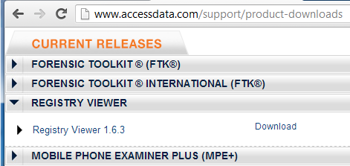
- In the "Current Releases" section, expand the "Registry Viewer" section, as shown below. On the "Registry Viewer 1.6.3" line, click Download.
- Save the file in your Downloads folder.

Installing FTK Registry Viewer
- Double-click the AccessData Registry Viewer.exe file and install the software with the default options.
- Right-click the Imager Lite 3.1.1.zip file and click "Extract All…", Extract. A "Downloads Imager_Lite_3.1.1" window opens showing the extracted files. Leave this window open.

Viewing the Hive Files
- Click Start. Type REGEDIT and press Enter.
- In Registry Editor, navigate to HKEY_LOCAL_MACHINE\System\CurrentControlSet\Control\HiveList
- You should see a list of the files that store the Registry, as shown below on this page. For this project, we want to capture those files, and not all the other files on the disk. FTK Imager will make that really easy!
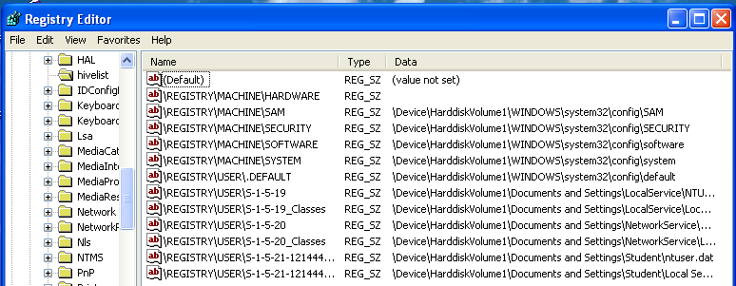

Creating a Registry Image with FTK Imager Lite
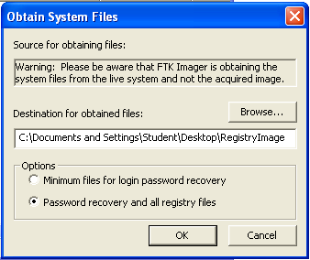
- In the "Downloads Imager_Lite_3.1.1" window, double-click the FTK Imager.exe file.
- In the "AccessData FTK Imager 3.1.1" window, click File, "Obtain Protected Files".
- The "Obtain System Files" box opens. Notice the Warning at the top of this box. You are obtaining data from your own computer, not from an evidence image. At least one forensic examiner actually went to court and submitted data accidentally gathered from his own forensic workstation by ignoring this warning.

- In the "Obtain System Files" box, click the Browse button and navigate to your desktop. Click the "Make New Folder" button, and name the new folder RegistryImage. Select the RegistryImage folder and click OK. Click the "Password recovery and all registry files" radio button, as shown on the previous page. Click OK.
- Wait until the process finishes. It should only take a few seconds. Close FTK Imager.
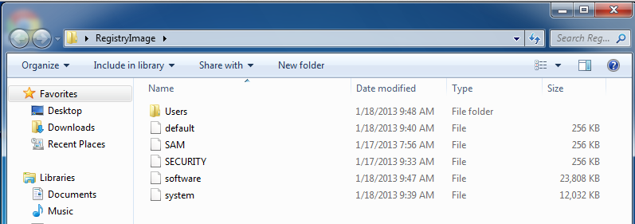
- On your desktop, open the RegistryImage folder. It should contain the five files and one folder shown below. You should get used to seeing these names--they are the Hive Files, and a lot of forensics involves working with them.

Showing System Files
- In the "RegistryImage" window, click Organize, "Folder and Search Options". On the View tab, click the "Show hidden files, folders, and drives" button and clear the "Hide protected operating system files (Recommended)" box. Click OK.

Starting Registry Viewer
- On your desktop, click Start, Registry Viewer.
- A box pops up saying "No security device was found." This is warning you that you are using the product in Demo mode, not the full version. Click No.
- A box pops up saying "No dongle found." Click OK.
- In Registry Viewer, click File, Open. Navigate to your Desktop, and open the RegistryImage\Users\Student\NTUSER.DAT file.
- Registry Viewer is similar to REGEDIT. In the left pane, navigate to Software\Microsoft\Internet Explorer\TypedURLs. The right pane should now show the URLS that have been visited, as shown on the next page:

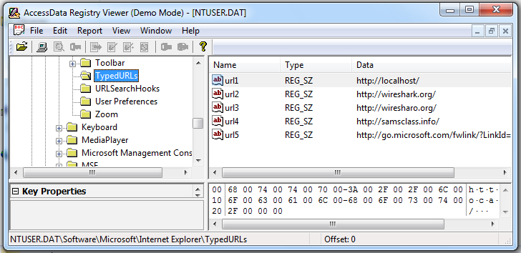

Saving a Screen Image
- Make sure your screen shows TypedURLs in the left pane.
- Click the taskbar at the bottom of your host Windows 7 desktop, to make the host machine active. Press the PrintScrn key in the upper-right portion of the keyboard.
- On the host machine, launch Paint and paste in the image. Save the image with the filename Your Name Proj 4. Select a Save as type of JPEG. The FTK Window

Turning in your Project
- Email the JPEG image to me as an email attachment. Send it to: cnit.121@gmail.com with a subject line of Proj 4 From Your Name, replacing Your Name with your own first and last name. Send a Cc to yourself.
Last Modified: 1-18-13

