What You Need for This Project
- A virtual machine (VM). While you could install FTK on a real machine, you might have a problem when you hit the limitation of 5000 evidence items for the trial version. I therefore recommend using a VM so you can easily start over with a clean machine if necessary.
- The instructions below assume you are using a host of Windows 7, VMware Workstation, and a guest of Windows XP, as set up in the S214 lab.

Copying Your VM (Virtual Machine)
- Before powering on your VM, copy the entire Win XP SP3 folder. That way when you hit the maximum of 5000 files indexed, you will be able to start over more quickly for future projects.

Starting Your VM (Virtual Machine)
- Double-click the VMware Workstation icon on the desktop. In the VMware Workstation window, from the menu bar, click View, Go to Home Tab.
- On the Home tab, click the Open Existing VM or Team icon. Navigate to the VMs: drive, open your folder, open the Win XP SP3 folder, and double-click the Windows XP Professional.vmx file. You should see a Windows XP Professional VM in the Powered Off state, as shown to the right on this page.
- Power on or resume the virtual machine.

Downloading FTK Registry Viewer
- In your virtual machine, open Firefox and go to accessdata.com
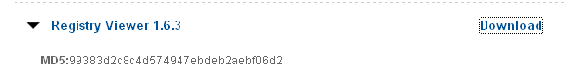
- On the upper right of the page, click SUPPORT. Click "AD Downloads". In the "Registry Viewer 1.6.3" section, click "Download", as shown below on this page.
- Save the file on your desktop.

Downloading FTK Imager Lite
- In Firefox, scroll down to the FTK Imager section, as shown below on this page.
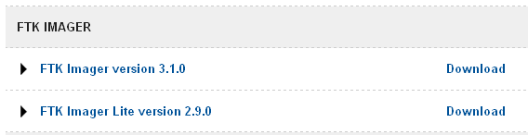
- In the "FTK Imager Lite version 2.9.0" section,-click Download.
- Enter your email address when you are prompted to.
- Save the file on your desktop.

Installing FTK Registry Viewer in your VM
- In your VM, on the desktop, double-click the AccessData Registry Viewer.exe file and install the software with the default options.
- In your VM, right-click the Imager Lite 2.9.0.zip file and click "Extract All…", Next, Next, Finish.

Viewing the Hive Files
- In your VM, click Start, Run. In the Run box, type REGEDIT and press Enter.
- In Registry Editor, navigate to HKEY_LOCAL_MACHINE\System\CurrentControlSet\Control\HiveList
- You should see a list of the files that store the Registry, as shown below on this page. For this project, we want to capture those files, and not all the other files on the disk. FTK Imager will make that really easy!
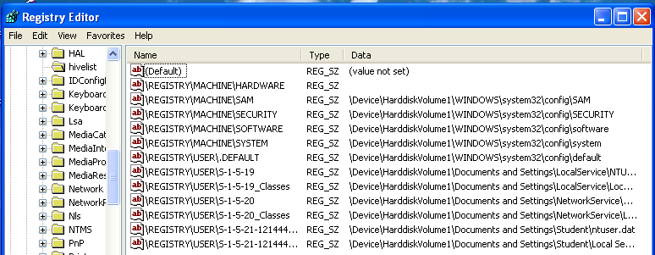

Creating a Registry Image with FTK Imager Lite
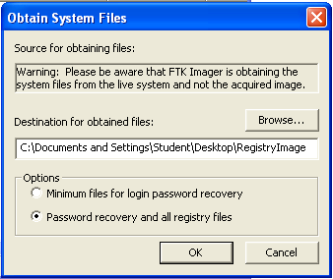
- In your VM, in the "C:\Documents and Settings\Student\Desktop\Imager Lite 2.9.0" folder, double-click the FTK Imager.exe file.
- In the FTK Imager window, click File, "Obtain Protected Files".
- The "Obtain System Files" box opens. Notice the Warning at the top of this box. You are obtaining data from your own VM, not from an evidence image. At least one forensic examiner actually went to court and submitted data accidentally gathered from his own forensic workstation by ignoring this warning.

- In the "Obtain System Files" box, click the Browse button and navigate to your desktop. Click the "Make New Folder" button, and name the new folder RegistryImage. Select the RegistryImage folder and click OK. Click the "Password recovery and all registry files" radio button, as shown on the previous page. Click OK.
- Wait until the process finishes. It should only take a few seconds. Close FTK Imager.
- On your VM's desktop, open the RegistryImage folder. It should contain the six files and ole folder shown below. You should get used to seeing these names--they are the Hive Files, and a lot of forensics involves working with them.
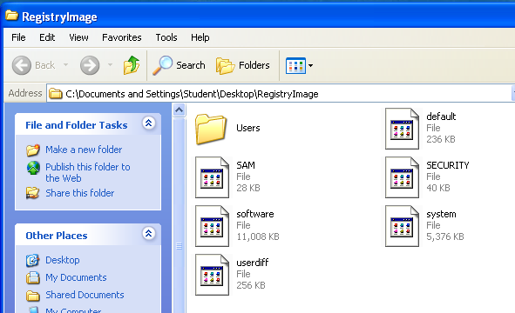

Starting FTK in your VM
- Double-click the "FTK Forensic Toolkit" icon on your desktop. (We will use Registry Viewer from within FTK).
- When you get an Error box saying "No security device was found…", click No.
- When you get an Error box saying "The KFF Hash library file was not found…", click OK.
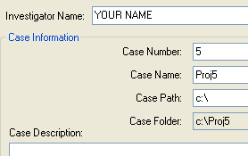
- When a box pops up explaining the limitations of the demonstration version, click OK.

Starting a New Case
- In the "AccessData FTK Startup" box, accept the default selection of "Start a new case" and click OK.
- In the screen titled "Wizard for Creating a New Case", fill in the fields as shown to the right on this page. Click Next.
- In the screen titled "Forensic Examiner Information", leave the fields blank and click Next.
- In the screen titled "Case Log Options", accept the default selections, which will log everything. Click Next.
- In the screen titled "Processes to Perform", deselect "KFF Lookup" and "Decrypt EFS Files". Click Next.
- In the screen titled "Refine Case-Default", accept the default of "Include All Items". Click Next.
- In the screen titled "Refine Index - Default", click Next.

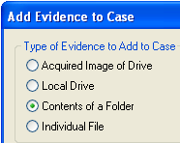
Adding Evidence
- In the "Add Evidence" box, click the "Add Evidence…". button.
- In the "Add Evidence to Case" box, select "Contents of a Folder", as shown to the right on this page, and click Continue.
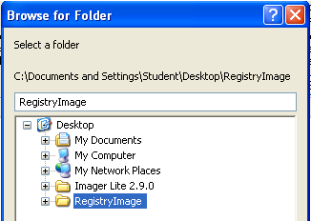
- In the "Browse for Folder" box, navigate to your Desktop and click RegistryImage, as shown to the right on this page. Click OK.
- In the "Evidence Information" box, click OK.
- In the "Add Evidence" box, click Next.
- In the "New Case Setup is Now Complete" box, click Finish.
- A "Processing Files…" box appears. Wait till the processing finishes.
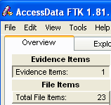
- You should now see a screen like that shown to the right on this page, showing "Evidence Items: 1" in the upper left portion of the window.

Starting Registry Viewer
- In FTK, click File, Registry Viewer. A list of available files opens, as shown below on this page.
- Click the file ending in "Student\NTUSER.DAT" to select it. Click the "View file" button.
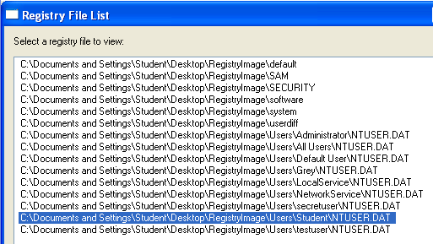

- An ERROR box pops up, saying "No security device was found…". Click No.
- A box pops up, saying "No dongle found…". Click OK.
- Registry Viewer is similar to REGEDIT. In the left pane, navigate to Software\Microsoft\Internet Explorer\TypedURLs. The right pane should now show the URLS that have been visited on that VM. If it's the VM I handed out in class, it will show samsclass.info and metasploit.org, as shown below on this page.
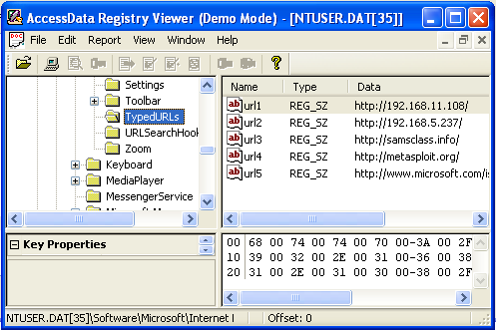

Saving a Screen Image
- Make sure your screen shows TypedURLs in the left pane.

- Click the taskbar at the bottom of your host Windows 7 desktop, to make the host machine active. Press the PrintScrn key in the upper-right portion of the keyboard.
- On the host machine, launch Paint and paste in the image. Save the image with the filename Your Name Proj 5. Select a Save as type of JPEG. The FTK Window

Turning in your Project
- Email the JPEG image to me as an email attachment. Send it to: cnit.121@gmail.com with a subject line of Proj 5 From Your Name, replacing Your Name with your own first and last name. Send a Cc to yourself.
Last Modified: 2-1-12

