What You Need for This Project
- Any computer with a PDF reader.

Downloading the Forensic Toolkit (FTK) User Guide
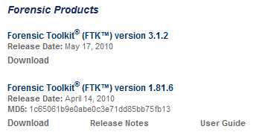
- In your host machine, open Firefox and go to accessdata.com
- On the upper cener of the page, click SUPPORT, "AD Downloads". In the "Forensic Toolkit (FTK) version 1.81.6" section, right-click "User Guide", as shown to the right on this page, and save the file on your desktop. You will need to study this file for many projects in this class, and to prepare for FTK ACE certification.

Read Appendix E
- Double-click the FTK_1.80_Manual.pdf file. It is 365 pages long.
- On the left side, near the bottom, click "Securing Windows Registry Evidence". This opens Appendix E, which goes from pages 316-330. Read through it--this is essential information about the Registry.

Answering Questions
- Find the answers to the questions below in the FTK User Guide. All questions refer to Win XP. Save the answers in a Notepad file so you can email them in.
- What registry key contains the current time zone set on the computer?
- What folder contains the Ntuser.dat file?
- What registry key tells you who the last user logged on was?

Turning in your Project
- Email the answers in the body of a message. Send it to: cnit.121@gmail.com with a subject line of Proj 6 From Your Name, replacing Your Name with your own first and last name. Send a Cc to yourself.
Last Modified: 1-16-12

