What You Need for This Project
- Any Windows computer, real or virtual
- A USB thumbdrive or external hard drive
- The instructions below assume you are using a Windows 7 computer

Creating a Restore Point on the Windows 7 Machine
- Regedit is a dangerous tool to use. If you make mistakes with it, you can damage your Windows OS. So to be safe, the first thing is to create a restore point, which backs up the Registry and other system files.
- On the Windows 7 machine, Click Start, and type RESTORE into the Search box.
- Click "Create a Restore Point".
- In the "System Properties" box, click "Create".
- In the "Create a restore point" box, enter a name of "Your Name - Before registry edits" and click the Create button. Wait while the restore point is created.
- A box appears saying "The restore point was created successfully". Click Close.
- Close "System Properties".

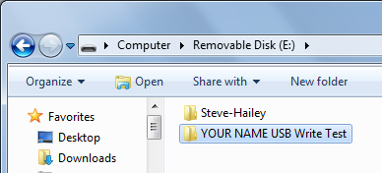
Writing to the USB Device
- Plug in the USB thumbdrive or hard drive.
- Click Start, Computer. Double-click the USB device.
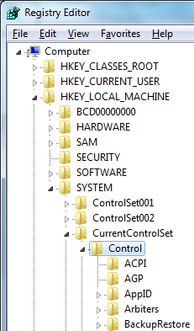
- In the USB device’s window, right-click an empty portion and click New, Folder. Name the folder "Your Name USB Write Test", replacing "Your Name" with your own name. Press the Enter key to make sure the folder's new name is written to the USB device, as shown above and to the right on this page.

Using Regedit to Block USB Writing
- Click Start. In the search box, type REGEDIT and then press the Enter key.
- In Registry Editor, in the left pane, expand HKEY_ LOCAL_ MACHINE, SYSTEM, CurrentControlSet, and Control keys., as shown to the right on this page.
- Scroll down and see if there is a subkey named StorageDevicePolicies in the Control key. It is probably not there.

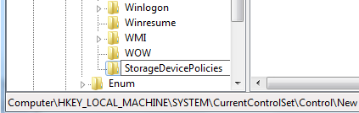
- If the StorageDevicePolicies key is not present, scroll back up, right-click the Control key and click New, Key.
- A new key appears at the bottom of the list: Type in the name StorageDevicePolicies, as shown to the right on this page, and press the Enter key.
- In the left pane of Registry Editor, click StorageDevicePolicies to select it.
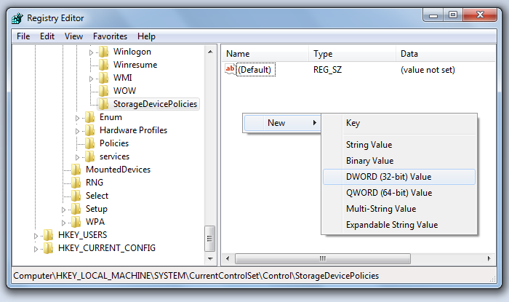
- In the right pane, right-click an empty portion of the window and click New, "DWORD 32-bit) Value", as shown below on this page.

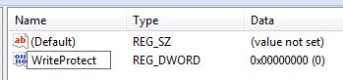
- Type the name WriteProtect into the name field for the new value, as shown to the right on this page, and press the Enter key.
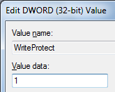
- Double-click the WriteProtect value. In the "Edit DWORD (32-bit) Value" box, enter a "Value data" of 1, as shown to the right on this page. Click OK.

Creating a REG File
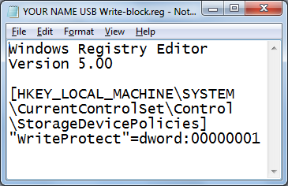
- In the left pane of Registry Editor, right-click StorageDevicePolicies click Export.
- In the Export Registry File dialog box, navigate to your Documents folder, and enter a file name of "YOUR NAME USB Write-block". Click Save. Close Registry Editor.
- Click Start, Documents. Right-click the "YOUR NAME USB Write-block.REG" file and click Edit. The REG file opens in Notepad, as shown to the right on this page.

Saving a Screen Image
- Make sure your screen shows the exact text shown above.
- Press the PrintScrn key. Open Paint and paste in the image. Save it with the filename Your Name Proj 7a. Select a Save as type of JPEG or PNG.

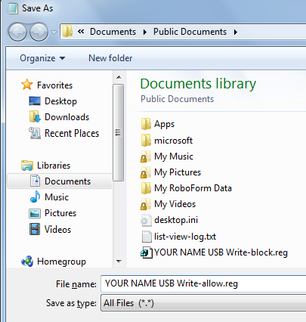
Editing the REG File
- In the "YOUR NAME USB Write-block.REG" window, carefully change the last character in the file from 1 to 0
- Click File, "Save As…". Navigate to your Documents folder, and enter a file name of "YOUR NAME USB Write-allow.reg".
- Change the "Save as type" to "All Files (*.*)", as shown to the right on this page.
- Click Save. Close Notepad.

Restarting the Computer
- Close all windows and restart your computer.

Trying to Write to the USB Device
- Plug in the USB thumbdrive or hard drive.
- Click Start, Computer. Double-click the USB device.
- In the USB device’s window, right-click an empty portion. The option New is no longer available.
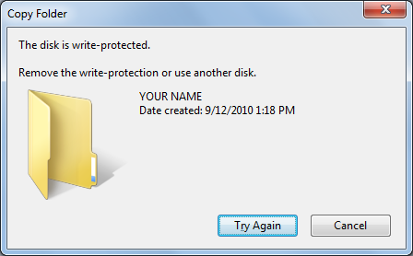
- On your desktop, right-click an empty space and click New, Folder.
- Name the folder "Your Name ", replacing "Your Name" with your own name. Press the Enter key to make sure the folder's new name is saved.
- Drag the "Your Name" folder and drop it in the USB device's window.
- A box pops up saying "The disk is write-protected", with your name on it, as shown to the right on this page.

Saving a Screen Image
- Make sure your screen shows the "The disk is write-protected" message.
- Press the PrintScrn key. Open Paint and paste in the image. Save it with the filename Your Name Proj 7b. Select a Save as type of JPEG or PNG.

Restoring USB Devices to Normal Operation
- Click Start, Documents. Double-click the "YOUR NAME USB Write-allow.reg".file. In the "User Account Control" box, click Yes. In the "Registry Editor" box, click Yes. In the "Registry Editor" box, click OK. The next time the machine starts, USB writing will be allowed again.

Turning in your Project
- Email the JPEG images to me as attachments to a single email message. Send it to: cnit.121@gmail.com with a subject line of Proj 7 From Your Name, replacing Your Name with your own first and last name. Send a Cc to yourself.

Last Modified: 2-15-12

