What You Need for This Project
- VMware Workstation
- The BackTrack 4 ISO file (bt4-final.iso, 1.46 GB)
- The instructions below assume you are using a host of Windows 7 as set up in the S214 lab.

Gathering the Files You Need
- The bt4-final.iso file is on the VMs drive in the computers in S214--you can copy it from them. If you are working in S214, just use that copy of the file.
  - If you have broadband, you can download it at home from www.backtrack-linux.org/downloads (I used the "BackTrack 4 Final Release ISO" version.)
- Click Start, Computer. Open the VMs drive. Open the folder with your name on it. Make a subfolder named 121-proj8.
- In Firefox, go to samsclass.info, click on "CNIT 121", and scroll down to the "Project 8" instructions, as shown below on this page. Click the "Proj 8 Evidence File (4 MB)" link and save the p08Evidence.zip file on your desktop.

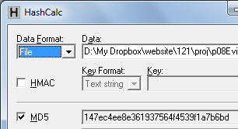
- On your desktop, right-click the p08Evidence.zip file and click "Extract All", Extract. A window opens containing a file named "Windows 2000 Professional-sparse.vmdk". Copy that file into the your 121-proj8 folder on the VMs drive. This is a virtual hard disk containing evidence.

Checking the Hash Value of the Evidence File
- Download and install Hashcalc from slavasoft.com/hashcalc
- Drag the proj8-evidence-v2.vmdk file and drop it on the HashCalc window. Verify that the MD5 hash value matches the image shown to the right on this page.

Creating a New VM (Virtual Machine)
- Double-click the VMware Workstation icon on the desktop. In the VMware Workstation window, from the menu bar, click View, Go to Home Tab.
- On the Home tab, click the "New Virtual Machine" icon.
- In the "Welcome to the New Virtual Machine Wizard" box, accept the default selection of "Typical (recommended)", and click Next.
- In the "Operating System Installation" box, click the "I will install the operating system later" button and click Next.
- In the "Select a Guest Operating System" box, click the "Linux" button, select a Version of "Ubuntu", and click Next. Note: This is important so VMware will use the right mouse driver, especially on netbooks and systems with USB mice.
- In the "Name the Virtual Machine box, accept the default name, but click the Browse button and navigate to the VMs drive, open your folder, and open the 121-proj8 folder. Click OK. . Click Next.
- In the "Specify Disk Capacity" box, accept the default size and click Next.
- In the "Ready to Create Virtual Machine" box, click Finish.

Connecting the Evidence Drive
- In VMware Workstation, on the left side, click "Edit virtual machine settings".
- In the "Virtual Machine Settings" box, click the Add… button.
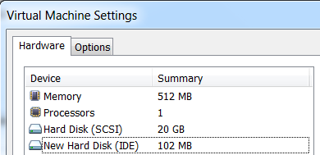
- In the "Hardware Type" box, click "Hard Disk". Click Next.
- In the "Select a Disk" box, click "Use an existing virtual disk". Click Next.
- In the "Select an Existing Disk" box, click the Browse… button. Navigate to your proj8-evidence-v2.vmdk file and double-click it. Click Finish.
- The "Virtual Machine Settings" box now shows a "New Hard Disk", as shown to the right on this page.

Booting from the BackTrack 4 ISO File in Forensics Mode
- In the "Virtual Machine Settings" box, in the left pane, click "CD/DVD". On the right side, click the "Use ISO image file" button. Click the Browse button, navigate to your bt4-final.iso file, and double-click it. Click OK.
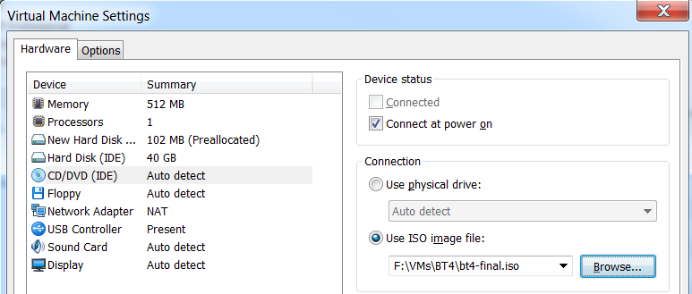

- In the "Virtual Machine Settings" box, in the left pane, click "Power on this virtual machine". If you see a message asking if you want to update the version of the hard disk, don't upgrade it.

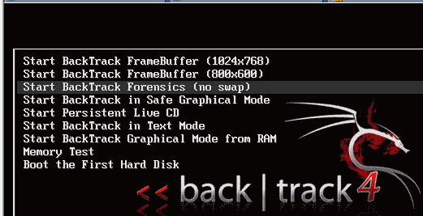
- BackTrack starts, as shown to the right on this page.
Note: if you see only a dark screen, click VM, Power Off, and then VM, Power, Power on to BIOS, and adjust the virtual BIOS to boot from CD-ROM.
- Click in the VM and use the down-arrow key to highlight "Start Backtrack Forensics (no swap)". Press the Enter key to boot BackTrack.
- When you see the root@bt:~# prompt, as shown below on this page, enter this command, followed by the Enter key:
startx
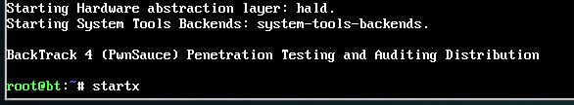

The BackTrack Desktop
- When BackTrack starts, you will see a decorative desktop, as shown below on this page.

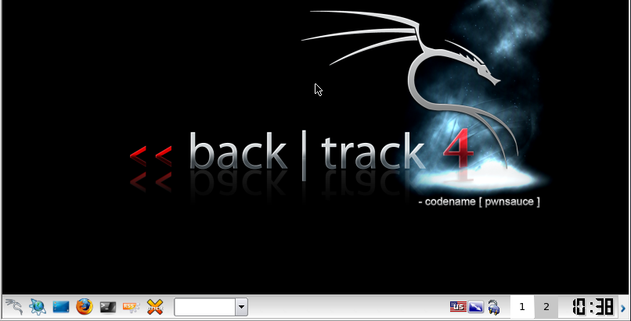
Start
Terminal

Identifying the Drives with GParted
- On the BackTrack desktop, click Start, System, "Partition Editor".
- GParted opens, as shown below on this page. On the upper right, click the little black down-arrow to show the attached drives. The evidence drive is /dev/hda and the empty hard drive available to perform collection is /dev/sda. The hda indicates that the evidence drive is an IDE drive. The other drive is SCSI.
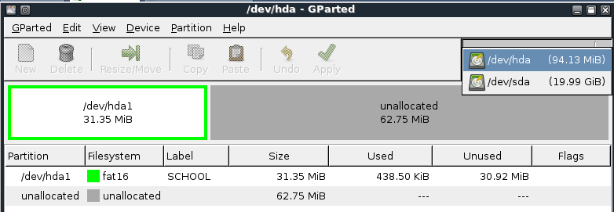

- Notice that the evidence drive is 94.13 MB in size, but it has a single partition only 31.35 MB in size, labeled "SCHOOL".

Formatting the Acquisition Drive
- We will use the empty 20 GB virtual hard disk to acquire an image of the evidence drive. It must be formatted first.
- In GParted, on the upper right, select /dev/sda.
- Click in the large gray unallocated area. Click the New button.
- A WARNING message appears, as shown below on this page. Make sure you are not erasing the wrong drive, and click the Create button.
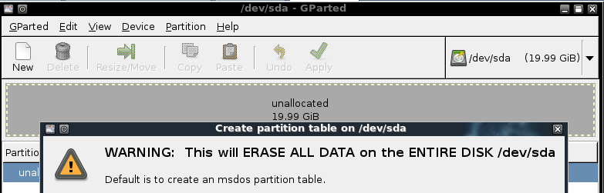

- Click in the large gray unallocated area again. Click the New button.
- A "Create new Partition" box appears, as shown below on this page. Make these selections:
  - New Size (MiB) 1000
  - Filesystem: fat32
  - Label: Images
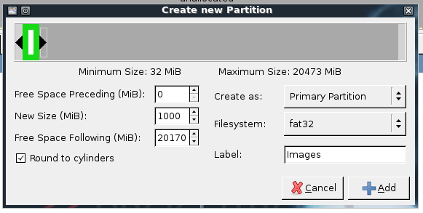

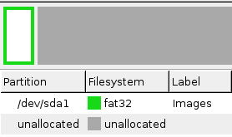
- Click the Add button.
- Click the Apply button. In the "Apply operations to hard disk" box, click Apply.
- In the "Applying pending operations " box, click Close.
- Notice that the name of the new partition is /dev/sda1, as shown to the right on this page.
- Close GParted.

Understanding the BackTrack Forensics Environment
- On the BackTrack desktop, click the Terminal icon.
- In the Terminal window, type this command, followed by the Enter key:
df
- This lists all connected filesystems, as shown below on this page. Notice that the hard drive partitions are not mounted yet. BackTrack 4 doesn't mount drives automatically, because you need to stay in control--that's good for forensic work.
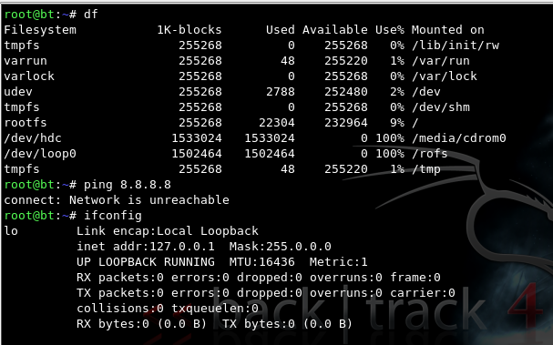

- In the Terminal window, type this command, followed by the Enter key:
ifconfig
- Notice that no network adapters are enabled--only the lo loopback adapter. This is also good--your forensic workstation should not be connected to any network, to eliminate the chance of contamination or infection by malware. Once again. BackTrack is designed so you can be sure exactly what your computer is doing, not to make it convenient for normal computing.
Note: if you want to network with BackTrack, you need to start networking with the /etc/init.d/networking start command and get an IP address with the dhclient command. But don't connect to any network now.

Mounting the Images Partition
- In the Terminal window, type this command, followed by the Enter key:
mkdir /media/sda1
This creates a directory to mount the Images partition in.
- In the Terminal window, type this command, followed by the Enter key:
mount /dev/sda1 /media/sda1
This mounts the partition so you can read and write to it..
- In the Terminal window, type this command, followed by the Enter key:
cd /media/sda1
This changes the working directory to the Images partition.
- In the Terminal window, type this command, followed by the Enter key:
echo "test" > foo
This creates a little file on the partition to test your ability to write to it.
- In the Terminal window, type this command, followed by the Enter key:
ls -l
Note that this command is LS -L using all lowercase letters. Don't use the numeral 1 or it won't work.
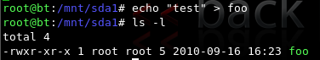
- The directory shows the foo file. Your Images partition is ready to be used.

Acquiring an Image of the Whole Evidence Disk with dd
- In the Terminal window, type this command, followed by the Enter key:
dd if=/dev/hda of=proj8-dd
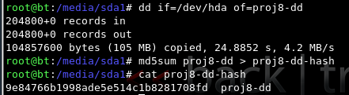
- The process should only take a minute or less, and when it completes, it reports how many bytes were processed, as shown to the right on this page.

Calculating the MD5 Hash
- In the Terminal window, type this command, followed by the Enter key:
md5sum proj8-dd > proj8-dd-hash
- In the Terminal window, type this command, followed by the Enter key:
cat proj8-dd-hash
- Your hash value should match the image shown above on this page.

Comparing the Hash to the Hashcalc Value
- This hash doesn't match the MD5 hash you calculated previously from the VMware hard disk file. That's OK, because the VMware hard disk format is not a simple dd of a hard drive. It adds headers, rollback data, and such, as explained at link Ch 4i on my Web page (http://www.vmware.com/app/vmdk/?src=vmdk).

Acquiring an Image of One Partition with dd
- We could also capture only the partition from the drive, which might contain all the data we are interested in, or perhaps all the data we are authorized to collect. In the Terminal window, type these commands:
dd if=/dev/hda1 of=proj8-1-dd
md5sum proj8-1-dd > proj8-1-dd-hash
cat proj8-1-dd-hash
- Your hash value should match the image shown below on this page.
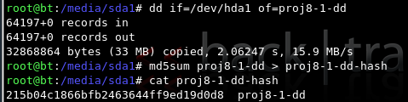

Acquiring an Image of the Whole Evidence Disk with dcfldd
- dcfldd is an enhanced version of dd developed by the U.S. Department of Defense Computer Forensics Lab. It's included in BackTrack 4.
- In the Terminal window, type this command, followed by the Enter key:
dcfldd if=/dev/hda of=proj8-dcfldd hashlog=proj8-dcfldd-hash
- Notice that this is nicer--it has a count of blocks written to reassure you that it hasn't crashed.
- In the Terminal window, type this command, followed by the Enter key:
ls -l
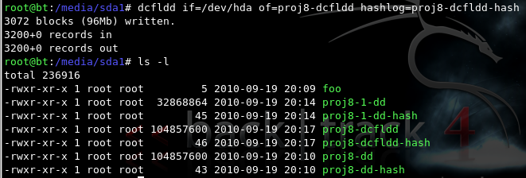
- The directory shows the two acquisition files proj8-dd and proj8-dd-dcfldd. They are the same size. In fact, they are identical, which we will verify next.

Viewing the MD5 Hash Calculated by dcfldd
- In the Terminal window, type this command, followed by the Enter key:
cat proj8-dcfldd-hash
- This hash value exactly matches the one you calculated by using md5sum on the dd image earlier, as shown below on this page.

Using dcfldd to Verify the Image
- In the Terminal window, type this command, followed by the Enter key:
dcfldd if=/dev/hda vf=proj8-dd
The vf value points to an image which is compared to the if file. The result is "Total: Match".

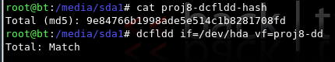
Saving a Screen Image
- Make sure your screen shows the "Total" Match" message, as shown above on this page.
- Press Ctrl+Alt to release the mouse from the Virtual Machine.
- Press the PrintScrn key in the upper-right portion of the keyboard.
- On the host machine, launch Paint and paste in the image. Save the image with the filename Your Name Proj 8. Select a Save as type of JPEG.

Testing the Effects of an Error
- What would happen if you made a mistake in a command, and wrote to the evidence drive?
- In the Terminal window, type this command, followed by the Enter key:
echo "test" > /dev/hda
- Did that corrupt the evidence? To see, run the verify command again:
dcfldd if=/dev/sdb vf=proj8-dd
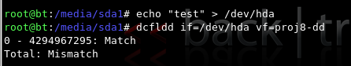
- As you see, the file no longer matches the drive. The evidence has been altered! So, although this technique works, it is not as good as using a hardware write-blocker at all.

Power Off the Virtual Machine
- From the VMware Workstation menu bar, click VM, Power, "Power Off". In the "VMware Workstation" box, click "Power Off".
  - Note: if you want to restart this virtual machine later, you will need to adjust the BIOS to boot from the CD-ROM first, because you have written data to the virtual hard disk drive and it will attempt to boot from that.

Checking the Hash Value of the Evidence File
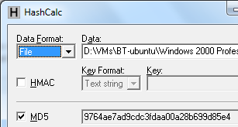
- Start Hashcalc.
- Click Start, Computer. Navigate to the VMs drive, open your folder, and open the 121-proj8 folder. Drag the proj8-flat file and drop it on the HashCalc window.
- Compare the hash to the hash value you found at the start of this project. As you can see, the MD5 value has changed--we really altered the evidence. So BackTrack has serious problems as an evidence collection tool.

Turning in your Project
- Email the JPEG image to me as an email attachment. Send it to: cnit.121@gmail.com with a subject line of Proj 8 From Your Name, replacing Your Name with your own first and last name. Send a Cc to yourself.
Last Modified: 9-19-10

