What You Need for This Project
- VMware Workstation
- The BackTrack 5 R1 ISO file BT5R1-GNOME-32.iso (Backtrack 4 works too)
- The instructions below assume you are using a host of Windows 7 as set up in the S214 lab.

Gathering the Files You Need
- The BT5R1-GNOME-32.iso file is on the DVDs handed out in class. If you are working in S214, please put a copy on the VMs drive in the Install folder and use that copy of the file.
  - If you have broadband, you can download it at home from www.backtrack-linux.org/downloads
- Click Start, Computer. Open the VMs drive. Open the folder with your name on it. Make a subfolder named 121-proj8.
- In Firefox, go to samsclass.info, click on "CNIT 121", and scroll down to the "Project 8" instructions, as shown below on this page. Click the "Proj 8 Evidence File" link and save the p08Evidence.zip file on your desktop.

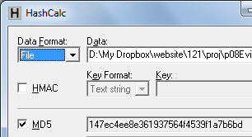
- On your desktop, right-click the p08Evidence.zip file and click "Extract All", Extract. A window opens containing a file named "Windows 2000 Professional-sparse.vmdk". Copy that file into the your 121-proj8 folder on the VMs drive. This is a virtual hard disk containing evidence.

Checking the Hash Value of the Evidence File
- Download and install Hashcalc from slavasoft.com/hashcalc
- Drag the Windows 2000 Professional-sparse.vmdk file and drop it on the HashCalc window. Verify that the MD5 hash value matches the image shown to the right on this page. If you are using Mac OS X, use the command-line utility md5.

Creating a New VM (Virtual Machine)
- Double-click the VMware Workstation icon on the desktop. In the VMware Workstation window, from the menu bar, click View, Go to Home Tab.
- On the Home tab, click the "New Virtual Machine" icon.
- In the "Welcome to the New Virtual Machine Wizard" box, accept the default selection of "Typical (recommended)", and click Next.
- In the "Operating System Installation" box, click the "I will install the operating system later" button and click Next.
- In the "Select a Guest Operating System" box, click the "Linux" button, select a Version of "Ubuntu", and click Next. Note: This is important so VMware will use the right mouse driver, especially on netbooks and systems with USB mice.
- In the "Name the Virtual Machine box, accept the default name, but click the Browse button and navigate to the VMs drive, open your folder, and open the 121-proj8 folder. Click OK. . Click Next.
- In the "Specify Disk Capacity" box, accept the default size and click Next.
- In the "Ready to Create Virtual Machine" box, click Finish.

Connecting the Evidence Drive
- In VMware Workstation, on the left side, click "Edit virtual machine settings".
- In the "Virtual Machine Settings" box, click the Add… button.
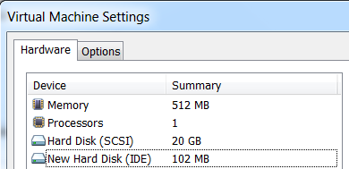
- In the "Hardware Type" box, click "Hard Disk". Click Next.
- In the "Select a Disk" box, click "Use an existing virtual disk". Click Next.
- In the "Select an Existing Disk" box, click the Browse… button. Navigate to your Windows 2000 Professional-sparse..vmdk file and double-click it. Click Finish.
- The "Virtual Machine Settings" box now shows a "New Hard Disk", as shown to the right on this page.

Booting from the BackTrack ISO File in Forensics Mode
- In the "Virtual Machine Settings" box, in the left pane, click "CD/DVD". On the right side, click the "Use ISO image file" button. Click the Browse button, navigate to your BT5R1-GNOME-32.iso file, and double-click it. Click OK. The image below shows the screen, but it references the older bt4-final.iso instead.
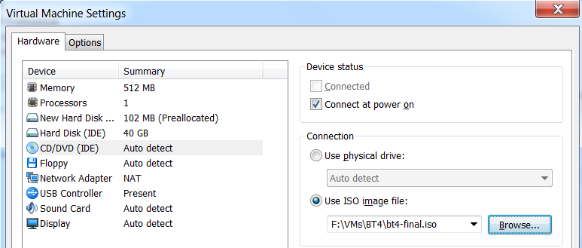

- In the "Virtual Machine Settings" box, in the left pane, click "Power on this virtual machine". If you see a message asking if you want to update the version of the hard disk, don't upgrade it.

- A prompt says boot:. Press Enter.
- BackTrack starts, as shown to the right on this page.
Note: if you see only a dark screen, click VM, Power Off, and then VM, Power, Power on to BIOS, and adjust the virtual BIOS to boot from CD-ROM.
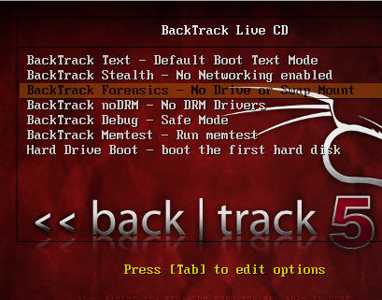
- Click in the VM and use the down-arrow key to highlight the third item "Backtrack Forensics" as shnown below on this page. Press the Enter key to boot BackTrack.

- When you see the root@bt5-forensics:~# prompt, as shown below on this page, enter this command, followed by the Enter key:
startx

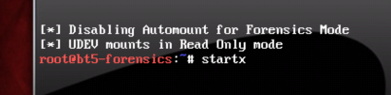

The BackTrack Desktop
- When BackTrack starts, you will see a decorative desktop, as shown below on this page. Click the Terminal button to open a Terminal window.
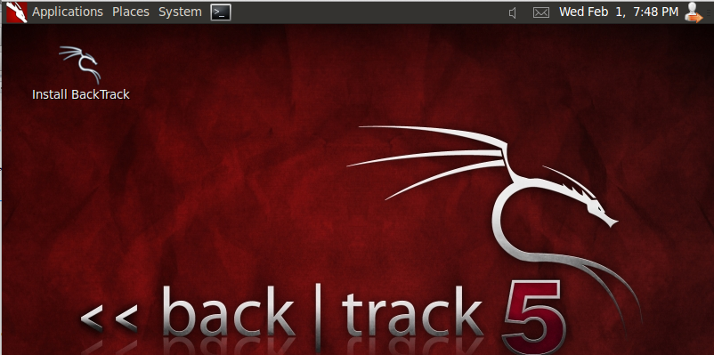

Terminal

Disabling Networking
- A fundamental rule of forensics is WORK IN ISOLATION--in other words, don't connect to the Internet while imaging drives. To disable networking, In the Terminal window, type this command, followed by the Enter key:
/etc/init.d/networking stop

Identifying the Drives with parted
- In the Terminal window, enter these commands, pressing the Enter key after each one:
parted
print devices

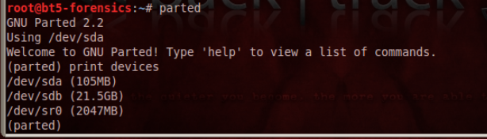

Evidence drive: ___________

Empty drive: ___________
- This lists the attached devices, as shown above on this page. Find the evidence drive--it is 105 MB in size. When I did it, the evidence drive was /dev/sda. The 21.5 GB empty hard drive available to perform collection was /dev/sdb. Fill in the correct names of your devices in the table to the right on this page.

Formatting the Empty Drive
- We will use the empty drive to acquire an image of the evidence drive. It must be formatted first.
- In the Terminal window, at the (parted) prompt, enter these commands, pressing the Enter key after each one. In the first command, make sure you are selecting the empty drive, not the evidence drive!
select /dev/sdb
mklabel msdos
mkpart primary fat32 0.0 500.0

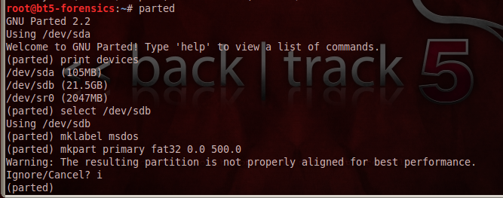

- A message appears: " The resulting partition is not properly aligned for best performance". Type i and press Enter, to ignore this warning.

- In the Terminal window, at the (parted) prompt, enter this command, and then press Enter:
print all
- A list of partitions appears, as shown below on this page. You should have a 32..9 MB partition on the evidence drive (/dev/sda when I did it), and a 500 MB partition on the empty drive (/dev/sdb when I did it):

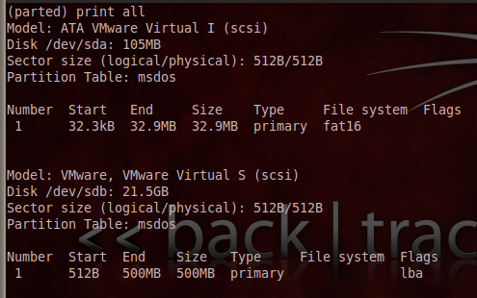

- In the Terminal window, at the (parted) prompt, enter this command, and then press Enter:
quit
- This closes parted and returns you to the normal Linux bash prompt.

Testing the Working Partition
- In the Terminal window, type this command, followed by the Enter key (if your empty drive was not sdb, you will need to adjust this command to point to the correct directory):
cd /media/sdb1
This changes the working directory to the working partition. on the empty drive, where we will create a drive image.
- In the Terminal window, type this command, followed by the Enter key:
echo "test" > foo
This creates a little file on the partition to test your ability to write to it.

- In the Terminal window, type this command, followed by the Enter key:
ls -l
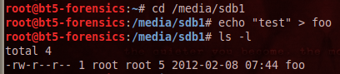
Note that this command is LS -L using all lowercase letters. Don't use the numeral 1 or it won't work.
- The directory shows the foo file, as shown to the right on this page. Your Images partition is ready to be used.

Acquiring an Image of the Whole Evidence Disk with dd
- In the Terminal window, type this command, followed by the Enter key. (If your evidence drive is not /dev/sda, adjust the command accordingly):
dd if=/dev/sda of=proj8-dd
- The process should only take a minute or less, and when it completes, it reports how many bytes were processed, as shown to the right on this page.

Calculating the MD5 Hash
- In the Terminal window, type this command, followed by the Enter key:
md5sum proj8-dd > proj8-dd-hash
- In the Terminal window, type this command, followed by the Enter key:
cat proj8-dd-hash
- Your hash value should match the image shown below on this page.
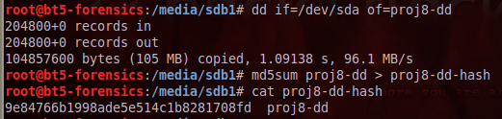

Comparing the Hash to the Hashcalc Value
- This hash doesn't match the MD5 hash you calculated previously from the VMware hard disk file. That's OK, because the VMware hard disk format is not a simple dd of a hard drive. It adds headers, rollback data, and such, as explained at link Ch 4i on my Web page (http://www.vmware.com/app/vmdk/?src=vmdk).

Acquiring an Image of One Partition with dd
- We could also capture only the partition from the drive, which might contain all the data we are interested in, or perhaps all the data we are authorized to collect. In the Terminal window, type these commands:
dd if=/dev/sda1 of=proj8-1-dd
md5sum proj8-1-dd > proj8-1-dd-hash
cat proj8-1-dd-hash
- Your hash value should match the image shown below on this page. This hash does not match the previous one, because it's an image of only one partition, not the whole drive.

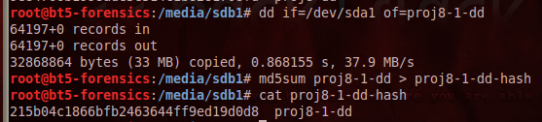

Acquiring an Image of the Whole Evidence Disk with dcfldd
- dcfldd is an enhanced version of dd developed by the U.S. Department of Defense Computer Forensics Lab. It's included in BackTrack 4.
- In the Terminal window, type this command, followed by the Enter key:
dcfldd if=/dev/sda of=proj8-dcfldd hashlog=proj8-dcfldd-hash
- Notice that this is nicer--it has a count of blocks written to reassure you that it hasn't crashed.
- In the Terminal window, type this command, followed by the Enter key:
ls -l
- The directory shows the two acquisition files proj8-dd and proj8-dd-dcfldd. They are the same size. In fact, they are identical, which we will verify next.

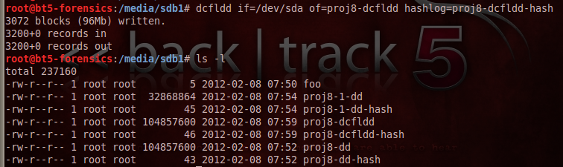

Viewing the MD5 Hash Calculated by dcfldd
- In the Terminal window, type this command, followed by the Enter key:
cat proj8-dcfldd-hash
- This hash value exactly matches the one you calculated by using md5sum on the dd image earlier, as shown below on this page.

Using dcfldd to Verify the Image
- In the Terminal window, type this command, followed by the Enter key:
dcfldd if=/dev/sda vf=proj8-dd
The vf value points to an image which is compared to the if file. The result is "Total: Match", as shown below on this page.
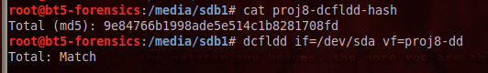

Saving a Screen Image
- Make sure your screen shows the "Total" Match" message, as shown above on this page.
- Press Ctrl+Alt to release the mouse from the Virtual Machine.
- Press the PrintScrn key in the upper-right portion of the keyboard.
- On the host machine, launch Paint and paste in the image. Save the image with the filename Your Name Proj 8. Select a Save as type of JPEG.

Testing the Effects of an Error
- What would happen if you made a mistake in a command, and wrote to the evidence drive?
- In the Terminal window, type this command, followed by the Enter key:
echo "test" > /dev/sda
- Did that corrupt the evidence? To see, run the verify command again:
dcfldd if=/dev/sda vf=proj8-dd
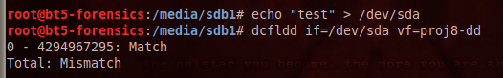
- As you see, the file no longer matches the drive. The evidence has been altered! So, although this technique works, it is not as good as using a hardware write-blocker at all.

Turning in your Project
- Email the JPEG image to me as an email attachment. Send it to: cnit.121@gmail.com with a subject line of Proj 8 From Your Name, replacing Your Name with your own first and last name. Send a Cc to yourself.
Last Modified: 2-8-12 2 pm

