What You Need for This Project
- VMware Workstation
- The instructions below assume you are using a host of Windows 7 as set up in the S214 lab.

Gathering the Files You Need
- Click Start, Computer. Open the VMs drive. Open the folder with your name on it. Make a subfolder named 121-proj9.
- If you still have the p08Evidence.zip file on your desktop, you can just unzip it to get a good evidence file. If not, you will need to re-download it because you damaged it in Project 8.

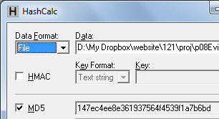
Checking the Hash Value of the Evidence File
- If necessary, download and install Hashcalc from slavasoft.com/hashcalc
- Drag the proj8-evidence.vmdk file and drop it on the HashCalc window. Verify that the MD5 hash value matches the image shown to the right on this page.
- When you are sure the evidence file is correct, drag it into your 121-proj9 folder on the VMs drive.

Choosing a VM
- You should have a Windows VM. It doesn't matter what version it is. It doesn't matter what software is installed.
- Double-click the VMware Workstation icon on the desktop. In the VMware Workstation window, from the menu bar, click View, Go to Home Tab. Open your existing Windows VM. Make sure it is powered off.

Connecting the Evidence Drive
- In VMware Workstation, on the left side, click "Edit virtual machine settings".
- In the "Virtual Machine Settings" box, click the Add… button.
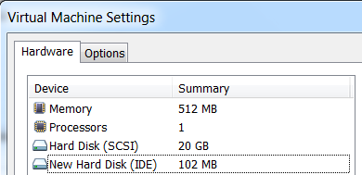
- In the "Hardware Type" box, click "Hard Disk". Click Next.
- In the "Select a Disk" box, click "Use an existing virtual disk". Click Next.
- In the "Select an Existing Disk" box, click the Browse… button. Navigate to your Windows 2000 Professional-sparse..vmdk file and double-click it. Click Finish.
- The "Virtual Machine Settings" box now shows a "New Hard Disk", as shown to the right on this page.

Starting your VM
- In the "Virtual Machine Settings" box, in the left pane, click "Power on this virtual machine".

Installing FTK Imager
- In the virtual machine, open Firefox and go to accessdata.com/support/adownloads
- Download the full version of FTK Imager, as shown below on this page.
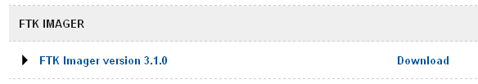
- Save the AccessData_FTK_Imager_3-1-0.exe file on your virtual machine's desktop. Install it in your VM with the default options.

Acquiring the Evidence with FTK Imager
- FTK Imager launches. In the "AccessData FTK Imager" window, click File, "Create Disk Image…"
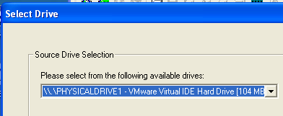
- In the "Select Source" box, accept the default selection of "Physical Drive" and click Next.
- In the "Select Drive" box, select the IDE hard drive with a size of 104 MB, as shown to the right on this page. Click Finish.
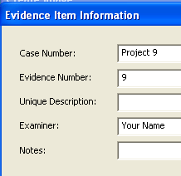
- In the "Create Image" box, click the Add… button.
- In the "Select Image Type" box, accept the default selection of "Raw (dd)". Click Next.
- In the "Evidence Item Information", fill in the blanks as shown to the right on this page. Click Next.
- In the "Select Image Destination" box, click the Browse button, click Desktop, and click OK.
- Enter an "Image Filename" of Proj9.dd and click Finish.
- In the "Create Image" box, click Start.

Evaluating the MD5 Hash
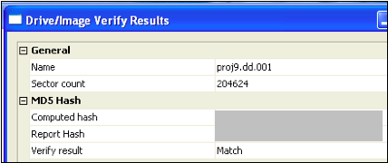
- When the process is done, you will see an MD5 Hash value, as shown below on this page. I grayed out my hash value, but yours should be visible.

Saving a Screen Image
- Make sure your screen shows the "MD5 Hash" value, as shown above on this page.
- Press Ctrl+Alt to release the mouse from the Virtual Machine.
- Press the PrintScrn key in the upper-right portion of the keyboard.
- On the host machine, launch Paint and paste in the image. Save the image with the filename Your Name Proj 9. Select a Save as type of JPEG.

Reflection
- Does this hash agree with the value you found using BackTrack Linux? Write a brief explanation of your results, and include it in the body of your email message. Be sure to answer these questions:
  - Is this a good image or not?
  - Should this procedure be modified? If so, what better procedure do you recommend?

Turning in your Project
- Email the JPEG image to me as an email attachment. Include your reflection in the body of your email! Send it to: cnit.121@gmail.com with a subject line of Proj 9 From Your Name, replacing Your Name with your own first and last name. Send a Cc to yourself.
Last Modified: 2-8-12

