What You Need for This Project
- Any 32-bit Windows computer you can install software on. You cannot use a 64-bit system.
- You do not need to use VMware for this project, but you can use the Windows XP virtual machine you used in the previous project if you want to.
- The instructions below assume you are using Windows 7 as set up in the S214 lab.

Gathering the Files You Need
- Click Start, Computer. Open the VMs drive. Open the folder with your name on it. Make a subfolder named 121-proj10.
- If you still have the p08Evidence.zip file on your desktop, you can just unzip it to get a good evidence file. If not, you will need to re-download it because you damaged it in Projects 8 and 9.

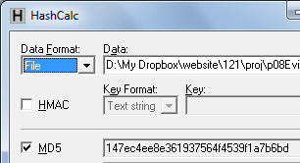
Checking the Hash Value of the Evidence File
- If necessary, download and install Hashcalc from slavasoft.com/hashcalc
- Drag the proj8-evidence.vmdk file and drop it on the HashCalc window. Verify that the MD5 hash value matches the image shown to the right on this page.
- When you are sure the evidence file is correct, drag it into your 121-proj10 folder on the VMs drive.

Downloading VDK
- VDK is a driver that can mount a partition from a virtual drive into Windows, with a software write-blocker. It will serve here as a free alternative to a hardware write-blocker.
- In Firefox, go to samsclass.info and click the CNIT 121 link. Scroll down and find Project 10, as shown below on this page.

- Right-click the vdk32-050406.zip link and save the file on the VMs drive, in your proj10 folder.
- Right-click the vdk32-050406.zip file and click "Extract All…", Extract.

Installing VDK
- Click Start, Computer. Find your VMs drive, and note its drive letter, which will be something like D:
- Click Start. In the search box, type CMD and then press Shift+Ctrl+Enter. In the "User Account Control" box, click Yes.
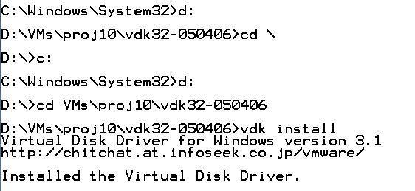
- In the Administrator Command Prompt window, type the drive letter of your VMs drive followed by a colon, such as D: and then press Enter.
- In the Administrator Command Prompt window, use the CD command to move to your proj10 folder , and into the vdk32-050406 subdirectory. The commands I used are shown to the right on this page.
- Once you are in the vdk32-050406 folder, type this command, followed by the Enter key:
vdk install
- Type this command, followed by the Enter key, as shown below on this page:
vdk open * "..\Windows 2000 Professional-sparse.vmdk" /WB /L:S
Type this command all on one line--let it break where it wants to. This mounts the evidence partition with write-blocking. Three error messages appear; answer I to each one to ignore them, as shown below on this page.
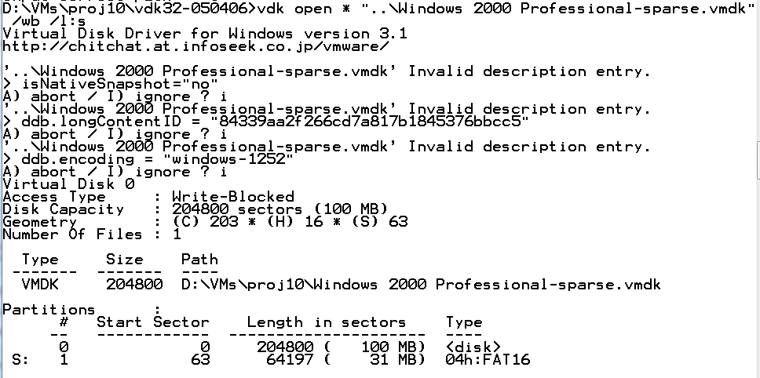

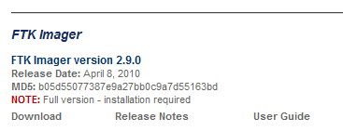
Installing FTK Imager
- In the host machine, open Firefox and go to accessdata.com/downloads
- Download the full version of FTK Imager, as shown to the right on this page.
- Install it with the default options.

Acquiring the Evidence with FTK Imager
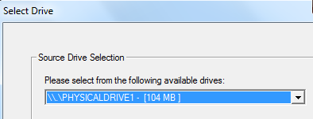
- FTK Imager launches. In the "AccessData FTK Imager" window, click File, "Create Disk Image…"
- In the "Select Source" box, accept the default selection of "Physical Drive" and click Next.
- In the "Select Drive" box, select the hard drive with a size of 104 MB, as shown to the right on this page. Click Finish.
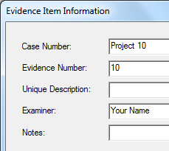
- In the "Create Image" box, click the Add… button.
- In the "Select Image Type" box, accept the default selection of "Raw (dd)". Click Next.
- In the "Evidence Item Information", fill in the blanks as shown to the right on this page. Click Next.
- In the "Select Image Destination" box, click the Browse button, click Desktop, and click OK.
- Enter an "Image Filename" of Proj10.dd and click Finish.
- In the "Create Image" box, click Start.

Evaluating the MD5 Hash
- When the process is done, you will see an MD5 Hash value, as shown below on this page. It should match the value in the figure exactly.
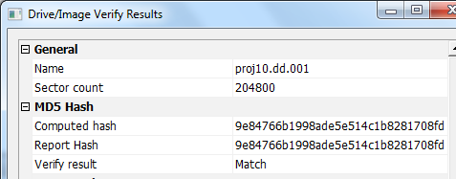

Saving a Screen Image
- Make sure your screen shows the "MD5 Hash" value shown above on this page.
- Press Ctrl+Alt to release the mouse from the Virtual Machine.
- Press the PrintScrn key in the upper-right portion of the keyboard.
- On the host machine, launch Paint and paste in the image. Save the image with the filename Your Name Proj 10. Select a Save as type of JPEG.

Acquiring the Evidence with FTK Imager in E01 Format
- In the "Drive Image Verify Results" box, click Close.
- In the "Creating Image" box, click Close.
- In the "AccessData FTK Imager" window, click File, "Create Disk Image…"
- In the "Select Source" box, accept the default selection of "Physical Drive" and click Next.
- In the "Select Drive" box, select the hard drive with a size of 104 MB, as shown to the right on this page. Click Finish.
- In the "Create Image" box, click the Add… button.
- In the "Select Image Type" box, select E01. Click Next.

- In the "Evidence Item Information", fill in the blanks as shown to the right on this page. Click Next.
- In the "Select Image Destination" box, click the Browse button, click Desktop, and click OK.
- Enter an "Image Filename" of Proj10-E and click Finish.
- In the "Create Image" box, click Start.
- A "Drive Image Verify Hash" box pops up. The hash should be the same as the one you got from the dd image.

Comparing File Sizes
- On your desktop, right-click the Proj10.dd.001 file and click Properties. Note the File Size--it is approximately 100 MB.
- On your desktop, right-click the Proj10-E.E01 file and click Properties. Note the File Size--it is approximately 578 KB--much smaller than the other file.

Reflection
- Does this hash agree with the value you found using BackTrack Linux? Write a brief explanation of your results, and include it in the body of your email message. Be sure to answer these questions:
  - How can the Proj10-E.E01 and Proj10.dd.001 files have the same MD5 hash and still be of different sizes?
  - Are these image files as good as the ones you made with Linux?
  - Should this procedure be modified? If so, what better procedure do you recommend?

Turning in your Project
- Email the JPEG image to me as an email attachment. Include your reflection in the body of your email! Send it to: cnit.121@gmail.com with a subject line of Proj 10 From Your Name, replacing Your Name with your own first and last name. Send a Cc to yourself.
Last Modified: 2-8-12

