What You Need for This Project
- VMware Workstation
- The Raptor 2 ISO file (fd-raptor20100814.iso, 697 MB)
- The instructions below assume you are using a host of Windows 7 as set up in the S214 lab.

Gathering the Files You Need
- The fd-raptor20100814.iso file is on the DVDs handed out in class.
  - If you have broadband, you can download it at home from raptorforensics.com (You will have to give them your name, email, and phone #.)
- Click Start, Computer. Open the VMs drive. Open the folder with your name on it. Make a subfolder named 121-proj11.
- In Firefox, go to samsclass.info, click on "CNIT 121", and scroll down to the "Project 8" instructions, as shown below on this page. Click the "Proj 8 Evidence File (4 MB)" link and save the p08Evidence.zip file on your desktop.

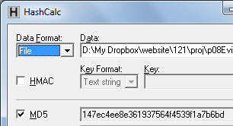
- On your desktop, right-click the p08Evidence.zip file and click "Extract All", Extract. A window opens containing a file named "Windows 2000 Professional-sparse.vmdk". Copy that file into the your 121-proj8 folder on the VMs drive. This is a virtual hard disk containing evidence.

Checking the Hash Value of the Evidence File
- Download and install Hashcalc from slavasoft.com/hashcalc
- Drag the proj8-evidence-v2.vmdk file and drop it on the HashCalc window. Verify that the MD5 hash value matches the image shown to the right on this page.

Creating a New VM (Virtual Machine)
- Double-click the VMware Workstation icon on the desktop. In the VMware Workstation window, from the menu bar, click View, Go to Home Tab.
- On the Home tab, click the "New Virtual Machine" icon.
- In the "Welcome to the New Virtual Machine Wizard" box, accept the default selection of "Typical (recommended)", and click Next.
- In the "Operating System Installation" box, click the "I will install the operating system later" button and click Next.
- In the "Select a Guest Operating System" box, click the "Linux" button, select a Version of "Ubuntu", and click Next. Note: This is important so VMware will use the right mouse driver, especially on netbooks and systems with USB mice.
- In the "Name the Virtual Machine" box, accept the default name, but click the Browse button and navigate to the VMs drive, open your folder, and open the 121-proj11 folder. Click OK. . Click Next.
- In the "Specify Disk Capacity" box, accept the default size and click Next.
- In the "Ready to Create Virtual Machine" box, click Finish.

Connecting the Evidence Drive
- In VMware Workstation, on the left side, click "Edit virtual machine settings".
- In the "Virtual Machine Settings" box, click the Add… button.
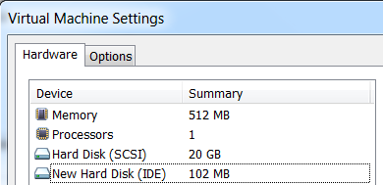
- In the "Hardware Type" box, click "Hard Disk". Click Next.
- In the "Select a Disk" box, click "Use an existing virtual disk". Click Next.
- In the "Select an Existing Disk" box, click the Browse… button. Navigate to your proj8-evidence-v2.vmdk file and double-click it. Click Finish.
- The "Virtual Machine Settings" box now shows a "New Hard Disk", as shown to the right on this page. If you see a message asking if you want to update the version of the hard disk, don't upgrade it.

Booting from the Raptor 2 ISO File
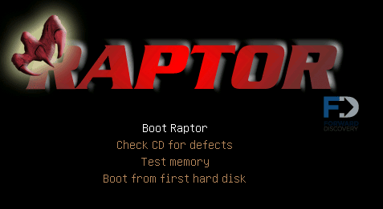
- In the "Virtual Machine Settings" box, in the left pane, click "CD/DVD". On the right side, click the "Use ISO image file" button. Click the Browse button, navigate to your fd-raptor20100814.iso file, and double-click it. Click OK.
- In the "Virtual Machine Settings" box, in the left pane, click "Power on this virtual machine".
- A RAPTOR splash screen appears, as shown to the right on this page, and immediately is covered by a list of languages. Click in the virtual machine and press the Enter key to choose English. Press the Enter key again to choose "Boot Raptor".
- A "Forward Discovery Raptor" screen appears, with a statement about redistribution. Click OK.

Launching the Toolbox
- When the desktop appears, double-click "Raptor Toolbox".

Formatting the Target Drive
- In the "Forward Discovery Raptor Toolbox" window, click the Format tab.
- Click the double-arrow to the right of the word <Select>. A list of available drives and volumes appears, as shown below on this page. Choose the "Physical device VMware Virtual S 21 GB (/dev/sdb)" item.
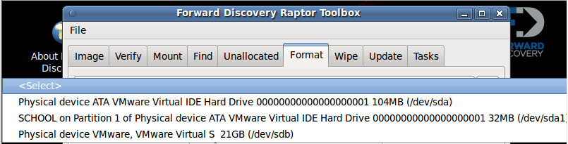

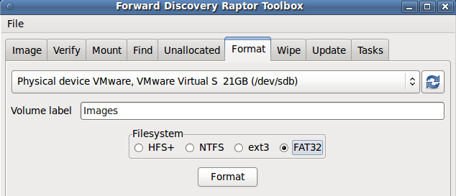
- Label the volume Images and select a Filesystem of FAT32, as shown to the right on this page. Click the Format button.

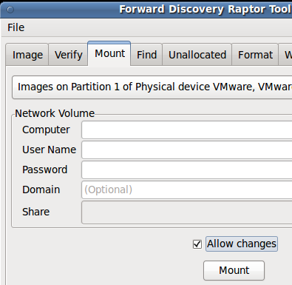

Mounting the Target Drive
- In the "Forward Discovery Raptor Toolbox" window, click the Mount tab.
- Click <Select>. Choose "Images on Partition 1 of Physical device VMware Virtual S 21 GB (/dev/sdb)".
- Ignore the "Network Volume" section in the middle of this window.
- Check the "Allow changes" box.
- Click the Mount button. A File Browser window opens, showing the newly mounted drive. Minimize that window.

Imaging the Evidence Drive
- In the "Forward Discovery Raptor Toolbox" window, click the Image tab.
- In the top field, select " Physical device ATA VMware Virtual IDE Hard Drive 00000000001 104M", as shown below on this page.
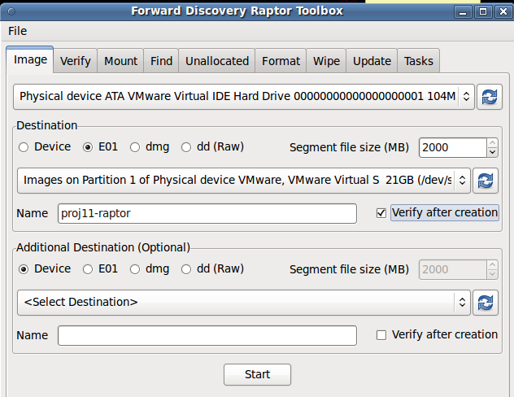
- In the Destination section, choose E01 format, a Destination of "Images on Partition 1 of Physical Device VMware, Vmware Virtual S 21 GB", and a Name of proj11-raptor, as shown to the right on this page. Check the "Verify after creation" box.
- Click the Start button.

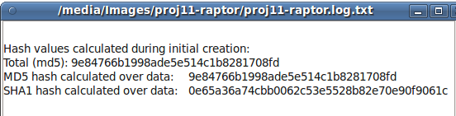
Saving a Screen Image
- Scroll down in the log so you can see the MD5 hash value. It should match the value shown to the right on this page.
- Press Ctrl+Alt to release the mouse from the Virtual Machine.
- Press the PrintScrn key in the upper-right portion of the keyboard.
- On the host machine, launch Paint and paste in the image. Save the image with the filename Your Name Proj 11. Select a Save as type of JPEG.

Turning in your Project
- Email the JPEG image to me as an email attachment. Send it to: cnit.121@gmail.com with a subject line of Proj 11 From Your Name, replacing Your Name with your own first and last name. Send a Cc to yourself.
Last Modified: 2-8-12

