What You Need for This Project
- A virtual machine (VM) with FTK installed on it.
- The InChap05.001 file from the CD in your textbook. It is 123 MB in size. To extract it, copy the InChap05.exe file to your desktop and run it to extract the InChap05.001 file.
- The instructions below assume you are using a host of Windows 7, VMware Workstation, and a guest of Windows XP, as set up in the S214 lab.

Copying the Evidence File to Your VM (Virtual Machine)
- Start your VM. Drag the InChap05.001 file to the VM's desktop.

Starting FTK in your VM
- Double-click the "FTK Forensic Toolkit" icon on your desktop. (
- When you get an Error box saying "No security device was found…", click No.
- When you get an Error box saying "The KFF Hash library file was not found…", click OK.
- When a box pops up explaining the limitations of the demonstration version, click OK.

Starting a New Case
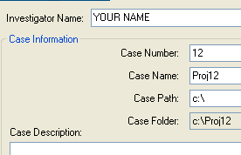
- In the "AccessData FTK Startup" box, select "Start a new case" and click OK.
- In the screen titled "Wizard for Creating a New Case", fill in the fields as shown to the right on this page. Click Next.
- In the screen titled "Forensic Examiner Information", leave the fields blank and click Next.
- In the screen titled "Case Log Options", accept the default selections, which will log everything. Click Next.
- In the screen titled "Processes to Perform", deselect "KFF Lookup" and "Decrypt EFS Files". Click Next.
- In the screen titled "Refine Case-Default", accept the default of "Include All Items". Click Next.
- In the screen titled "Refine Index - Default", click Next.

Adding Evidence
- In the "Add Evidence" box, click the "Add Evidence…". button.
- In the "Add Evidence to Case" box, select "Acquired Image of Drive", and click Continue.
- In the "Browse for Folder" box, navigate to your Desktop and double-click the InChap05.001 file.
- In the "Evidence Information" box, select a "Local Evidence Time Zone" of "Pacific Time with Faylight Savings Time (US - Los Angeles)" and click OK.
- In the "Add Evidence" box, click Next.
- In the "New Case Setup is Now Complete" box, click Finish.
- A "Processing Files…" box appears. Wait till the processing proceeds.
- Click the Explore tab. Check the "List all Descendants" box.. You should see a long list of files, with "143 Listed" in the Status Bar, as shown below on this page.
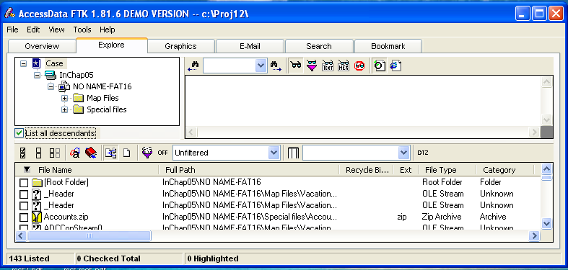

Case Background
- As detailed in your textbook, this evidence is from a USB drive left behind by two missing employees at a bicycle company. They are suspected to be running a side business from work, and left behind a travel brochure for European tours. Their names are Chris Murphy and Nau Tjeriko.

Search Procedure 1: File-by-file
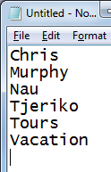
- In the lower pane of FTK, click the first item. Look in the upper-right pane to see what's in the file. Press the down-arrow key on the keyboard to move to the next file. The first 20 files contain very little useful information--as you can see, this is not an efficient way to find relevant evidence.

Search Procedure 2: Keyword Search
- A much better procedure is to use keyword search. FTK is designed to work this way--it makes an index of all the words in the evidence file.
- Open Notepad and type in the keywords shown to the right on this page. Save this file on your desktop as keywords.txt. These words are chosen from the background of the case.
- In FTK, click the Search tab.
- Click the Import button.
- In the "Import Search Terms" box, mavigate to your desktop and double-click the keywords.txt file.
- A "Import Search Terms" box pops up, saying 'Do you wish to show items that have 0 hits?". Click No.

.Results of the Search
- Three of the keywords were found, as shown in the top pane of FTK.
- In the "Cumulative Operator" line, click the OR button.
- In the "Cumulative Operator" line, click the "View Cumulative Results" button.
- In the "Filter Search Hits" box, accept the default selection of "All files" and click the OK button.
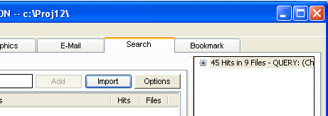
- The upper right pane should now show "45 Hits in 9 Files", as shown to the right on this page.

Saving a Screen Image
- Make sure your screen shows "45 Hits in 9 Files".
- Click the taskbar at the bottom of your host Windows 7 desktop, to make the host machine active. Press the PrintScrn key in the upper-right portion of the keyboard.
- On the host machine, launch Paint and paste in the image. Save the image with the filename Your Name Proj 12a. Select a Save as type of JPEG.

Examining the Hits
- Click the first item in the upper-right pane. This is a container, labeled "45 Hits in 9 Files". Expand it by pressing the right-arrow key on the keyboard. Then press the down-arrow to go to the next item, labeled "[6 Hits -- Untitled0]". This item is also a container, so press the right-arrow and down-arrow keys.
- Your screen should now look like the image shown below on this page.
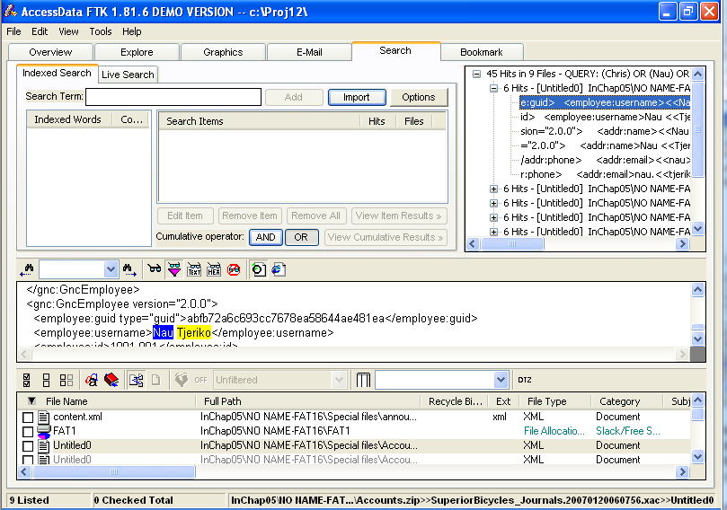

A

B

C

- Use this process to search through all the hits.
  - Highlight a hit in the upper-right "Hits pane", labeled A in the image above.
  - Read the text near the highlighted search word in the next-to-bottom pane, labeled B in the image above.
  - If the text looks important, check the box on the highlighted line in the lower pane, labeled C in the image above.
- You should find at least one file with obvious incriminating evidence, and have at least one file checked in the bottom pane.

Saving a Screen Image
- Make sure your screen shows the obvious incriminating evidence you found.
- Click the taskbar at the bottom of your host Windows 7 desktop, to make the host machine active. Press the PrintScrn key in the upper-right portion of the keyboard.
- On the host machine, launch Paint and paste in the image. Save the image with the filename Your Name Proj 12b. Select a Save as type of JPEG.

Turning in your Project
- Email the JPEG image to me as an email attachment. Send it to: cnit.121@gmail.com with a subject line of Proj 12 From Your Name, replacing Your Name with your own first and last name. Send a Cc to yourself.
Last Modified: 9-27-10

