What You Need for This Project
- A Linux machine. In the instructions, I will use a virtual machine and BackTrack 4
- The CD that came with your textbook. The file you need is in the Chap08 folder, named GCFI-LX.xxx.exe. To extract the contents, copy the GCFI-LX.xxx.exe file to your desktop and run it. That will extract five files, named GCFI-LX.001, GCFI-LX.002, GCFI-LX.003, GCFI-LX.004, and GCFI-LX.005.
- The instructions below assume you are using a host of Windows 7, VMware Workstation, and BackTrack 4, as set up in the S214 lab.

Sharing a Folder with your VM (Virtual Machine)
- Create a folder on the C: drive named C:\Share. Move the five files named GCFI-LX.001, GCFI-LX.002, GCFI-LX.003, GCFI-LX.004, and GCFI-LX.005 to C:\Share.
- Start VMware Workstation. On the Home tab, click "Open Existing VM or Team", Navigate to the VM you prepared earlier for project 8 and open it, but don't start it yet.
- In the VMware Workstation window, in the left pane, click "Edit virtual machine settings".
- In the "Virtual Machine Settings" box, click the Options tab.
- Click "Shared Folders". On the right side, click "Always enabled". At the lower right, click the Add… button.
- In the "Welcome to the Add Shared Folder Wizard" box, click Next.
- In the "Name the Shared Folder" box, enter a "Host path" of C:\Share and click Next.
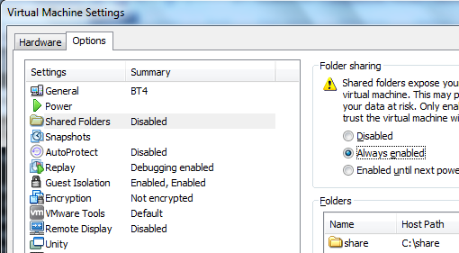
- In the "Specify Shared Folder Attributes" box, click Finish.
- The shared folder should now appear in the lower right portion of the "Virtual Machine Settings" box, as shown to the right on this page. Click OK.

Installing BackTrack 4 in a VM (Virtual Machine)
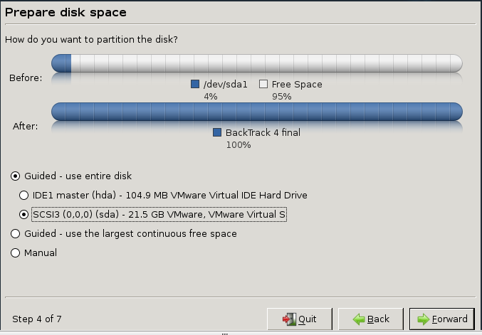
- Boot the VM from the BackTrack 4 ISO image.
- On the VM's desktop, click the install.sh icon.
- In the "Where are you?" screen, select "Los Angeles" and click Forward.
- In the "Keyboard layout" screen, click Forward .
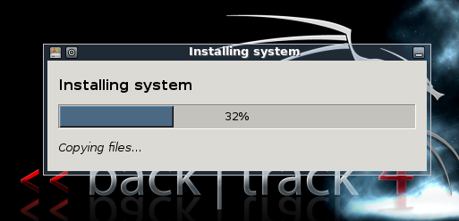
- In the "Prepare disk space" screen, select your empty VMware hard disk and click Forward, as shown to the right on this page
- In the "Ready to install" screen, click Install.
- Now wait till it finishes, probably about 30 minutes.
- When you see the "Installation complete" message, click "Restart now".
- This message appears: "Please remove the disc and close the tray". Click VM, Settings….
- In the 'Virtual Machine Settings" box, click "CD/DVD". On the right side, clear the Connected and "Connect at power on" boxes. Click OK.
- A "BT4 - VMware Workstation" box pops up, saying the CD-ROM is locked. Click Yes.
- Click in the VM and press the Enter key.

Starting BackTrack 4
- At the bt login: prompt enter root
- At the Password: prompt enter toor
Konqueror
- At the root@bt:~# prompt, enter startx

Installing VMware Tools
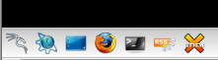
- In the VMware window, click VM, "Install VMware Tools…". This connects a virtual CD-ROM to your VM.
- On the lower left of your BackTrack desktop, click the blue Konqueror icon, as shown to the right on this page
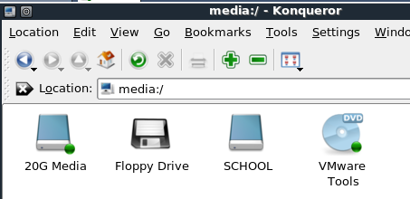
- In the Konqueror window, click "Storage Media". If the window is empty, press the F5 key.
- You should see a "VMware Tools" icon, as shown to the right on this page. Click that icon.
- Drag the VMwareTools-8.4.2-2610… icon to the BackTrack desktop and drop it there. In the context menu, click "Copy here".
- When the copy is complete, close Konqueror.
- On your BackTrack desktop, click the VMwareTools-8.4.2-2610… icon.
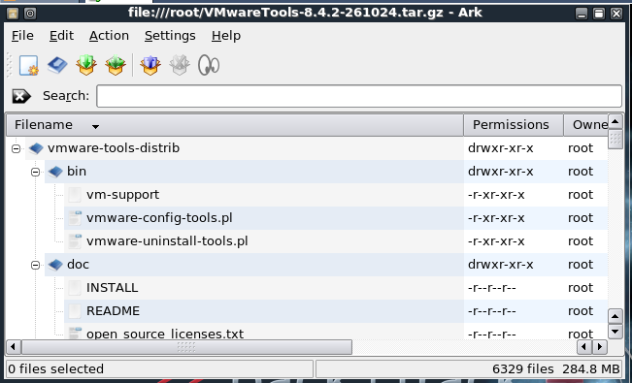
- When the Ark window shows the files, as shown to the right on this page, click Action, Extract. Click OK.

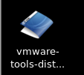
- When you see the blue vmware-tools-distrib folder, as shown to the right on this page, close Ark.
- On the lower left of your BackTrack desktop, click the black icon with the < sign on it to open a Konsole window.
- In the Konsole window, type this command, and then press the Enter key:
cd vmware-tools-distrib
- In the Konsole window, type this command, and then press the Enter key:
./vmware-install.pl
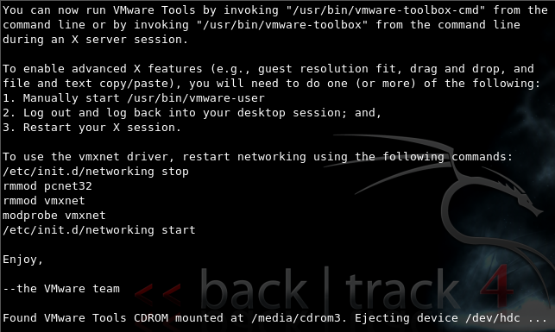
- A long series of esoteric questions appear on the screen. Answer each question by pressing the Enter key to accept the default options: Eventually several screens of text scroll by. Then the whole screen turns black and the desktop is redrawn. Then more text scrolls by.
- When it's all done you will see the screen shown to the right on this page.

Connecting to the Shared Folder
- In the VMware Workstation window, click VM, Settings.
- In the "Virtual Machine Settings" box, click the Options tab.
- Click "Shared Folders". On the right side, make sure the "Always enabled" box is checked. Click OK.
- In the Konsole window, type this command, and then press the Enter key:
cd /mnt/hgfs
- In the Konsole window, type this command, and then press the Enter key:
ls
- You should see your share folder. This is the data from your Windows system.
- In the Konsole window, type this command, and then press the Enter key:
cd share
- In the Konsole window, type this command, and then press the Enter key:
ls
- You should see the GCFI-LX.001 file and the other files you put in this folder.

Starting Autopsy
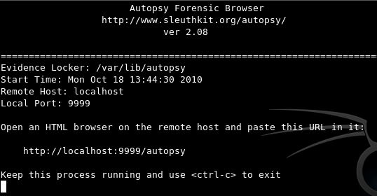
- In the Konsole window, type this command, and then press the Enter key:
autopsy
- The program launches, printing the text shown above on this page.
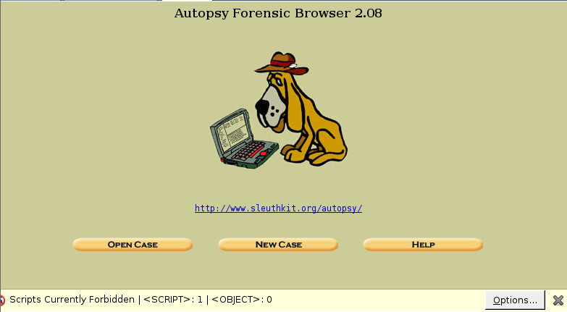
- From the BackTrack desktop, on the bottom left, click the red Firefox icon. When Firefox opens, go to this address: localhost:9999/autopsy
- Autopsy opens, as shown to the right on this page. Notice that NoScript is blocking scripts on this page, as indicated at the bottom. That's fine--Autopsy doesn't use JavaScript anyway. If you enable Javascript, it will just post a message telling you to turn it off.

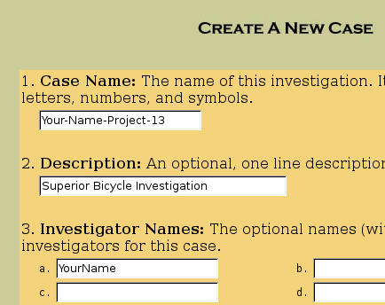
Opening a New Case in Autopsy
- In the Autopsy window, click the "New Case" button.
- In the "Create a New Case" window, enter a Case Name of "Your-Name-Project-13", replacing Your-Name with your own name.
- Enter a Description of "Superior Bicycle Investigation".
- Enter your name (without spaces) in the Investigator Names section, as shown to the right on this page.
- Click the "New Case" button.
- In the "Creating Case" .window, click the "Add Host" button.

- In the "Add a New Host" window, accept the default options and click the "Add Host" button.
- In the "Adding host" window, click the "Add Image" button.
- In the next window, click the "Add Image File" button.
- In the "Add a New Image" window, enter in these options, as shown below on this page:
  - Location /mnt/hgfs/share/GCFI-LX.00*
  - Type Partition
  - Import Method: Move
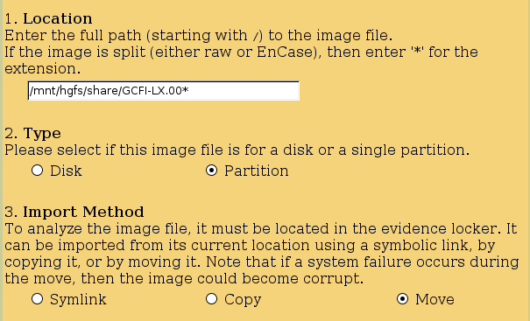

- Click Next.
- In the "Split Image Confirmation" window, click Next.
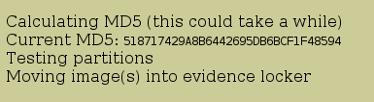
- In the "Image File Details" section, click the "Calculate the hash value for this image" button. Click Add.
- A message appears saying "Calculating MD5 (this could take a while)". It took about 15 minutes when I did it. When it completes, you will see a MD5 hash, as shown to the right on this page.
- Now you need to wait again while the evidence is moved into the evidence locker. This only took about 5 minutes when I did it. When the process completes, click the OK button.

Searching in Autopsy
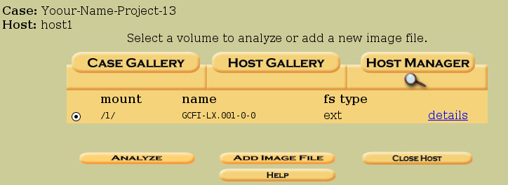
- The "Select a volume to analyze or add a new image file" window appears, as shown to the right on this page. Click the Analyze button.
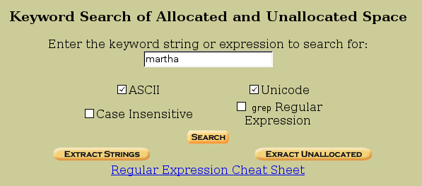
- In the next window, click the "Keyword Search" tab.
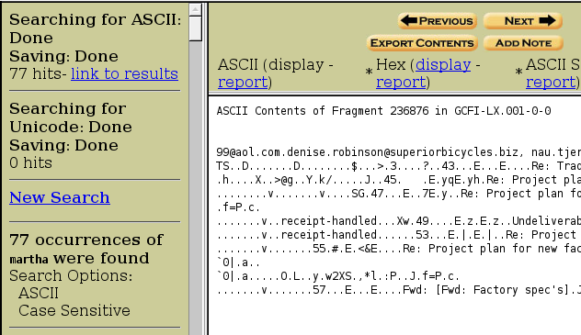
- In the search box, type martha as shown to the right on this page. Click the Search button. Wait while the search is performed--it took about 10-15 minutes when I did it.

Results of the Search
- It finds "77 hits", as shown to the right on this page.

Saving a Screen Image
- Make sure your screen shows "77 Hits".
- Click the taskbar at the bottom of your host Windows 7 desktop, to make the host machine active. Press the PrintScrn key in the upper-right portion of the keyboard.
- On the host machine, launch Paint and paste in the image. Save the image with the filename Your Name Proj 13a. Select a Save as type of JPEG.

Examining the Hits
- On the left side, scroll down to see the individual hits, labeled "Fragment 236019" and so on. Click the blue Ascii links to see the details of the hits in the right pane. Look at a few of them to see how the interface works. When you are done, click the Close button on the top right.

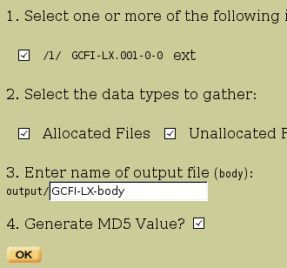
File Activity Time Line
- In the "Select a volume to analyze or add a new image file" window, on the lower left, click the "File Activity Time Lines" button.
- In the upper left of the screen, click the "Create Data File" button.
- In the Create Data File dialog box, click the"/ 1/ gcfi- lx. 001- 0- 0 ext" check box. Type GCFI- LX- body for the name of the output file, as shown to the right on this page, and click OK.
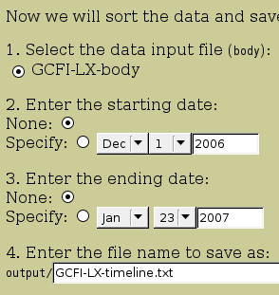
- The next screen shows a few messages as the process proceeds, and when it is complete, an OK button appears. Click OK.
- In the next screen, select a starting date of Dec 1 2006 and an ending date of Jan 23, 2007. Enter an output file name of GCFI-LX-timelime.txt as shown to the right on this page. Leave the other selections at the default values. Click OK.
- When the timeline is complete, an OK button will appear. Click OK.
- message will appear showing the complete file path to it. When I did it, the path was /var/lib/autopsy/Your-Name-Project-13/host1/output/GCFI-LX-timeline.txt
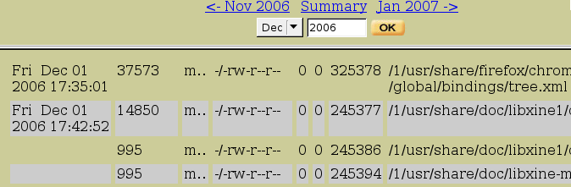
- In the next screen, change the date at the top to Dec 2006. You see a list of the files that were changed on that date, as shown below on this page.

Saving a Screen Image
- Make sure your screen shows "Dec 2006" and the first few files found for that date.
- Click the taskbar at the bottom of your host Windows 7 desktop, to make the host machine active. Press the PrintScrn key in the upper-right portion of the keyboard.
- On the host machine, launch Paint and paste in the image. Save the image with the filename Your Name Proj 13b. Select a Save as type of JPEG.

Turning in your Project
- Email the JPEG image to me as an email attachment. Send it to: cnit.121@gmail.com with a subject line of Proj 13 From Your Name, replacing Your Name with your own first and last name. Send a Cc to yourself.
Last Modified: 10-25-10

Sources
http://www.question-defense.com/2010/01/14/backtrack-4-final-installation-in-vmware-with-vmware-tools
http://www.casadeltom.com/2009/04/vmware-shared-folders-and-backtrack-4.html

