What You Need for This Project
- A Windows computer
- A hex editor, such as HxD.
- The instructions below assume you are using Windows 7 as set up in the S214 lab.

Downloading the Image File
- Open a Web browser and go to samsclass.info
- Click "CNIT 121". Click Projects. Scroll to "Project 14", as shown below on this page. Right-click "Proj 14 image" and save the JPEG file on your desktop.

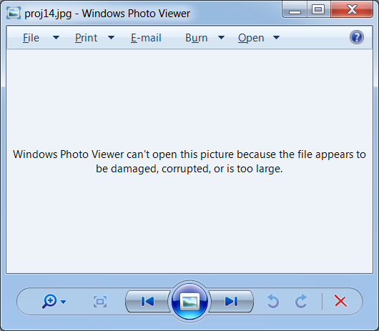
Opening the Image File
- On your desktop, double-click the proj14.jpg file.
- You see an error message, as shown to the right on this page.
- This happens because the header has been corrupted. But you can fix it by correcting five bytes in the header.

Fixing the Header
- If you don't have HxD installed, go to this URL to get it:
mh-nexus.de/en/hxd/
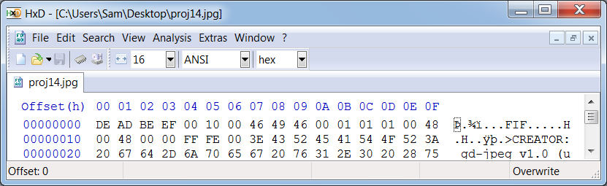
- Start HxD. Click File, Open. Open the proj14.jpg file, as shown below on this page.

Fixing the Header
- The first four bytes of the file need to be replaced by FF D8 FF E0, and the byte at offset 06 needs to be changed from 00 to 4A. You can fix them by typing hexadecimal values directly into the bytes in the center pane of HxD. The corrected file should match the figure below.
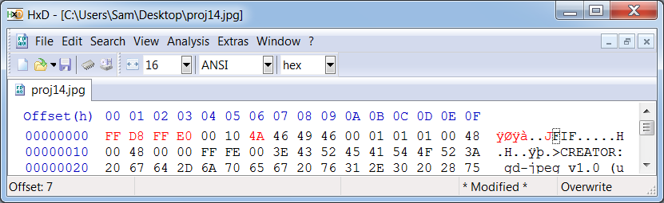
- When your file is fixed, click File, Save to save it. Close HxD

Viewing the Image
- On your desktop, double-click the proj14.jpg file. The image should open correctly now, showing a wooden window frame with a cat looking through it.

Turning in your Project
- Email the repaired JPEG image to me as an email attachment. Send it to: cnit.121@gmail.com with a subject line of Proj 14 From Your Name, replacing Your Name with your own first and last name. Send a Cc to yourself.
Last Modified: 11-1-10

