What You Need for This Project
- A Windows XP computer, real or virtual. This project does NOT work on Windows 7.

Starting your Virtual Machine
- Start VMware Workstation and launch your Windows XP SP3 Virtual Machine. Do all the steps below in it.

Downloading Memoryze and Audit Viewer
- Open a Web browser and go to mandiant.com/products/free_software
- Click the Memoryze link. Scroll to the bottom of the next page and click the "Specs & Download" button. Click the "Download Now" button. Save the MemoryzeSetup.msi file on your desktop.
- At the top of the Mandiant Web page, click Products.
- On the left of the page, click "Free Software".
- In the center of the page, click the "Audit Viewer" link. Click the "Specs & Download" button. Click the "Download Now" button. On the next page, click the "Download binary (zip)" link. Save the AuditViewer-bin.zip file on your desktop.

Installing Memoryze
- Click Start, Run. In the Run box, type CMD and press Enter to open a Command Prompt window.
- Type this command and press the Enter key. If you are not using a login account named "Student", replace "Student" with your login name.
cd desktop
- Type this command and press the Enter key:
msiexec /a MemoryzeSetup2.0.msi /qb TARGETDIR=C:\RAMFOR

Creating an Internet Explorer Process with Data in it
- Open Internet Explorer. Go to wikipedia.org and click English. On the upper right, click "log in". Enter your own name for the user name, enter the password SWORDFISH123 and click the "Log In" button. You won't be approved, but that doesn't matter--we just want to capture that password from the RAM.
- Leave Internet Explorer open.

Capturing the RAM
- In the Command Prompt window, type this command and press the Enter key:
cd C:\RAMFOR\x86
- In the Command Prompt window, type this command and press the Enter key:
MemoryDD
- When I did it, I saw a box of text with a yellow Warning message, but it worked. If you see a red error message, that probably means it failed. Make sure you are using an Administrator Command prompt, and try disabling any antivirus software.

- Click Start, Computer. Open the C:\RAMFOR\x86\Audits folder, and the folder with your name on it. Open the folder with a long number for a name, and find a file with a name like memory.1e0b0203.img (the portion after the first dot will be different).

Extracting Audit Viewer
- On your desktop, right-click the AuditViewer-bin.zip file and click "Extract All…". Click Next, Next, Finish.

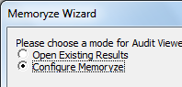
Opening the Memory Image for Review
- After the extraction, an AuditViewer-bin window appears. Open the AuditViewer-1.4.4501-bin folder. Double-click the auditviewer.exe file
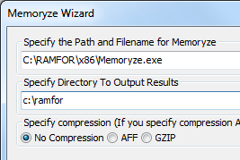
- A command window opens with Debug message, and a graphical "Memoryze Wizard" box also opens. You may have to press Alt+Tab a few times to make the "Memoryze Wizard" box visible.
- In the "Memoryze Wizard" box, click "Configure Memoryze", as shown to the right on this page, and click Next.
- In the next box, on the "Specify the Path and Filename for Memoryze" line, click the Browse button and navigate to C:\RAMFOR\x86\Memoryze.exe. In the second field, type C:\RAMFOR as shown to the right on this page. Accept the default selection of "No Compression" and click Next.
- In the next box, accept the default selection of "Analyze Dead Memory". Click the Browse button and navigate to the memory image file you created earlier, in a subfolder of C:\RAMFOR\x86\Audits. Click Next.
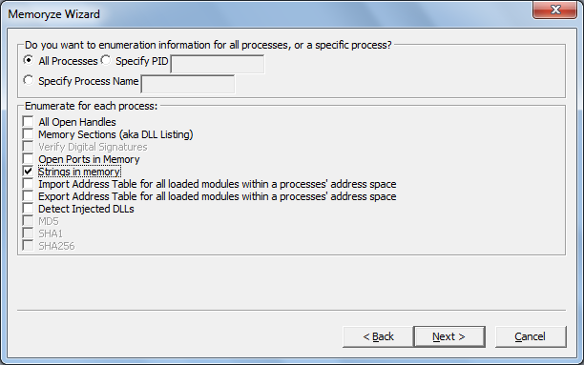
- In the next box, click "Process Enumeration" and click Next.
- In the next box, click "Process Acquisition" and click Next.
- In the next box, click Next.
- In the next box, click "All Processes" and "Strings in memory", as shown to the right on this page. Click Next.
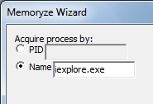
- In the next box, click the Name button. In the Name field, type iexplore.exe, as shown to the right on this page, and click Next. Click Finish.

- It may take several minutes to process the memory image. When it is complete, a window showing a lot of files pops up.

Viewing Strings in Audit Viewer
- Bring the "Audit Viewer" window to the front, as shown below on this page.
- In the left pane of Audit Viewer, click iexplore.exe.
- In the right pane click the Strings tab. These are all the readable strings in the memory being used by Internet Explorer. Somewhere in here is your username and password.

Saving a Screen Image
- Make sure your screen shows Audit Viewer with some Processes visible in the left pane, as shown below on this page.
- Press the PrintScrn key. Open Paint and paste in the image. Save it with the filename Your Name Proj 16a. Select a Save as type of JPEG or PNG.
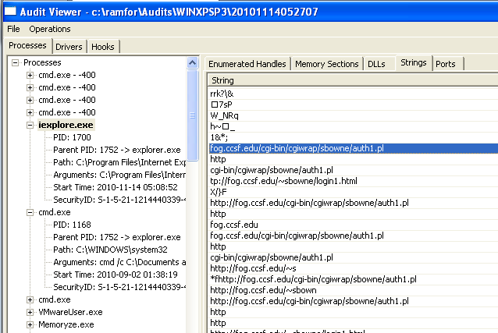

Last Modified: 11-8-10

Note: If you don't see any strings, keep clicking "iexplore.exe" repeatedly, ten or more times, a nd also click the other tabs like DLL and back to the "Strings" tab over and over. Eventually it should show the strings.

Finding the Password
- In the right pane of "Audit Viewer", right-click one of the strings. Click "Export all from strings to CSV file". Save the file on your desktop with the filename YOURNAME-RAM.csv.
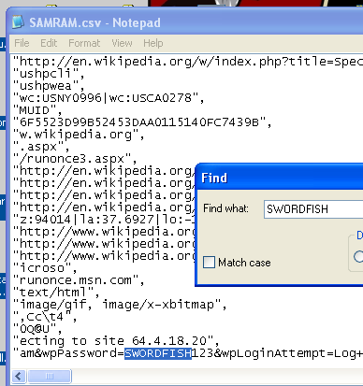
- Press Logo+M to minimize all windows. On your desktop, right-click the YOURNAME-RAM.csv file and click "Open with…", Notepad.
- In Notepad, click Edit, Find…. In the Find box, type SWORDFISH and press Enter.
- You should find your password, as shown to the right on this page.

Saving a Screen Image
- Make sure the password of SWORDFISH123 is visible.
- Press the PrintScrn key. Open Paint and paste in the image. Save it with the filename Your Name Proj 16b. Select a Save as type of JPEG or PNG.

Conclusion
- As you can see, this tool makes it somewhat easier to interpret a RAM capture, but it's still hard to understand. And a major limitation of RAM captures is that there are no timestamps, so you can't be sure how old the items there are.

Turning in your Project
- Email the JPEG images to me as email attachments. Send it to: cnit.121@gmail.com with a subject line of Proj 16 From Your Name, replacing Your Name with your own first and last name. Send a Cc to yourself.

Source
http://blogs.sans.org/computer-forensics/2010/11/08/digital-forensics-howto-memory-analysis-mandiant-memoryze/
Last mofidied: 5-2-12

