What You Need for This Project
- VMware Workstation
- Any other tools you choose to use

Getting the Evidence File
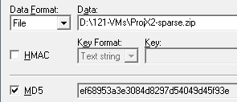
- In Firefox, go to samsclass.info, click on "CNIT 121", and scroll down to the "Project X2" instructions. Click the "Proj X2 Evidence File" link and save the ProjX2-sparse.zip file on your desktop.
- Calculate the MD5 hash of the file and verify that it matches the value shown to the right on this page.
- Unzip the file to extract the virtual hard disk inside.

Imaging the Evidence Drive
- Mount the evidence drive in an appropriate virtual machine.
- Use any technique you like to make a correct forensic image of the drive.
- Calculate the MD5 hash of your forensic image.
.

Saving a Screen Image
- Make sure your screen shows the MD5 of the image, from whatever tool you chose to use.

Turning in your Project
- Email the JPEG image to me as an email attachment. Send it to: cnit.121@gmail.com with a subject line of Proj X2 From Your Name, replacing Your Name with your own first and last name. Send a Cc to yourself.
Last Modified: 10-4-10

