What You Need for This Project
- A Windows computer
- The "MS E-mail Files.E01" file you used in the earlier "EnCase Demo" project
- Your VM with FTK, which you also made in an earlier project
- The instructions below assume you are using Windows 7 as set up in the S214 lab.

Downloading and Installing ProDiscover Demo Version
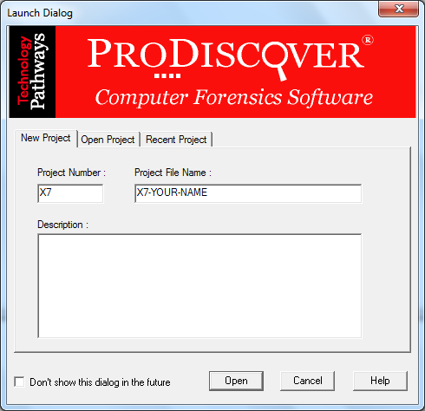
- Open a Web browser and go to www.techpathways.com/Demo.htm
- Downolad "ProDiscover Basic Edition Freeware".
- Right-click the ZIP file and click "Extract All…", Extract.
- Open the ProDiscoverRelease65Basic folder. Right-click the ProDiscoverRelease65Basic.exe file and click "Run as Administrator".
- Install the software with the default options.

Using ProDiscover to Find Email Files
- Click Start, type Prodiscover, and click "ProDiscover Basic".
- In the "Launch Dialog" box, enter a "Project Number" of X7 and a "Project File Name" of X7-YOUR-NAME, as shown to the right on this page, replacing YOUR-NAME with your own name. Click the Open button.
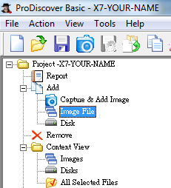
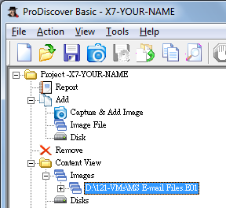
- In the left pane, expand the Add item and click Image File, as shown to the right on this page. Browse to the "MS E-mail Files.E01" file you used in the earlier "EnCase Demo" project and double-click it.
- In the left pane of the "ProDiscover Basic" window, in the "Content View" section, expand the Images container and click the "MS E-mail Files.E01" item to select it, as shown below on this page.

- From the ProDiscover menu bar, click Action, Search.
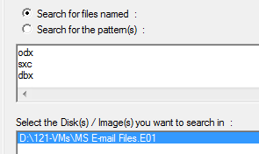
- In the Search dialog box, click the "Search for files named" option button, and in the text box underneath, type the following extensions, pressing Enter after each one:
  - ods
  - sxc
  - dbx
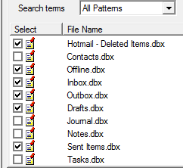
- In the "Select the Disk(s)…" box, click "MS E-mail Files.E01", as shown to the right on this page: Click the OK button.
- In the results, click the check box next to "Hotmail - Deleted Items (.dbx)". An "Add Comment" box pops up. Enter a comment of "Proj X7 from YOUR NAME", check the "Apply to all items" box, and click the OK button.

Creating a Report with ProDiscover
- In the Search results pane, check these additional items, as shown to the right on this page:
  - Offline.dbx
  - Inbox.dbx
  - Outbox.dbx
  - Drafts.dbx
  - Sent Items.dbx
- Click the "Add to Report" button.
- From the Menu bar, click View, Report. The Report appears in the right pane. Scroll down to read it--this report lists the files, but it does not contain the file contents. It's not what we want.
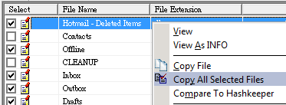
- In the left pane, in the "Search Results" section, click "Content Search Results". In the top right pane, double-click "Hotmail - Deleted Items.dbx".
- Right-click "Hotmail - Deleted Items" and click "Copy All Selected Files", as shown to the right on this page.
- In the "Choose Destination" box, click the Browse button and navigate to your desktop. Create a folder named "Proj-X7-YOUR-NAME" and click OK. Click OK.
- In the left pane, click Report, and then click Action, Export… from the menu. In the Export dialog box, type "ProjX7-YOUR-NAME" and click the Browse button. Navigate to your desktop, open the folder named "Proj-X7-YOUR-NAME" and click Save. Click OK
- Close ProDiscover. If you’re prompted to save the project, click Yes, and then click Save.

Launching FTK
- If you installed FTK on a virtual machine, start that VM.
- Drag the folder named "Proj-X7-YOUR-NAME" from your desktop to the virtual machine's desktop.
- Double-click the "FTK Forensic Toolkit" icon on your desktop.
- When you get an Error box saying "No security device was found…", click No.
- When you get an Error box saying "The KFF Hash library file was not found…", click OK.
- When a box pops up explaining the limitations of the demonstration version, click OK.

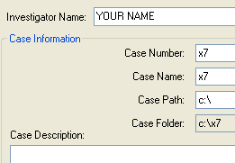
Starting a New Case
- In the "AccessData FTK Startup" box, accept the default selection of "Start a new case" and click OK.
- In the screen titled "Wizard for Creating a New Case", fill in the fields as shown to the right on this page. Click Next.
- In the screen titled "Forensic Examiner Information", leave the fields blank and click Next.
- In the screen titled "Case Log Options", accept the default selections, which will log everything. Click Next.
- In the screen titled "Processes to Perform", deselect "KFF Lookup" and "Decrypt EFS Files". Click Next.
- In the screen titled "Refine Case-Default", accept the default of "Include All Items". Click Next.
- In the screen titled "Refine Index - Default", click Next.

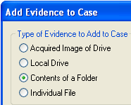
Adding Evidence
- In the "Add Evidence" box, click the "Add Evidence…". button.
- In the "Add Evidence to Case" box, select "Contents of a Folder", as shown to the right on this page, and click Continue.

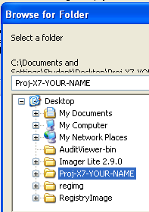
- In the "Browse for Folder" box, navigate to your Desktop and click Proj-X7-YOUR-NAME, as shown to the right on this page. Click OK.
- In the "Evidence Information" box, click OK.
- In the "Add Evidence" box, click Next. Click Finish.

Finding the Hotmail Messages
- In the main FTK window, click the Search tab, and then click the "Indexed Search" tab.
- In the "Search Term" text box, type Hotmail
- Click Add, and then click the "View Cumulative Results" button.
- In the "Filter Search Hits" dialog box, click OK.

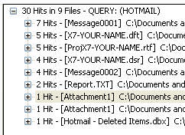
- In the upper- right pane of the main FTK window, expand the list of hits, as shown to the right on this page.

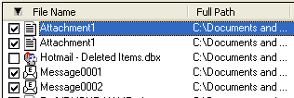
- In the File List pane at the bottom of the FTK window, click the two Attachments and the two Messages, as shown to the right on this page.

Bookmarking the Hotmail Messages
- In the FTK menu bar, click Tools, "Create Bookmark".
- In the "Create New Bookmark" dialog box, in the Bookmark name text box, type "Proj X7 YOUR NAME" and click the "All checked items" button.

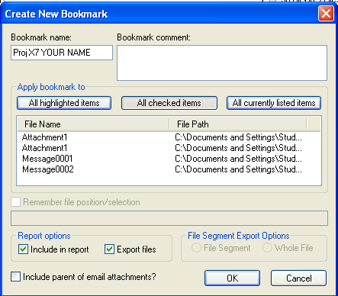
- Click the "Include in report" and "Export files" check boxes, as shown to the right on this page. Click OK.

Creating a Report
- From the FTK menu, click File, "Report Wizard".
- In the Case Information dialog box, click Next.

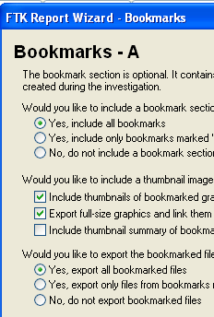

- In the Bookmarks dialog box, in the top section, accept the default selection of "Yes, include all bookmarks". In the bottom section, click "Yes, export all bookmarked files", as shown to the right on this page. Click Next.
- In the "Bookmarks - B" box, click Next.
- In the "Graphic Thumbnails" box, click Next.
- In the "List by File Path" box, click Next.
- In the "List File Properties - A" box, click Next.
- In the "Supplemental Files" box, click the "Add Files" button. In the Open box, navigate to your Desktop and double-click the Proj-X7-YOUR-NAME folder. Double-click the Proj-X7-YOUR-NAME.rtf file.
- In the "Supplemental Files" box, click Next.
- In the "Report Location" box, click Finish.
- In the "Report Wizard" box, click Yes.

- The report opens in a Web browser, as shown below on this page.
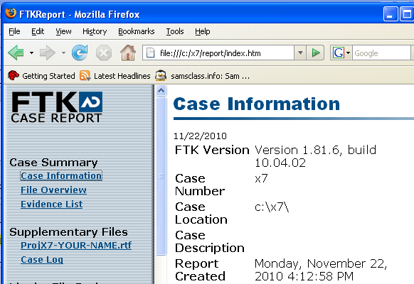

Saving a Screen Image
- Make sure your screen shows "FTK CASE REPORT" on the left side, with the Supplementary File named "ProjX7-YOUR-NAME.rtf" filename visible.
- Click the taskbar at the bottom of your host Windows 7 desktop, to make the host machine active. Press the PrintScrn key in the upper-right portion of the keyboard.
- On the host machine, launch Paint and paste in the image. Save the image with the filename Your Name Proj X7. Select a Save as type of JPEG.

Examining the Report
- Click through the items to explore the report. Note that this is a rather clumsy report format, and that opening some of the links requires Word or Access. But that's how FTK works.

Turning in your Project
- Email the JPEG image to me as an email attachment. Send it to: cnit.121@gmail.com with a subject line of Proj X7 From Your Name, replacing Your Name with your own first and last name. Send a Cc to yourself.
Last Modified: 11-22-10

