Objectives

Explain the component parts of information security in general and network security in particular

Define the key terms and critical concepts of information and network security

Describe the organizational roles of information and network security professionals

Discuss the business need for information and network security

Identify the threats posed to information and network security, as well as the common attacks associated with those threats

Differentiate threats to information within systems from attacks against information within systems

Introduction

Network security

Critical activity for almost every organization

Perimeter defense

Cornerstone of most network security programs

Effective firewall

Properly configured to be safe and efficient

Chapter 1

Overview of the entire field of information security

How that broader field influences current trends in network security

What Is Information Security?

Information security (InfoSec)

Protection of information and its critical elements,

Includes the systems and hardware that use, store, and transmit that information

Unified process encompasses

Network security

Physical security

Personnel security

Operations security

Communications security

C.I.A. triangle

Industry standard for computer security

Based on the three characteristics of information that make it valuable to organizations:

Confidentiality

Integrity

Availability

Critical Characteristics of Information

Availability

Information is accessible by authorized users

Accuracy

Information is free from mistakes or errors

Authenticity

Information is genuine or original

Confidentiality

Information is protected from disclosure or exposure

Integrity

Information remains whole, complete, and uncorrupted

Utility

Information has value for some purpose or end

Possession

Information object or item is owned or controlled by somebody

CNSS Security Model

U.S. Committee on National Systems Security (CNSS)

National Training Standard for Information Security Professionals NSTISSI No. 4011

McCumber Cube

3 x 3 x 3 cube, with 27 cells representing the various areas that must be addressed to secure today’s information systems

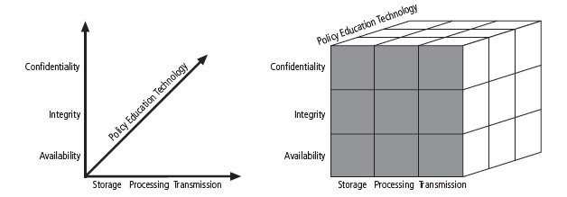

Balancing Information Security and Access

Information security

Process, not an end state

Balance protection of information and information assets with the availability of that information to authorized users

Security must allow reasonable access

Yet protect against threats

Business Needs First

Protect the organization’s ability to function

Enable the safe operation of applications implemented on the organization’s IT systems

Protect the data the organization collects and uses

Safeguard the technology assets in use at the organization

Security Professionals and the Organization

Wide range of professionals to support the complex information security program needed by a moderate or large organization

Chief information officer (CIO)

Senior technology officer

Chief information security officer (CISO)

Responsible for the assessment, management, and implementation of information security in the organization

Information security project team

Champion

Team leader

Security policy developers

Risk assessment specialists

Security professionals

Systems, network, and storage administrators

End users

Data Management

Data owners

Responsible for the security and use of a particular set of information

Data custodians

Responsible for the storage, maintenance, and protection of the information

Data users

Allowed by the data owner to access and use the information to perform their daily jobs

Key Information Security Terminology

Security professional must be familiar with common terms

To effectively support any information security effort

Threats and Attacks

Threat

Category of object, person, or other entity that poses a potential risk of loss to an asset

Asset

Anything that has value for the organization

Can be physical or logical

Attack

Intentional or unintentional action that could represent the unauthorized modification, damage, or loss of an information asset

Subject of an attack

Used as an active tool to conduct the attack

Object of an attack

Entity being attacked

Direct attack

Hacker uses a personal computer to break into a system

Indirect attack

System is compromised and used to attack other systems

Vulnerabilities and Exploits

Threat agent

Specific instance of a general threat

Well-known vulnerabilities

Vulnerabilities that have been examined, documented, and published

“Exploit”

Threat agents attempt to exploit a system or information asset

Specific recipe that an attacker creates to formulate an attack

Controls, safeguards, or countermeasures

Synonymous terms

Security mechanisms, policies, or procedures that can successfully counter attacks, reduce risk, resolve vulnerabilities, and generally improve the security within an organization

Risk

State of being unsecure, either partially or totally, and thus susceptible to attack

Described in terms of likelihood

Risk management

Involves risk identification, risk assessment or analysis, and risk control

Risk appetite or risk tolerance

Amount of risk an organization chooses to live with

Residual risk

Amount of risk that remains after an organization takes precautions, implements controls and safeguards, and performs other security activities

To control risk:

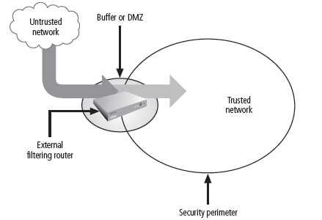
Self-protection

Risk transfer

Self-insurance or acceptance

Avoidance

Security Perimeter and Defense in Depth

Security perimeter

Defines the boundary between the outer limit of an organization’s security and the beginning of the outside network

Perimeter does not protect against internal attacks

Organization may choose to set up security domains

Defense in depth

Layered implementation of security
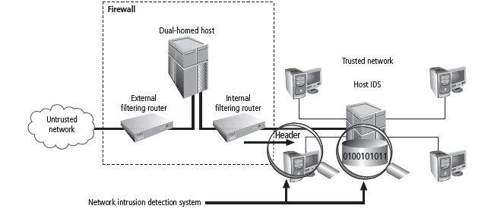

Redundancy

Implementing technology in layers

Threats to Information Security

Table 1-1

Reveals how many organizations have experienced the listed types of attack or misuse

Table 1-2

12 categories that represent a clear and present danger to an organization’s people, information, and systems
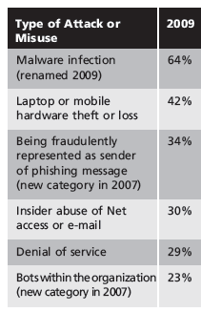
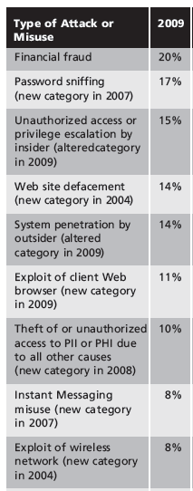
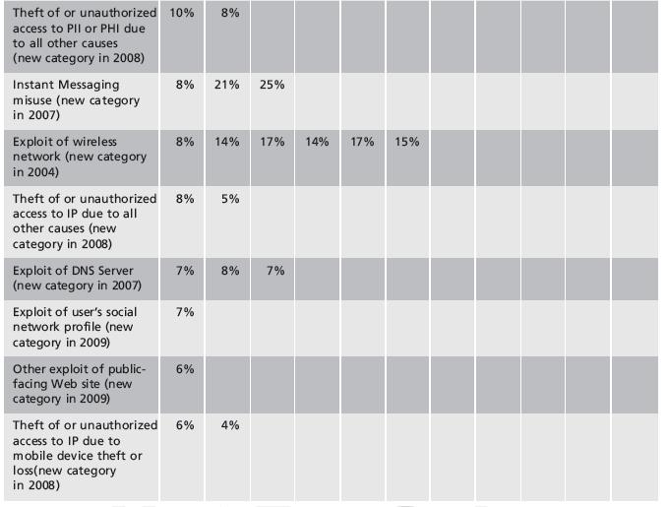
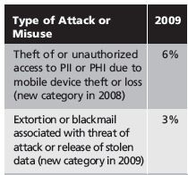
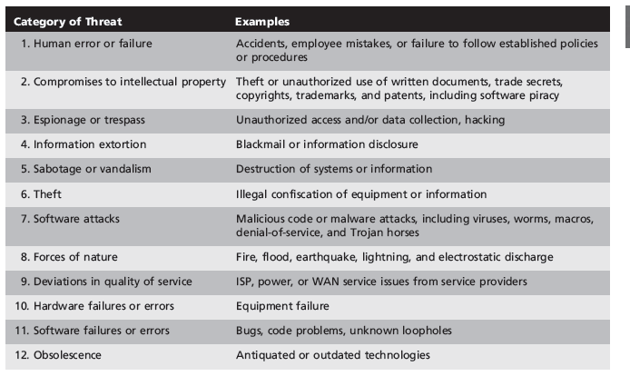

The TVA Triple

“TVA Triple” of Threat-Vulnerability-Asset

Use to prioritize your work

T1-V1-A1—Vulnerability 1 that exists between Threat 1 and Asset 1

T1-V2-A1—Vulnerability 2 that exists between Threat 1 and Asset 1

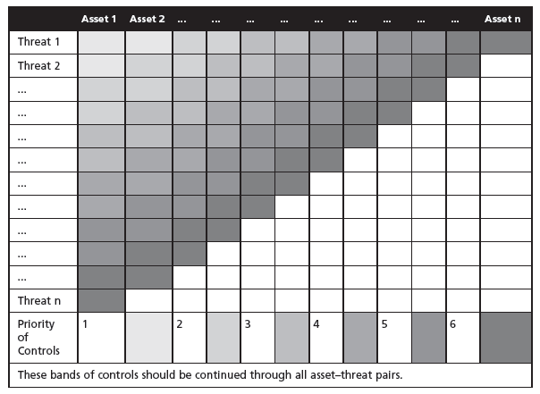
T1-V1-A2—Vulnerability 1 that exists between Threat 1 and Asset 2

Organize in a TVA worksheet

Other Ways to View Threats

Perspectives:

Intellectual property

Software piracy

Shoulder surfing

Hackers

Script kiddies

Packet monkeys

Cracker

Phreaker

Hacktivist or cyberactivist

Cyberterrorist

Malicious code, malicious software, or malware

Computer virus: macro virus, boot virus

Worms

Trojan horses

Backdoor, trapdoor, maintenance hook

Rootkit

Power irregularities

Spike (momentary increase)

Surge (prolonged increase)

Sag (momentary decrease)

Brownout (prolonged decrease)

Fault (momentary complete loss)

Blackout (prolonged complete loss)

Attacks on Information Assets

Attacks occur through a specific act that may cause a potential loss

Each of the major types of attack used against controlled systems discussed

Malicious Code

Malicious code

Includes viruses, worms, Trojan horses, and active Web scripts

Executed with the intent to destroy or steal information

Polymorphic, multivector worm

Constantly changes the way it looks

Uses multiple attack vectors to exploit a variety of vulnerabilities in commonly used software

Threat Vectors
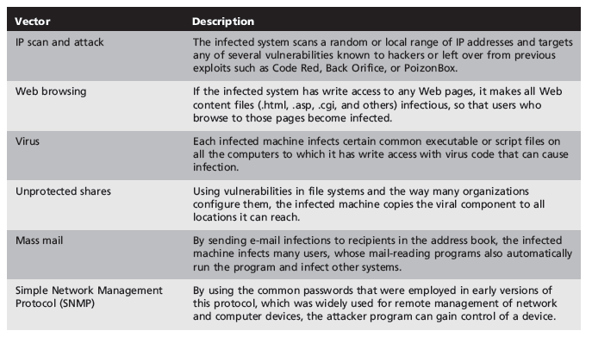

Compromising Passwords

Bypass access controls by guessing passwords

Cracking

Obtaining passwords from hash values

Brute force attack

Application of computing and network resources to try every possible combination of characters

Dictionary attack

Variation on the brute force attack

Narrows the field by selecting specific target accounts and using a list of commonly used passwords

Denial-of-Service (DoS) and Distributed Denial-of-Service (DDoS)

Denial-of-service (DoS) attack

Attacker sends a large number of connection or information requests to a target

So many requests are made that the target system cannot handle them along with other, legitimate requests for service

Distributed denial-of-service (DDoS)

Coordinated stream of requests against a target from many locations at the same time

Any system connected to the Internet is a potential target for denial-of-service attacks

Spoofing

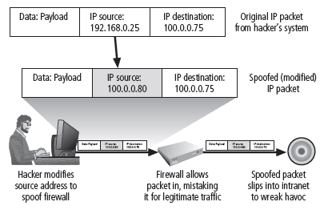
Intruder sends messages to IP addresses that indicate to the recipient that the messages are coming from a trusted host

Man-in-the-Middle

Attacker monitors (or sniffs) packets from the network

Modifies them using IP spoofing techniques

Inserts them back into the network

Allows the attacker to eavesdrop, change, delete, reroute, add, forge, or divert data

E-mail Attacks

E-mail

Vehicle for attacks rather than the attack itself

Spam

Used as a means to make malicious code attacks more effective

Mail bomb

Attacker routes large quantities of e-mail to the target system

Sniffers

Sniffer

Program or device that can monitor data traveling over a network

Used both for legitimate network management functions and for stealing information from a network

Impossible to detect

Can be inserted almost anywhere

Packet sniffers

Work on TCP/IP networks

Social Engineering

Process of using social skills to convince people to reveal access credentials or other valuable information to the attacker

“People are the weakest link. You can have the best technology, [then] somebody call[s] an unsuspecting employee. That’s all she wrote, baby. They got everything”

Kevin Mitnick

Buffer Overflow

Application error

Occurs when more data is sent to a buffer than it can handle

Attacker can make the target system execute instructions

Attacker can take advantage of some other unintended consequence of the failure

