Overview

Define information security policy and describe its central role in a successful information security program

Explain the three types of information security policy and list the critical components of each

Define management’s role in the development, maintenance, and enforcement of information security policy, standards, practices, procedures, and guidelines

List the dominant national and international security management standards

Describe the fundamental elements of key information security management practices

Discuss how an organization institutionalizes policies, standards, and practices using education, training, and awareness programs

Introduction

Organization

Collection of people working together toward a common goal

Must have clear understanding of the rules of acceptable behavior

Policy

Conveys management’s intentions to its employees

Effective security program

Use of a formal plan to implement and manage security in the organization

Information Security Policy, Standards, and Practices

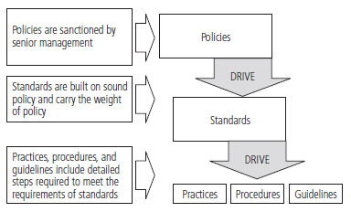
Policy

Set of guidelines or instructions

Organization’s senior management implements

Regulates the activities of the organization members who make decisions, take actions, and perform other duties

Standards

More detailed descriptions of what must be done to comply with policy

De facto standards

Informal part of an organization’s culture

De jure standards

Published, scrutinized, and ratified by a group

For a policy to be considered effective and legally enforceable:

Dissemination (distribution)

Review (reading)

Comprehension (understanding)

Compliance (agreement)

Uniform enforcement

Mission of an organization

Written statement of purpose of organization

Vision of an organization

Witten statement of the organization’s long-term goals

Strategic planning

Process of moving the organization toward its vision.

Security policy

Set of rules that protects an organization’s assets

Information security policy

Set of rules for the protection of an organization’s information assets

NIST SP 800-14

Enterprise information security policies

Issue-specific security policies

Systems-specific security policies

Enterprise Information Security Policy (EISP)

Supports the mission, vision, and direction of the organization

Sets the strategic direction, scope, and tone for all security efforts

Executive-level document

Drafted by organization’s chief information officer

Expresses the security philosophy within the IT environment

Guides the development, implementation, and management of the security program

Address an organization’s need to comply with laws and regulations in two ways:

General compliance

Identification of specific penalties and disciplinary actions
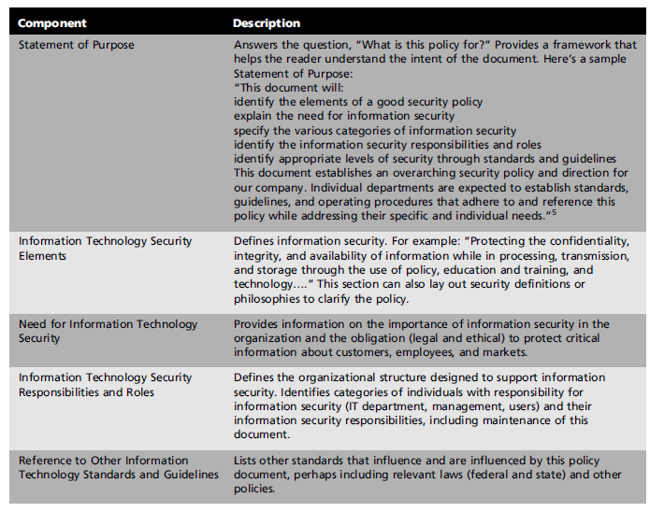

Issue-Specific Security Policy (ISSP)

Addresses specific areas of technology

Requires frequent updates

Contains a statement on the organization’s position on a specific issue

May cover:

Use of company-owned networks and the Internet

Use of telecommunications technologies (fax and phone)

Use of electronic mail

Specific minimum configurations of computers to defend against worms and viruses

Prohibitions against hacking or testing organization security controls

Home use of company-owned computer equipment

Use of personal equipment on company networks

Use of photocopy equipment

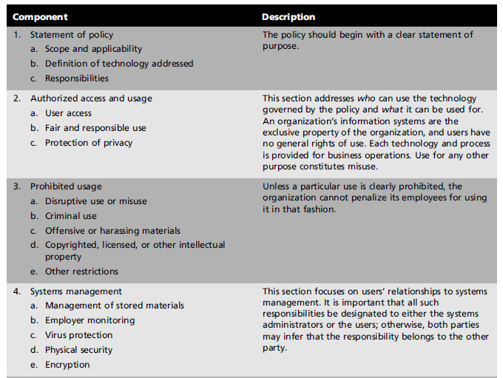

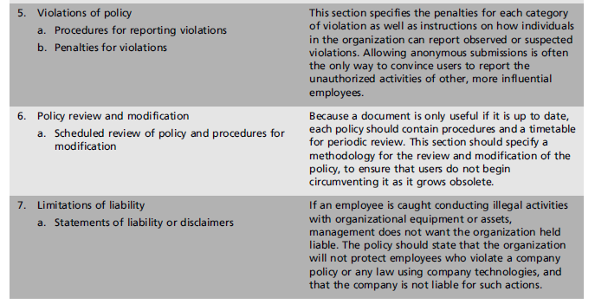

Systems-Specific Policy (SysSP)

Appear with the managerial guidance expected in a policy

Include detailed technical specifications not usually found in other types of policy documents

Managerial Guidance SysSPs

Guide the implementation and configuration of a specific technology

Technical Specifications SysSPs

General methods for implementing technical controls

Access control lists

Set of specifications that identifies a piece of technology’s authorized users and includes details on the rights and privileges those users have on that technology

Access control matrix

Combines capability tables and ACLs

Access Control List

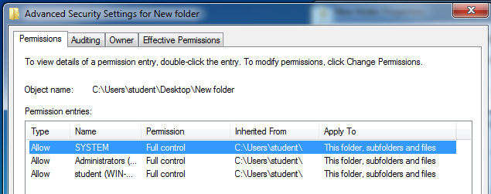

Capability Table

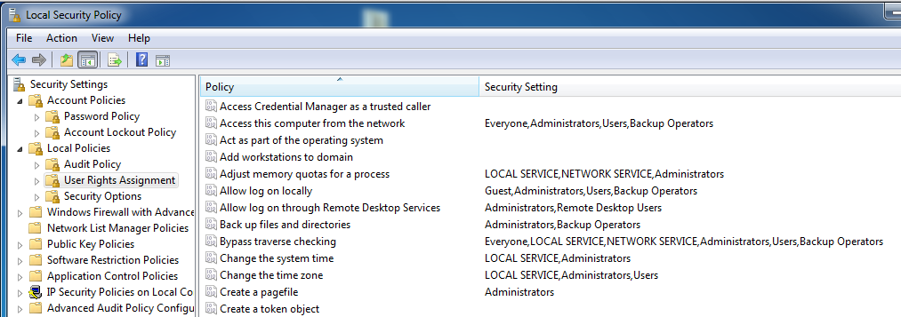

Configuration rules

Specific instructions entered into a security system to regulate how it reacts to the data it receives

Rule-based policies

More specific to a system’s operation than ACLs

May or may not deal with users directly

Frameworks and Industry Standards

Security blueprint

Basis for the design, selection, and implementation of all security program elements

Security framework

Outline of the overall information security strategy

Roadmap for planned changes to the organization’s information security environment

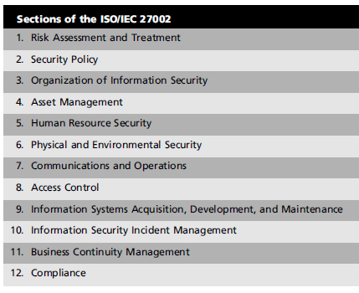
The ISO 27000 Series

Information Technology—Code of Practice for Information Security Management

Most widely referenced security models

Details of ISO/IEC 27002 available only for purchase

Summary description

See Table 2-3

NIST Security Models

Computer Security Resource Center (CSRC) publications

SP 800-14: Generally Accepted Principles and Practices for Securing Information Technology Systems

Lists the principles and practices to be used in the development of a security blueprint

SP 800-41 Rev. 1: Guidelines on Firewalls and Firewall Policy

Provides an overview of the capabilities and technologies of firewalls and firewall policies

SP 800-53 Rev. 3: Recommended Security Controls for Federal Information Systems and Organizations

Describes the selection and implementation of security controls for information security to lower the possibility of successful attack from threats

SP 800-53 A, Jul 2008: Guide for Assessing the Security Controls in Federal Information Systems: Building Effective Security Assessment Plans

Provides a systems developmental lifecycle approach to security assessment of information systems

Other NIST Special Publications

See Table 2-6

IETF Security Architecture

Internet Engineering Task Force (IETF)

Coordinates the technical issues involved in promulgating the Internet’s technology standards

Security Area Working Group

Acts as an advisory board for security topics that affect the various Internet-related protocols

Prepares publications called requests for comment (RFCs)

RFC 2196: Site Security Handbook

Benchmarking and Best Practices

Best practices

Federal Agency Security Practices (FASP) Web site, http://csrc.nist.gov/groups/SMA/fasp/index.html

Popular place to look up best practices other public and semipublic institutions provide information on best practices

Spheres of security

Generalized foundation of a good security framework

Controls

Implemented between systems and the information, between networks and the computer systems, and between the Internet and internal networks

Information security

Designed and implemented in three layers: policies, people (education, training, and awareness programs), and technology
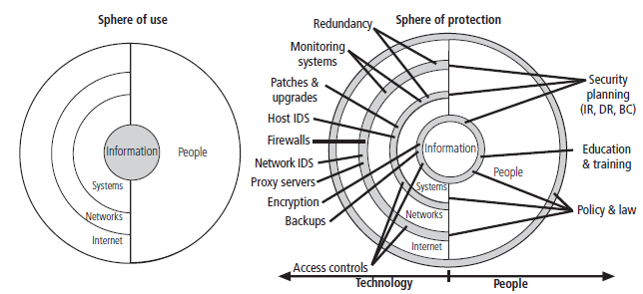

Security Education, Training, and Awareness Program

Education, training, and awareness (SETA) program

Responsibility of the CISO

Control measure designed to reduce the incidences of accidental security breaches by employees

Designed to supplement the general education and training programs

SETA program elements:

Security education, security training, and security awareness

Purpose of SETA is to enhance security by:

Improving awareness of the need to protect system resources

Developing skills and knowledge so computer users can perform their jobs more securely

Building in-depth knowledge, as needed, to design, implement, or operate security programs for organizations and systems

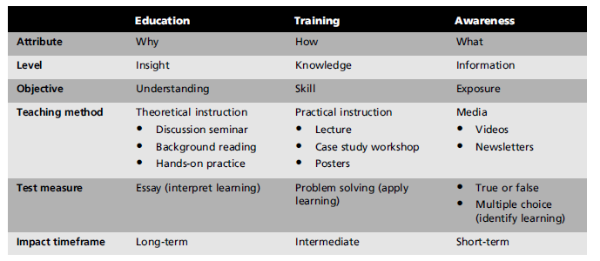

Security Education

Investigate available courses from local institutions of higher learning or continuing education

Centers of Excellence program

Identifies outstanding universities that have both coursework in information security and an integrated view of information security in the institution itself

Security Training

Provides detailed information and hands-on instruction to employees to prepare them to perform their duties securely

Industry training conferences and programs offered through professional agencies

SETA resources

Offer assistance in the form of sample topics and structures for security classes

Security Awareness

Designed to keep information security at the forefront of users’ minds

Include newsletters, security posters, videos, bulletin boards, flyers, and trinkets

Continuity Strategies

Various types of plans used to prepare for an attack

Contingency plan

Business continuity, incident response, and disaster recovery planning

Prepared by the organization to anticipate, react to, and recover from adverse events and, subsequently, to restore the organization to normal modes of business operations

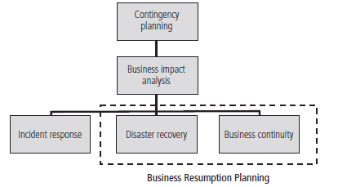
Incident

Any clearly identified attack on the organization’s information assets that would threaten the assets’ confidentiality, integrity, or availability

Incident response (IR) plan

Identification, classification, response, and recovery from an incident

Disaster recovery (DR) plan

Preparation for and recovery from a disaster

Business continuity (BC) plan

Ensures that critical business functions continue

Primary functions of these three types of planning:

IR plan focuses on immediate response

Process moves on to the DR plan and BC plan

DR plan typically focuses on restoring systems at the original site after disasters occur

BC plan occurs concurrently with the DR plan when the damage is major or long term

Establishes critical business functions at an alternate site

Contingency planning team

Assembled to create contingency plan

Consists of

Champion

Project manager

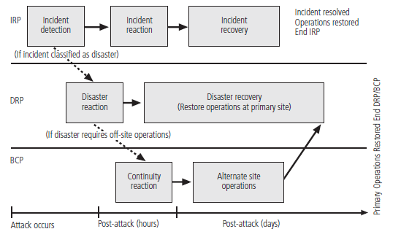
Team members

Business Impact Analysis

BIA

Investigation and assessment of the impact that various attacks can have on the organization

Provides detailed analyses of the potential impact each attack could have

Identification and prioritization of threats and attacks

Attack profile

Detailed description of the activities that occur during an attack

Business unit analysis

Analysis and prioritization of the business functions within the organization

Determine which are most vital to continued operations

Scenarios of successful attacks

Long and detailed process

Assessment of potential damage

Estimate the cost of the best, worst, and most likely cases

Classification of subordinate plans

Attack scenario end case is categorized either as disastrous or not disastrous

Incident Response Planning

Includes the identification of, classification of, and response to an incident

Made up of activities that are to be performed when an incident has been identified

Incident response (IR)

Set of activities taken to plan for, detect, and correct the impact of an incident on information assets

Four phases:

Planning—getting ready to handle incidents

Detection—identifying that an incident has occurred

Reaction—responding to the immediate threat of an incident and regaining control of information assets

Recovery—getting things “back to normal,” resolving the damage done during the incident, and understanding what happened to prevent reoccurrence

Disaster Recovery Planning

Disaster

Organization is unable to mitigate the impact of an incident during the incident

Level of damage or destruction is so severe that the organization is unable to recover quickly

Disaster recovery planning (DRP)

Preparing an organization to handle and recover from a disaster

Disaster Recovery Plan

Specifies recovery procedures during and after each type of disaster

Recovery Operations

Each organization must examine the scenarios developed at the start of contingency planning

Determine how to respond

Business Continuity Planning

Prepares an organization to reestablish critical business operations during a disaster at the primary site

Developing continuity programs

Identification of critical business functions and the resources needed to support them

Crisis Management

What may truly distinguish an incident from a disaster are the actions of the response teams

Crisis management.

Focuses first and foremost on the people involved

Establishes a base of operations or command center to support communications until the disaster has ended

