Overview

Explain why authentication is a critical aspect of perimeter defense

Explain why firewalls authenticate and how they identify users

Describe user, client, and session authentication

List the advantages and disadvantages of popular centralized authentication systems

Discuss the potential weaknesses of password security systems

Describe the use of password security tools

Introduction

Firewall authentication

Reliably determine whether persons or entities are who or what they claim to be

Access controls

Learn how and why firewalls serve as access controls in providing authentication services

Main types of authentication performed by firewalls:

Client, user, and session

Different types of centralized authentication methods that firewalls can use:

Kerberos, TACACS+, and RADIUS

Access Controls

Four processes:

Identification: obtaining the identity of the entity requesting access to a logical or physical area

Authentication: confirming the identity of the entity seeking access to a logical or physical area

Authorization: determining which actions that entity can perform in that physical or logical area

Accountability: documenting the activities of the authorized individual and systems

Address the admission of users into a trusted area of the organization

Integrate a number of key principles:

Least privilege: employees are provided access to the minimal amount of information for the least duration of time necessary to perform their duties

Need to know: limits individuals’ information access to what is required to perform their jobs

Separation of duties: more than one individual be responsible for a particular information asset, process, or task

Classified based on function:

Preventive: help the organization avoid an incident

Deterrent: discourage or deter an incident from occurring

Detective: detect or identify an incident or threat when it occurs

Corrective: remedy a circumstance or mitigate the damage caused during an incident

Recovery: restore operating conditions to normal

Compensating: use alternate controls to resolve shortcomings

Mandatory Access Control (MAC)

Data classification scheme and a personnel clearance scheme

Assigns each collection or type of information to a sensitivity level

Each user rated with a sensitivity level called a clearance

Lattice-based access control

Variation of MAC

Users are assigned a matrix of authorizations for various areas of access

Data Classification Model

U.S. Department of Defense (DoD) classification scheme

Relies on a more complex categorization system than the schemes of most corporations

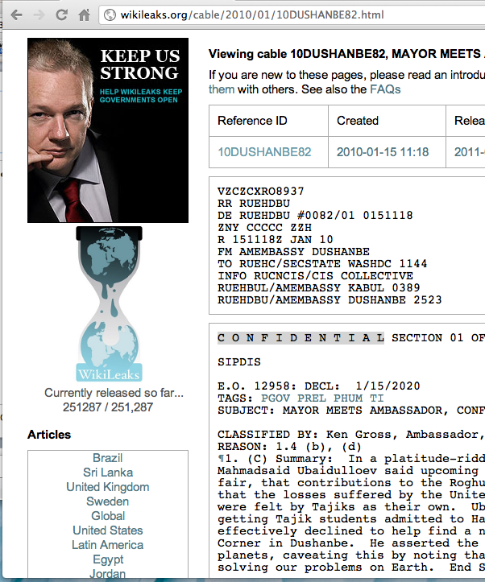
Five-level classification scheme

Unclassified data

Sensitive But Unclassified (SBU) data

Confidential data

Secret data

Top secret data

Wikileaks Cables

Link Ch 3d

Most organizations do not need the detailed level of classification

Suggested classifications:

Public

For Official Use Only

Sensitive

Classified

Security Clearances

Each user of an information asset is assigned an authorization level

Indicates the level of information classification he or she can access

Assign each employee a titular role

Data entry clerk, development programmer, information security analyst, or even CIO

Nondiscretionary Access Controls

Determined by a central authority in the organization

Role-based access controls or RBAC

Based on roles

Task-based access controls

Based on a specified set of tasks

Discretionary Access Controls (DACs)

Implemented at the discretion of the data user

Rule-based access controls

Granted based on a set of rules specified by the central authority

Content-dependent access controls

Dependent on the information’s content

Constrained user interfaces

Systems designed specifically to restrict the information that an individual user can access

Temporal (time-based) isolation

Information can only be accessed depending on what time of day it is

Centralized vs. Decentralized Access Controls

Collection of users with access to the same data typically have a centralized access control authority

Even using a discretionary access control model

Varies by organization and type of information protected

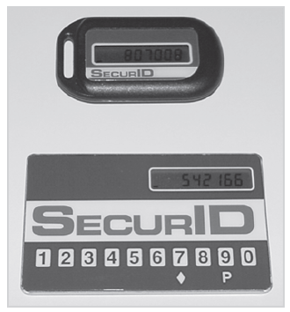
The Authentication Process

Authentication

Act of confirming the identity of a potential user

Verify identity by providing one or more of:

Something you know

Something you have

Something you are

Something you do

Strong authentication

Authentication system uses two or more different forms of confirming the proposed identity

Network authentication forms:

Local authentication

Most common form of authentication

Centralized authentication service

Most commonly set up as a form of auditing

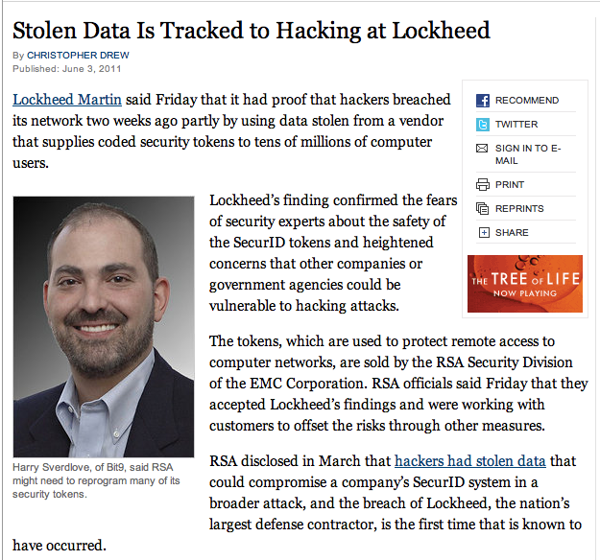
Tokens

Synchronous tokens

Use the present time to generate an authentication number entered during the user login

Asynchronous tokens

Use a challenge-response system

RSA Hacked

Link Ch 3f

Biometrics

Retinal scans, fingerprints, etc.

Mainly done by large, security-minded entities

How Firewalls Implement the Authentication Process

Many organizations depend on firewalls to provide more secure authentication than conventional systems

Firewall uses authentication to identify individuals

Apply the rules that are associated with those individuals

General process:

The client makes a request to access a resource

Firewall intercepts the request and prompts the user for name and password

User submits the requested information to firewall

The user is authenticated

Request checked against the firewall’s rule base

If the request matches an existing allow rule, the user is granted access

The user accesses the desired resources
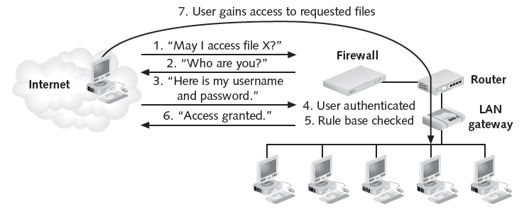

Firewall Authentication Methods

Some firewalls provide a variety of authentication methods

Including user, client, or session authentication

User Authentication

Simplest type of authentication program

Prompts the user for a username and password.

Software checks the information against a list of usernames and passwords in its database

Authorized users added to your access control lists (ACLs)

Only allows Telnet, HTTP, FTP and RLOGIN attempts (for Checkpoint firewalls)

See link Ch 3a

Client Authentication

Establish limits to user access

Firewall enables the authenticated user to access the desired resources for a specific period of time or a specific number of times

Configure client authentication

Standard sign-on system

Specific sign-on system

Allows any protocol for the specified time (for Checkpoint firewalls)

Session Authentication

Requires authentication whenever a client system attempts to connect to a network resource and establish a session

Requires session agent software to be installed on each client (for Checkpoint firewalls)

Some advanced firewalls offer multiple authentication methods

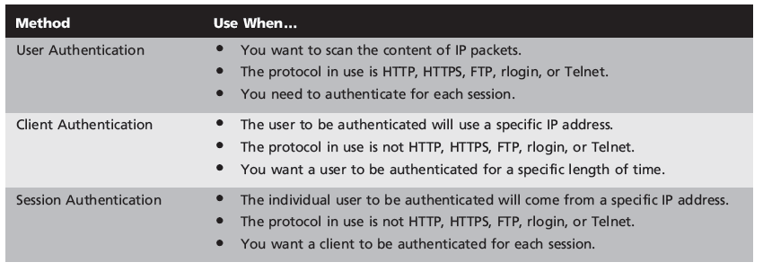

Centralized Authentication
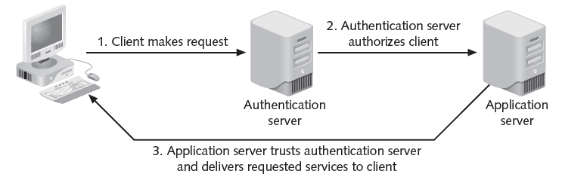

Alleviates the need to provide each server on the network with a separate database of usernames and passwords

Substantial downside:

Authentication server becomes a single point of failure

Different authentication methods

Kerberos,

TACACS+

RADIUS

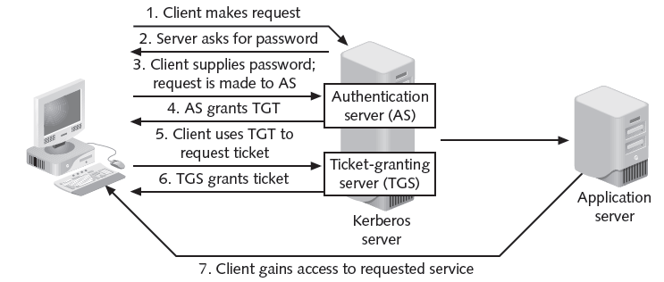
Kerberos

Kerberos

Developed at the Massachusetts Institute of Technology (MIT)

Provides authentication and encryption on standard clients and servers

Both client and server place their trust in the Kerberos server

Used internally on many Windows systems

Never sends or stores passwords in cleartext (Serious error in textbook on page 79!)

See links Ch 3b, Ch 3c.

Advantage of using Kerberos

Passwords are not stored on the system

Cannot be intercepted by hackers

Tickets tend to have a time limit

Widely used in the UNIX environment

TACACS+

Terminal Access Controller Access Control System Plus (TACACS+)

Latest and strongest version of a set of authentication protocols developed by Cisco Systems

Provide the AAA services

Authentication, authorization, accounting

Uses a hashing algorithm (MD5) to keep the password itself a secret

RADIUS

Remote Authentication Dial-In User Service (RADIUS)

Does not transmit cleartext passwords

Stores cleartext passwords on the server

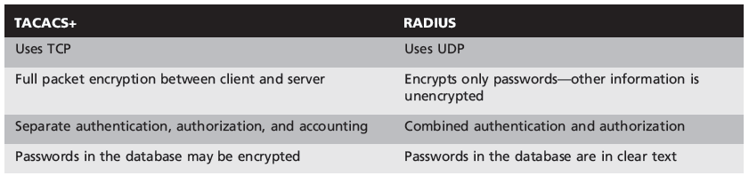
TACACS+ and RADIUS Compared

Strength of security

Filtering characteristics

TACACS+ uses TCP Port 49

RADIUS uses UDP Port 1812 and 1813

See Table 3-3

Proxy characteristics

RADIUS doesn’t work with generic proxy systems

RADIUS server can function as a proxy server

NAT characteristics

RADIUS doesn’t work with Network Address Translation (NAT)

TACACS+ should work with NAT systems

Static IP address mappings work best for both

Password Security Issues

Many authentication systems depend in part or entirely on passwords

Method is truly secure only for controlling outbound Internet access

Password guessing and eavesdropping attacks are likely on inbound access attempts

Preventing Passwords from Being Cracked

Avoid vulnerabilities by ensuring that network’s authorized users

Protect their passwords effectively

Observe some simple security habits

The Shadow Password System

Linux stores passwords in the /etc/passwd file

In encrypted format using a one-way hash function

Shadow password system

Feature of the Linux operating system

Enables the secure storage of passwords

File has restricted access

Passwords are stored only after being encrypted with the salt value and an encoding algorithm

One-Time Password Software

Two types of one-time passwords are available:

Challenge-response passwords

Authenticating computer or firewall generates a random number (the challenge) and sends it to the user, who enters a secret PIN or password (the response)

Password list passwords

User enters a seed phrase, and the password system generates a list of passwords

Other Authentication Systems

Most firewalls make use of one or more well-known systems

RADIUS and TACACS+

Other systems for authentication:

Certificate-based

802.1x Wi-Fi

Certificate-Based Authentication

Use of digital certificates to authenticate users

Must set up a Public-Key Infrastructure (PKI)

Generates keys for users

User receives a code called a public key

Generated using the server’s private key

Uses the public key to send encrypted information to the serve

802.1x Wi-Fi Authentication

Provides for authentication of users on wireless networks

Can use many authentication methods, including smart card, digital certificate, or hashed passwords

Error on page 84: Other methods besides smart card & certificate are possible

Link Ch 3g

Enables a system that uses Wi-Fi to authenticate users on other kinds of network operating systems

