Overview

Identify common misconceptions about firewalls

Explain why a firewall is dependent on an effective security policy

Understand what a firewall does

Describe the types of firewall protection

Recognize the limitations of firewalls

Introduction

Firewalls and related technical controls are a fundamental security tool

Overview of the issues involved in planning and designing firewalls

Each individual firewall

Combination of software and hardware components

Firewalls Explained

Firewall

Anything that can filter the transmission of packets of digital information

As they attempt to pass through an interface between networks

Basic security functions:

Packet filtering

Allow or deny packets based on rules

Application proxy

Provide network services to users while blocking direct connections to them

Misconceptions about Firewalls

Firewalls

Permit authorized traffic to pass through while blocking unauthorized and unwanted traffic

Need constant maintenance to keep up with the latest security threats

Work best as part of a multilayered approach to network security

An Analogy: Office Tower Security Guard

Firewall performs same types of functions as does a security guard at a checkpoint

Monitors entry and exit points

Scans for viruses and repairing infected files before they invade the network

Can be configured to send out alert messages and notify staff of break-ins or if viruses are detected

Firewall Security Features

Advanced security functions offered by some firewalls

Logging

VPN

Authentication

Shielding hosts inside the network so that attackers cannot identify them and use them as staging areas for sustained attacks

Caching data

Filtering content that is considered inappropriate

Firewall Network Perimeter Security

Perimeter

Boundary between two zones of trust

Blurred by

Extranet

VPN

Mobile devices

Benefit of locating firewall at the perimeter

Set up a checkpoint where you can block viruses and infected e-mail messages before they get inside
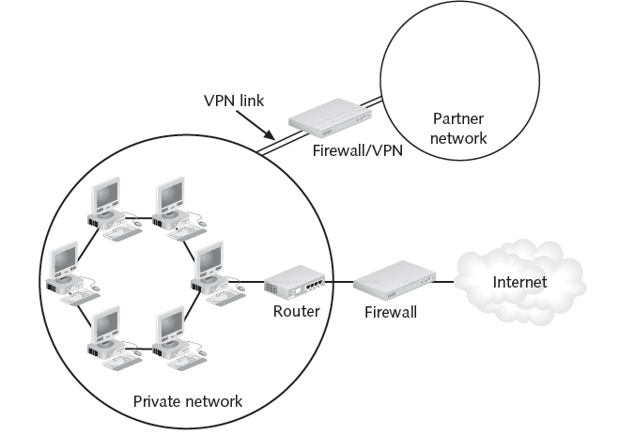

Figure 4-2 VPN Perimeter

Firewall Components

Packet filter

Proxy server

Authentication system

Software that perform Network or Port Address Translation (NAT or PAT)

Bastion host

Has only the bare essentials

See Figure 4-3

Firewall Security Tasks

Restricting access from outside the network

Regulate which packets of information can enter the network

Firewall that does packet filtering protects networks from port scanning attacks

Restricting unauthorized access from inside the network

Prevent damage from malicious and careless employees
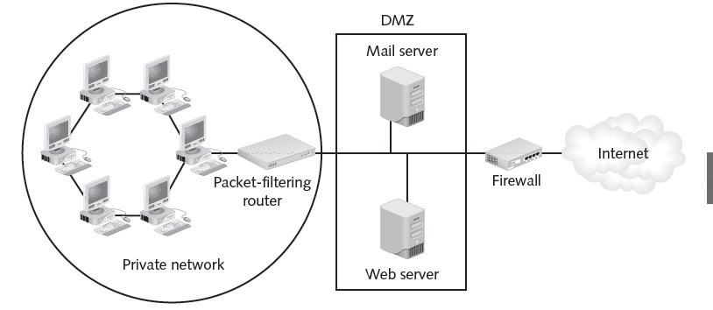Figure 4-3 DMZ Networks

Technical Details: Ports

Ports

Allow many network services to share a single network address

Socket

Combination of a sender’s full address and receiver’s address

Port numbers come in two flavors:

Well-known ports: number 1023 or below

Ephemeral ports: number from 1024 to 65535

Limiting employee access to external hosts

Provide precise control of how employees inside the network use external resources

Act as a proxy server

Protecting critical resources

Protect from varied types of attacks

Protecting against hacking

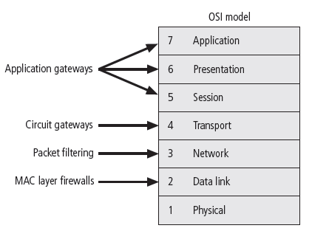
Attacks can also have tangible organization-wide impact

Providing centralization

Centralizes security for the organization it protects

Enabling documentation

Provide information to the network administrator in the form of log files

Providing for authentication

Users with registered usernames and passwords are recognized by the server and allowed to enter

Contributing to a VPN

Connects two companies’ networks over the Internet

Types of Firewall Protection

Firewalls work in different ways

Seven-layer OSI networking model

See Figure 4-5

Packet Filtering

Packet

Sometimes called a datagram

Basic element of network data

Contains two types of information: header and data

Packet-filtering firewall

Functions at the IP level

Determines whether to drop a packet or forward it to the next network connection based on the rules programmed into the firewall

Filtering firewalls

Inspect packets at the network layer (Layer 3) of the OSI model

When device finds a packet that violates a rule, it stops the packet from traveling from one network to another

Based on a combination of the following:

IP source and destination address

Direction (inbound or outbound)
Figure 4-9 Packet Filtering Router

TCP or UDP (User Datagram Protocol) source and destination port
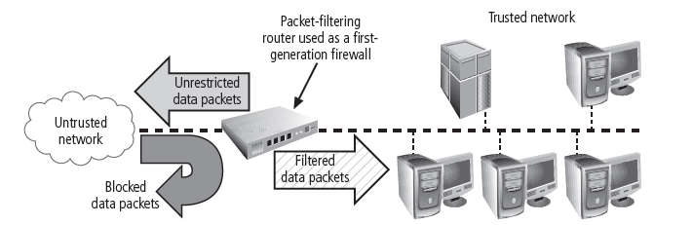

Stateless packet-filtering firewalls

Ignores the state of the connection between the internal computer and the external computer

Stateful packet-filtering firewalls

Examination of the data contained in a packet and the state of the connection between the internal and the external computer

State table

Kept in a memory location called the cache.

Can leave the system vulnerable to a DoS or DDoS attack

Packet-filtering rules

Depends on the establishment of rules

Must have a basic understanding of how some of the various protocols that make up the Internet function

Internet Control Message Protocol (ICMP)

User Datagram Protocol (UDP)

TCP filtering

IP filtering

PAT and NAT

Each computer on a network is assigned an IP address

Port Address Translation (PAT) and Network Address Translation (NAT)

Make internal network addresses invisible to outside computers

Function as an outbound network-level proxy

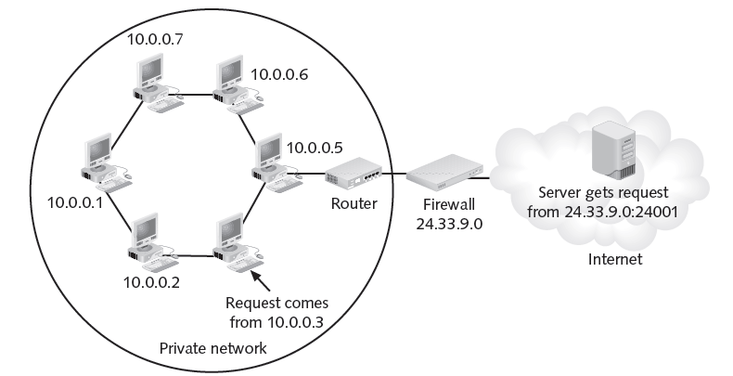
Figure 4-11 Port Address Translation (PAT)

Application Layer Gateways

Work at the Application layer

Control the way applications inside the network access external networks by setting up proxy services

Minimize the effect of viruses, worms, Trojan horses, and other malware

Run special software that enable them to act as a proxy for a specific service request

Primary disadvantage

Designed for a specific protocol

Cannot easily be reconfigured to protect against attacks on other protocols

Valuable security benefit

Can be configured to allow or deny (both actions can be taken as a result of filtering) specific content, such as viruses and executables

Offline
“X” Marks the Spot

Letter “x” used in two ways

10.10.x.x, where the “x” indicates a value in the range of 0 to 254 that can be assigned by the user organization

Represent “any” value, but in a different location

Any address that meets the defined portion of the address

Technical Details: Fresh Hot CIDR

“CIDR”

Classless Inter-Domain Routing

CIDR Mask

Mitigate the inefficiencies in the way IP addresses used to be organized and assigned

Assigns addresses using the demarcation between network address and host address

Slash (/) and number following the slash

Indicate where the boundary between network address and host address is located

CIDR Notation

Class A: 10.11.12.13

Subnet mask: 255.0.0.0

Subnet mask in binary:

11111111 00000000 00000000 00000000

CIDR: 10.11.12.13/8

Because there are 8 1’s in the subnet mask

Class B: 147.144.1.212

Subnet mask: 255.255.0.0

Subnet mask in binary:

11111111 11111111 00000000 00000000

CIDR: 147.144.1.212/16

Because there are 16 1’s in the subnet mask

Class C: 208.67.220.220

Subnet mask: 255.255.255.0

Subnet mask in binary:

11111111 11111111 11111111 00000000

CIDR: 208.67.220.220/24

Because there are 24 1’s in the subnet mask

Firewall Categories

“Processing mode”

How the firewall examines the network traffic that it is trying to filter

“Generation”

Level of technology a firewall has

Later generations being more complex and more recently developed

“Structure”

Kind of structure for which the firewalls are intended

Processing Mode

Five major processing-mode categories for firewalls:

Packet-filtering firewalls, application gateways, circuit gateways, MAC layer firewalls, and hybrids

Most are hybrids

Packet-filtering firewalls

Three kinds of packet-filtering firewalls:

Static filtering

Rules must be manually configured

Dynamic filtering

Automatically changes rules in response to network events

Stateful inspection

Maintains a state table

Application gateways

Frequently installed on a dedicated computer,

Separate from the filtering router

Commonly used in conjunction with a filtering router

Circuit gateways

Operates at the transport layer

Connections are authorized based on addresses

Very similar to port forwarding

SOCKS proxies work this way

Link Ch 4a

MAC layer firewalls

Operate at the media access control sublayer of the data link layer

Consider specific host computer’s identity

Not common

Similar to MAC address filtering in wireless networks

Hybrid firewalls

Combine the elements of various types of firewalls

Firewall Generations

First-generation firewalls

Static packet-filtering firewalls

Second-generation firewalls

Application-level firewalls or proxy servers

Third-generation firewalls

Stateful inspection firewalls

Fourth-generation firewalls

Also known as dynamic packet-filtering firewalls

Allow only a particular packet with a particular source, destination, and port address to enter

Fifth-generation firewalls

Kernel proxies

Works under Windows NT Executive

Kernel of Windows NT

2nd & 3rd Generation are Switched Sometimes

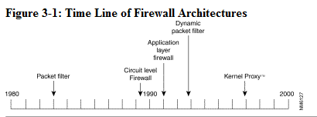
From Cisco (link Ch 4b)

Firewall Structures

Commercial-grade firewall appliances

Stand-alone, self-contained combinations of computing hardware and software

Have many of the features of a general-purpose computer

With the addition of firmware-based instructions

Increase reliability and performance

Minimize the likelihood of being compromised

Commercial-grade firewall systems

Consists of application software that is configured for the firewall application

Runs on a general-purpose computer

Full-featured, commercial-grade firewall packages

Check Point Power-1

Cisco ASA

Microsoft Internet Security & Acceleration Server

McAfee Firewall Enterprise (Sidewinder)

Small office/home office (SOHO) firewall appliances

Most effective methods of improving computing security in the SOHO setting

Serves first as a stateful firewall

Enables inside-to-outside access

Can be configured to allow limited TCP/IP port forwarding and/or screened subnet capabilities

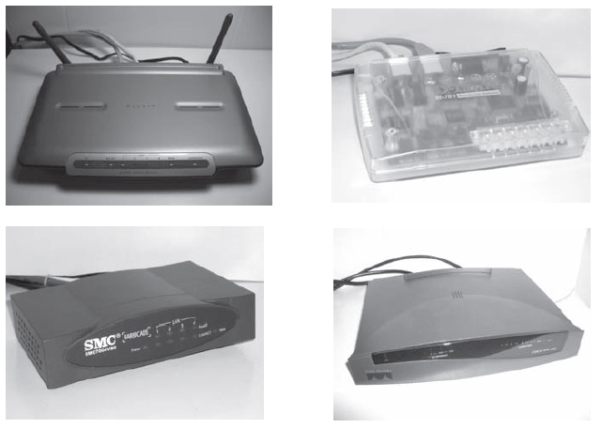
Broadband router devices

Can function as packet-filtering firewalls

Enhanced to combine the features of wireless access points (WAPs) as well as small stackable LAN switches in a single device

Provide more than simple NAT services

Include packet filtering, port filtering, and simple intrusion detection systems

Restrict access to specific MAC addresses

Software firewalls

Many of the firewalls in Table 4-4 provide free versions of their software

Not fully functional

“You get what you pay for”

Free firewall tools on the Internet

Most of the free firewall software also run on a free operating system

Convenience, simplicity, and unbeatable price

Netfilter/iptables

Firewall software that comes with the Linux 2.4 kernel

Powerful solution for stateless and stateful packet filtering, NAT, and packet processing

Link Ch 4c

Software vs. hardware: the SOHO firewall debate

Hardware device

If the attacker manages to crash the firewall system

Computer and information are still safely behind the now-disabled connection

Assigned a nonroutable IP address

Virtually impossible to reach from the outside

Software device

Can be disabled and allow free network access

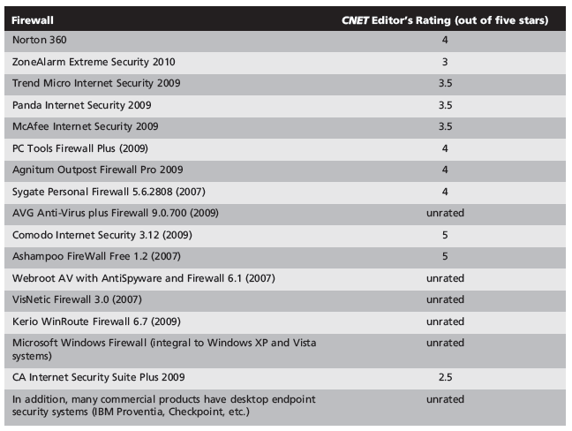
Table 4-4 Common Software Firewalls As Rated by CNET (www.cnet.com)

Firewall Architectures

Packet-filtering routers

Can be configured to reject packets that the organization does not allow into the network

Screened host firewalls

Combine the packet-filtering router with a separate, dedicated firewall

Application proxy server

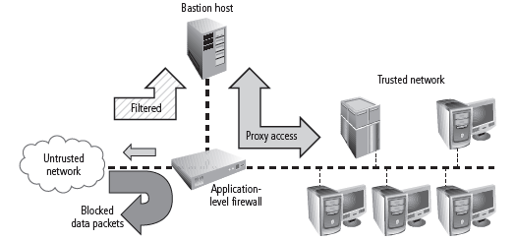
Figure 4-17 Screened Host Architecture

Dual-homed host firewalls

Bastion host contains two NICs rather than one

One NIC is connected to the external network

One is connected to the internal network

All traffic must physically go through the firewall to move between the internal and external networks
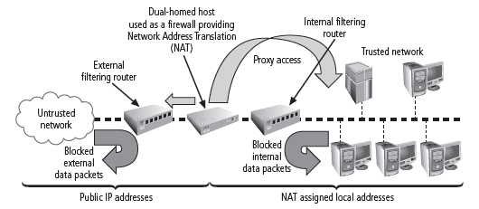
Figure 4-18 Dual-Homed Host

Screened subnet firewalls (with DMZ)

Dominant architecture used today

Subnet firewall consisting of two or more internal bastion hosts behind a packet-filtering router

Each host protecting the trusted network

Many variants of the screened subnet architecture

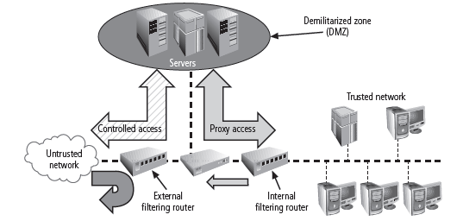

Figure 4-19 Screened Subnet

Limitations Of Firewalls

Cannot be expected to do everything

Should not be the only form of protection for a network

