Overview

Describe packets and packet filtering

Explain the approaches to packet filtering

Configure specific filtering rules based on business needs

Introduction

Packets

Discrete blocks of data

Basic unit of data handled by a network

Network traffic is broken down into packets for network transmission

Then reassembled into its original form at its destination

Packet filter

Hardware or software that blocks or allows transmission of information packets based on criteria

Understanding Packets and Packet Filtering

Packet filter

Acts like a doorman in a very popular night club

Reviews the packet header before sending it on its way to a specific location within the network

Packet-Filtering Devices

Routers:

Most common packet filters

Operating systems

Built-in utilities can filter packets on the TCP/IP stack of the server software

Software firewalls

Most enterprise-level programs filter packets

Firewall appliances

Standalone hardware and software devices that have self-contained components

Anatomy of a Packet

Part of Transport Control Protocol/Internet Protocol (TCP/IP)

Provides for the transmission of data in small, manageable chunks

Start as messages developed by the higher-level protocols

Format it into usable data sets

Lower-networking protocols take packets and break them into frames

Coded as electronic pulses on the media

Each packet consists of two parts:

Header

Contains information that is normally only read by computers

Data

Part that end users actually see

IP Header

Header of an IP packet

See Figure 5-2

Version: identifies the version of IP that was used to generate the packet

Internet Header Length: describes the length of the header in 32-bit words

Type of Service: indicates which of four service options is used to transmit the packet:

Minimize delay, maximize throughput, maximize reliability, and minimize cost

Total Length: 16-bit field gives the total length of the packet

Identification: 16-bit value aids in the division of the data stream into packets of

Information Flags: 3-bit value tells whether this packet is a fragment

Fragment Offset: If the data received is a fragment, indicates where the fragment belongs in the sequence of fragments

So that packet can be reassembled

Time to Live (TTL): 8-bit value identifies the maximum time the packet can remain in the system before it is dropped

Protocol: identifies the IP protocol that was used in the data portion of the packet

Header Checksum: summing up of all the 16-bit values in the packet header in a single value

Source IP Address: address of the computer or device that sent the IP packet

Destination IP Address: address of the computer or device that is to receive the IP packet

Options: can contain a security field, as well as several source routing fields

Data: part that the end user actually sees

Trailer or footer: contains data that indicates the end of the packet (optional)

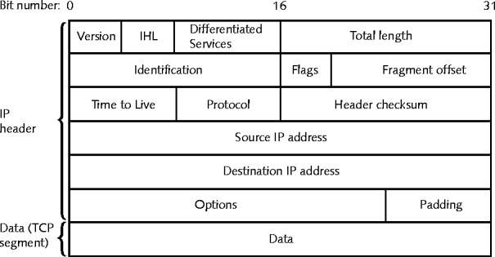
IP packet

Technical Details
The Binary Connection

Actual packets sent and received across the Internet are encoded into binary

Just 1s and 0s

Example:

Time to Live (TTL): 8-bit value

In binary, packet’s life can be between 00000001 and 11111111

Between 1 and 255 hops (also referred to as device transfers)

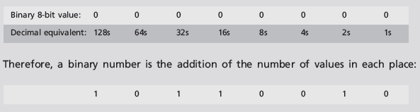

Packet-Filtering Rules

“Allow” rules

Packet is allowed to pass

“Deny” rules

Packet is dropped

Packet filters only examine packet headers

Common rules for packet filtering:

Drop all inbound connections except connection requests for configured servers

Eliminate packets bound for all ports that should not be available to the Internet

Filter out any ICMP redirect or echo (ping) messages

Drop all packets that use the IP header source routing feature

Small-scale, software-only personal firewall

Should set up an access list that includes all of the computers in your local network by name or IP address so communications can flow between them

Easy way to identify computers on the local network

Put them in a list of machines in a trusted zone

Block all the traffic that uses protocol on all ports

Add specific ports or programs that enable only the functionality that is needed

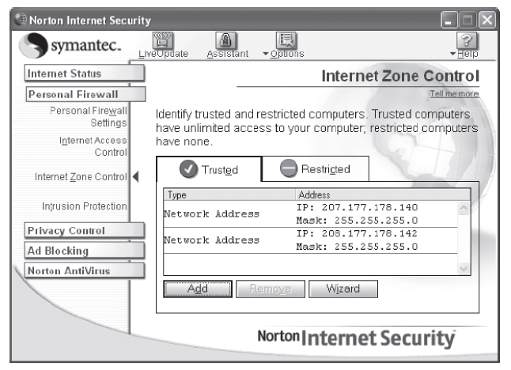
Figure 5-3 Trust Rules

Packet-Filtering Methods

Stateless packet filtering

Reviews packet header content

Allow or drop the packets based on whether a connection has actually been established between an external host and an internal one

Stateful packet filtering

Maintains a record of the state of a connection and can thus make informed decisions

Filtering based on packet content

Based on the contents of the data part of a packet and the header

Stateless Packet Filtering

Stateless packet filters

Useful for completely blocking traffic from a subnet or other network

Filtering on IP header criteria

Compares the header data against its rule base and forwards each packet as a rule is found to match

Acknowledgement (ACK) flag

Indicates destination computer has received the packets that were previously sent

Can be used to determine connection status

Source IP address

First IP header criteria you can filter on

Allow only certain source IP addresses to access your resources

Destination IP address

Enable external hosts to connect to your public servers in the DMZ, but not to hosts in the internal LAN

Protocol

Specify which protocols are available

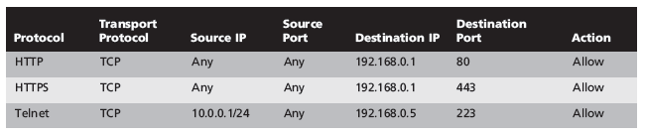
23
Table 5-1 Filtering by Destination IP and Port Number

IP protocol ID field

Internet Group Management Protocol (IGMP) enables a computer to identify its multicast

Options

Rarely used

Filtering by TCP or UDP port number

Called port filtering or protocol filtering

Helps filter a wide variety of information

Filtering by ICMP message type

Internet Control Message Protocol (ICMP)

General management protocol for TCP/IP

Used to diagnose various communication problems and communicate certain status information

A firewall/packet filter must be able to determine, based on message type, whether an ICMP packet should be allowed to pass

Common ICMP message types are shown in Table 5-2

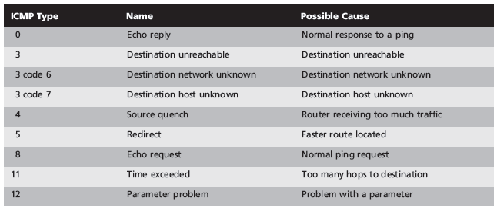
Table 5-2 ICMP Message Types

Filtering by fragmentation flags

TCP or UDP port number appears only in fragments numbered 0

Should have the firewall reassemble fragmented packets before making the admit/drop decision

Filtering by ACK flag

Configure the firewall to allow packets with the ACK bit set to 1 to access

Only the ports you specify

Only in the direction you want

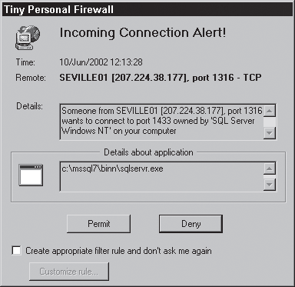
Filtering suspicious inbound packets

If a packet arrives at the firewall from the external network but contains an IP address that is inside the network

Firewall should send an alert message

Most firewalls customize rules to work with all ports or all protocols

Stateful Packet Filtering

Stateful filter

Can do everything a stateless filter can

Also has ability to maintain a record of the state of a connection

Powerful enterprise firewalls do stateful packet filtering

State table

List of current connections

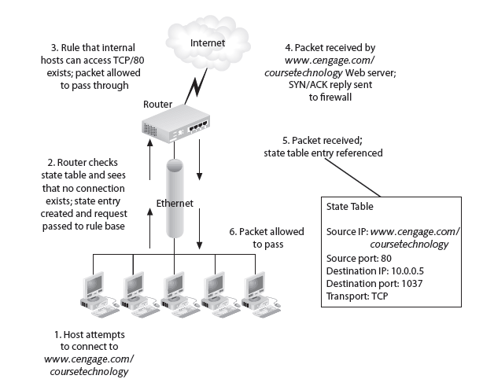
Figure 5-8 Stateful Packet Filtering

Stateful packet filtering limitation

Inspects only header information and doesn't verify the packet data

Filtering Based on Packet Content

Some traffic uses packets that are difficult to filter reliably for various reasons

Stateful inspection

Examine both the contents of packets and the headers for signs that they are legitimate

Temporarily opens high-numbered ports when FTP needs them, then closes them again

Proxy gateway

Looks at the data within a packet to decide how to handle it

May keep logs by username, block certain types of email attachments, etc.

Link Ch 5b

Specialty firewall

Spam or content filter

Looks at the body of e-mail messages or Web pages for profanities or other content identified as offensive

FTP Port Usage Demo

watch "netstat -an | grep .*tcp4.*147\.144.*"

Link Ch 5a
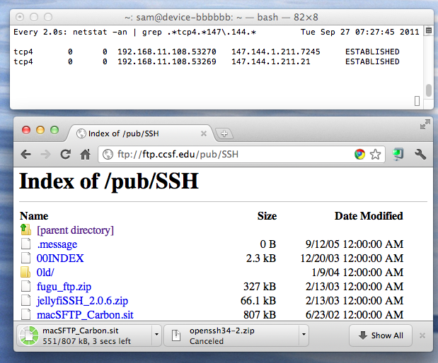

Setting Specific Packet Filter Rules

Establish packet-filter rules that control traffic to various resources

Block potentially harmful packets

Pass packets that contain legitimate traffic

Each rule must be crafted, placed in proper sequence, debugged, and tested

Place resource-intensive rules after the most restrictive rules, to decrease the number of packets that must be inspected so thoroughly

Best Practices for Firewall Rules

Firewall device is never accessible directly from the public network

Restrict internal access as well, require encrypted protocol & two-factor authentication

Simple Mail Transport Protocol (SMTP) data

Allowed to pass through the firewall, but all of it is routed to a well-configured SMTP gateway

All Internet Control Message Protocol (ICMP) data denied

Telnet access to all internal servers from the public networks is blocked

HTTP traffic

Prevented from reaching the internal networks via the implementation of some form of proxy access or DMZ architecture

Test all firewall rules before they are placed into production use

ftester is an old tool to test firewalls (link Ch 5c)

scapy is newer and more powerful (link Ch 5d)

Included in BackTrack

Rules That Cover Multiple Variations

Packet-filter rules

Account for all possible ports that a type of communication might use or for all variations within a particular protocol

Created and modified as a result of trial and error

Figure 5-9

Typical LAN that is protected by a firewall and two routers

Rules allow Web, FTP, e-mail, and other services while blocking potentially harmful packets from getting to the internal LAN

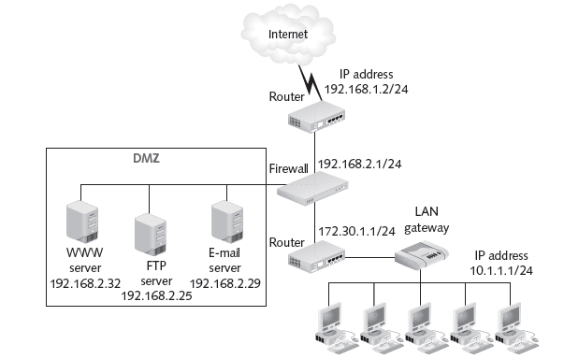
Figure 5-9 Sample Network

Rules for ICMP Packets

ICMP packets

Easily forged

Used to redirect other communications

Packet Internet Groper (commonly called ping)

Determines if a host is unreachable on the network

Establish specific ICMP commands

Table 5-3

Rules to send and receive needed ICMP packets

While blocking those that open internal hosts to intruders

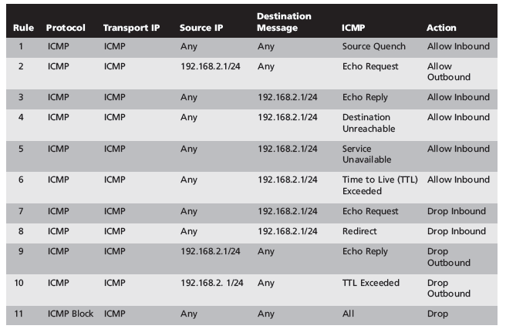
Table 5-3 ICMP Packet Filter Rules

Rules That Enable Web Access

Cover

Standard HTTP traffic on TCP Port 80

Secure HTTP (HTTPS) traffic on TCP Port 443

Table 5-4

Rules for Internet-accessible Web server in test network

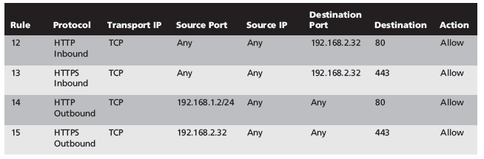
Table 5-4 HTTP Access Rules

Rules That Enable DNS

Employees need to be able to resolve the fully qualified domain names (FQDNs)

Domain Name System (DNS)

Uses either UDP Port 53 or TCP Port 53 for connection attempts

Table 5-5

Rules that enable external clients to access computers in own network using the same TCP and UDP ports

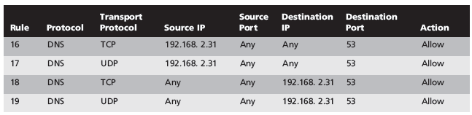
Table 5-5 Rules That Enable DNS Resolution

Rules That Enable FTP

FTP transactions

Either active or passive.

Support two separate connections:

TCP Port 21: FTP control port

TCP 20: FTP data port.

Client can establish a connection with the FTP server at any port above 1023

Table 5-6

Specify the IP address of your FTP server

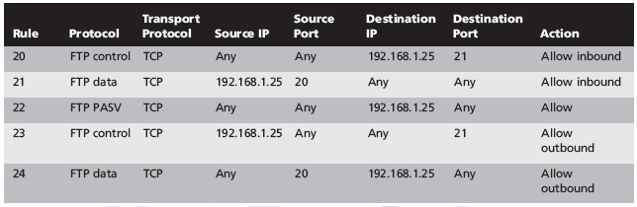
Table 5-6 Rules to Enable Active and Passive FTP

Rules That Enable E-Mail

Setting up firewall rules that filter e-mail messages can be difficult

Large variety of e-mail protocols used

Table 5-7

Configuration only uses POP3 and SMTP for inbound and outbound e-mail, respectively

Assess:

Whether your organization needs to accept incoming e-mail messages at all

Whether users can access external mail services

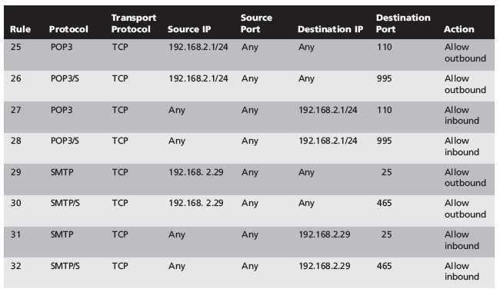
Table 5-7 POP3 and SMTP E-mail Rules

Last modified: 10:13 am 9-27-11

