Overview

Identify and implement different firewall configuration strategies

Update a firewall to meet new needs and threats

Adhere to proven security principles to help the firewall protect network resources

Use a remote management interface

Track firewall log files and follow the basic initial steps in responding to security incidents

Understand the nature of advanced firewall functions

Introduction

Use one or more firewalls in conjunction with routers, gateways, hubs, and switches

Block many common attacks while permitting hosts inside the network to access the Internet.

Ongoing firewall administration necessary to maintain security

Establishing Firewall Rules and Restrictions

Rule set

Set of instructions based on organizational policy

Configured by the administrator

Give the firewall specific criteria for deciding whether to allow packets through or drop them

The Importance of the Rule Set

Restrictive approach

Blocks all access by default

Permits only specific types of traffic to pass through

Permissive or connectivity-based approach

Primary intent is to let all traffic through

Block specific types of traffic

Rules implemented by the firewall

Enable internal traffic to get outside the network

Establish an execution order that the firewall should follow

Restrictive Firewalls

Primary goal of a firewall: block unauthorized access

Deny-All approach

Blocks everything by default

Only allows those services you need on a case-by-case basis

Table 6-1

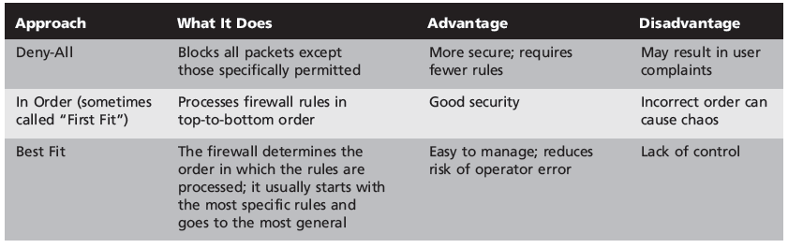

Restrictive approaches

Least privilege

Minimum system privileges

Connectivity-Based Firewalls

Primary orientation of firewall is permissive

Allows connectivity through the gateway

Burden is on the security administrator to educate coworkers on how to use the network responsibly

Table 6-2
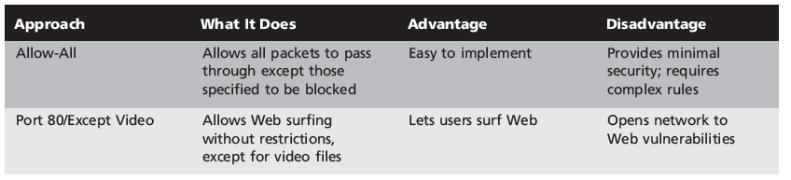

Lists the advantages and disadvantages of firewalls that emphasize connectivity

Permissiveness is not an either/or question

Rules must be placed in a very specific order or they will not work properly

Firewall Configuration Strategies: A High-Level Overview

Scalable

Grow with the network it protects

Take into account the communication needs of individual employees

Deal with the IP address needs of the organization

Scalability

Adapt to the changing needs of the organization

Increase the need for firewall resources

Periodic review

Upgrade software and hardware as needed

Productivity

Stronger and more elaborate firewall means slower data transmissions

Productivity

Concern for a proxy server

Consider processing and memory resources available to bastion host

Critical resource

Software- or hardware-related item that is indispensable to the operation of a device or program

Performance considerations

System memory

Hard drive capacity

Hard drive I/O throughput

System CPU capacity

Interface (Network card) data rate

Host OS socket performance

Dealing with IP Address Issues

IP addresses needed by demilitarized zone (DMZ) and service network

Network Address Translation (NAT) or Port Address Translation (PAT)

Convert internal network to private addresses

IP forwarding

Enables a packet to get from one network’s OSI stack of interfaces to another

Should be disabled on routers and other devices that lie between the networks

Approaches That Add Functionality to the Firewall

Network security setups can become incrementally more complex when specific functions added

Can be part of a perimeter security system that includes a firewall:

NAT/PAT

Encryption

Application proxies

VPNs

Intrusion detection and prevention systems

NAT/PAT

Converts publicly accessible IP addresses to private ones and vice versa

Shields the IP addresses of computers on the protected network from those on the outside

Table 6-3

Ranges of commonly used private addresses
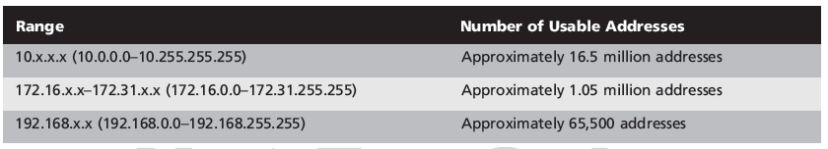

Encryption

Secure Sockets Layer (SSL)

Or other type of encryption

Takes a request, encrypts it using a private key, and exchanges the public key with the recipient firewall or router
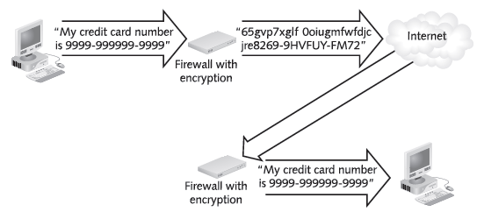

Application Proxies

Application proxy

Service that acts on behalf of a client

Receive requests

Rebuild them from scratch

Forward them to the intended location as though the request originated with it (the proxy)

Set up with either a dual-homed host or a screened-host system

VPNs

Virtual private network (VPN)

Connects internal hosts with specific clients in other organizations

Encrypted and limited to machines with specific IP addresses (link Ch 6a)

VPN gateway

Can go in a screened subnet

Or the gateway can bypass the firewall and connect directly to the internal LAN

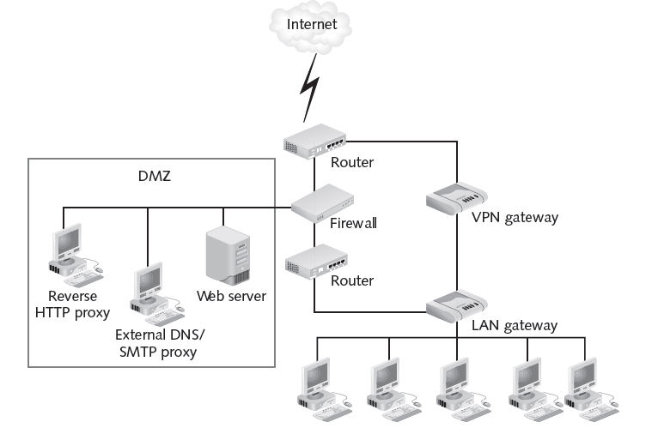

Intrusion Detection and Prevention Systems

Software

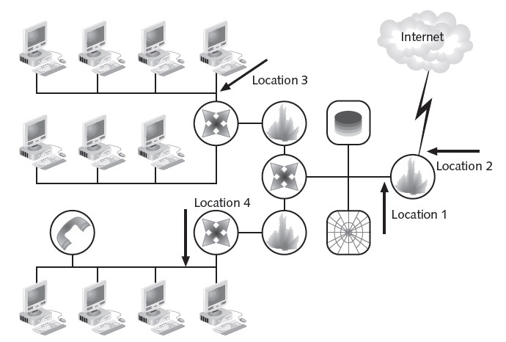
Detect intrusion attempts

Notify administrators when they occur

React dynamically to the intrusion

Sensors can be placed in various locations to provide information on attacks

Enabling a Firewall to Meet New Needs

Organization should consider the following constraints:

Throughput

Scalability

Security

Recoverability

Manageability

Might need to upgrade the security software, hardware, or even add new layers of security to the overall firewall perimeter

Verifying Resources Needed by the Firewall

Test firewall and evaluate performance

Ensure that the network traffic is moving efficiently

Make use of vendor recommendations

Keep track of the memory and system resources being consumed

Use the vendor’s software-monitoring feature

Follow a best practice approach

Systems are purchased and equipped with the recommended amounts of memory

Identifying New Risks

Monitor activities on an ongoing basis

Store all the data that accumulates

In the form of logs

Keep informed of the latest dangers

Install patches and updates as they become available

Adding Software Updates and Patches

Install updated software specifically designed to meet threats

Combat the constant stream of new viruses and security threats

Develop a maintenance window

Period of two or three hours that is set aside every month

Perform improvements such as software upgrades

Some software-only firewalls provide automatic update module

Adding Hardware

Whenever a piece of hardware is added to the network

Identify in some way

So firewall can include it in its routing and protection services

Applies to routers, VPN appliances, and other gateways added as the network

Choose good passwords that you then guard closely

Be sure to change default password

Dealing with Complexity on the Network

Distributed firewalls

Installed at all endpoints of the network

Including the remote computers that connect to the network through VPNs

Install and maintain a variety of firewalls

Located in own corporate network and in remote locations

Configure remote users to access your network via a VPN

Determine what level of firewall security they already have

SCADA Vulnerabilities and the Air Gap

Not in book

SCADA Vulnerabilities

Link Ch 6b

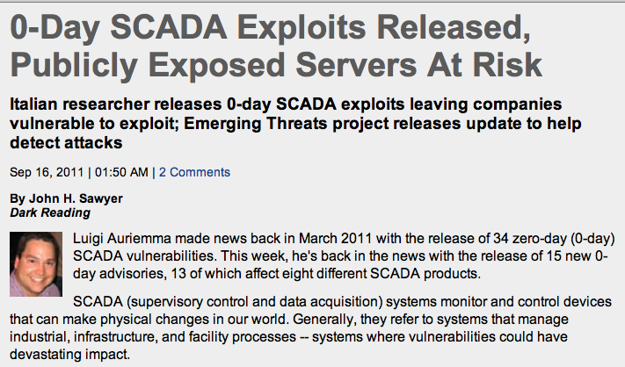

290 Vulnerable Sites

Using SHODAN

Outside USA

Link Ch 6c

Even Worse

Later articles claim that many other systems are vulnerable, including passenger jets

Links Ch 6d, 6e

DHS Response

Link Ch 6f

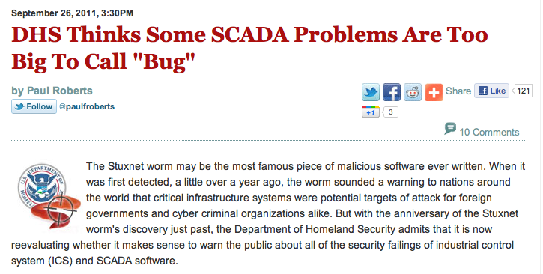

Back to Textbook

Adhering to Proven Security Principles

Generally Accepted System Security Principles (GASSP)

Set of security and information management practices put forth by the International Information Security Foundation (I2SF)

Accountability

Awareness

Ethics

Multidisciplinary

Proportionality

Integration

Timeliness

Assessment

Equity

Environmental Management

Measures to reduce risks to the physical environment where the resources are stored

Secure building where network resources located

From natural disasters such as earthquakes, floods, hurricanes, or tornadoes

Consider installing:

Power-conditioning systems

Back-up hardware and software

Sprinkler and fire alarm systems

Locks to guard against theft

BIOS, Boot, and Screen Locks and Passwords

Laptop computers:

Boot-up and supervisor passwords

Post public notice in the company’s logon screen

Boot-up password

Also called BIOS or CMOS password

Must be entered to complete the process of starting up a computer

Blocks booting to removable media, like floppy disk, CD/DVD, or USB

Examples: Kon-boot, Ophcrack, UBCD

Supervisor password

Used to gain access to the BIOS set-up program or to change the BIOS password

Screen saver password

Make screen saver vanish to return to desktop and resume working

Remote Management Interface

Software used to configure and monitor one or more firewalls that are located at different network locations

Start and stop the firewall

Change the rule base

Why Remote Management Tools Are Important

Saves many hours

Makes the security administrator’s job much easier

Reduces the chance of configuration errors

Might result if the same changes have to be made manually for each firewall in the network

Security Concerns

Remote management interface offers strong security controls

Multifactor authentication and encryption

Auditing features

Keep track of who uses the software and when

Uses tunneling to connect to the firewall or certificates for authentication

Rather than establishing an insecure connection like a Telnet interface

Basic Features of Remote Management Tools

Monitor and configure firewalls from single centralized location

Start and stop firewalls as needed

View and change firewall status

View the firewall’s current activity

View any firewall event or alert messages

Stop or start firewall services as needed

Automating Security Checks

May be more efficient to outsource the firewall administration

Must be a high level of trust in the outside company to maintain network security

Ask network administrators in other organizations for their personal recommendations

Scan security-related sites such as SANS (www.sans.org) for recommendations

Configuring Advanced Firewall Functions

High availability

Operates on a 24/7 basis or close to it

Scalability

Grow while maintaining its effectiveness as the organization grows

Data Caching

Caching

Storing data in a part of disk storage space

So it can be retrieved as needed

One of the primary functions of proxy servers

Choose one of four options

No caching

UFP server (URL Filtering Protocol)

VPN & Firewall (cache after one request)

VPN & Firewall (cache after two requests)

Hot Standby Redundancy

Standby system

One or more auxiliary (or failover) firewalls are configured to take over all traffic if the primary firewall fails

Only involves two firewalls: primary and secondary

Heartbeat network

Monitors the operation of the primary firewall

Synchronizes the state table connections so the two firewalls have the same information at any given time
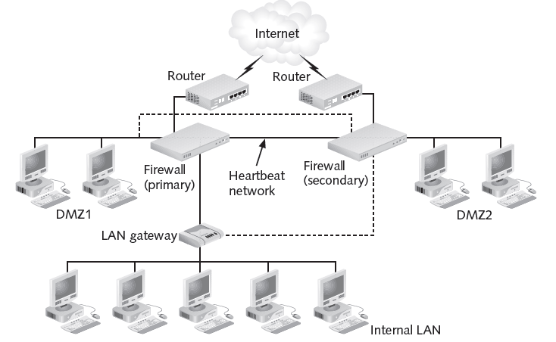
Figure 6-9 Hot Standby Example

Load Balancing

Mission-critical

Integral, key part of the company’s core operations

Must maximize firewall’s uptime and smooth operation

Load balancing

Distributing the work placed on the firewall so that it is handled by two or more firewall systems

Load sharing

Configuring two or more firewalls to share the total traffic load

Traffic between firewalls distributed by routers using special routing protocols

Open Shortest Path First (OSPF)

Border Gateway Protocol (BGP)

Layer four switches

Network devices with the intelligence to make routing decisions based on source and destination IP address or port numbers

Filtering Content

Open Platform for Security (OPSEC) model

Extend functionality and integrate virus scanning into set of abilities

Content Vectoring Protocol (CVP)

Enables firewalls to work with virus-scanning applications so that such content can be filtered out

Antivirus protection

Fast becoming one of the most important aspects of network security

Last modified: 9 am 10-4-11

