Overview

Describe proxy servers and their function

Identify the goals your organization can achieve using a proxy server

Discuss critical issues in proxy server configurations

Evaluate the most popular proxy-based firewall products

Explain how to deploy and use reverse proxy

Determine when a proxy server is not the correct choice

Introduction

Proxies can:

Conceal the end users in a network

Filter out undesirable Web sites

Block harmful content

Most proxy servers function as firewalls at the boundaries of networks

Perform packet filtering, Network Address Translation (NAT), and other services

Overview of Proxy Servers

Proxy servers

Also called proxy services, application-level gateways, or application proxies

Specialized firewall software applications

Evaluate the application-layer data buried in the data portion of an IP packet

Most common to dedicate a device to a single application

HTTP for Web traffic, SMTP for e-mail, etc.

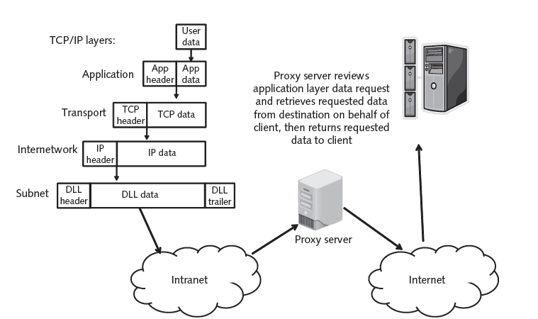

How Proxy Servers Work

Function as a software go-between

Screen all traffic into and out of the relevant ports

Decide whether to block or allow traffic based on rules set up by the proxy server administrator

Main complaint about proxy servers

Time they take to inspect, compare, and rebuild packets and process client requests

How Proxy Servers Differ from Packet Filters

Create much more detailed log file listings than packet filters

Rebuild the packet with new source IP information

Shields internal users from those on the outside

Attacks that can start with mangled packet data never reach the internal host

Far more critical to network communications than packet filters—failure of the proxy server usually blocks network access

Sample Proxy Server Configurations

Figure 7-3

Computer that has two separate network interfaces, one to the external Internet and one to the internal LAN

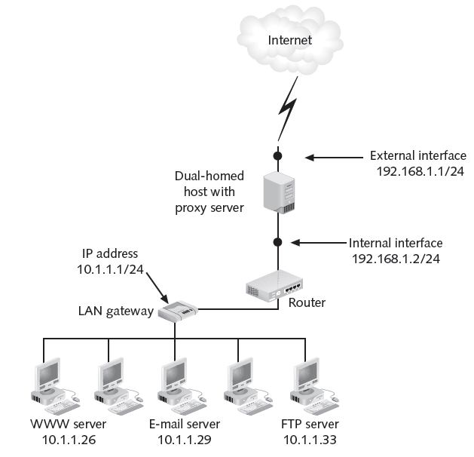
Figure 7-3 Proxy Using a Dual-Homed Host

Figure 7-4

Packet filter has an interface on the Internet

Configured so that external traffic is allowed to pass only if it is destined for a service provided on the proxy server

Sits on the protected side of the perimeter

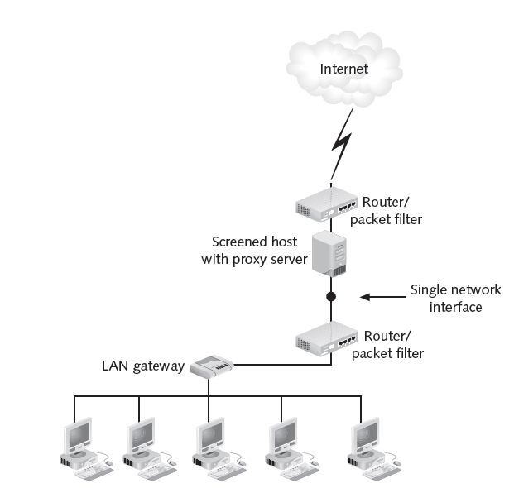
Figure 7-4 Proxy Using a Screened Host

Common Proxy Servers

Small business:

Wingate for Windows (link Ch 7a)

Squid for many OS's (link Ch 7b)

Large business

Microsoft Internet Security and Acceleration Server has been replaced by Microsoft Forefront Threat Management Gateway (links Ch 7c, 7d)

Sun Java System Web Proxy Server 4.0 is now Oracle iPlanet Proxy Server 4.0

(link Ch 7e)

Benefits of Proxy Servers

Understand benefits that proxy systems can provide

Concealing Internal Clients

Conceal internal clients from external clients

External clients see a single machine

Commonly used to share Internet connections

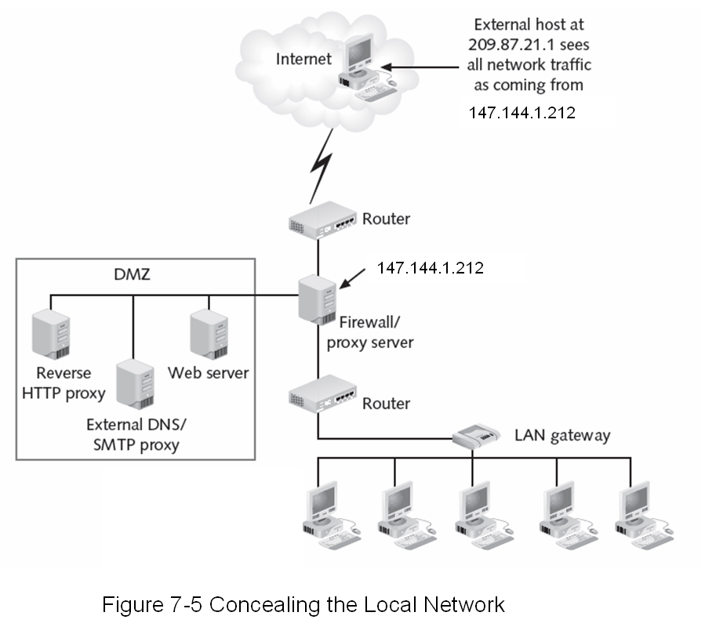

Blocking URLs

Block users from accessing certain URLs

Configure either IP addresses or DNS names

Security policy

More effective method of preventing employees from visiting certain Web sites

Link Ch 7f

URLs can easily be changed

Blocking and Filtering Content

Configure to scan packets for questionable content

Java applets or ActiveX controls

Executable files attached to e-mail messages

Filtering parameters: time, IP address, and port number, etc.

All proxy server products scan the payload of a packet

Provide some sort of content-filtering system

E-Mail Proxy Protection

Can be used to support and protect other network services, including e-mail

Figure 7-7

Configuration that provides e-mail protection for a network with a proxy Simple Mail Transfer Protocol (SMTP) server

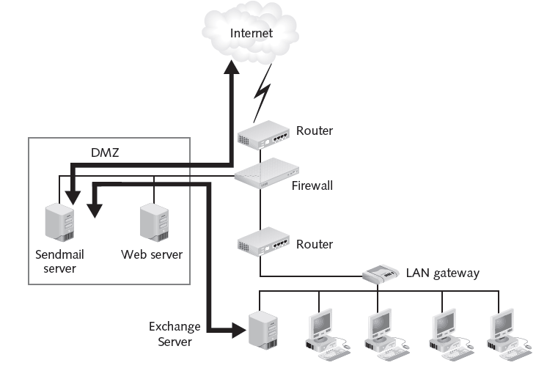
Figure 7-7 E-Mail Proxy Protection

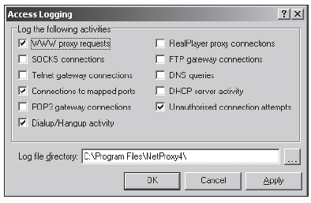
Improving Performance

Slow down some requests for information

Speed up access to documents that have been requested repeatedly

Store Web pages in a disk cache

Ensuring Security

Log files

Tedious and time consuming to review

Serve several different functions to help ensure the effectiveness of a
firewall
Figure 7-8 NetProxy Logging Services

Proxy servers provide very complete log files

Providing User Authentication

Most proxy server products can prompt users who connect to the server for a username and password

Redirecting URLs

Scan specific parts of the data portion of an HTTP packet

Redirect it to a specific location

Known as URL redirection

Direct clients to a different Web server based on the Host: field in the HTTP request

Many Web servers have URL redirection built in

Alleviate the need for a proxy server to do redirection

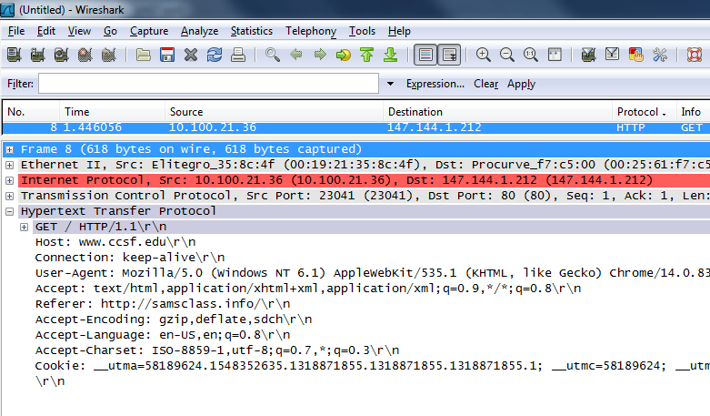
HTTP GET

Configuring Proxy Servers

Make sure proxy server has enough capacity

If it gets overloaded, client performance will suffer

Must configure the environment properly

Configuration of the proxy server itself

May need to configure each piece of client software that uses the proxy server

Potential security vulnerabilities

Present a single point of failure for the network

Susceptible to various forms of attack

Providing for Scalability

As number of users on the network grows

Machine that hosts the proxy server should be upgraded

Capacity of the server must match the amount of traffic that has to flow through each gateway

Can add multiple proxy servers to the same network connection

Working with Client Configurations

Configure each client program to work with the proxy server

Specify for FTP and Gopher connections

Browser can use the SOCKS standard

Configuration file

Browsers on your network can automatically retrieve the proxy settings

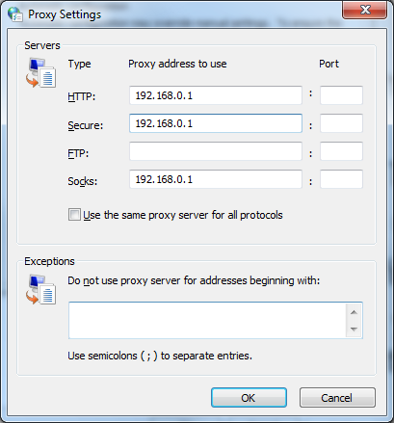
SOCKS Proxy

SOCKS proxy is a circuit-level gateway

Layer 5

Used by Tor

Link Ch 7g

To open this box, in Windows

Internet Options

Connections

LAN Settings

Use a proxy server…

Advanced

Working with Service Configurations

General-purpose firewall includes a proxy server that monitors all inbound and outbound traffic

HTTP and DNS

SMTP and POP3 for e-mail

Use SOCKS generic proxy

For services for which no proxy server is available

Creating Filter Rules

Firewall rules

Optimize the performance of the proxy environment

Enable known hosts to bypass the proxy

Filter out specific URLs

Enable internal users to send outbound requests only at certain times

Govern the length of time a session can last

Recognizing the Single Point of Failure

Potential to be a single point of failure for the network

Network could be totally cut off from the Internet

Most network architectures include alternate means of enabling traffic to flow

Network load balancing (NLB)

Use multiple systems to take turns handling requests

Prevent any one system from getting overloaded

Recognizing Buffer Overflow Vulnerabilities

Problems that result from misconfiguration or other vulnerabilities

Buffer overflow

Attempt to store more data in a temporary storage area than that area can hold

Resulting overflow of data renders the program nonfunctional

Check manufacturer’s Web site for patches

Choosing a Proxy Server

WinGate

Commercial product primarily used by home and small business users

Squid

Designed to protect one type of service (Web or FTP) and to serve cached Web pages

Hybrid firewall

Combines several different security technologies such as packet filtering, application-level gateways, and VPNs

Transparent Proxies

Totally invisible to end users

Sits between two networks like a router

Firewall intercepts outgoing traffic

Directs it to a specific computer, such as a proxy server

No client configuration needed

Can leaks client IP address out

Nontransparent Proxies

Also called explicit proxies

Require that the client software be configured

All target traffic is forwarded to the proxy at a single target port

Typically by means of the SOCKS protocol

Require more labor to configure than transparent proxies

Each client program must be set up to route all requests to a single port

Provide greater security than transparent proxies

SOCKS-Based Proxies

SOCKS

Protocol that enables the establishment of generic proxy applications

Used to direct all traffic from the client to the proxy using a target port of TCP/1080

Acts as a transparent proxy

Operates at Session Layer, as a circuit-level gateway

Can encrypt data between client & proxy

Hides local IP addresses

Disadvantage: does not examine the data part of a packet

SocksCap

Free SOCKS application available from Permeo Technologies

Graphical interface

Quickly configure applications to use SOCKS

Last updated in 2007

Proxy Server-Based Firewalls Compared

Choice depends on:

Platform

Number of hosts and services to protect

Squid

High-performance and free open-source application

Specially designed to act as a proxy server and cache files for Web and FTP servers

Performs access control and filtering

Especially good at quickly serving cached files

Runs on all UNIX-based systems (also Windows)

Developers have come up with plug-in applications that enhance functionality

WinGate

WinGate

By QBIK

Very popular proxy server for home and small business environments

Components

WinGate

WinGate VPN

PurSight (Web content classification)

Kaspersky AV

NetPatrol (IDS)

Norton from Symantec

Norton offers a number of residential firewall and security applications

Also provide various degrees of content filtering and proxy services

Combine antivirus functions with network and system protection

Microsoft Internet Security & Acceleration Server

Microsoft proxy server product

Complex, full-featured firewall

Includes stateful packet filtering as well as proxy services, NAT, and intrusion detection

Standard Edition and Enterprise Edition

Replaced by Microsoft Forefront Threat Management Gateway

Reverse Proxies

Acts as a proxy for inbound connections

Used outside the firewall as a secure content server to outside clients

Prevent direct, unmonitored access to your server’s data from outside your company

Setup shown in Figure 7-14

Benefits

Performance

Cut down on unnecessary requests

Reduces the load on the company’s Web server

Privacy

Stand-in for a Web server can protect sensitive information stored on that Web server that must remain secure

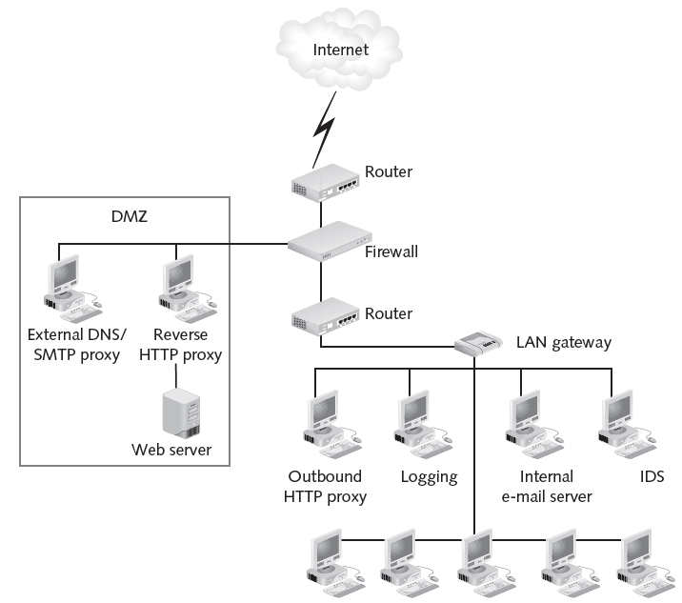
Figure 7-14 Reverse Proxy Example

When a Proxy Server Isn’t the Correct Choice

Some organizations find that a proxy server slows down traffic excessively

Might use ISP proxy server

But better off installing and configuring own proxy server even for small home or business network

Last modified: 2 pm 10-17-11

