Overview

Describe the role encryption plays in firewall and VPN architectures

Explain how digital certificates work and why they are important security tools

Analyze the workings of SSL, PGP, and other popular encryption schemes

Discuss Internet Protocol Security (IPSec) and identify its protocols and modes

Introduction

Firewalls can be equipped to serve Virtual Private Network (VPN) endpoints

Encryption

Integral part of VPNs

Enables the firewall to determine whether the user who wants to connect to the VPN is actually authorized to do so

Encodes the payload of the information to maintain privacy

Encryption Overview

Encryption

Process that turns information that is plainly readable (plaintext) into scrambled form (ciphertext)

Added to firewall and VPN products to provide protection against:

Passive attacks -- sniffing

Loss of confidentiality

Active attacks -- session hijacking

Loss of integrity

Packet integrity and confidentiality is maintained

Security statistics

Laptop is stolen every 12 seconds

Over 2.6 million laptops stolen per year

42 percent of surveyed companies suffered laptop or mobile device theft

Average loss of over $234,000 per incident

Another source says $49,000 (link Ch 9a)

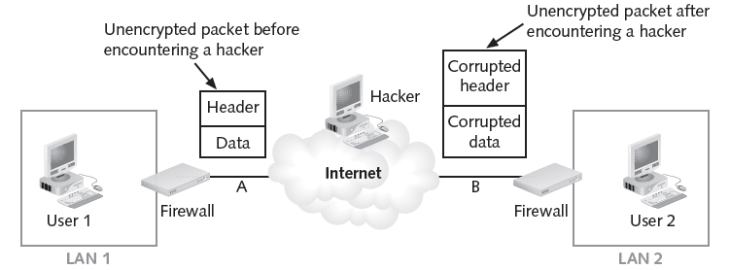
Unencrypted Packet

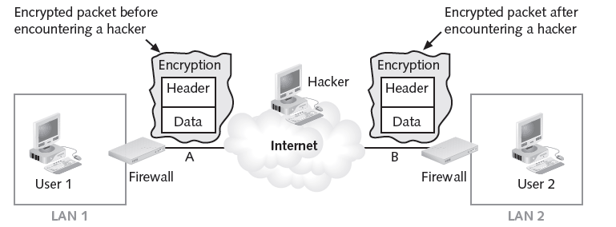
Encrypted Packet

Principles of Cryptography

Encryption

Converting a message into a form that cannot be read by unauthorized individuals

Cryptology encompasses two disciplines

Cryptography

Encoding and decoding messages so that others cannot understand them

Cryptanalysis

Deciphering the original message from an encrypted message without knowing the algorithms and keys used to perform the encryption

Encryption Definitions

Algorithm:

Mathematical formula or method used to convert an unencrypted message into an encrypted message

Cipher:

Transformation of the individual components (characters, bytes, or bits) of an unencrypted message into encrypted components

Ciphertext or cryptogram:

Encrypted or encoded message resulting from an encryption

Cryptosystem:

Set of transformations necessary to convert an unencrypted message into an encrypted message

Decipher:

Decrypt or convert ciphertext to plaintext

Encipher:

Encrypt or convert plaintext to ciphertext

Key or cryptovariable:

Information used in conjunction with the algorithm to create the ciphertext from the plaintext

Keyspace:

Entire range of values that can possibly be used to construct an individual key

Plaintext:

Original unencrypted message or the results from successful decryption

Work factor:

Amount of effort (usually expressed in units of time) required to perform cryptanalysis on an encoded message

General methods: stream or block ciphers

Stream

Each plaintext bit is transformed into a cipher bit, one after the other

Block

Message is divided into blocks

Each block is transformed using the algorithm and key

Common Encryption Operations

Substitution

A -> D; B ->E

Transposition

APPLE -> PALEP

XOR (Exclusive OR)

1100101 XORed with

1001010

-------------

0101111

Common Ciphers

Substitution cipher

Substitute one value for another

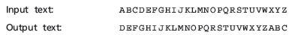

Monoalphabetic substitution

Uses only one alphabet

Polyalphabetic substitutions

More advanced substitution ciphers

Use two or more alphabets

Transposition cipher

Rearranges the values within a block to create the ciphertext

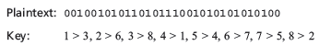

Transposition ciphers and substitution ciphers

Used in multiple combinations to create a very secure encryption process

XOR cipher conversion

Bit stream is subjected to a Boolean XOR function against some other data stream

Process is reversible

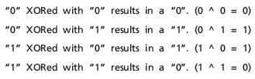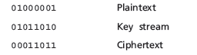

Vernam Cipher (One-Time Pad)

Developed at AT&T

Uses a set of characters for encryption operations only one time and then discards it

Unbreakable--there is no pattern in the output

No way to crack it without stealing the one-time pad

Book Code

Uses text in a book as the algorithm to decrypt a message

Relies on:

Knowing which book to use

Having a list of codes representing the page number, line number, and word number of the plaintext word

Sample message: 67,3,1;145,9,4;375,7,4;394,17,3

Using dictionaries

Necessary to use only a page and word number

Symmetric Encryption

Secret key

Used to both encipher and decipher the message

Known as private key encryption, or symmetric encryption

If either copy of the key becomes compromised

An intermediary can decrypt and read the messages

Popular symmetric encryption cryptosystems:

Data Encryption Standard (DES)

56-bit key

Cracked in 1997

Triple DES (3DES)

Improvement to DES

Uses as many as three keys in succession

Performs three different encryption operations

Employs 48 rounds in its encryption computation,

Effective strength: 112 bits

Require only three times longer to process

Rijnjdael Block Cipher features a variable block length key length of either 128, 192, or 256 bits

Four steps within each Rijndael round

Symmetric Encryption

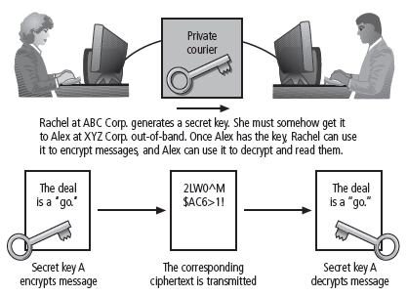

Animation of AES Algorithm

Link Ch 9b

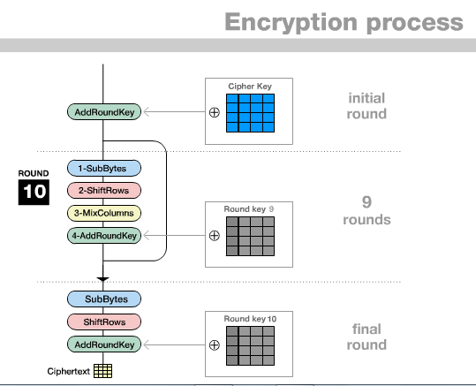

Asymmetric Encryption
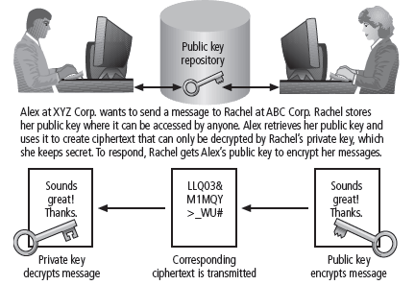

Asymmetric Encryption

Public key encryption

Uses two different keys for encryption and decryption

Most valuable when one of the keys is private and the other is public

Requires four keys to hold a single conversation between two parties

Not as efficient in its use of CPU resources as symmetric encryption

Because of the extensive mathematical calculations

Digital Signatures

Asymmetric process is reversed

Private key encrypts a message

Public key decrypts it

Proves message was sent by the organization that owns the private key

Digital signatures

Encrypted messages that can be independently verified by a central facility (registry) as authentic

Can also be used to prove certain characteristics of the message or file with which they are associated

Often used in Internet software updates

Digital certificate

Similar to a digital signature

Asserts that a public key is associated with a particular identity

Certificate authority (CA)

Agency that manages the issuance of certificates

Serves as the electronic notary public to verify their origin and integrity

Encryption Operations: RSA

Rivest-Shamir-Aldeman (RSA)

Has been integrated into both Microsoft Internet Explorer and Netscape Navigator

Extensions to the RSA algorithm

RSA Encryption Scheme—Optimal Asymmetric Encryption Padding (RSAES-OAEP)

RSA Signature Scheme with Appendix—Probabilistic Signature Scheme (RSASSA-PSS)

Public Key Infrastructure

Public key infrastructure (PKI)

Entire set of hardware software, and cryptosystems necessary to implement public key encryption

Common implementations of PKI include

Systems to issue digital certificates to users and servers

Encryption enrollment

Key-issuing systems

Tools for managing the key issuance

Verification and return of certificates

Key revocation services

Other services associated with PKI that vendors bundle into their products

PKI can increase organization’s capability to protect its information assets by providing

Authentication

Integrity

Confidentiality

Authorization

Nonrepudiation

Hybrid Systems

Asymmetric encryption used to exchange a symmetric key

Two organizations can conduct quick, efficient, secure communications

Based on symmetric encryption

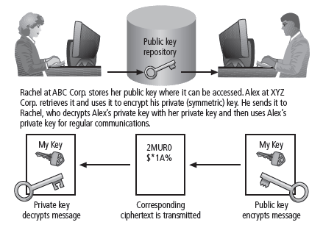

Using Cryptographic Controls

Organizations can use cryptographic controls to support

Confidentiality and integrity of e-mail and its attachments

Authentication, confidentiality, integrity, and nonrepudiation of e-commerce transactions

Authentication and confidentiality of remote access through VPN connections

A higher standard of authentication when used to supplement access control systems

E-Mail Security

Secure/Multipurpose Internet Mail Extensions (S/MIME)

Builds on the Multipurpose Internet Mail Extensions (MIME)

Encode format by adding encryption and authentication via digital signatures based on public key cryptosystems

Privacy Enhanced Mail (PEM)

Proposed by the Internet Engineering Task Force (IETF) as a standard for public key cryptosystems

Uses 3DES symmetric key encryption and RSA for key exchanges and digital signatures

Pretty Good Privacy (PGP)

Uses the IDEA Cipher

Uses a "Web of Trust" instead of Certificate Authorities

Securing the Web

Secure Electronic Transactions (SET)

Developed by MasterCard and VISA

Provides protection from electronic payment fraud works by encrypting the credit card transfers with DES for encryption and RSA for key exchange

Secure Sockets Layer (SSL)

Provide security for online electronic commerce transactions

Has largely been replaced by TLS (Transport Layer Security)

Many people still refer to it as SSL

Hypertext Transfer Protocol over SSL (HTTPs)

Encrypted solution to the unsecured version of HTTP

Provide secure e-commerce transactions as well as encrypted Web pages for secure data transfer over the Web

Secure Shell (SSH)

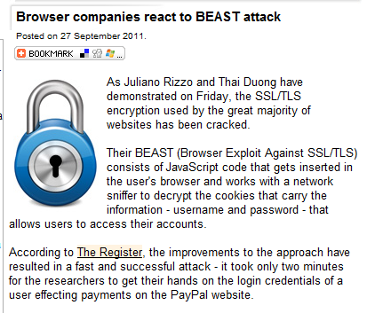
Extension to the TCP/IP protocol suite

Provides security for remote access connections over public networks by creating a secure and persistent connection

BEAST Attack

Exploits a weakness in cipher-block chaining

Can break into an SSL connection without the key

Most browsers have been patched now

Link Ch 9c

IP Security (IPSec)

Predominant cryptographic authentication and encryption protocol suite in use today

Combines:

Diffie-Hellman key exchange

Public key cryptography

Bulk encryption algorithms

Digital certificates

IPSec components

IP Security protocol itself

Internet Key Exchange (IKE)

IPSec modes:

Transport mode

Only the IP data is encrypted

Tunnel mode

Entire IP packet is encrypted and inserted as the payload in another IP packet

Virtual private network (VPN)

Private, secure network

Operated over a public and insecure network

Keeps the contents of the network messages hidden from observers

Securing Authentication

Kerberos

Uses symmetric key encryption to validate an individual user’s access

Consists of:

Authentication Server (AS)

Key Distribution Center (KDC)

Kerberos Ticket Granting Service (TGS)

Attacks on Cryptosystems

Frequency Analysis (incorrectly called "brute force" on page 277)

Ciphertext is repeatedly searched for clues that can lead to the algorithm’s structure.

Known as ciphertext attacks

Involve searching for a common text structure, wording, or syntax in the encrypted message

Known-plaintext attack

Helps to reverse-engineer the encryption algorithm

Brute Force Attack (not in textbook)

Simply try every possible key

56-bit and 64-bit keys have been brute-forced

A 72-bit key is being brute-forced, and is expected to be cracked within 90 years

Ch 9f

Selected-plaintext attack

Sending the potential victim a specific text that gets forwarded to others

Attacks on cryptosystems

Man-in-the-middle

Correlation

Dictionary

Timing

Man-in-the-Middle

Intercept the transmission of a public key

Can be prevented by establishing public keys with digital signatures

Trusted third party

Attacker cannot duplicate the signatures

Correlation Attacks

Collections of brute-force methods

Attempt to deduce statistical relationships between the structure of the unknown key and the ciphertext

Defense against this kind of attack

Selection of strong cryptosystems that have stood the test of time

Thorough key management

Strict adherence to the best practices of cryptography in the frequency of changing keys

Dictionary Attacks

Attacker encrypts every word in a dictionary using the same cryptosystem used by the target

Attempt to locate a match between the target ciphertext and the list of encrypted words from the same cryptosystem

Windows does not salt password hashes and is therefore vulnerable to dictionary attacks

Timing Attacks

Attacker eavesdrops during a victim’s session

Uses statistical analysis of the user’s typing patterns and inter-keystroke timings to discern sensitive session information

It can also use timing of the encryption process itself to deduce information about the key

Replay Attack

Replay encrypted packets without decrypting them

Effective against SMB authentication (Windows file shares)

Defending from Attacks

Encryption

Process of hiding the true meaning of information

Sophisticated encryption and cryptosystems

Have the same flaw that the first systems contained thousands of years ago

If you discover the key, you can determine the message

Last modified: 2 pm 11-1-11

