Overview

Explain the components and essential operations of virtual private networks (VPNs)

Describe the different types of VPNs

Discuss VPN setups, such as mesh or hub-and-spoke configurations

Select the right VPN tunneling protocol for a specific user need

Define the process of setting up secure remote access for individual users via a VPN

Discuss best practices for effective configuration and maintenance of VPNs

Introduction

Private leased lines

Give the user dedicated use of a predefined bandwidth or data rate

Often used to connect remote users or branch offices to a central administrative site

Don’t scale well

VPNs

Function like private leased lines

Provide a means of secure point-to-point communications over the public Internet

VPN Components and Operations

Many telecommunications companies provide VPN services

Can be set up with special hardware or with firewall software that includes VPN functionality

Many firewalls have VPN systems built into them

Goal of a VPN

Provide a cost-effective and secure way to connect business locations to one another and connect remote workers to office networks

VPN Components

Endpoints

Hardware and/or software components that perform encryption and encapsulation,

VPN connection

Occurs within the context of a TCP/IP tunnel

Tunnel

Channel or pathway over a packet network used by the VPN

Runs through the Internet from one endpoint to another

Not a physical connection

Virtual tunnel

Communications path that makes use of Internet-based hosts and servers to conduct data from one network station to another

Figure on (next page)

Illustrates that VPNs in fact traverse the public Internet and must therefore handle the Internet’s protocols and procedures

Devices that form the endpoints of the VPN:

Server running VPN protocols

VPN appliance

Firewall/VPN combination

Router-based VPN

Certificate servers

Manage certificates if that is required

Client computers

Run VPN client software

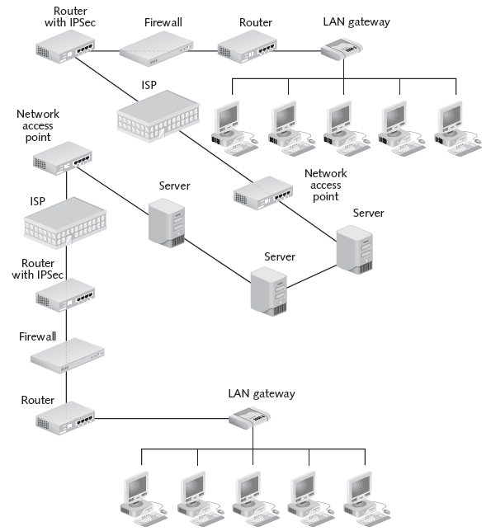

Essential Activities of VPNs

IP encapsulation

Data payload encryption

Encrypted authentication

IP Encapsulation

Hides the source and destination information of the encapsulated packets

Encapsulating packet

Uses the source and destination addresses of the VPN gateway

Encapsulated packet

Source and destination IP addresses can be in the private reserved blocks

Not usually routable over the Internet

Data Payload Encryption

Encryption accomplished using:

Transport mode

Host encrypts data when it is transmitted

Header is not encrypted

Tunnel mode

Traffic encrypted in transit

Entire packet encrypted, including headers

Level of encryption varies

Longer keys makes stronger encryption

Encrypted Authentication

Encryption domain

Everything in the protected network and behind the gateway

Authentication

Hosts in the network need to know that originating host is an approved user of the VPN

Exchange of long blocks of code, called keys

Generated by complex formulas called algorithms

Benefits and Drawbacks of VPNs

Benefits

Secure networking without the expense of establishing and maintaining leased lines

Allow the packet encryption/translation overhead to be done on dedicated systems

Provide control of physical setup

Drawbacks

Complex

If configured improperly, can create significant network vulnerabilities

Make use of the unpredictable and often unreliable Internet

Can expose inner workings of network

If misconfigured

VPNs Extend Network Boundaries

VPN users will have a high-speed connection that is always on

Can be connected to network around the clock

Exposes your network to viruses & intrusions

Guidelines for “always-on” users

Use two or more authentication tools to identify remote user

Multifactor authentication

Integrate virus protection

Use Network Access Control (NAC)

Checks security settings on the remote computer before granting access

Microsoft's Quarantine Server (links Ch 10a, 10b)

Set usage limits

Types of VPNs

Site-to-site VPN

Links two or more networks

Client-to-site

Makes a network accessible to remote users

Options for configuring VPNs:

Hardware systems, software systems, and systems that combine hardware and software

VPN Appliances

General-purpose hardware device

Such as a router

Configure to use IPSec or another VPN protocol

Obtain a VPN appliance

Hardware device specially designed to serve as the endpoint for one or more VPNs

Hardware VPN

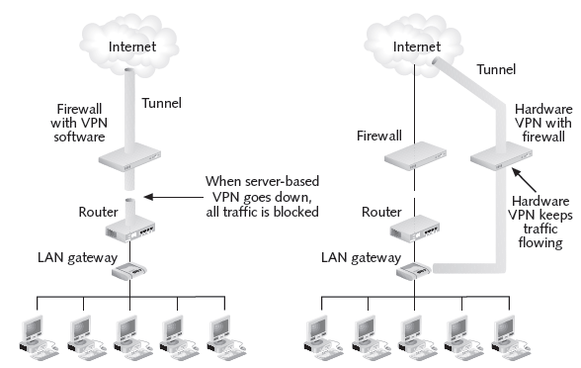

Software VPN Systems

Less expensive than hardware systems

Tend to scale better on fast-growing networks

Use policy manager systems

For enterprise-wide software distribution, policy creation, and management

Allows multiple configuration profiles for end users

SSL-based VPNs

Use the SSL protocol instead of IPSec

Only allow access to Web-enabled applications

VPN Combinations of Hardware and Software

Implement a VPN appliance at the central network

Use client software at the remote end of each VPN connection

Client mode

Concentrator acts as a software client

Network extension mode

Concentrator acts as a hardware device

Enables a secure site-to-site VPN connection

Mixed Vendor VPNs

Might have different vendors for:

Certificates

Client software

VPN termination

Pick a standard security protocol that is widely supported by all the devices

Such as IPSec

VPN Setups

When three or more networks or individuals need to be connected:

Mesh configuration

Hub-and-spoke arrangement

Hybrid setup

Mesh Configuration

Each participant has an approved relationship with every other participant

Called a security association (SA)

Need to specifically identify each of these participants to every other participant that uses the VPN

Figure 10-5

Four separate LANs are joined in a mesh VPN

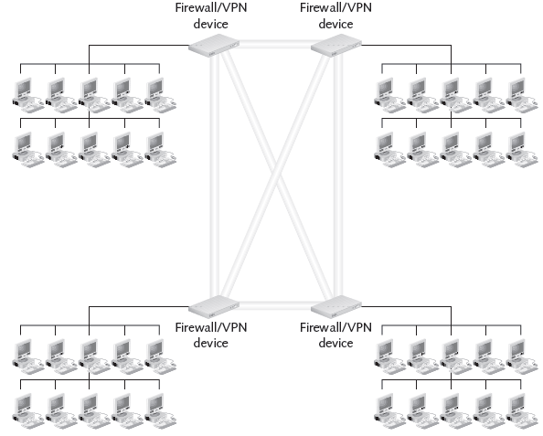

Hub-and-Spoke Configuration

Single VPN router contains records of all SAs in the VPN

Any LANs or computers need to connect to the central server

Makes it easy to increase the size of the VPN

As more branch offices or computers are added

Central point of administration is more secure

Drawback: centralization slows down communications

Hub-and-Spoke VPN

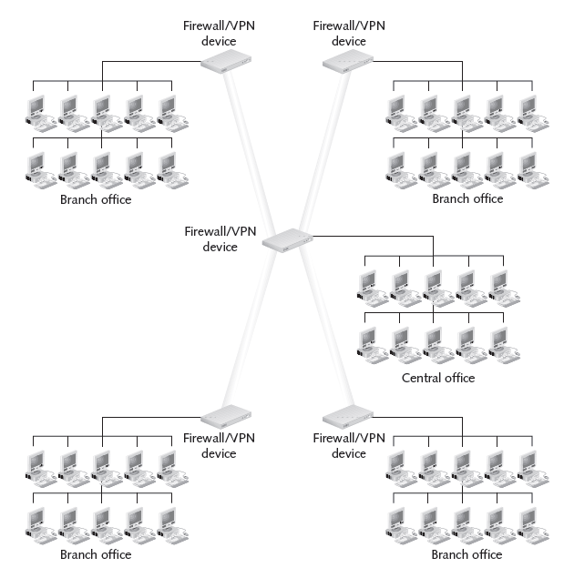

Hybrid Configuration

Mesh configurations tend to operate more efficiently

As branch offices are added

Add as spokes that connect to a central VPN router at the central office

Hybrid setup

Combines the two configurations

Benefits from the strengths of each one

Configurations and Extranet and Intranet Access

Extranet

Each end of the VPN represents an extension of your organizational network to a new location

Each remote user or business partner should have firewalls and antivirus software enabled

Intranet

Give parts of organization access to other parts

VPN users inside organization should have usage limits and antivirus and firewall protection

Tunneling Protocols Used with VPNs

Widespread acceptance of the IPSec protocol with the Internet Key Exchange (IKE) system

Proprietary protocols are used far less often than in the past

IPSec/IKE

IPSec

Standard for secure encrypted communications

Two security methods:

Authenticated Headers (AH) and Encapsulating Security Payload (ESP)

Different modes:

Transport mode and tunnel mode

However, tunnel mode IPSec does not provide user authentication, so Kerberos or some other authentication protocol will be needed as well

Transport Mode v. Tunnel Mode

Transport mode

Host encrypts data when it is transmitted

Header is not encrypted

Can be used to reach any IP address

Tunnel mode

Traffic encrypted in transit

Entire packet encrypted, including headers

Intended for point-to-point tunnel between two fixed IP addresses

IKE (Internet Key Exchange)

Means of using public key cryptography to encrypt data between LANs or between a client and a LAN

Provides for the exchange of public and private keys

If VPN uses more than one kind of firewall

Check with the manufacturers of those firewalls to see if their products will work with the other firewalls you have

PPTP

Point-to-Point Tunneling Protocol (PPTP)

Commonly used to a network using a dial-in modem connection

Uses Microsoft Point-to-Point Encryption (MPPE)

Useful if support for older clients is needed

L2TP

Layer 2 Tunneling Protocol (L2TP)

Extension of the protocol long used to establish dialup connections on the Internet

Uses IPSec rather than MPPE to encrypt data

Provides secure authenticated remote access by encapsulating data into packets that are sent over a PPP channel

PPP Over SSL and PPP Over SSH

Point-to-Point Protocol (PPP) over Secure Sockets Layer (SSL) and Point-to-Point Protocol (PPP) Over Secure Shell (SSH)

UNIX-based methods for creating VPNs

Combine an existing tunnel system (PPP) with a way of encrypting data in transport (SSL or SSH)

SSL

Public key encryption system

Used to provide secure communications over the World Wide Web

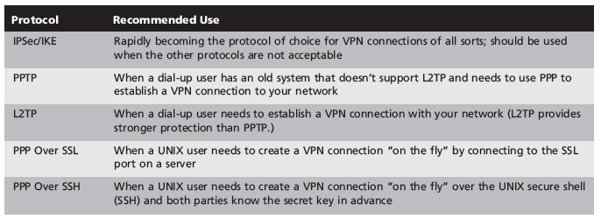

Enabling Remote Access Connections Within VPNs

Issue VPN client software user

Make sure the user’s computer is equipped with antivirus software and a firewall

May need to obtain a key for the remote user

Configuring the Server

Firewall-based VPN

Identify the client computer

Major operating systems incorporate their own methods of providing secure remote access

Linux: IP Masquerade

Similar to a transparent proxy (links Ch 10c, 10d)

Windows: Wizard that makes it easy to set up a workstation to make a VPN connection

Configuring Clients

Configure each client that wants to use the VPN

Consider whether:

The client software will work with all client platforms

The client workstation is itself protected by a firewall

All users of VPN extend the LAN

Open up a new “hole” through which viruses and hackers can gain access

VPN Best Practices

Security policy rules that specifically apply to the VPN

Integration of firewall packet filtering with VPN traffic

Auditing the VPN to make sure it is performing acceptably

The Need for a VPN Policy

Essential for:

Identifying who can use the VPN

Ensuring that all users know what constitutes proper use of the VPN

Policy should state:

Who should have VPN access to network

Whether authentication is to be used and how it is to be used

Whether split tunneling is permitted

How long users can be connected using the VPN at any one session

Whether virus protection is included

Connecting from Personal Computers

Remote users must be carefully trained

Understand that all organizational security policies apply during VPN use

Even when connecting from personal equipment

Packet Filtering and VPNs

Decide where data encryption and decryption will be performed in relation to packet filtering

Figure 10-11

Encryption and decryption outside the packet-filtering perimeter

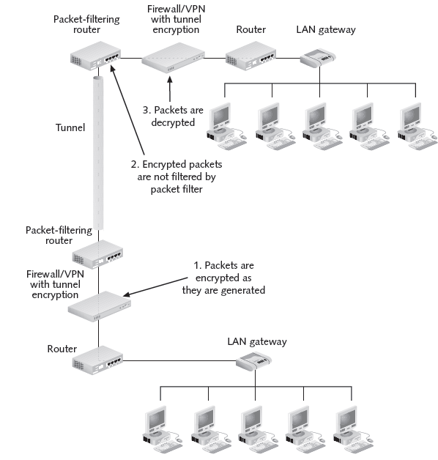
Transport Encryption (Encryption Prevents Filtering)

Figure 10-12

Encryption and decryption performed inside the packet-filtering perimeter using the tunnel method

Tunnel Encryption (Encryption does not Prevent Filtering)
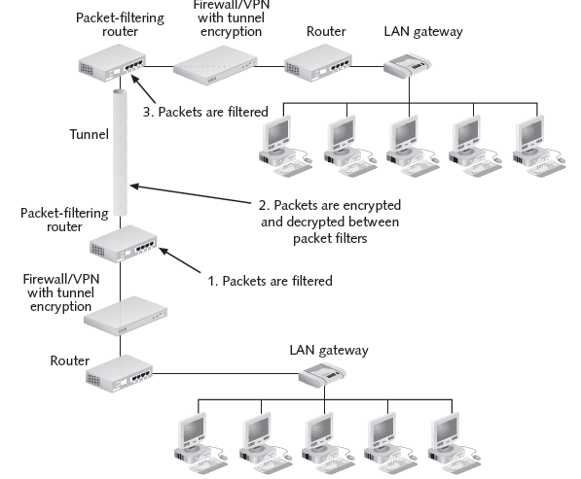

PPTP Filters

PPTP uses TCP 1723 as the control channel

It also uses Generic Routing Encapsulation to carry data

Protocol ID 47

Link Ch 10e

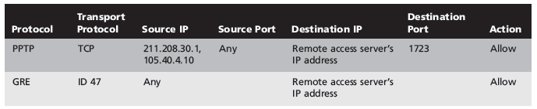

L2TP and IPSec Filters

Negotiation of IPsec security association (SA), typically through Internet key exchange (IKE)

UDP port 500

Establishment of Encapsulating Security Payload (ESP) communication in transport mode

The IP protocol number for ESP is 50

Negotiation and establishment of L2TP tunnel between the SA endpoints

UDP port 1701

From Link Ch 10f
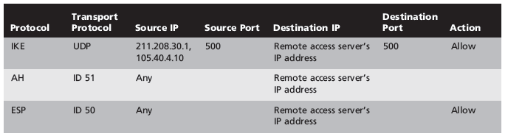

L2TP and IPSec Filters

Note: This is Table 10-3 in the book and it is mislabeled "PPTP"

Auditing and Testing the VPN

Test VPN client on each computer that might use the VPN

Choose client software that is easy for end users to install on their own

Save time and effort

Check the VPN

Make sure files are being transferred at an acceptable rate

All parts of the VPN remain online when needed

If part of the network goes down frequently:

Switch to another ISP

Asking ISPs questions to help determine which ones are best

Last modified: 8 am 11-8-11

