What You Need for This Project
- A trusted computer running any OS and VMware Workstation or VMware Player.
- The instructions below assume you are working in the S214 lab. If you are working at home, you will have to adapt the steps to match your situation.

Start Your Host Machine
- Power on your computer. Boot to Windows 7. Log on as Student with no password.

Making Your VM (Virtual Machines) Folder
- Click Start, Computer. Find the VMs-S214 drive and double-click it to open it. If there is already a folder there with your name on it, skip the next step.
- In the VMs-S214 window, right-click the empty space and click New, Folder. Name the folder YOUR NAME VMs replacing YOUR NAME with your own name.

Copying the BT5-GNOME-VM-32.7z into Your VM Folder
- If necessary, open a Computer window and open the VMs-S214 drive. Open the Install folder. Right-click the BT5-GNOME-VM-32.7z file and click Copy.
- Navigate back to the VMs-S214 drive and right-click the folder with your name on it. Click Paste.
- Double-click the folder with your name on it.

Extracting the BT5-GNOME-VM-32.7z File
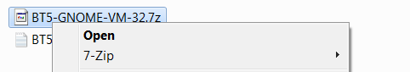
- Right-click the BT5-GNOME-VM-32.7z file. If you see a 7-Zip item, as shown to the right on this page, you have 7-Zip installed and you can proceed to the next step. If there is no 7-zip item, open a Web browser, go to 7-zip.com, download it, and install it.
- Right-click the BT5-GNOME-VM-32.7z file. In the context menu, point to 7-Zip, and click Extract Here. The file extracts and creates a folder named BT5-GNOME-VM-32.

Starting VMware
- Double-click the VMware Workstation icon on the desktop. In the VMware Workstation window, from the menu bar, click View, Go to Home Tab.
- On the Home tab, click the Open Existing VM or Team icon. Navigate to the VMs-S214: drive, open your folder, open the BT5-GNOME-VM-32 folder, and double-click the BT5-GNOME-VM-32.vmx file.

Starting Your BT5 Virtual Machine
- In the VMware Workstation window, on the left side, click the "Power on this virtual machine" link.
- If a box opens asking whether you moved the machine or copied it, click "I copied it".
- At the bt login: prompt, type root and press the Enter key.
- At the Password: prompt, type toor and press the Enter key.
- At the root@bt:~# prompt, type startx and press the Enter key.

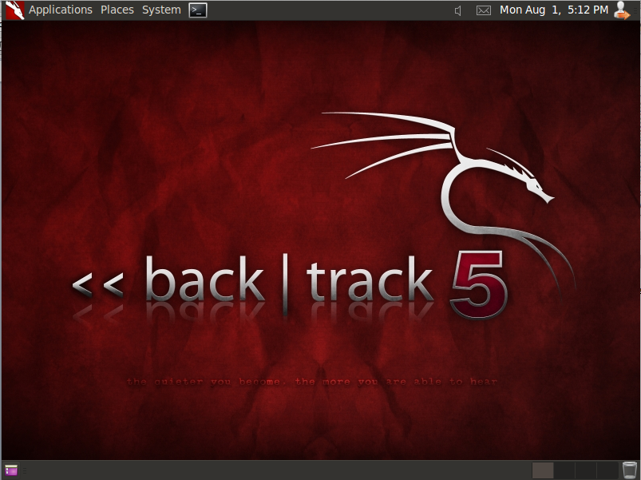
Saving a Screen Image

- You should see the BackTrack desktop, as shown to the right on this page.
- Click the taskbar at the bottom of your host Windows 7 desktop, to make the host machine listen to the keyboard, instead of the virtual machine.
- Press the PrintScrn key in the upper-right portion of the keyboard. That will copy the whole desktop to the clipboard.
- Open Paint, paste in the image, and save it with the filename Your Name Proj 4.
- Email the JPEG image to me as an attachment to an e-mail message. Send it to: cnit.123@gmail.com with a subject line of Proj 4 From Your Name, replacing Your Name with your own first and last name. Send a Cc to yourself.
Last Modified: 8-29-11

