Objectives

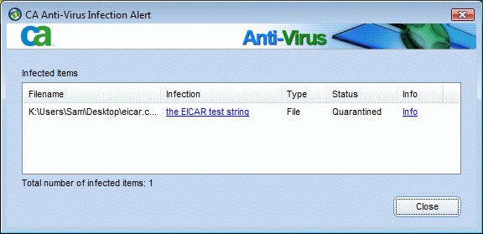
Describe the different types of malicious software

Describe methods of protecting against malware attacks

Describe the types of network attacks

Identify physical security attacks and vulnerabilities

Malicious Software (Malware)

Network attacks prevent a business from operating

Malicious software (Malware) includes

Virus

Worms

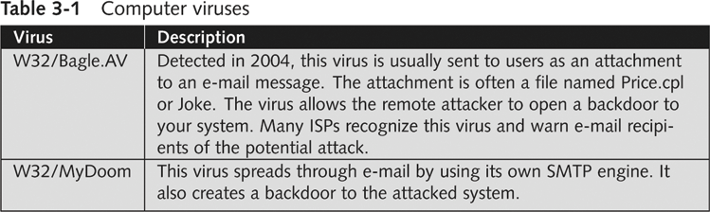
Trojan horses

Goals

Destroy data

Corrupt data

Shutdown a network or system

Viruses

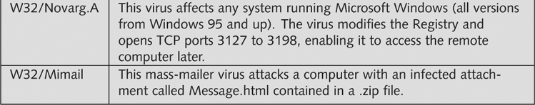
Virus attaches itself to an executable file

Can replicate itself through an executable program

Needs a host program to replicate

No foolproof method of preventing them

Antivirus Software

Detects and removes viruses

Detection based on virus signatures

Must update signature database periodically

Use automatic update feature

Base 64 Encoding

Used to evade anti-spam tools, and to obscure passwords

Encodes six bits at a time (0 – 64) with a single ASCII character

A - Z: 0 – 25

a – z: 26 – 51

1 – 9: 52 – 61

+ and - 62 and 63

See links Ch 3a, 3b

Viruses (continued)

Commercial base 64 decoders

Shell

Executable piece of programming code

Should not appear in an e-mail attachment

Macro Viruses

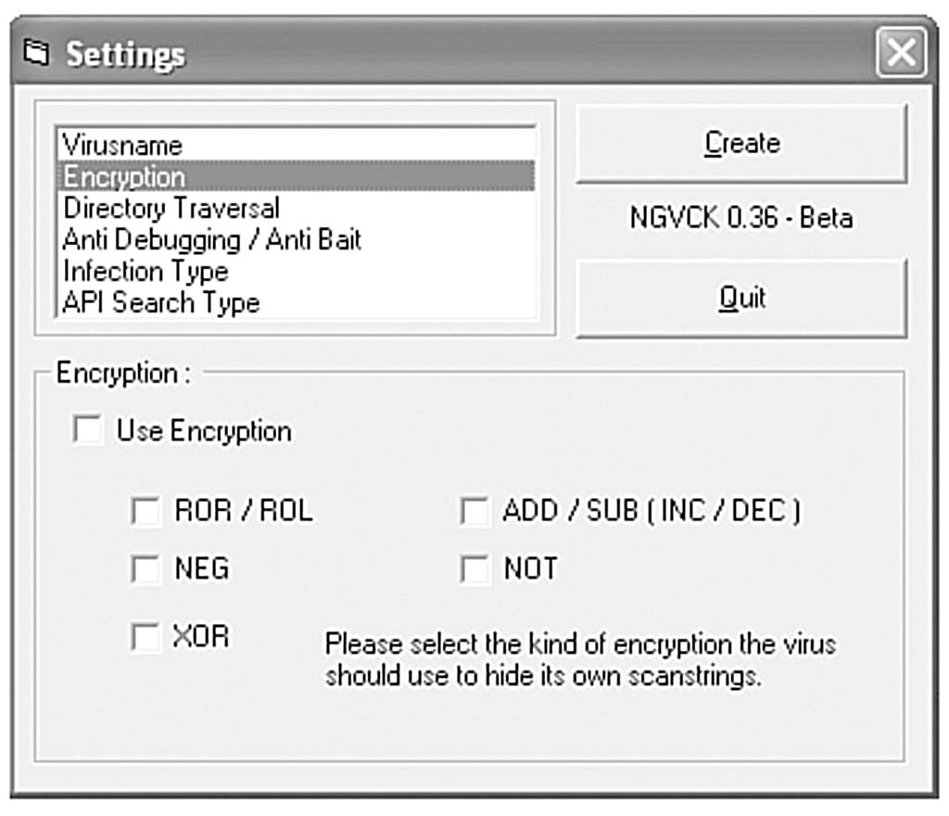
Virus encoded as a macro

Macro

Lists of commands

Can be used in destructive ways

Example: Melissa

Appeared in 1999

It is very simple – see link Ch 3c for source code

Writing Viruses

Even nonprogrammers can create macro viruses

Instructions posted on Web sites

Virus creation kits available for download (see link Ch 3d)

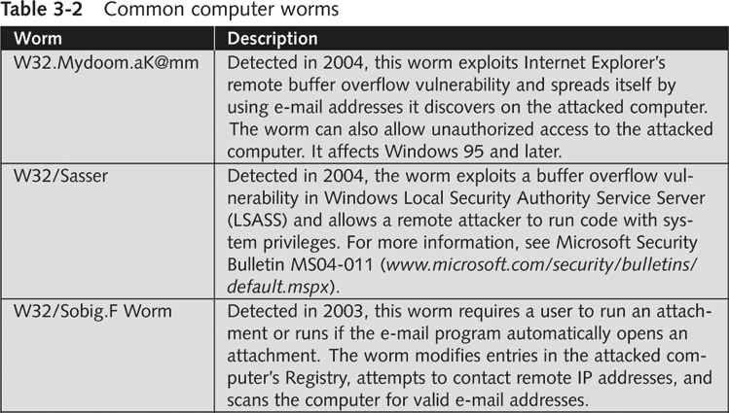
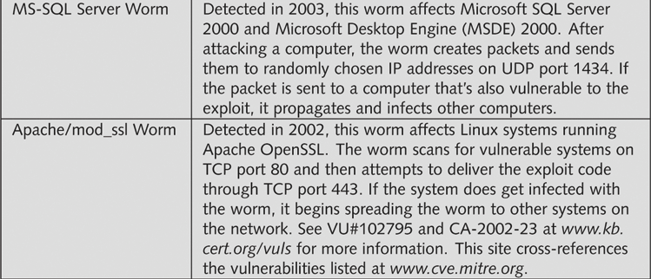
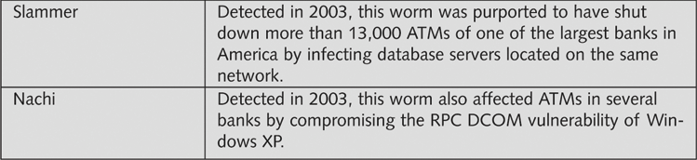
Security professionals can learn from thinking like attackers

But don’t create and release a virus! People get long prison terms for that.

Worms

Worm

Replicates and propagates without a host

Infamous examples

Code Red

Nimda

Can infect every computer in the world in a short time

At least in theory

ATM Machine Worms

Cyberattacks against ATM machines

Slammer and Nachi worms

Trend produces antivirus for ATM machines

See links Ch 3g, 3h, 3i

Nachi was written to clean up damage caused by the Blaster worm, but it got out of control

See link Ch 3j

Diebold was criticized for using Windows for ATM machines, which they also use on voting machines

Trojan Programs

Insidious attack against networks

Disguise themselves as useful programs

Hide malicious content in program

Backdoors

Rootkits

Allow attackers remote access

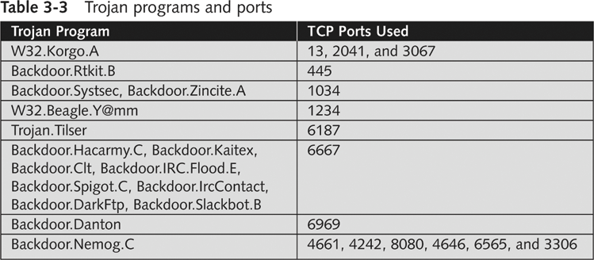

Firewalls

Identify traffic on uncommon ports

Can block this type of attack, if your firewall filters outgoing traffic

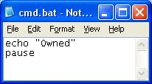
Windows XP SP2’s firewall does not filter outgoing traffic

Vista’s firewall doesn’t either (by default), according to link Ch 3l and 3m

Trojan programs can use known ports to get through firewalls

HTTP (TCP 80) or DNS (UDP 53)

Trojan Demonstration

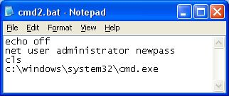
Make a file with command-line Windows commands

Save it as C:\Documents and Settings\
username\cmd.bat

Start, Run, CMD will execute this file instead of C:\Windows\System32\Cmd.exe

Improved Trojan

Resets the administrator password

Almost invisible to user

Works in Win XP, but not so easy in Vista

Spyware

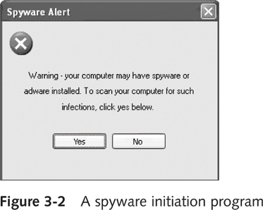
Sends information from the infected computer to the attacker

Confidential financial data

Passwords

PINs

Any other stored data

Can register each keystroke entered (keylogger)

Prevalent technology

Educate users about spyware

Deceptive Dialog Box

Adware

Similar to spyware

Can be installed without the user being aware

Sometimes displays a banner

Main goal

Determine user’s online purchasing habits

Tailored advertisement

Main problem

Slows down computers

Protecting Against Malware Attacks

Difficult task

New viruses, worms, Trojan programs appear daily

Antivirus programs offer a lot of protection

Educate your users about these types of attacks

Educating Your Users

Structural training

Most effective measure

Includes all employees and management

E-mail monthly security updates

Simple but effective training method

Update virus signature database automatically

SpyBot and Ad-Aware

Help protect against spyware and adware

Windows Defender is excellent too

Firewalls

Hardware (enterprise solution)

Software (personal solution)

Can be combined

Intrusion Detection System (IDS)

Monitors your network 24/7

FUD

Fear, Uncertainty and Doubt

Avoid scaring users into complying with security measures

Sometimes used by unethical security testers

Against the OSSTMM’s Rules of Engagement

Promote awareness rather than instilling fear

Users should be aware of potential threats

Build on users’ knowledge

Intruder Attacks on Networks and Computers

Attack

Any attempt by an unauthorized person to access or use network resources

Network security

Security of computers and other devices in a network

Computer security

Securing a standalone computer--not part of a network infrastructure

Computer crime

Fastest growing type of crime worldwide

Denial-of-Service Attacks

Denial-of-Service (DoS) attack

Prevents legitimate users from accessing network resources

Some forms do not involve computers, like feeding a paper loop through a fax machine

DoS attacks do not attempt to access information

Cripple the network

Make it vulnerable to other type of attacks

Testing for DoS Vulnerabilities

Performing an attack yourself is not wise

You only need to prove that an attack could be carried out

Distributed Denial-of-Service Attacks

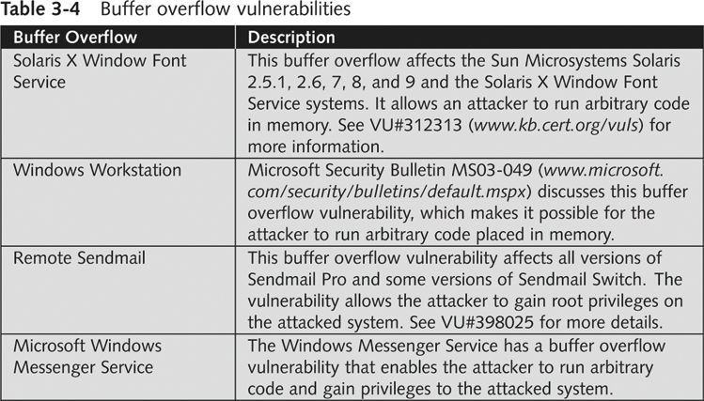
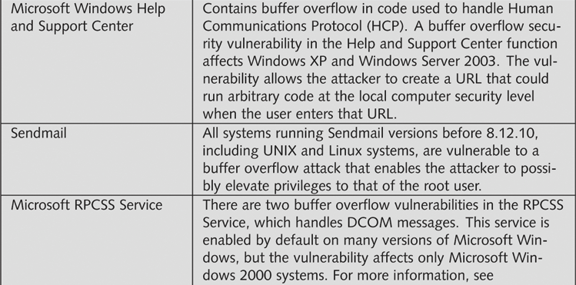
Attack on a host from multiple servers or workstations

Network could be flooded with billions of requests

Loss of bandwidth

Degradation or loss of speed

Often participants are not aware they are part of the attack

Attacking computers could be controlled using Trojan programs

Buffer Overflow Attacks

Vulnerability in poorly written code

Code does not check predefined size of input field

Goal

Fill overflow buffer with executable code

OS executes this code

Can elevate attacker’s permission to Administrator or even Kernel

Programmers need special training to write secure code

Ping of Death Attacks

Type of DoS attack

Not as common as during the late 1990s

How it works

Attacker creates a large ICMP packet

More than 65,535 bytes

Large packet is fragmented at source network

Destination network reassembles large packet

Destination point cannot handle oversize packet and crashes

Modern systems are protected from this (Link Ch 3n)

Session Hijacking

Enables attacker to join a TCP session

Attacker makes both parties think he or she is the other party

Addressing Physical Security

Protecting a network also requires physical security

Inside attacks are more likely than attacks from outside the company

Keyloggers

Used to capture keystrokes on a computer

Hardware

Software

Software

Behaves like Trojan programs

Hardware

Easy to install

Goes between the keyboard and the CPU

KeyKatcher and KeyGhost

Protection


Software-based

Antivirus

Hardware-based

Random visual tests

Look for added hardware

Superglue keyboard connectors in

Behind Locked Doors

Lock up your servers

Physical access means they can hack in

Consider Ophcrack – booting to a CD-based OS will bypass almost any security

Lockpicking

Average person can pick deadbolt locks in less than five minutes

After only a week or two of practice

Experienced hackers can pick deadbolt locks in under 30 seconds

Bump keys are even easier (Link Ch 3o)

Card Reader Locks

Keep a log of who enters and leaves the room

Security cards can be used instead of keys for better security

Image from link Ch 3p

Last modified 2-2-07 3 pm

