Objectives

Footprinting

Describe DNS zone transfers

Identify the types of social engineering
Footprinting

Using Web Tools for Footprinting

“Case the joint”

Look over the location

Find weakness in security systems

Types of locks, alarms

In computer jargon, this is called footprinting

Discover information about

The organization

Its network
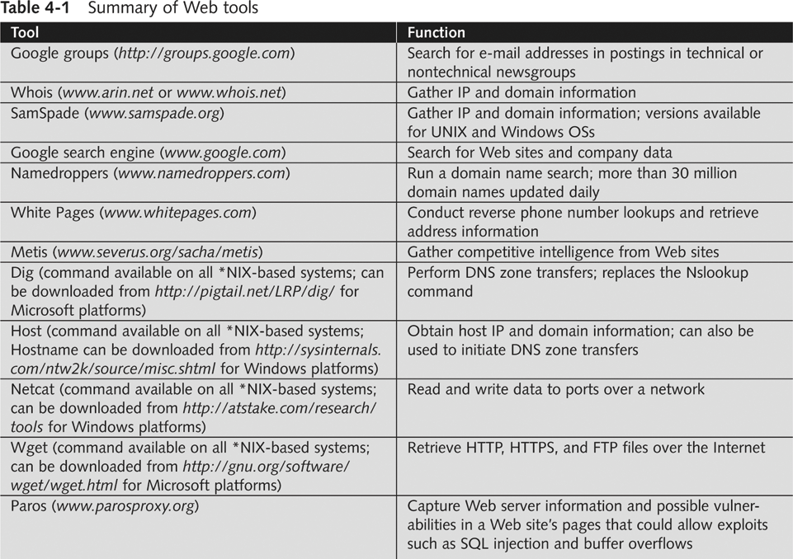

Conducting Competitive Intelligence

Numerous resources to find information legally

Competitive Intelligence

Gathering information using technology

Identify methods others can use to find information about your organization

Limit amount of information company makes public

Analyzing a Company’s Web Site

Web pages are an easy source of information
Setting Proxy Server

Many tools available

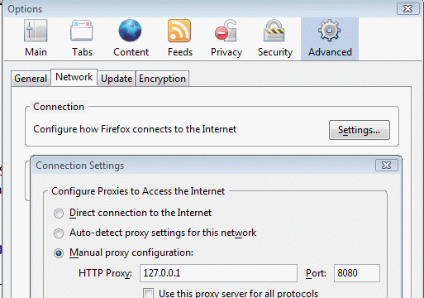
Paros

Powerful tool for UNIX and Windows

www.parosproxy.org

Requires having Java J2SE installed

www.sun.com

Paros

Start Paros

Set proxy server in a browser

Then go to a site in the browser

mtsconsulting.net is a good test

Analyze -> Spider to find all the pages

Setting a Proxy Server in Firefox

Tools

Options

Advanced

Settings

Then go to mtjconsulting.com

Spider Results
Scan Results

In Paros:

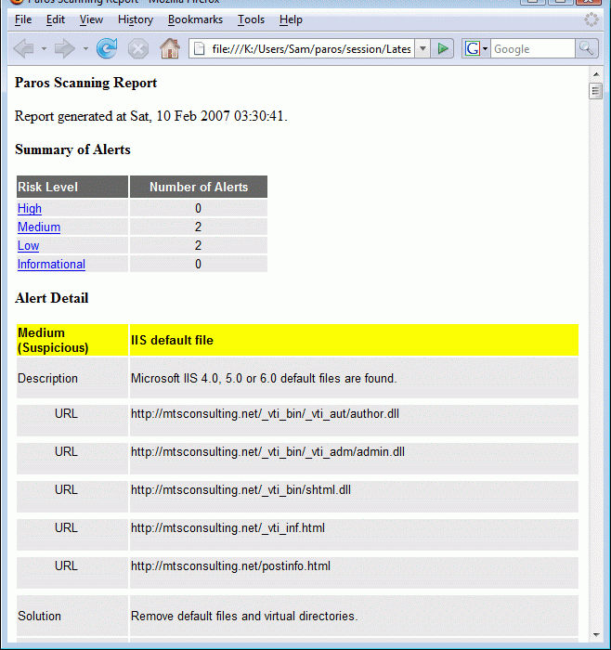
Analyze
Spider Results

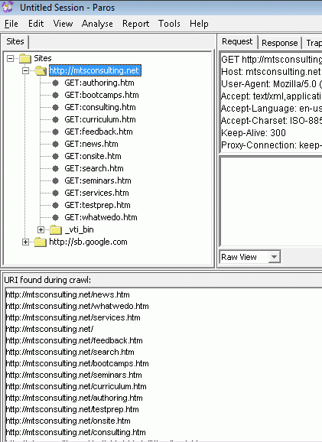
Spider

Finds all the pages in a site

Don’t scan any sites without permission! Only mtjconsulting.com

Scan Results

In Paros:

Analyze

Scan

Finds security risks in a site

Again, don’t scan sites without permission!

Using Other Footprinting Tools

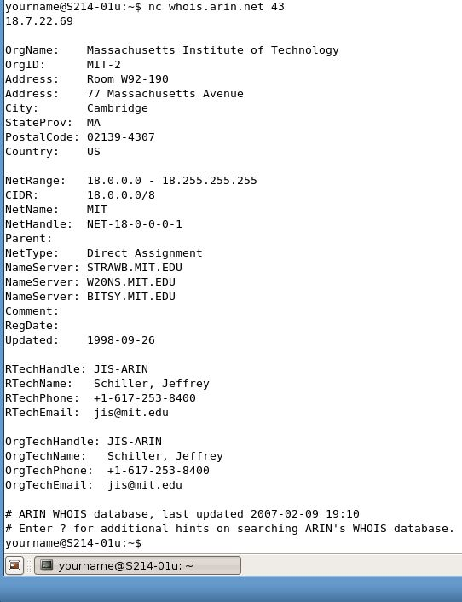
Whois

Commonly used tool

Gathers IP address and domain information

Attackers can also use it

Host command

Can look up one IP address, or the whole DNS Zone file

All the servers in the domain

ARIN Whois from Linux

host mit.edu

nc whois.arin.net

18.7.22.69

This shows registration information for the domain

SamSpade

GUI tool

Available for UNIX and Windows

Easy to use

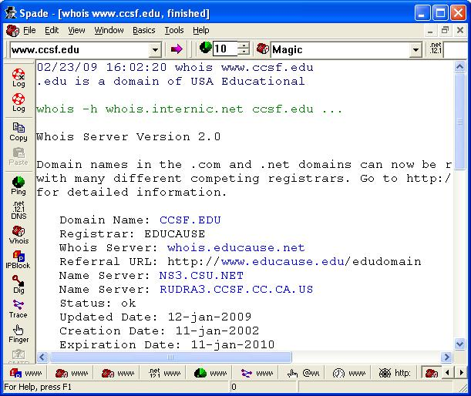

Using E-mail Addresses

E-mail addresses help you retrieve even more information than the previous commands

Find e-mail address format

Guess other employees’ e-mail accounts

Tool to find corporate employee information

Groups.google.com

Using HTTP Basics

HTTP operates on port 80

Use HTTP language to pull information from a Web server

Basic understanding of HTTP is beneficial for security testers

Return codes

Reveal information about server OS

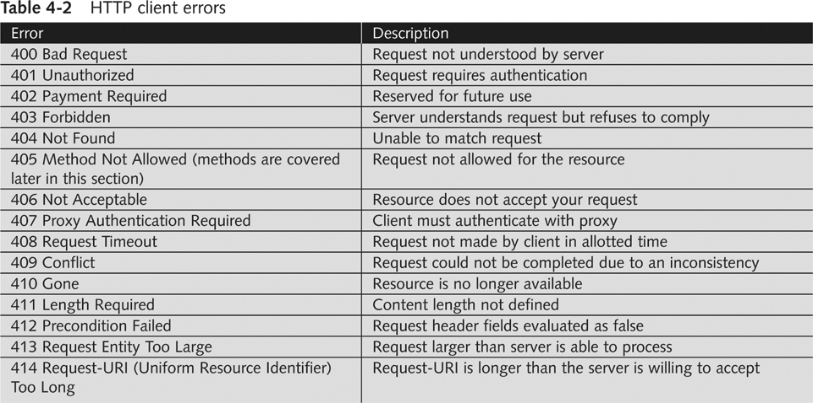
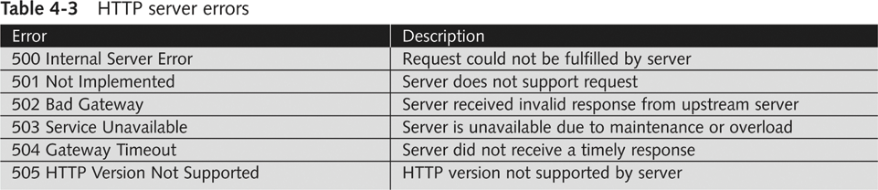

HTTP methods

GET / HTTP/1.1. is the most basic method

Can determine information about server OS from the server’s generated output
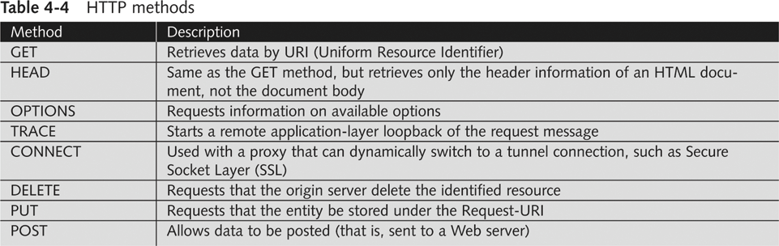

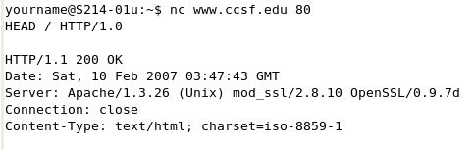
Using Netcat as a Browser

Use Ubuntu Linux

nc www.ccsf.edu 80

HEAD / HTTP/1.0

Gets header

GET / HTTP/1.0

Gets whole Web page

Open www.ccsf.edu in a browser and compare to source code

Activity 4-3 in your book does not work
Cookies and Web Bugs

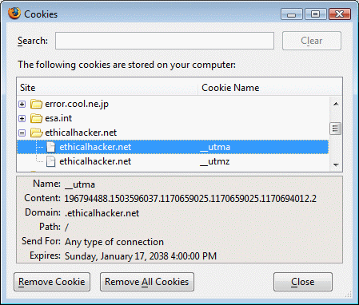
Detecting Cookies and Web Bugs

Cookie

Text file generated by a Web server

Stored on a user’s browser

Information sent back to Web server when user returns

Used to customize Web pages

Some cookies store personal information

Security issue

Viewing Cookies

In Firefox

Tools, Options

Privacy tab

Show Cookies

Web bug

1-pixel x 1-pixel image file (usually transparent)

Referenced in an <IMG> tag

Usually works with a cookie

Purpose similar to that of spyware and adware

Comes from third-party companies specializing in data collection

Web Bug Detector 1.0

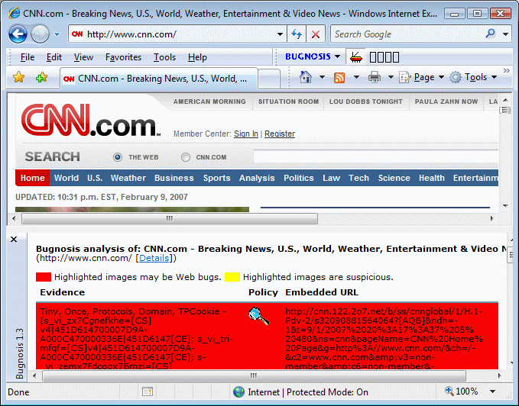
Firefox experimental add-in program that warns you about Web bugs

Bugnosis is gone

Using Domain Name Service (DNS) Zone Transfers

DNS

Resolves host names to IP addresses

People prefer using URLs to IP addresses

Extremely vulnerable

Zone Transfer tools

Dig

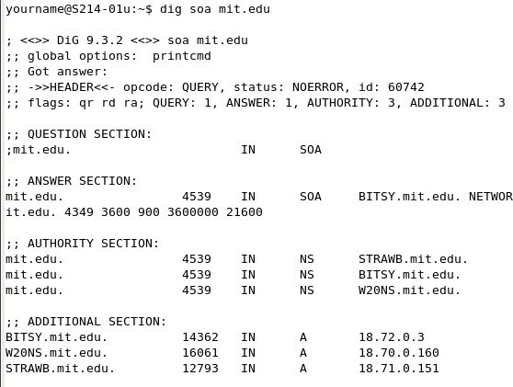
Host

Primary DNS Server

Determining company’s primary DNS server

Look for the Start of Authority (SOA) record

Shows zones or IP addresses

Using dig top find the SOA

dig soa mit.edu

Shows three servers, with IP addresses

This is a start at mapping the MIT network

Using (DNS) Zone Transfers

Zone Transfer

Enables you to see all hosts on a network

Gives you organization’s network diagram

MIT has protected their network – zone transfers no longer work

dig @BITSY.mit.edu mit.edu axfr

Command fails now

Introduction to Social Engineering

Older than computers

Targets the human component of a network

Goals

Obtain confidential information (passwords)

Obtain personal information

Tactics

Persuasion

Intimidation

Coercion

Extortion/blackmailing

The biggest security threat to networks

Most difficult to protect against

Main idea:

“Why to crack a password when you can simply ask for it?”

Users divulge their passwords to IT personnel

Studies human behavior

Recognize personality traits

Understand how to read body language

Techniques

Urgency

Quid pro quo

Status quo

Kindness

Position

Preventing Social Engineering

Train user not to reveal any information to outsiders

Verify caller identity

Ask questions

Call back to confirm

Security drills

The Art of Shoulder Surfing

Shoulder surfer

Reads what users enter on keyboards

Logon names

Passwords

PINs

Tools for Shoulder Surfing

Binoculars or telescopes or cameras in cell phones

Knowledge of key positions and typing techniques

Knowledge of popular letter substitutions

s equals $, a equals @

Prevention

Avoid typing when someone is nearby

Avoid typing when someone nearby is talking on cell phone

Computer monitors should face away from door or cubicle entryway

Immediately change password if you suspect someone is observing you

Dumpster Diving

Attacker finds information in victim’s trash

Discarded computer manuals

Notes or passwords written in them

Telephone directories

Calendars with schedules

Financial reports

Interoffice memos

Company policy

Utility bills

Resumes of employees

Prevention

Educate your users about dumpster diving

Proper trash disposal

Use “disk shredder” software to erase disks before discarding them

Software writes random bits

Done at least seven times

Discard computer manuals offsite

Shred documents before disposal

The Art of Piggybacking

Trailing closely behind an employee cleared to enter restricted areas

How it works:

Watch authorized personnel enter an area

Quickly join them at security entrance

Exploit the desire of other to be polite and helpful

Attacker wears a fake badge or security card

Prevention

Use turnstiles

Train personnel to notify the presence of strangers

Do not hold secured doors for anyone

Even for people you know

All employees must use secure cards

Last modified 2-23-09

