Objectives

Describe the enumeration step of security testing

Enumerate Microsoft OS targets

Enumerate NetWare OS targets

Enumerate *NIX OS targets

Introduction to Enumeration

Enumeration extracts information about:

Resources or shares on the network

User names or groups assigned on the network

Last time user logged on

User’s password

Before enumeration, you use Port scanning and footprinting

To Determine OS being used

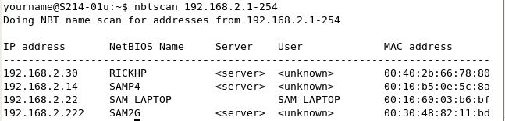
Intrusive process

NBTscan

NBT (NetBIOS over TCP/IP)

is the Windows networking protocol

used for shared folders and printers

NBTscan

Tool for enumerating Microsoft OSs

Enumerating Microsoft Operating Systems

Study OS history

Knowing your target makes your job easier

Many attacks that work for older Windows OSs still work with newer versions

Windows 95

The first Windows version that did not start with DOS

Still used the DOS kernel to some extent

Introduced the Registry database to replace Win.ini, Autoexec.bat, and other text files

Introduced Plug and Play and ActiveX

Used FAT16 file system

Windows 98 and ME

More Stable than Win 95

Used FAT32 file system

Win ME introduced System Restore

Win 95, 98, and ME are collectively called "Win 9x"

Windows NT 3.51 Server/Workstation

No dependence on DOS kernel

Domains and Domain Controllers

NTFS File System to replace FAT16 and FAT31

Much more secure and stable than Win9x

Many companies still use Win NT Server Domain Controllers

Win NT 4.0 was an upgrade

Windows 2000 Server/Professional

Upgrade of Win NT

Active Directory

Powerful database storing information about all objects in a network

Users, printers, servers, etc.

Based on Novell's Novell Directory Services

Enumerating this system would include enumerating Active Directory

Windows XP Professional

Much more secure, especially after Service Pack 2

Windows File Protection

Data Execution Prevention

Windows Firewall

Windows Server 2003

Much more secure, especially after Service Pack 1

Network services are closed by default

Internet Explorer security set higher

NetBIOS Basics

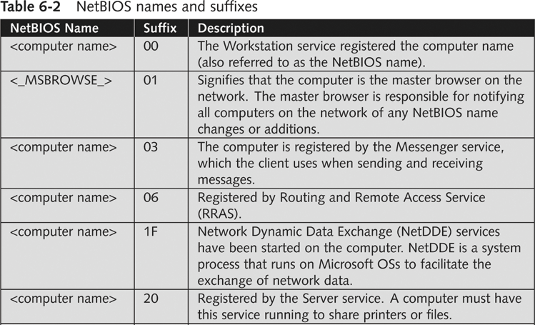
Network Basic Input Output System (NetBIOS)

Programming interface

Allows computer communication over a LAN

Used to share files and printers

NetBIOS names

Computer names on Windows systems

Limit of 16 characters

Last character identifies type of service running

Must be unique on a network

NetBIOS Null Sessions

Null session

Unauthenticated connection to a Windows computer

Does not use logon and passwords values

Around for over a decade

Still present on Windows XP

A large vulnerability

See links Ch 6a-f

Null Session Information

Using these NULL connections allows you to gather the following information from the host:

List of users and groups

List of machines

List of shares

Users and host SIDs (Security Identifiers)

From brown.edu (link Ch 6b)

Demonstration of Null Sessions

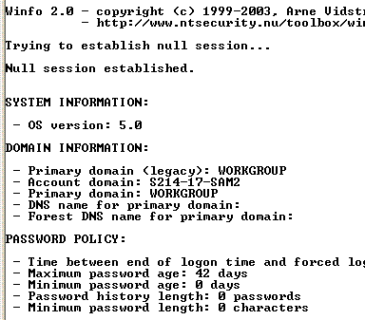
Start Win 2000 Pro

Share a folder

From a Win XP command prompt

NET VIEW \\ip-address Fails

NET USE \\ip-address\IPC$ "" /u:""

Creates the null session

Username="" Password=""

NET VIEW \\ip-address Works now

Demonstration of Enumeration

Download Winfo from link Ch 6g

Run it – see all the information!

NULL Session Information

NULL sessions exist in windows networking to allow:

Trusted domains to enumerate resources

Computers outside the domain to authenticate and enumerate users

The SYSTEM account to authenticate and enumerate resources

NetBIOS NULL sessions are enabled by default in Windows NT and 2000

From brown.edu (link Ch 6b)

NULL Sessions in Win XP and 2003 Server

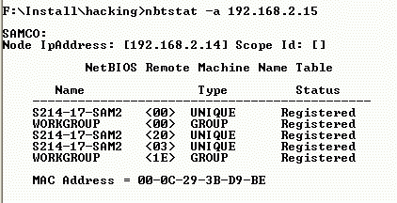
Windows XP and 2003 don't allow Null Sessions, according to link Ch 6c.

I tried the NET USE command on Win XP SP2 and it did not work

Link Ch 6f says you can still do it in Win XP SP2, but you need to use a different procedure

NetBIOS Enumeration Tools

Nbtstat command

Powerful enumeration tool included with the Microsoft OS

Displays NetBIOS table

Net view command

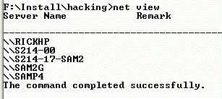
Shows whether there are any shared resources on a network host

Net use command

Used to connect to a computer with shared folders or files

Additional Enumeration Tools

NetScanTools Pro

DumpSec

Hyena

NessusWX

NetScanTools Pro

Produces a graphical view of NetBIOS running on a network

Enumerates any shares running on the computer

Verifies whether access is available for shared resource using its Universal Naming Convention (UNC) name

Costs about $250 per machine (see link Ch 6i)

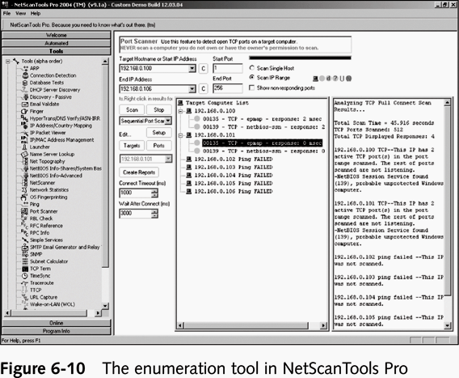

DumpSec

Enumeration tool for Microsoft systems

Produced by Foundstone, Inc.

Allows user to connect to a server and “dump” the following information

Permissions for shares

Permissions for printers

Permissions for the Registry

Users in column or table format

Policies and rights

Services

Hyena

Excellent GUI product for managing and securing Microsoft OSs

Shows shares and user logon names for Windows servers and domain controllers

Displays graphical representation of:

Microsoft Terminal Services

Microsoft Windows Network

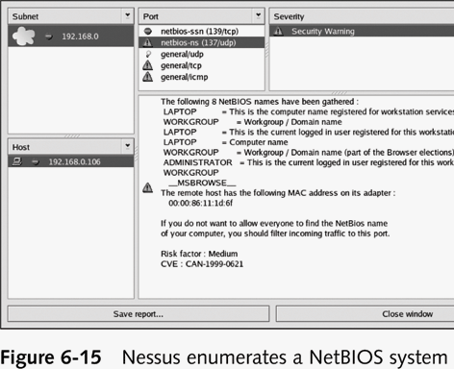
Web Client Network

Find User/Group

Prices

DumpSec seems to be free
Hyena costs bout $200 per station (Link Ch 6j)

NessusWX

This is the client part of Nessus

Allows enumeration of different OSs on a large network

Running NessusWX

Be sure Nessus server is up and running

Open the NessusWX client application

To connect your client with the Nessus server

Click Communications, Connect from the menu on the session window

Enter server’s name

Log on the Nessus server

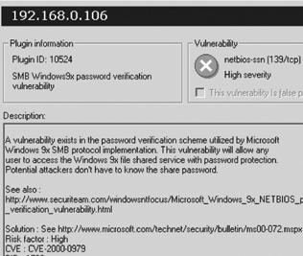
Nessus identifies

NetBIOS names in use

Shared resources

Vulnerabilities with shared resources

Also offers solutions to those vulnerabilities

OS version

OS vulnerabilities

Firewall vulnerabilities

Etherleak Vulnerability

Padding in Ethernet frames comes from RAM, it's not just zeroes

Real data can leak out that way

See link Ch 6l

Enumerating the NetWare Operating System

Security professionals see Novell NetWare as a “dead horse”

Ignoring an OS can limit your career as a security professional

Novell NetWare version 4.11

Novell does not offer any technical support for earlier versions

Novell has switched to SUSE Linux now

NetWare Enumeration Tools

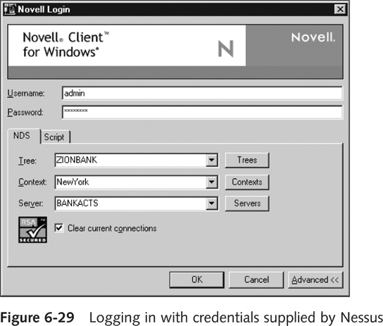
NetWare 5.1 is still used on many networks

New vulnerabilities are discovered daily

You need to be vigilant in checking vendor sites and security sites

Tool

Nessus

Nessus

Enumerates a NetWare server

Determines eDirectory information

Discovers the user name and password for the FTP account

Discovers names of several user accounts

Novell Client32

Available at www.novell.com

Client available for several OSs

Specify information for

Tree

Content

Server

Enumerating the *NIX Operating System

Several variations

Solaris

SunOS

HP-UX

Linux

Ultrix

AIX

BSD UNIX

FreeBSD

OpenBSD

UNIX Enumeration

Finger utility

Most popular tool for security testers

Finds out who is logged in to a *NIX system

Determine owner of any process

Nessus

Another important *NIX enumeration tool

Last modified 2-23-07 8 pm

