Objectives

Tools to assess Microsoft system vulnerabilities

Describe the vulnerabilities of Microsoft operating systems and services

Techniques to harden Microsoft systems against common vulnerabilities

Best practices for securing Microsoft systems
Tools to Identify Vulnerabilities on Microsoft Systems

Many tools are available for this task

Using more than one tool is advisable

Using several tools help you pinpoint problems more accurately

Built-in Microsoft Tools

Microsoft Baseline Security Analyzer (MBSA)

Winfingerprint

HFNetChk

Microsoft Baseline Security Analyzer (MBSA)

Effective tool that checks for

Patches

Security updates

Configuration errors

Blank or weak passwords

Others

MBSA supports remote scanning

Associated product must be installed on scanned computer
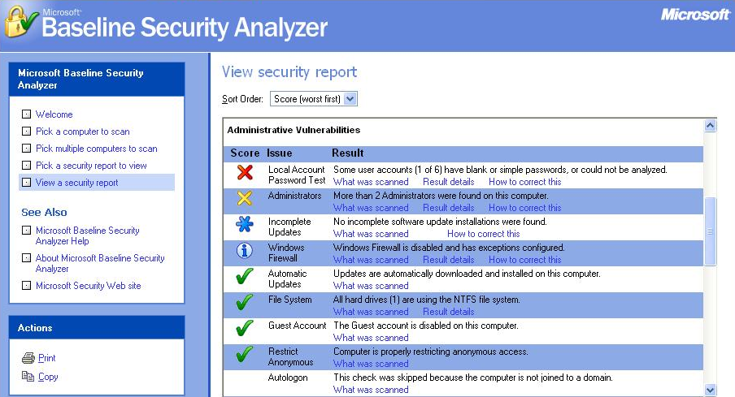

MBSA Results

MBSA Versions

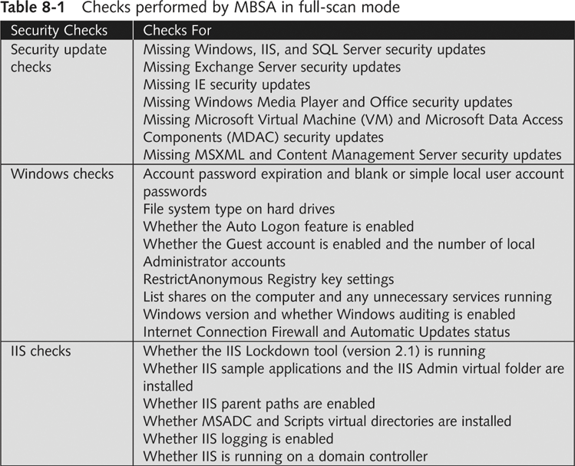
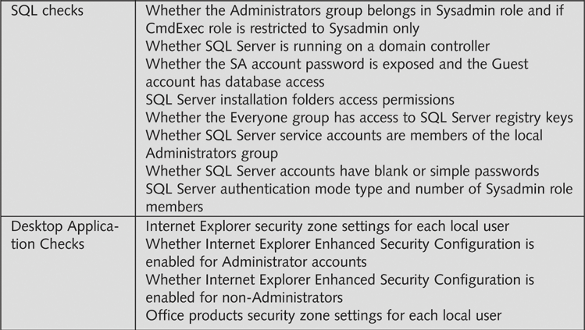
2.x for Win 2000 or later & Office XP or later

1.2.1 if you have older products

After installing, MBSA can

Scan the local machine

Scan other computers remotely

Be scanned remotely over the Internet

HFNetChk

HFNetChk is part of MBSA

Available separately from Shavlik Technologies

Can be used to control the scanning more precisely, from the command line

Winfingerprint

Administrative tool

It can be used to scan network resources

Exploits Windows null sessions

Detects

NetBIOS shares

Disk information and services

Null sessions

Can find

OS detection

Service packs and hotfixes

Running Services

See Proj X6 for Details
Microsoft OS Vulnerabilities

Microsoft integrates many of its products into a single package

Such as Internet Explorer and Windows OS

This creates many useful features

It also creates vulnerabilities

Security testers should search for vulnerabilities on

The OS they are testing

Any application running on the server

CVE (Common Vulnerabilities and Exposures )

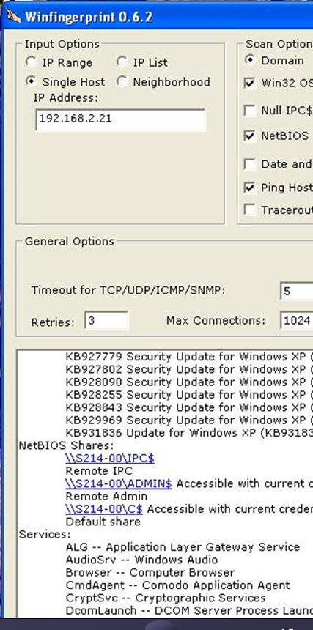
A list of standardized names for vulnerabilities

Makes it easier to share information about them

cve.mitre.org (link Ch 8c)

Demonstration: Search

Remote Procedure Call (RPC)

RPC is an interprocess communication mechanism

Allows a program running on one host to run code on a remote host

Examples of worms that exploited RPC

MSBlast (LovSAN, Blaster)

Nachi

Use MBSA to detect if a computer is vulnerable to an RPC-related issue

NetBIOS

Software loaded into memory

Enables a computer program to interact with a network resource or other device

NetBIOS is not a protocol

NetBIOS is an interface to a network protocol

It’s sometimes called a session-layer protocol, or a protocol suite (Links Ch 8d, 8e, 8f)

NetBEUI

NetBIOS Extended User Interface

Fast, efficient network protocol

Allows NetBIOS packets to be transmitted over TCP/IP

NBT is NetBIOS over TCP

Newer Microsoft OSs do not need NetBIOS to share resources

NetBIOS is used for backward compatibility

You can turn off NetBIOS for Windows 2000 and later (links Ch 8g & 8h)

Server Message Block (SMB)

Used by Windows 95, 98 and NT to share files

Usually runs on top of NetBIOS, NetBEUI or TCP/IP

Hacking tools

L0phtcrack’s SMB Packet Capture utility

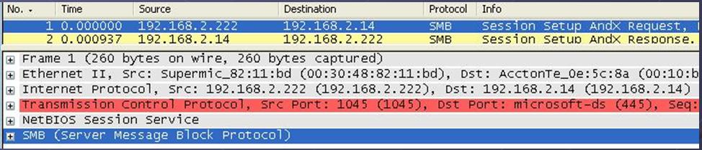
SMBRelay

Ettercap (see Project 23, links Ch 8r, Ch 8s)

Demonstration: ettercap

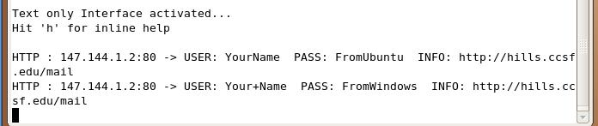
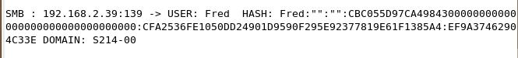

Common Internet File System (CIFS)

CIFS replaced SMB for Windows 2000, XP, and Windows 2003 Server

SMB is still used for backward compatibility

CIFS is a remote file system protocol

Enables computers to share network resources over the Internet

Enhancements over SMB

Resource locking (if 2 people use the same thing at once)

Support for fault tolerance

Capability to run more efficiently over dial-up

Support for anonymous and authenticated access

Server security methods

Share-level security

A password assigned to a shared resource

User-level security

An access control list assigned to a shared resource

Users must be on the list to gain access

Passwords are stored in an encrypted form on the server

But CIFS is still vulnerable (see link Ch 8n)

Don’t let NetBIOS traffic past the firewall

Understanding Samba

Open-source implementation of CIFS

Created in 1992

Samba allows sharing resources over multiple OSs

Samba accessing Microsoft shares can make a network susceptible to attack

Samba is used to “trick” Microsoft services into believing the *NIX resources are Microsoft resources

Samba is Built into Ubuntu

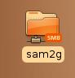
Click Places, Connect to Server

Windows shares are marked with SMB

Closing SMB Ports

Best way to protect a network from SMB attacks

Routers should filter out ports

137 to 139 and 445

Default Installations

Windows 9x, NT, and 2000 all start out with many services running and ports open

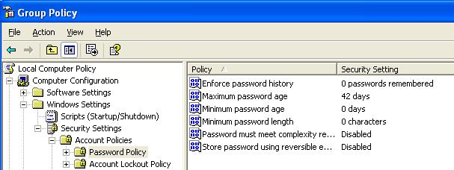
They are very insecure until you lock them down

Win XP, 2003, and Vista are much more secure by default

Services are blocked until you open them

Passwords and Authentication

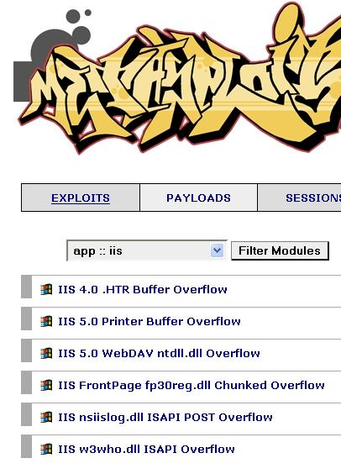
A comprehensive password policy is critical

Change password regularly

Require passwords length of at least six characters

Require complex passwords

Never write a password down or store it online or on the local system

Do not reveal a password over the phone

Configure domain controllers

Enforce password age, length and complexity

Account lockout threshold

Account lockout duration

Start, Run, GPEDIT.MSC
IIS (Internet Information Services)

IIS 5 and earlier installs with critical security vulnerabilities

Run IIS Lockdown Wizard (link Ch 8p)

IIS 6.0 installs with a “secure by default” posture

Configure only services that are needed

Windows 2000 ships with IIS installed by default

Running MBSA can detect IIS running on your network

SQL Server

SQL vulnerabilities exploits areas

The SA account with a blank password

SQL Server Agent

Buffer overflow

Extended stored procedures

Default SQL port 1433

Vulnerabilities related to SQL Server 7.0 and SQL Server 2000

The SA Account

The SA account is the master account, with full rights

SQL Server 6.5 and 7 installations do not require setting a password for this account

SQL Server 2000 supports mixed-mode authentication

SA account is created with a blank password

SA account cannot be disabled

SQL Server Agent

Service mainly responsible for

Replication

Running scheduled jobs

Restarting the SQL service

Authorized but unprivileged user can create scheduled jobs to be run by the agent

Buffer Overflow

Database Consistency Checker in SQL Server 2000

Contains commands with buffer overflows

SQL Server 7 and 2000 have functions that generate text messages

They do not check that messages fit in the buffers supplied to hold them

Format string vulnerability in the C runtime functions

Extended Stored Procedures

Several of the extended stored procedures fail to perform input validation

They are susceptible to buffer overruns

Default SQL Port 1443

SQL Server is a Winsock application

Communicates over TCP/IP using port 1443

Spida worm

Scans for systems listening on TCP port 1443

Once connected, attempts to use the xp_cmdshell

Enables and sets a password for the Guest account

Changing default port is not an easy task
Best Practices for Hardening Microsoft Systems

Penetration tester

Finds vulnerabilities

Security tester

Finds vulnerabilities

Gives recommendations for correcting found vulnerabilities

Patching Systems

The number-one way to keep your system secure

Attacks take advantage of known vulnerabilities

Options for small networks

Accessing Windows Update manually

Automatic Updates

This technique does not really ensure that all machines are patched at the same time

Does not let you skip patches you don’t want

Some patches cause problems, so they should be tested first

Options for patch management for large networks

Systems Management Server (SMS)

Software Update Service (SUS)

Patches are pushed out from the network server after they have been tested

Antivirus Solutions

An antivirus solution is essential

For small networks

Desktop antivirus tool with automatic updates

For large networks

Corporate-level solution

An antivirus tool is almost useless if it is not updated regularly

Enable Logging and Review Logs Regularly

Important step for monitoring critical areas

Performance

Traffic patterns

Possible security breaches

Logging can have negative impact on performance

Review logs regularly for signs of intrusion or other problems

Use a log-monitoring tool

Disable Unused or Unneeded Services

Disable unneeded services

Delete unnecessary applications or scripts

Unused applications or services are an invitation for attacks

Requires careful planning

Close unused ports but maintain functionality

Other Security Best Practices

Use a firewall on each machine, and also a firewall protecting the whole LAN from the Internet

Delete unused scripts and sample applications

Delete default hidden shares

Use different names and passwords for public interfaces

Other Security Best Practices

Be careful of default permissions

For example, new shares are readable by all users in Win XP

Use available tools to assess system security

Like MBSA, IIS Lockdown Wizard, etc.

Disable the Guest account

Rename the default Administrator account

Enforce a good password policy

Educate users about security

Keep informed about current threats

Last modified 3-18-07 5:30 pm

